Helm
>> Install Package installer [helm]
>> Install ingress controller [nginx] using helm
>> Create a Deployment for sBoot app
>> Create an ingress rule for the sBoot endpoint
>> Verify using ingress ctrl port and ingress ctrl logs

Step1: >> Install Package installer [helm]

$ curl https://baltocdn.com/helm/signing.asc | sudo apt-key add -
$ curl https://baltocdn.com/helm/signing.asc | sudo apt-key add -
$ sudo apt-get install apt-transport-https --yes
$ echo "deb https://baltocdn.com/helm/stable/debian/ all main" | sudo tee /etc/apt/sources.list.d/helm-stable-debian.list
$ sudo apt-get update
$ sudo apt-get install helm
$ helm -version

Step2:>> Install ingress controller [nginx] using helm
$ helm repo add ingress-nginx https://kubernetes.github.io/ingress-nginx
$ helm repo update
$ helm install nginx ingress-nginx/ingress-nginx
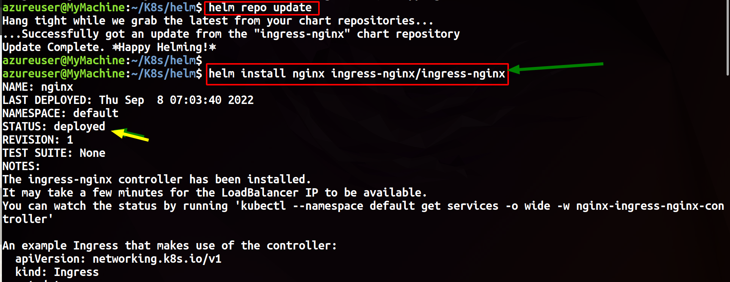

Step3: >> Create a Deployment for sBoot app
>> Create a loadbalancer Service
$ kubectl create deployment sboot --image=manoj701m/sboot --dry-run=client -o=yaml > sboot_deploy.yaml
$ kubectl apply -f sboot_deploy.yaml

$ kubectl create svc loadbalancer sboot --tcp=8080:8080 --dry-run=client -o yaml >> sboot_loadb_svc.yaml
$ kubectl apply -f sboot_loadb_svc.yaml
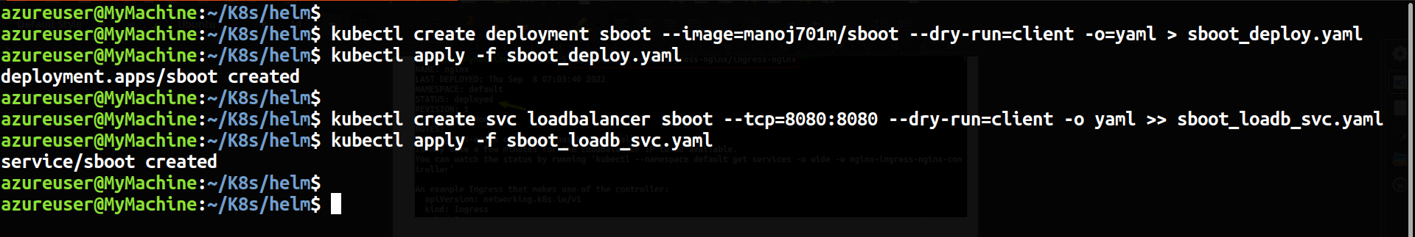

Step4: >> Create an ingress rule for the sBoot endpoint
$ kubectl create ingress <ingress-rule> --rule="/actuator/=sboot:8080" --class=nginx --dry-run=client -o yaml > sboot_ingress_rule.yaml
$ kubectl apply -f sboot_ingress_rule.yaml
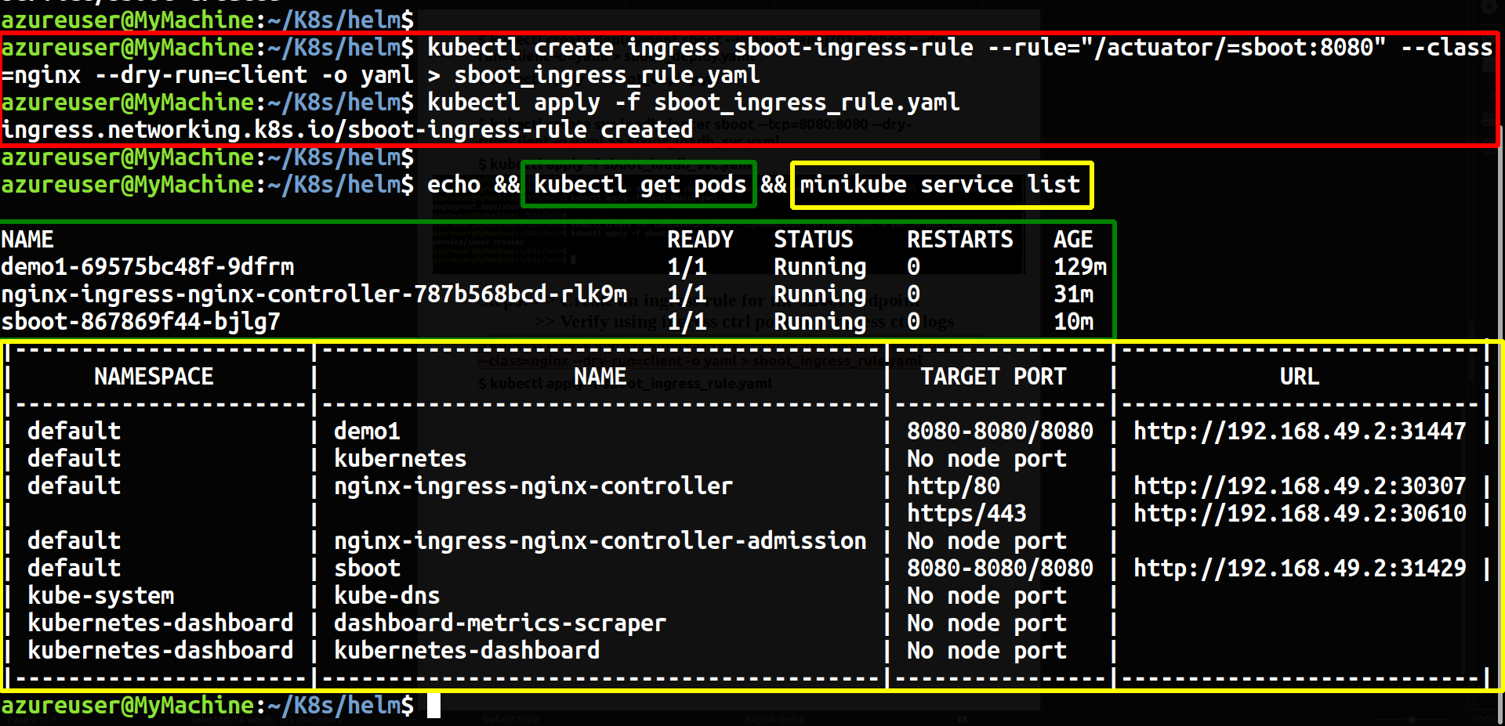

Step5: >> Verify using ingress ctrl port and ingress ctrl logs
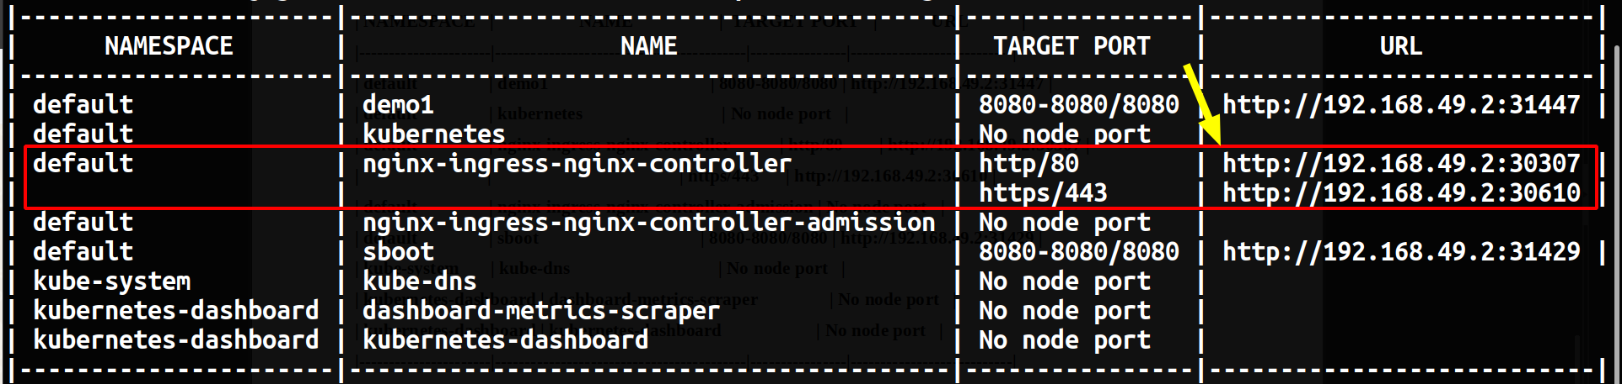
$ curl http://192.168.49.2:30307/actuator/
[ip address is minikube’s ip | To get minikube ip >> $ minikube ip]
$ kubectl logs nginx-ingress-nginx-controller-787b568bcd-rlk9m
