Kubernetes Components
When you deploy Kubernetes, you get a cluster.
A Kubernetes cluster consists of a set of worker machines, called nodes, that run containerized applications. Every cluster has at least one worker node.
The worker node(s) host the Pods that are the components of the application workload. The control plane manages the worker nodes and the Pods in the cluster. In production environments, the control plane usually runs across multiple computers and a cluster usually runs multiple nodes, providing fault-tolerance and high availability.
The components of a Kubernetes cluster :
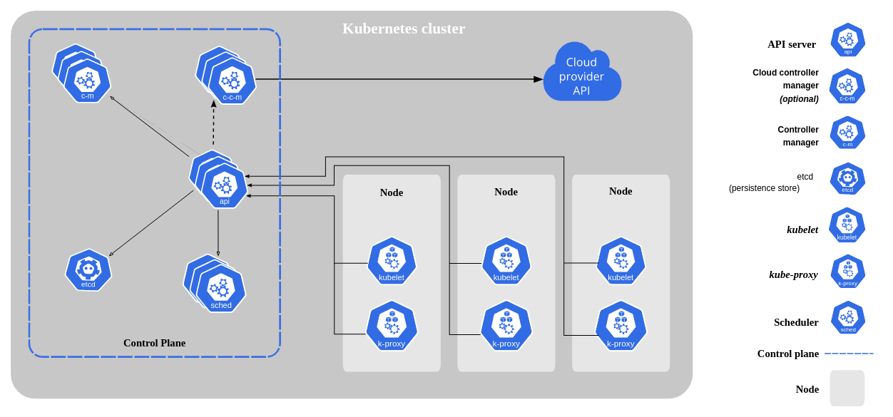

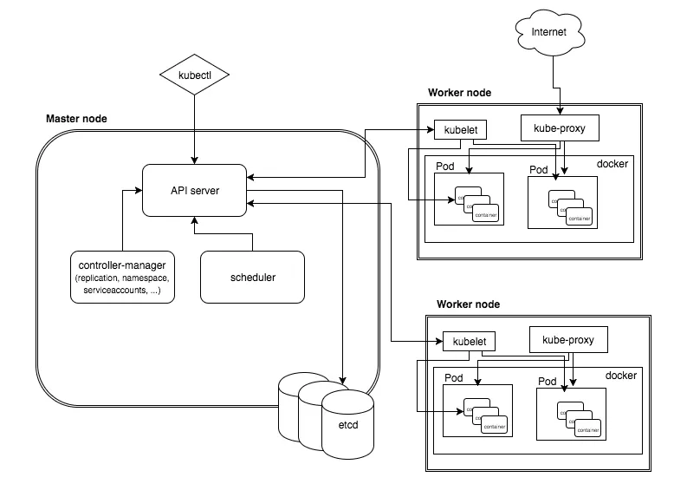

Control Plane Components (Master Node) :
The control plane's components make global decisions about the cluster (for example, scheduling), as well as detecting and responding to cluster events (for example, starting up a new pod when a deployment's replicas field is unsatisfied).
Control plane components can be run on any machine in the cluster. However, for simplicity, set up scripts typically start all control plane components on the same machine, and do not run user containers on this machine.

kube-api server
The API server is a component of the Kubernetes control plane that exposes the Kubernetes API. The API server is the front end for the Kubernetes control plane.
The main implementation of a Kubernetes API server is kube-apiserver. kube-apiserver is designed to scale horizontally—that is, it scales by deploying more instances. You can run several instances of kube-apiserver and balance traffic between those instances.

etcd
Consistent and highly-available key value store used as Kubernetes' backing store for all cluster data.
If your Kubernetes cluster uses etcd as its backing store, make sure you have a back up plan for those data.
You can find in-depth information about etcd in the official documentation.

kube-scheduler
Control plane component that watches for newly created Pods with no assigned node, and selects a node for them to run on.
Factors taken into account for scheduling decisions include: individual and collective resource requirements, hardware/software/policy constraints, affinity and anti-affinity specifications, data locality, inter-workload interference, and deadlines.

kube-controller-manager
Control plane component that runs controller processes.
Logically, each controller is a separate process, but to reduce complexity, they are all compiled into a single binary and run in a single process.
Some types of these controllers are:
- Node controller: Responsible for noticing and responding when nodes go down.
- Job controller: Watches for Job objects that represent one-off tasks, then creates Pods to run those tasks to completion.
- Endpoints controller: Populates the Endpoints object (that is, joins Services & Pods).
- Service Account & Token controllers: Create default accounts and API access tokens for new namespaces.

cloud-controller-manager
A Kubernetes control plane component that embeds cloud-specific control logic. The cloud controller manager lets you link your cluster into your cloud provider's API, and separates out the components that interact with that cloud platform from components that only interact with your cluster.
The cloud-controller-manager only runs controllers that are specific to your cloud provider. If you are running Kubernetes on your own premises, or in a learning environment inside your own PC, the cluster does not have a cloud controller manager.
As with the kube-controller-manager, the cloud-controller-manager combines several logically independent control loops into a single binary that you run as a single process. You can scale horizontally (run more than one copy) to improve performance or to help tolerate failures.
The following controllers can have cloud provider dependencies:
- Node controller: For checking the cloud provider to determine if a node has been deleted in the cloud after it stops responding
- Route controller: For setting up routes in the underlying cloud infrastructure
- Service controller: For creating, updating and deleting cloud provider load balancers
Node Components (Worker Node) :
Node components run on every node, maintaining running pods and providing the Kubernetes runtime environment.

kubelet
An agent that runs on each node in the cluster. It makes sure that containers are running in a Pod.
The kubelet takes a set of PodSpecs that are provided through various mechanisms and ensures that the containers described in those PodSpecs are running and healthy. The kubelet doesn't manage containers which were not created by Kubernetes.

kube-proxy
kube-proxy is a network proxy that runs on each node in your cluster, implementing part of the Kubernetes Service concept.
kube-proxy maintains network rules on nodes. These network rules allow network communication to your Pods from network sessions inside or outside of your cluster.
kube-proxy uses the operating system packet filtering layer if there is one and it's available. Otherwise, kube-proxy forwards the traffic itself.

Container runtime
The container runtime is the software that is responsible for running containers.
Kubernetes supports container runtimes such as containerd, CRI-O, and any other implementation of the Kubernetes CRI (Container Runtime Interface).

Kubernetes Installation:
Types of installation :
- On-prem cluster creation
- Cloud based cluster (AKS)
- Single node cluster (minikube)
- Online Lab
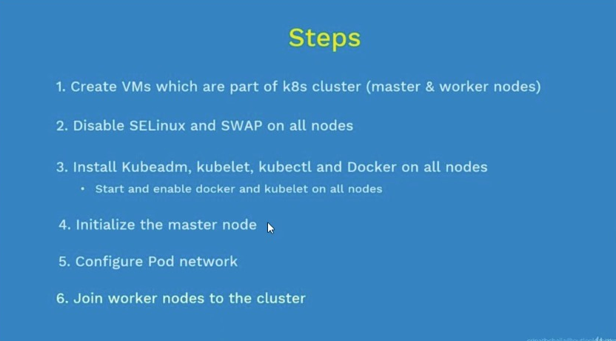
- Create Vms which are part of k8s cluster (Master & Worker nodes)
- Disable SELinux & SWAP on all nodes.
  - Check SELinux is Disabled or not, if not, Disable..!
    - cat /etc/selinux/config
  - $ apt install policycodeutils
  - $ sestatus
  - $ vi /etc/selinux/config
    - SELINUXTYPE = premissive >> to >> SELINUXTYPE = disabled
  - Check Swap is Disabled or not.
  - $ free -h
  - To Disable >> $ sudo swapoff -a
  - To Enable >> $ sudo swapon -a

- Install kubeadm, kubelet, kubectl and Docker on all nodes
  - Installing kubeadm, kubelet and kubectl
You will install these packages on all of your machines:
- kubeadm: the command to bootstrap the cluster.
- kubelet: the component that runs on all of the machines in your cluster and does things like starting pods and containers.
- kubectl: the command line util to talk to your cluster.
kubeadm will not install or manage kubelet or kubectl for you, so you will need to ensure they match the version of the Kubernetes control plane you want kubeadm to install for you. If you do not, there is a risk of a version skew occurring that can lead to unexpected, buggy behaviour. However, one minor version skew between the kubelet and the control plane is supported, but the kubelet version may never exceed the API server version. For example, the kubelet running 1.7.0 should be fully compatible with a 1.8.0 API server, but not vice versa.

- Update the apt package index and install packages needed to use the Kubernetes apt repository:
  - $ sudo apt-get update
  - $ sudo apt-get install -y apt-transport-https ca-certificates curl
- Download the Google Cloud public signing key:
  - $ sudo curl -fsSLo /usr/share/keyrings/kubernetes-archive-keyring.gpg https://packages.cloud.google.com/apt/doc/apt-key.gpg
- Add the Kubernetes apt repository:
  - $ echo "deb [signed-by=/usr/share/keyrings/kubernetes-archive-keyring.gpg] https://apt.kubernetes.io/ kubernetes-xenial main" | sudo tee /etc/apt/sources.list.d/kubernetes.list
- Update apt package index, install kubelet, kubeadm and kubectl, and pin their version:
  - $ sudo apt-get update
  - $ sudo apt-get install -y kubelet kubeadm kubectl
  - $ sudo apt-mark hold kubelet kubeadm kubectl

- Initialize the master node
  - sudo kubeadm init –pod-network-cidr “10.10.0.0/16”
Output >>
manoj@Aspire-E1:~/Desktop/Kubernetes$ sudo kubeadm init --pod-network-cidr "10.10.0.0/16"
[init] Using Kubernetes version: v1.25.0
[preflight] Running pre-flight checks
[preflight] Pulling images required for setting up a Kubernetes cluster
[preflight] This might take a minute or two, depending on the speed of your internet connection
[preflight] You can also perform this action in beforehand using 'kubeadm config images pull'
[certs] Using certificateDir folder "/etc/kubernetes/pki"
[certs] Generating "ca" certificate and key
[certs] Generating "apiserver" certificate and key
[certs] apiserver serving cert is signed for DNS names [aspire-e1 kubernetes kubernetes.default kubernetes.default.svc kubernetes.default.svc.cluster.local] and IPs [10.96.0.1 192.168.1.102]
[certs] Generating "apiserver-kubelet-client" certificate and key
[certs] Generating "front-proxy-ca" certificate and key
[certs] Generating "front-proxy-client" certificate and key
[certs] Generating "etcd/ca" certificate and key
[certs] Generating "etcd/server" certificate and key
[certs] etcd/server serving cert is signed for DNS names [aspire-e1 localhost] and IPs [192.168.1.102 127.0.0.1 ::1]
[certs] Generating "etcd/peer" certificate and key
[certs] etcd/peer serving cert is signed for DNS names [aspire-e1 localhost] and IPs [192.168.1.102 127.0.0.1 ::1]
[certs] Generating "etcd/healthcheck-client" certificate and key
[certs] Generating "apiserver-etcd-client" certificate and key
[certs] Generating "sa" key and public key
[kubeconfig] Using kubeconfig folder "/etc/kubernetes"
[kubeconfig] Writing "admin.conf" kubeconfig file
[kubeconfig] Writing "kubelet.conf" kubeconfig file
[kubeconfig] Writing "controller-manager.conf" kubeconfig file
[kubeconfig] Writing "scheduler.conf" kubeconfig file
[kubelet-start] Writing kubelet environment file with flags to file "/var/lib/kubelet/kubeadm-flags.env"
[kubelet-start] Writing kubelet configuration to file "/var/lib/kubelet/config.yaml"
[kubelet-start] Starting the kubelet
[control-plane] Using manifest folder "/etc/kubernetes/manifests"
[control-plane] Creating static Pod manifest for "kube-apiserver"
[control-plane] Creating static Pod manifest for "kube-controller-manager"
[control-plane] Creating static Pod manifest for "kube-scheduler"
[etcd] Creating static Pod manifest for local etcd in "/etc/kubernetes/manifests"
[wait-control-plane] Waiting for the kubelet to boot up the control plane as static Pods from directory "/etc/kubernetes/manifests". This can take up to 4m0s
[apiclient] All control plane components are healthy after 22.006800 seconds
[upload-config] Storing the configuration used in ConfigMap "kubeadm-config" in the "kube-system" Namespace
[kubelet] Creating a ConfigMap "kubelet-config" in namespace kube-system with the configuration for the kubelets in the cluster
[upload-certs] Skipping phase. Please see --upload-certs
[mark-control-plane] Marking the node aspire-e1 as control-plane by adding the labels: [node-role.kubernetes.io/control-plane node.kubernetes.io/exclude-from-external-load-balancers]
[mark-control-plane] Marking the node aspire-e1 as control-plane by adding the taints [node-role.kubernetes.io/control-plane:NoSchedule]
[bootstrap-token] Using token: mj4v0y.vbtdfnakpfwv4le8
[bootstrap-token] Configuring bootstrap tokens, cluster-info ConfigMap, RBAC Roles
[bootstrap-token] Configured RBAC rules to allow Node Bootstrap tokens to get nodes
[bootstrap-token] Configured RBAC rules to allow Node Bootstrap tokens to post CSRs in order for nodes to get long term certificate credentials
[bootstrap-token] Configured RBAC rules to allow the csrapprover controller automatically approve CSRs from a Node Bootstrap Token
[bootstrap-token] Configured RBAC rules to allow certificate rotation for all node client certificates in the cluster
[bootstrap-token] Creating the "cluster-info" ConfigMap in the "kube-public" namespace
[kubelet-finalize] Updating "/etc/kubernetes/kubelet.conf" to point to a rotatable kubelet client certificate and key
[addons] Applied essential addon: CoreDNS
[addons] Applied essential addon: kube-proxy

Your Kubernetes control-plane has initialized successfully!
To start using your cluster, you need to run the following as a regular user:
- mkdir -p $HOME/.kube
- sudo cp -i /etc/kubernetes/admin.conf $HOME/.kube/config
- sudo chown $(id -u):$(id -g) $HOME/.kube/config

Alternatively, if you are the root user, you can run:
- export KUBECONFIG=/etc/kubernetes/admin.conf
You should now deploy a pod network to the cluster.
- Run "kubectl apply -f [podnetwork].yaml" with one of the options listed at:
https://kubernetes.io/docs/concepts/cluster-administration/addons/
Then you can join any number of worker nodes by running the following on each as root:
kubeadm join 192.168.1.102:6443 --token mj4v0y.vbtdfnakpfwv4le8 \
--discovery-token-ca-cert-hash sha256:ca32193bade66b3f93b69fa86d814be4fedfa7f3068e4cc8db1df5209cab3c87

