1. **Database with entries**

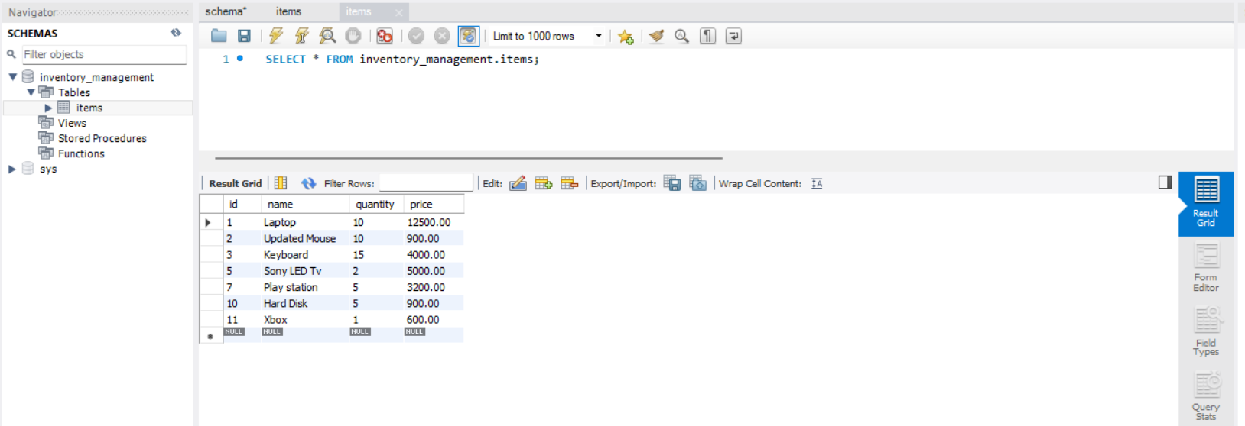

1. **Homepage for the application.**

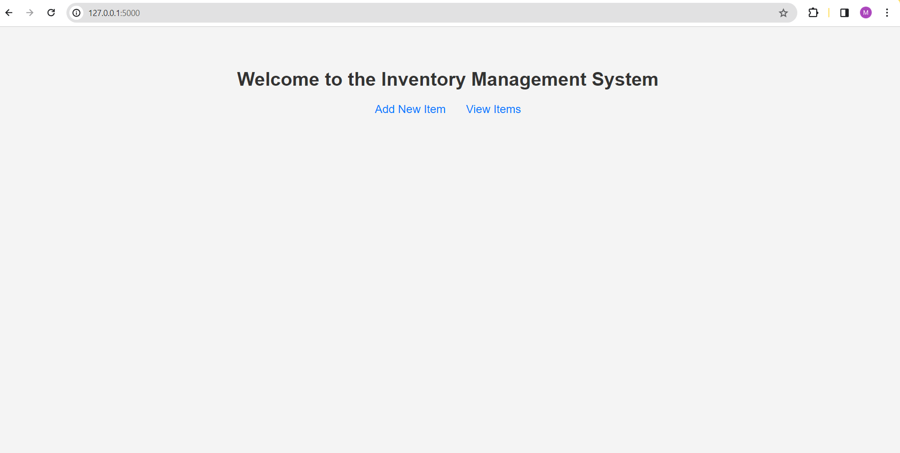

**Code**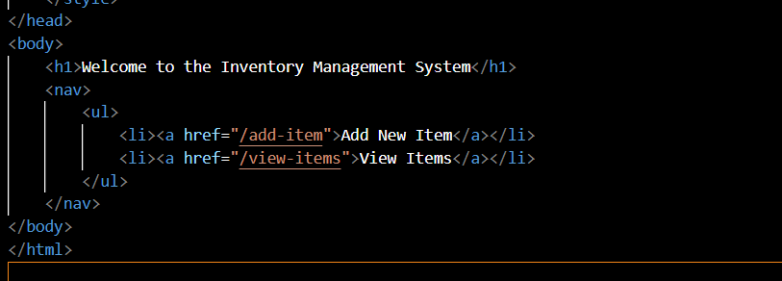

**Index.html**

1. **When user clicks on Add New Item**

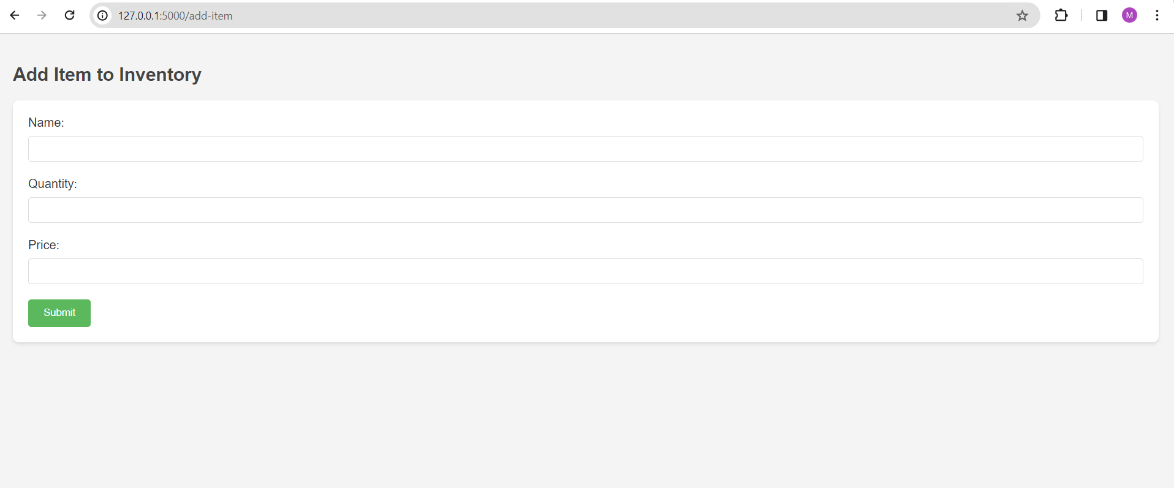

**Code –**

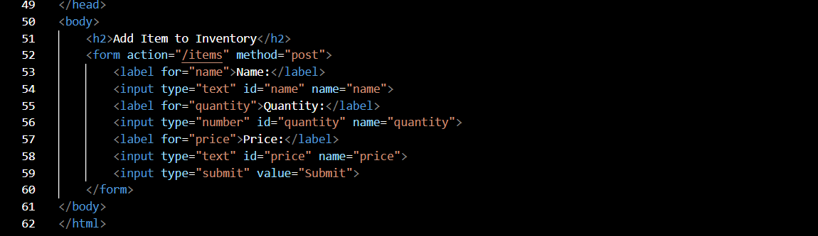

**add_item.html**

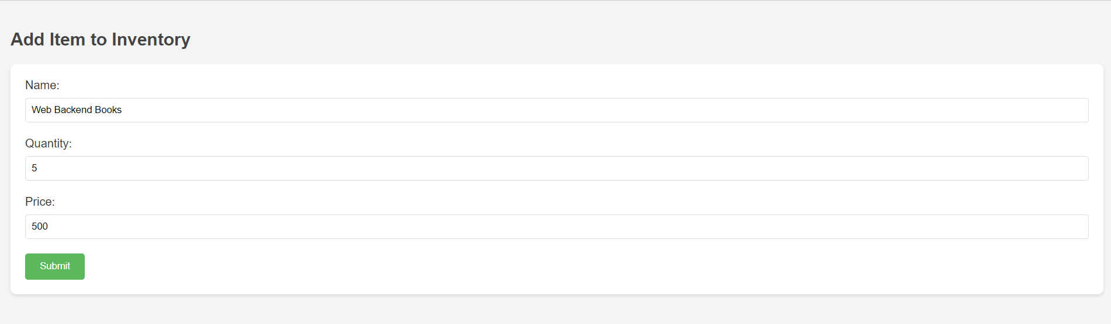

**Adding Product and click on submit.**

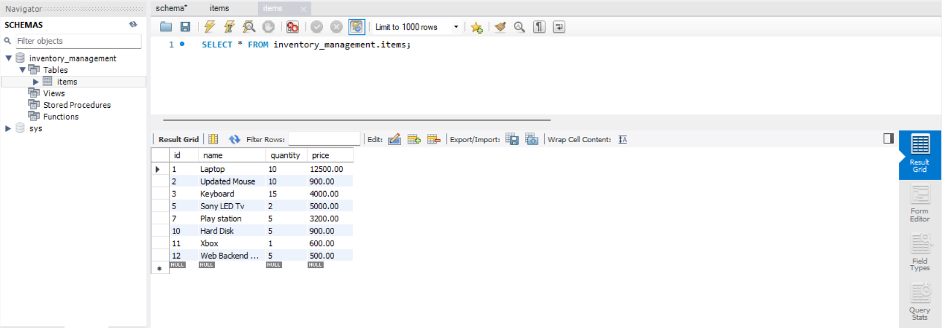

**Product added to Data base.**

**4. Now If user clicks on View Items then user will see items list with edit and delete options.**

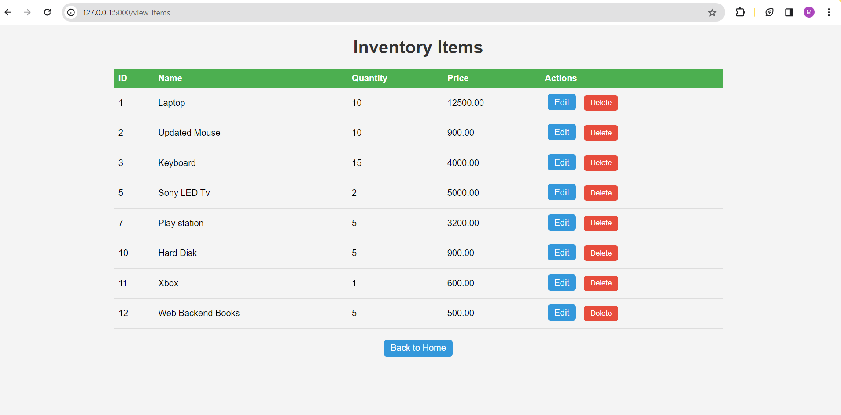

**Code –**

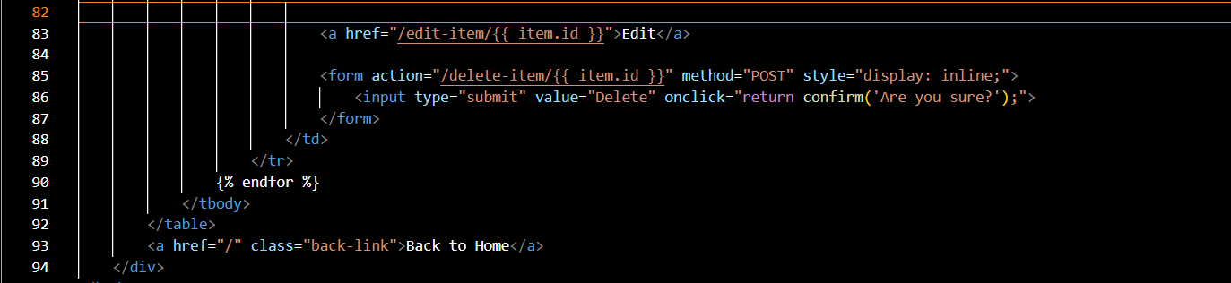

**View_items.html**

**5. Click on edit and update the item.**

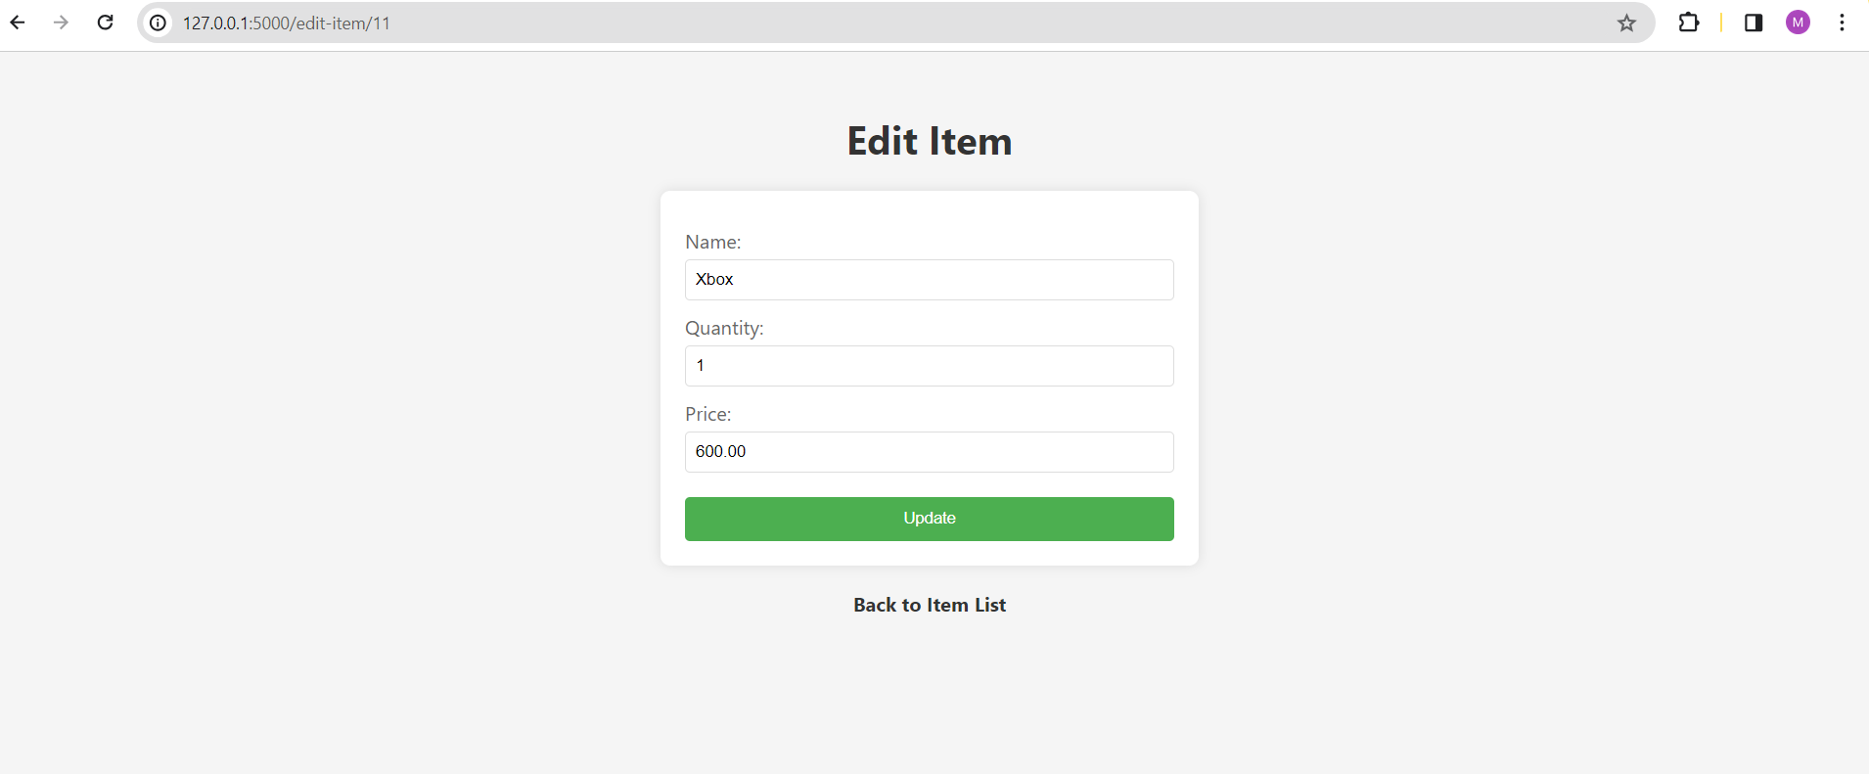

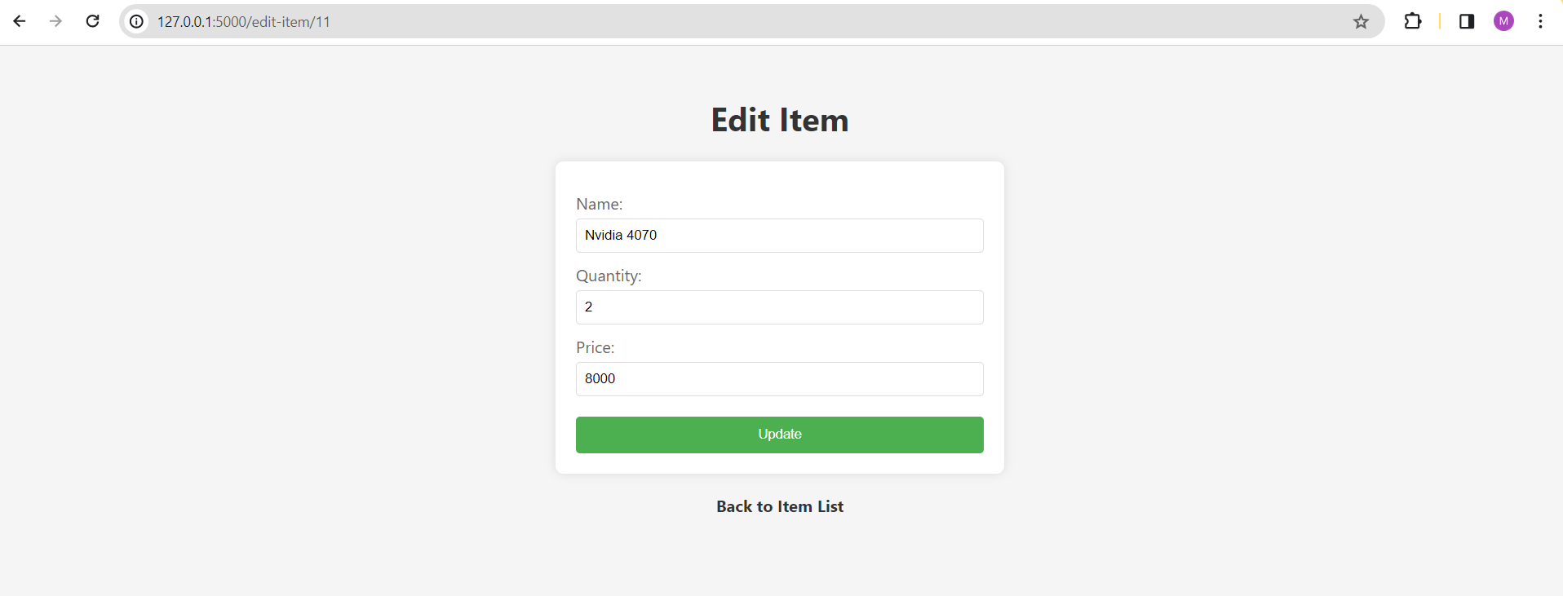

**Viewing products after clicking on Update.**

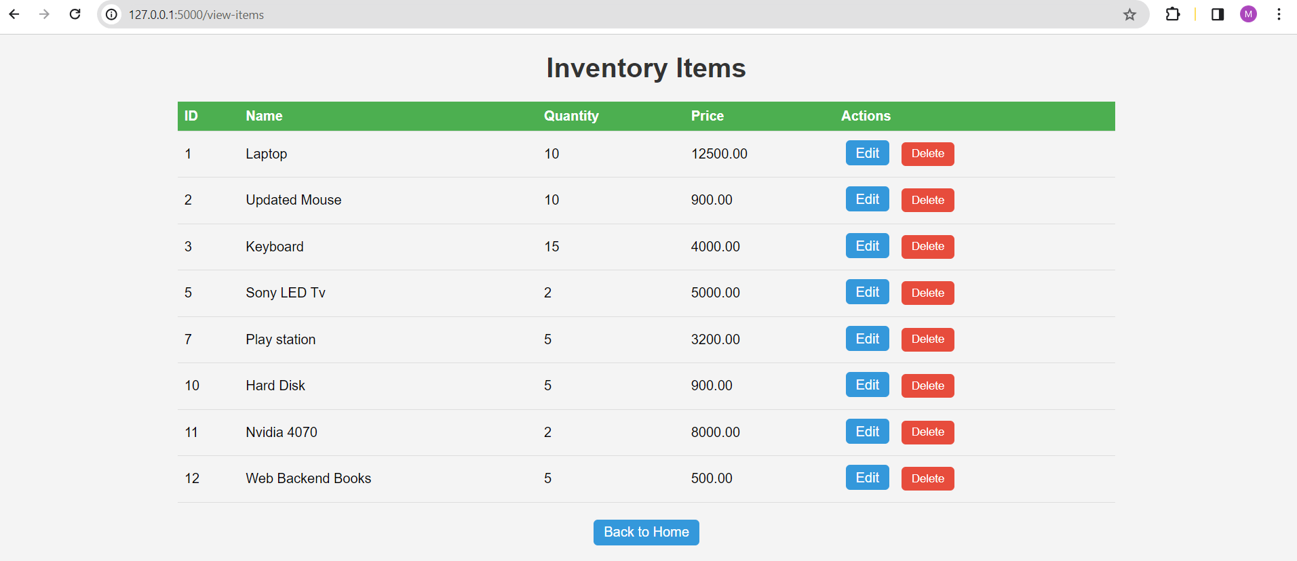

**Code-**

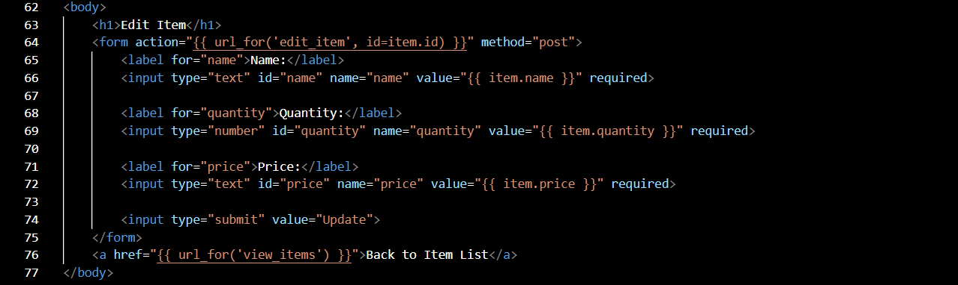

**edit_item.html**

**6. Deleting Item entry.**

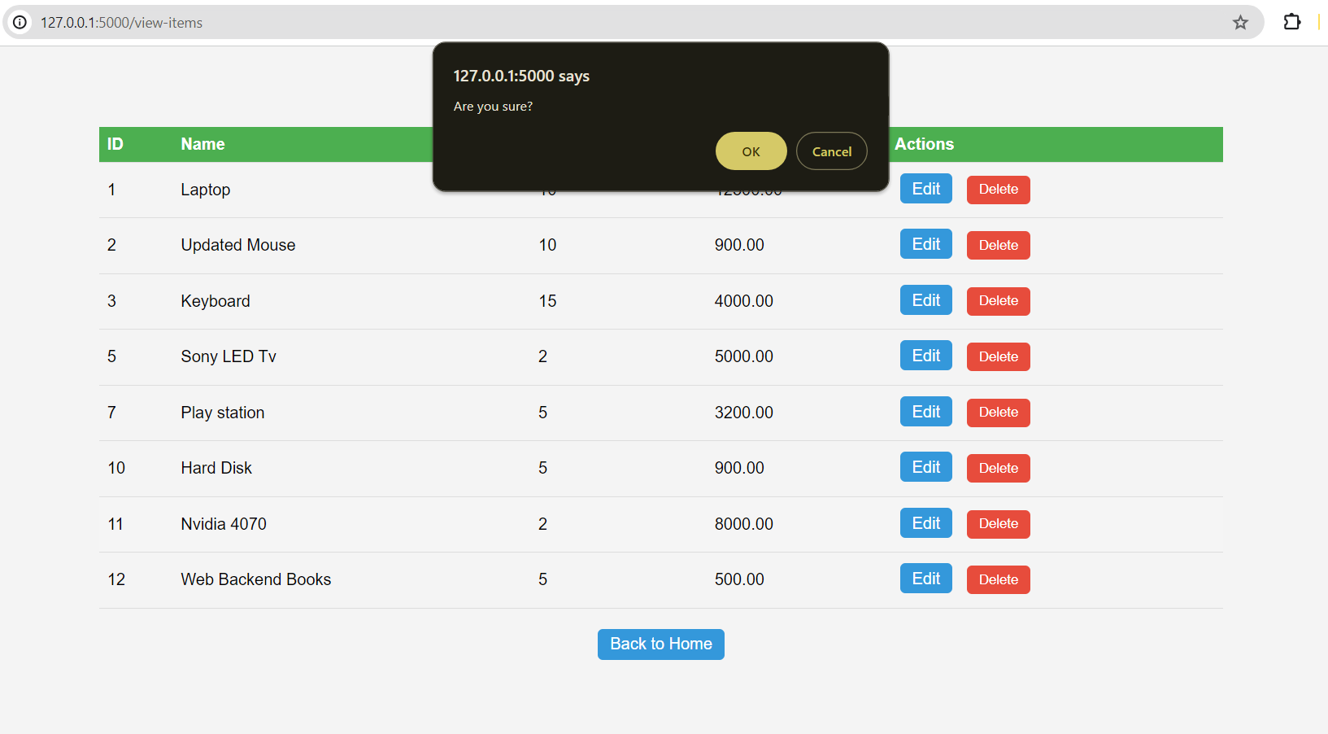

**Trying to Delete the Item with Id 11.**

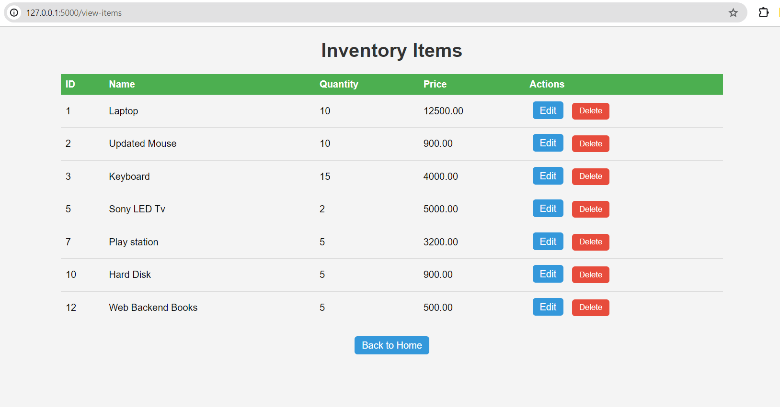

**Item with Product Id 11 is deleted.**

**7. app.py file with Database connection and integrating html files with app.py file with CRUD operations to perform in the application.**

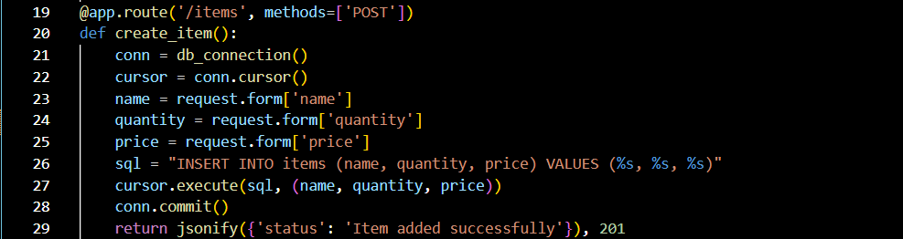

**Adding items.**

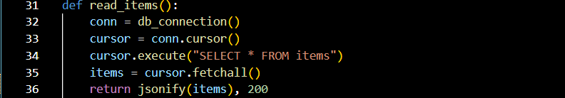

**Reading items**

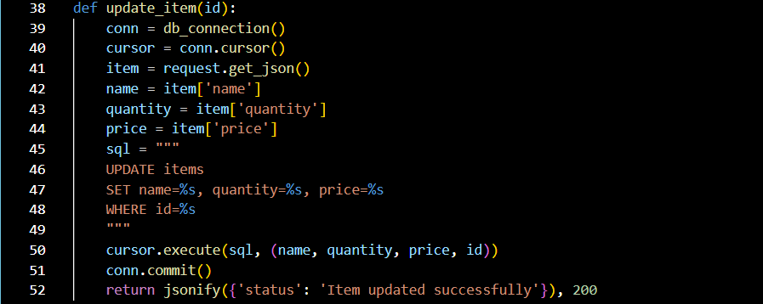

**Updating items**

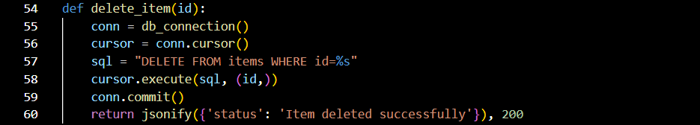

**Delete item.**

**Postman –**

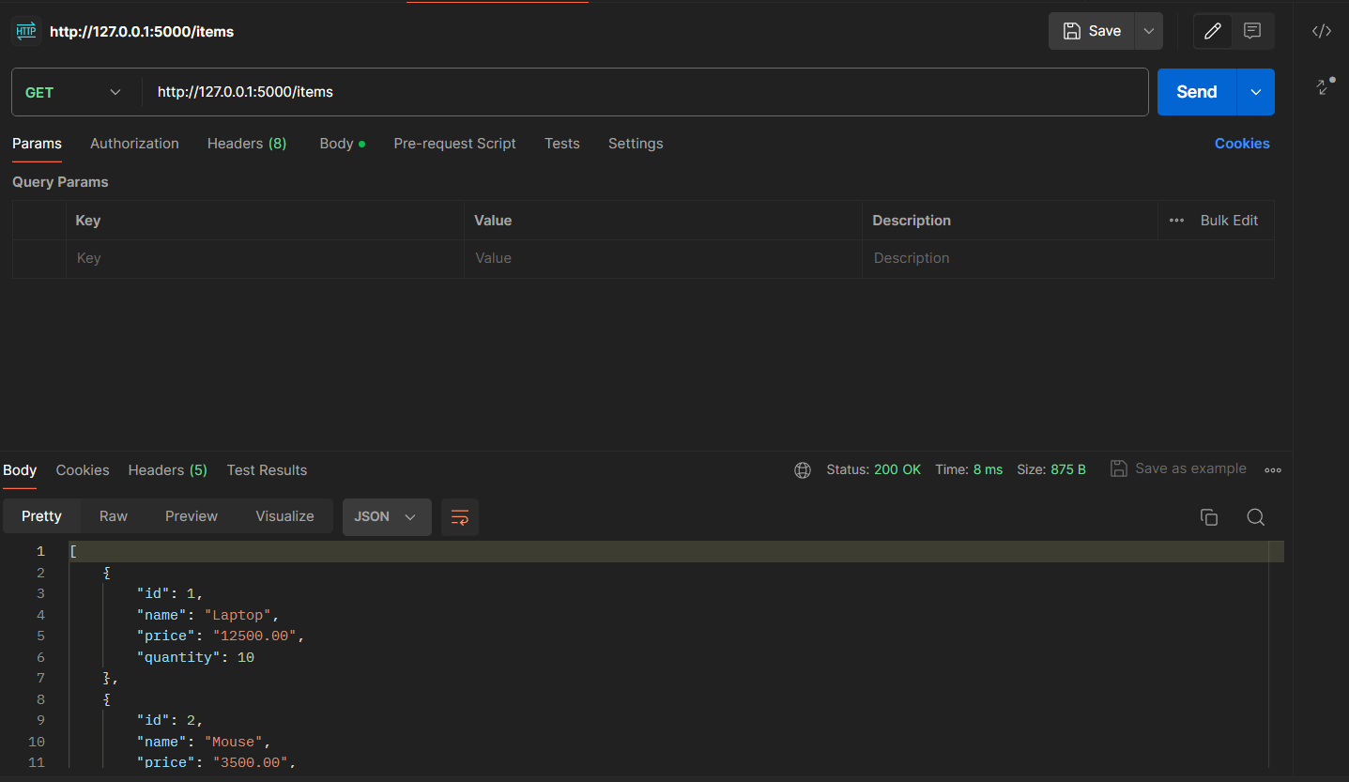

**Fig 1 – Viewing the data present in the table -items.**

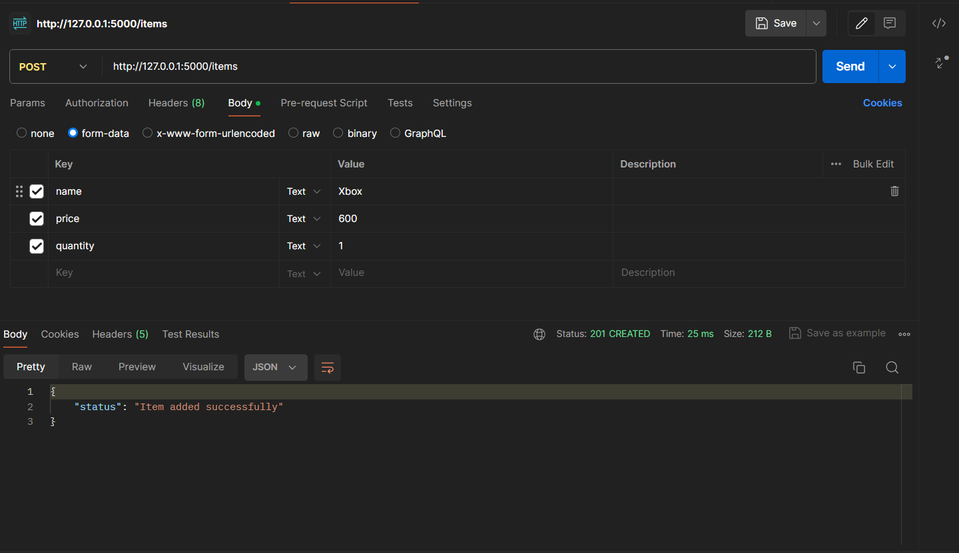

**Fig 2 -Adding product from Postman.**

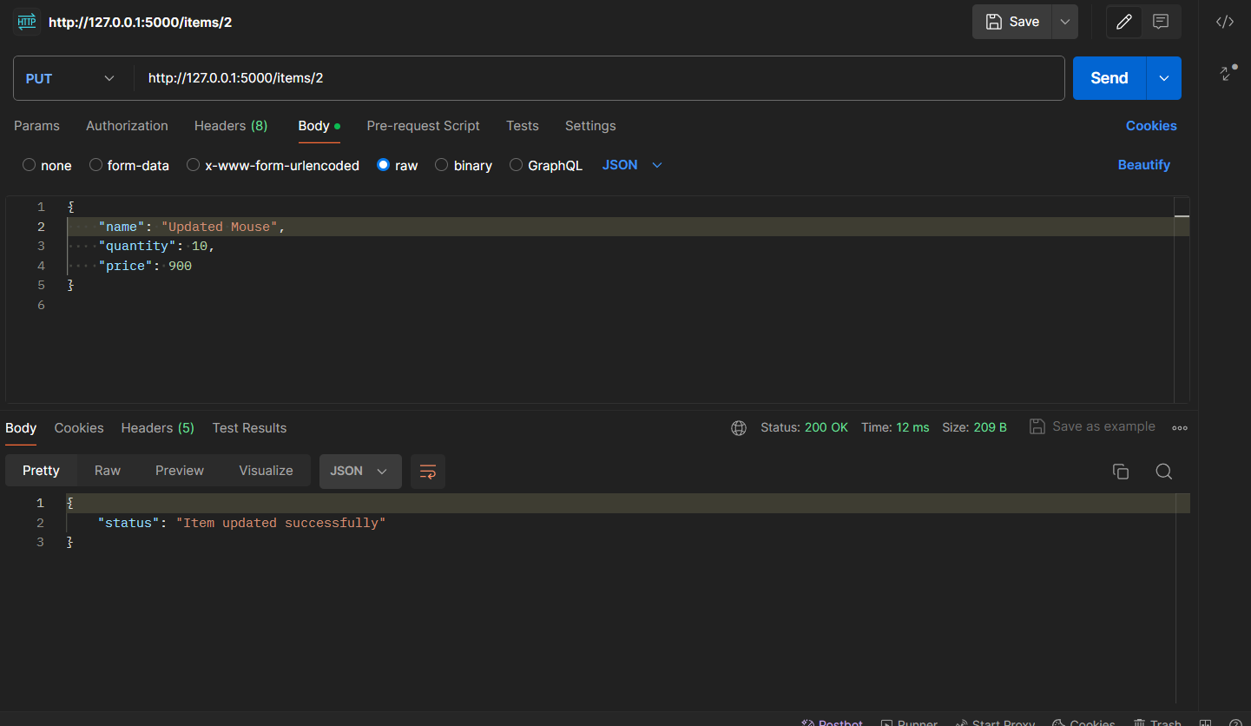

**Fig 3 – Updated Mouse item with index 2 in the table. Changed name, quantity and price.**

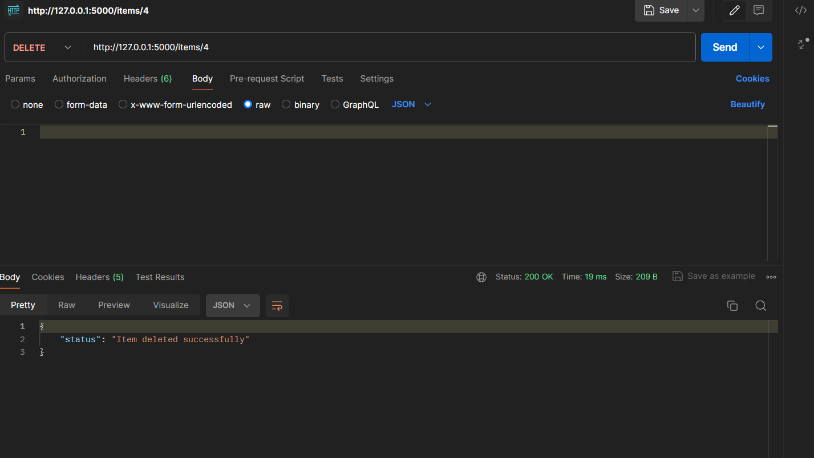

**Fig 4 – Deleted product with product Id 4.**

**Github Link -** [**https://github.com/manoj7032/Inventory_ManagementCPSC449/tree/main**](https://github.com/manoj7032/Inventory_ManagementCPSC449/tree/main)