**<https://jnjprod.service-now.com/iris?id=sc_cat_item&sys_id=bed69885139f1340371f50bf3244b064---to> create openlab sweep task request and tv sop form-** **"C:\Users\MPradha8\OneDrive - JNJ\Documents\to update an openlab sweep task-TV-FRM-07344_v3.0 6.doc"**

**smart qc- ELIMSplanningdata202408191251431- 2024/08/19 12:51pm cest to ist 4:21pm**

**search the sample query first and then query with parameter smapleid, check the tenant id in result if its correct or not, then check the arrival id and similar arrival id is given in name of file as well(if records are uploaded)….If records are not uploaded then export the result of query with parameter smapleid and upload it in sftp ‘upload’ folder.**

**tim--------------**

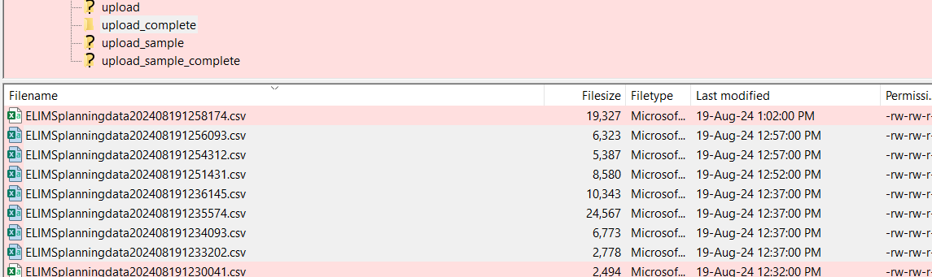

**given that the samples were showing in the query output, that leads me to think that the samples have been sent. So then I check in Filezilla on the timewindow just before and after the arrival date**

**I downloaded these files and searched for the sample ids**

**and they came up**

**a record is selected, once it is received in eLIMS. You can find that datetime in the Arrival_Date column. This datetime can then be used to find files in FileZilla that were sent during this timewindow**

**I think I selected files within the hour**

**this time I did not use the merge function as there were only a handful of files**

**then the Win Explorer search does the trick**

**--------------------**

**Comet investigation- for nc and nc-capa combo:-**

We need to check state column for comet and not action. There are 2 flows,

1. Just NC 2. NC-CAPA combo

1.For NC – state and action column may be both synchronous.

2. For NC-CAPA combo- we just need to check state column….NC- COMBO batch may have have open state for NC only for few days but if investigation is required then it becomes NC-CAPA combo and here for this we check ‘closed’ action

OR

Verification-Complete (NC) / Implement-Open (CAPA) is the state for NC-CAPA combo here, That means this is closed for both NC and NC-CAPA combo

[5:55 PM] Hustinx, Tim [GPSBE]

if you check the grid in the user story, you can see the actions that are sent

based upon the process (NC or NC+CAPA)

 if there is CAPA, the NC status will not trigger any action anymore

[5:53 PM] Hustinx, Tim [GPSBE]

we don't send a separate close for NC. The project id field combines nc and capa ref (in case a capa is present).

if we send Close, it applies to both the nc and capa. We consider these as one record

1. CLOSE
   1. For a NC record in status ‘VOID’ AND Product impact = Product grid is filled with Product and lot number (Test 1)
   2. NC flow
      1. For a NC record with an existing site/material/batch, at **NC ‘IMPLEMENT’ stage ; NC ‘OPEN’ status** AND Product impact = Product grid is filled with Product and lot number (Test 2)
      2. For a NC record with an existing site/material/batch, at **NC ‘CLOSED’ stage ; NC ‘CLOSED’ status** AND Product impact = Product grid is filled with Product and lot number (Test 3)
      3. For a NC record from which a product/lot has been removed from the grid. If the record in NC ‘**Disposition/Investigate’**stage; NC ‘**OPEN’** status and the **Release_from_investigation**flag = ‘Yes’ in the lot table. (Test 4)

**Eg.1**

Hi! Jaimie! Tim told me that in Comet we don't consider action column but the state column...so according to the state column for NC-013875 (cork chem) - batch A24AC0787

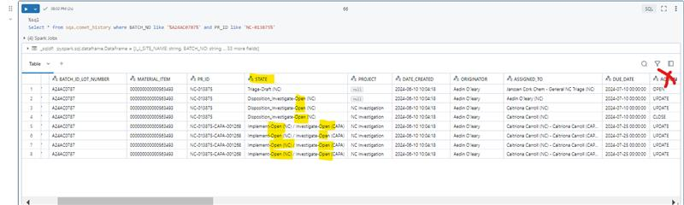

 so the state was open for NC even if action was closed and the NC-CAPA combo is still in open state

**Eg2**

Similarly for 927407-24BG0902,

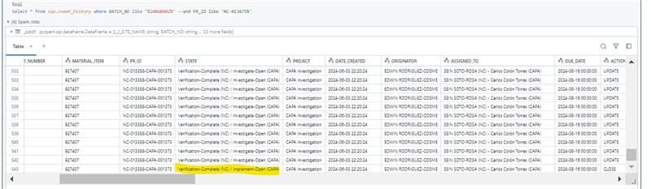

Verification-Complete (NC) / Implement-Open (CAPA) is the state for NC-CAPA combo here, That means this is closed for both NC and NC-CAPA combo

**Query used:**

%sql

Select * from sqa.comet_history where BATCH_NO like '%24BG0902%' --and PR_ID like 'NC-013875%'

%sql

Select * from sqa.comet_history where PR_ID like '%CAPA%' and action = 'CLOSE' and INSERTED_AT > TIMESTAMP '2024-07-22 07:11:14.850+00:00'

]

generally how much time it takes to complete the job runs?

[Wednesday 7:44 PM] Pradhan, Manoj [JJCUS NON-J&J]

are the job runs for each notebook or just the parent notebook

[Wednesday 7:49 PM] Pradhan, Manoj [JJCUS NON-J&J]

Are the job clusters created for each notebook

[Wednesday 7:59 PM] Pradhan, Manoj [JJCUS NON-J&J]

will it be fine If I rerun the job on failure or repair run

[Wednesday 9:38 PM] Pradhan, Manoj [JJCUS NON-J&J]

Token Renewal proces

[Wednesday 9:39 PM] Pradhan, Manoj [JJCUS NON-J&J]

forward some emails related to each issue

[Thursday 11:20 AM] Pradhan, Manoj [JJCUS NON-J&J]

KT LINK

<https://jnj-my.sharepoint.com/:v:/p/mpradha8_its/EV5YUfVCNMNPi16mt-LQ2A4B-zHo4xpHYuBfTTvWaRZj2g?referrer=Teams.TEAMS-ELECTRON&referrerScenario=MeetingChicletGetLink.view.view>

[SMARTQA Transition KT Session-20240221_190039-Meeting Recording.mp4](https://jnj-my.sharepoint.com/personal/mpradha8_its_jnj_com/Documents/Recordings/SMARTQA%20Transition%20KT%20Session-20240221_190039-Meeting%20Recording.mp4)

[Thursday 1:58 PM] Pradhan, Manoj [JJCUS NON-J&J]

ITS-EP-AZR-ALV-DatabricksDataAdministrators  
    ITS-EP-AZR-ALV-DatabricksAdministrators  
    ITS-EP-AZR-ALV-AccountDBAs  
    ITS-EP-AZR-ALV-AccountAdministrators  
    ITS-EP-AZR-ALV-AccountMembers  
    ITS-EP-AZR-ALV-AccountMonitors  
    ITS-EP-AZR-ALV-AccountOperators

[Thursday 2:00 PM] Pradhan, Manoj [JJCUS NON-J&J]

Need access to perform GLI Support activities.

[Friday 5:48 PM] Pradhan, Manoj [JJCUS NON-J&J]

|  |  |
| --- | --- |
| SMARTQA QA CDL L0/L1 | RITM000021418792 |
| SMARTQA QA CDL MAKE | RITM000021418812 |

[Friday 5:49 PM] Pradhan, Manoj [JJCUS NON-J&J]

RAISE REQUEST FOR TOKEN EXPIRY

<https://jnjprod.service-now.com/iris?id=sc_cat_item_guide&sys_id=b8cf367bdbdc44104f608396489619ac&sysparm_category=cd46d2d00fdb8e4003dd1b9ff2050e85>

|  |  |
| --- | --- |
| SMARTQA PROD CDL L0/L1 | RITM000021776293 |
| SMARTQA PROD CDL MAKE | RITM000021776765 |

|  |  |
| --- | --- |
| **SMARTQA** | **Renewal Date** |
| SMARTQA CDL L0/L1 token renewal for PROD | 25-11-2024 |
| SMARTQA CDL MAKE SAS token renewal for PROD | 25-11-2024 |
| SMART QA CDL L0/L1 token renewal for QA | 26-08-2024 |
| SmartQA CDL MAKE SAS token renewal for QA | 26-08-2024 |
| SMARTQA CDL L0/L1 token renewal for DEV | 11-06-2024 |
| SMARTQA CDL MAKE SAS token renewal for DEV | 19-06-2024 |