Set 5
GUNUGANTI MANOJ Ht No:- 2505B04101

Subject:- AI Assisted Problem Solving Using Python
Lab question2 :-
Q2. Write a Python queue class (`enqueue`, `dequeue`, `peek`). Use an AI assistant and test the class with multiple scenarios. Describe how AI-generated code manages edge cases and how you improved it.
Title: Lab Report – Queue Class Implementation with AI Assistance
Objective: To implement a queue data structure in Python using an AI assistant, test it with multiple scenarios, and refine the code to handle edge cases.
Step 1: Initial AI-Generated Code The AI assistant generated a basic queue class using Python lists with enqueue, dequeue, and peek.
- Worked for normal operations.
- Failed when trying to dequeue or peek from an empty queue.
Step 2: Edge Case Management
- Empty Queue Dequeue: Added a check using is_empty() and raised IndexError.
- Empty Queue Peek: Similarly, added validation to raise IndexError.
- Improvement: Introduced is_empty() and size() methods for better usability.
Step 3: Testing Scenarios
- Enqueue Elements: Successfully added items [10, 20, 30].
- Peek Operation: Returned the front element 10 without removing it.
- Dequeue Operation: Removed elements in FIFO order (10, 20, 30).
- Multiple Dequeues: Verified correct order of removal.
- Empty Queue Dequeue: Raised error "Dequeue from empty queue".
- Empty Queue Peek: Raised error "Peek from empty queue".
Code:-
class Queue:
def __init__(self):
self.items = []

def enqueue(self, item):
"""Add an item to the end of the queue"""
self.items.append(item)

def dequeue(self):
"""Remove and return the front item of the queue"""
if self.is_empty():
raise IndexError("Dequeue from empty queue")
return self.items.pop(0)

def peek(self):
"""Return the front item without removing it"""
if self.is_empty():
raise IndexError("Peek from empty queue")
return self.items[0]

def is_empty(self):
"""Check if the queue is empty"""
return len(self.items) == 0

def size(self):
"""Return the number of items in the queue"""
return len(self.items)

# 🔹 Testing the Queue class
q = Queue()

# Scenario 1: Enqueue elements
q.enqueue(10)
q.enqueue(20)
q.enqueue(30)
print("Queue after enqueues:", q.items)

# Scenario 2: Peek at the front
print("Peek:", q.peek()) # Expected: 10

# Scenario 3: Dequeue elements
print("Dequeued:", q.dequeue()) # Expected: 10
print("Queue after dequeue:", q.items)

# Scenario 4: Multiple dequeues
print("Dequeued:", q.dequeue()) # Expected: 20
print("Dequeued:", q.dequeue()) # Expected: 30

# Scenario 5: Edge case - Dequeue from empty queue
try:
q.dequeue()
except IndexError as e:
print("Error:", e)

# Scenario 6: Edge case - Peek from empty queue
try:
q.peek()
except IndexError as e:
print("Error:", e)

Input:-
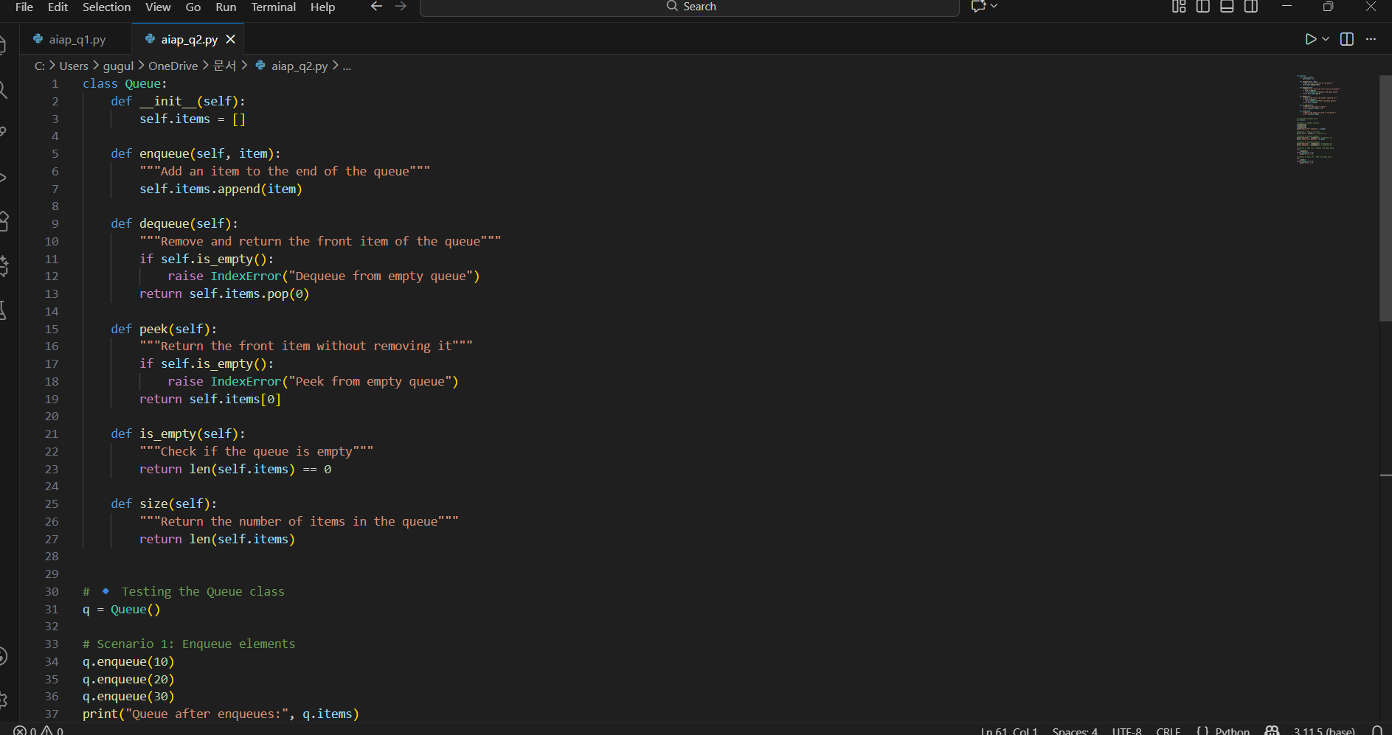

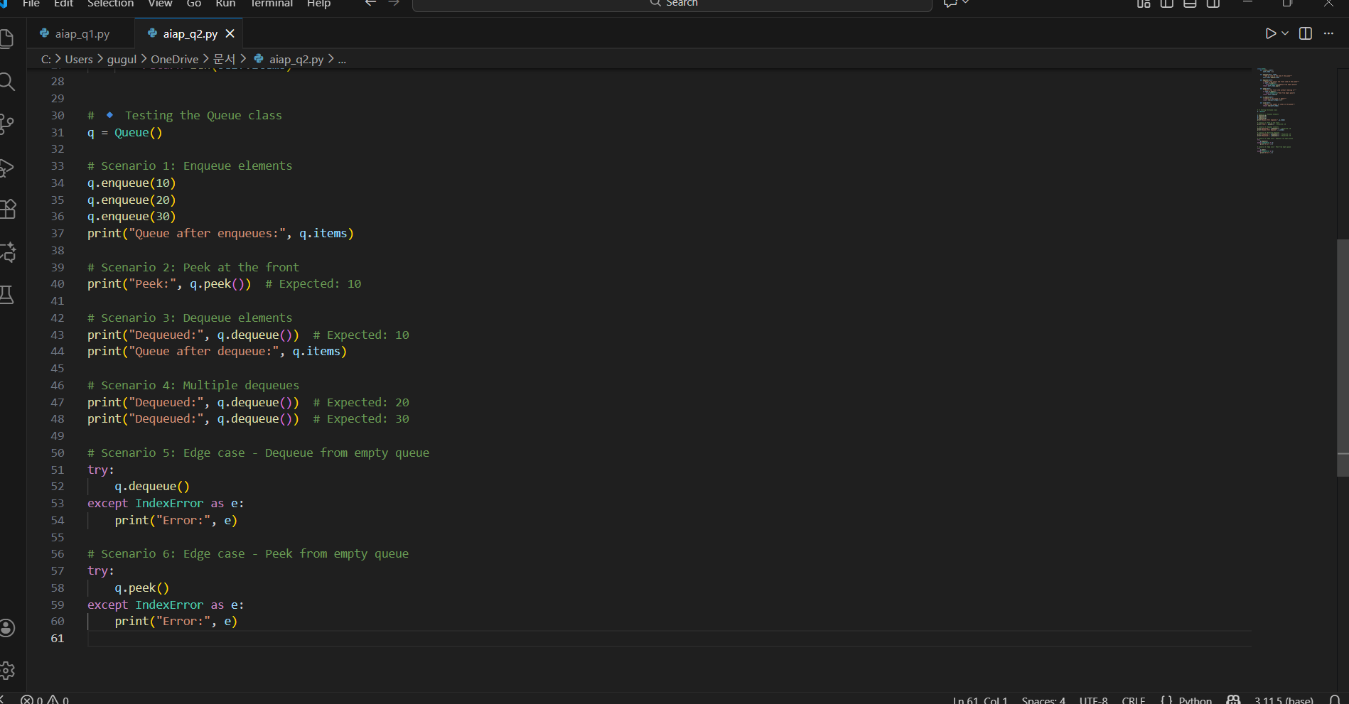

Output:-
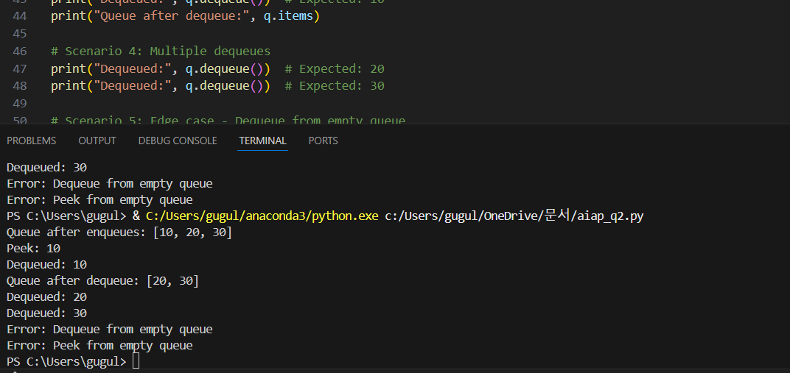

Conclusion:- The AI assistant provided a strong foundation for the queue implementation. Through refinement, edge cases were handled gracefully, resulting in a robust and user-friendly queue class. Testing confirmed correct FIFO behavior and proper error handling.

