**SMART BODY POSTURE RECOGNITION AND GUIDING SYSTEM**

Antony raj.M*1 ,Padmajaa.B*2 ,Manoj.M*3

Department of Information Technology

Kgisl institute of technology

**ABSTRACT:**

**A gesture is a form of nonverbal communication or non vocal communication. Gestures include movement of the hands, face, or other parts of the body. Gestures allow individuals to communicate a variety of feelings and thoughts. Gesture processing takes place in areas of the brain such as Broca's and Wernicke's areas, which are used by speech and sign language. We provide a system that captures the image of the whole body and it recognizes the body posture of an individual and gives them the right posture for calculating the blood pressure through image processing.**

**KEYWORDS- Gesture; smart body posture recognition;gesture processing.**

**I.INTRODUCTION:**

Image processing is a method to translate an image into digital form and execute some operations on it to get an enhanced image or to extract some useful information from it. It includes basically three steps: Importing the image, analyze and manipulate and output. The challenge to scientists, engineers and business people is to quickly extract valuable information from raw image data. This is the primary purpose of image processing-converting images to information. Various techniques have been developed in Image Processing during the last four to five decades. Most of the techniques are industrial for attractive

images obtained from unmanned spacecraft’s, space probes and military reconnaissance flights. Image Processing systems are becoming popular due to easy availability of powerful human resources computers, large size memory devices, graphics software’s etc. In human, posture can provide a huge quantity of significant information on nonverbal communication. Researches studies have shown the result of body posture on emotions. Physical posture has been study using two methods: static and dynamic. In static, human can sit in certain position and in dynamic the human perform certain actions. There are so many types of human body posture such as standing, sitting, squatting, lying, kneeling, and crouching. Posture recognition is a topic in computer science and language technology with the goal of interprets human posture via mathematical algorithms. Posture originated from human body shape. Human body posture recognition is an essential part in the field of computer vision with the wide range of applications. With the development of image processing and computer vision techniques, it is possible to analysis human behaviour automatically by recognition the posture of human body, which has become one of most significant research topic in both computer-based intelligent video surveillance system and pattern recognition area.

**II. RELATED WORK**

A recognition system can be divided into different units: data acquisition, preprocessing, segmentation, feature extraction and classification. In this paper we discuss each unit and its methods to recognize the human body posture.

A.**Data Acquisition**

The human body posture recognition system start with the capturing the image. By the literature survey there are two type of recognition system: intrusive and non-intrusive.

B. **Preprocessing**

Captured image contains the noise, which causes the reduce the accuracy of recognition system. So maintain the accuracy of system noises is to be removed using different types of filtering methods.

C. **Segmentation**

Image segmentation is a process to separate ROI image from background. ROI is a region that we want to examine for the recognition system. Output of this step is human body posture shape region. There are different types of segmentation methods are used for segmentation. Presentation of background model, exciting methods can be divided in to three groups like basic (such as frame difference, running average and temporal median filtering), parametric (e.g. mixture o Gaussian), and non-parametric

**D.Feature Extrcation**

Feature extraction is a crucial step in the frame work of object recognition. It extracts certain feature from the original rich content of images. Feature extraction reduces the

amount of information that is requiring representing the original pattern. It also increases the accuracy ofthe classification. Various kinds of feature and a large number of representations have been proposed and exploited by researchers. Human vision can recognize and discrimination objects by their color, texture and shape. Researcher said that the object’s class identity is more basically related with its volumetric description (shape) rather than surface characteristics such as color and texture. However, this does not means color and texture are useless. There are many examples in nature and also artificial environment where color (or texture) correlates well with class identity. Colour and texture feature are interesting in terms of their low complexity and high efficiency in circumstances where images contains noticeable unique colour or texture. However, in general, there are many cases where colours or texture are not available or not clearly discriminative for different objects. Therefore, shapes such as edges or lines, corners, contours or silhouettes have been widely adopted in object tracking, pattern recognition, and human activity

**E.Classification**

After the review of various kinds of feature extraction methods, it is time to move on the classification part. In this section several popular classifier, such as k-nearest neighbour .

1.Capture the images using web camera.

2. On applying Image Processing technique we will be able to detect the hands and Gesture and perform some console based operation.

i. Edge Detection: Edges are the sharp black shadow surrounding the objects.

ii. Threshold Control: for controlling sharpness of edges.

iii. Finding Contours, contours are nothing but shadow areas of hand.

iv. Set the proper beginning of the contours.

v. Detect Convexity Defect in the picture. Defects are the points which are having thick edges.

vi. Detect Convexity Defect ending points for the tip of our hand detection.

vii. Draw Circles on the defects we obtained.

viii. Save the Co-ordinates of the Defects obtained in each areas.

3. Trigger Image Capture.

4. Background Subtraction is done for clearingbackground.

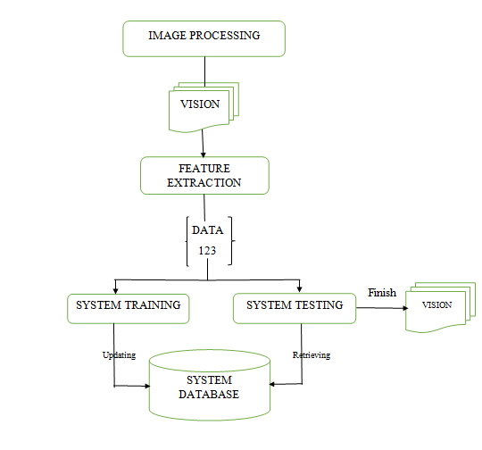

**ALGORITHM FOR HAND DETECTION**

Finger Identification Algorithm

1. The first and easiest step is to identify the thumb and the index finger, since the distance between them is the largest among all neighboring fingers.

2. The little finger is identified as the farthest finger away from the thumb; meanwhile the middle finger is identified as the closest one to the index finger.

3. The remaining one is the ring finger. The process of detecting hands and identifying fingers are performed every time when the input data source changes. If the same object still exists in the current frame with some transformation compared to the previous frame, all properties of this object is mapped from the previous frame to the current frame; otherwise the disappeared object is collected by an unmapped item collector.

Background subtraction is a major preprocessing step in many vision-based applications. For example, consider the case of a visitor counter where a static camera takes the number of visitors entering or leaving the room, or a traffic camera extracting informationabout the vehicles etc. In all these cases, first you need to extract the person or vehicles alone. Technically, you need to extract the moving foreground from static background.

If you have an image of background alone, like an image of the room without visitors, image of the road without vehicles etc, it is an easy job. Just subtract the new image from the background. You get the foreground objects alone. But in most of the cases, you may not have such an image, so we need to extract the background from whatever images we have. It becomes more complicated when there are shadows of the vehicles. Since shadows also move, simple subtraction will mark that also as foreground. It complicates things.

Several algorithms were introduced for this purpose. OpenCV has implemented three such algorithms which are very easy to use. We will see them one-by-one.

It is a Gaussian Mixture-based Background/Foreground Segmentation Algorithm. It was introduced in the paper "An improved adaptive background mixture model for real-time tracking with shadow detection" by P. KadewTraKuPong and R. Bowden in 2001. It uses a method to model each background pixel by a mixture of K Gaussian distributions . The weights of the mixture represent the time proportions that those colours stay in the scene. The probable background colours are the ones which stay longer and more static.

**WORKING OF BACKGROUNG ELIMINATION ALGORITHM**

**ORIGINALFRAME**

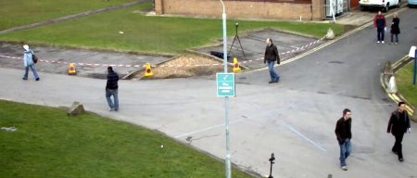

**BACKGROUND ELIMINATIONALGORITHM**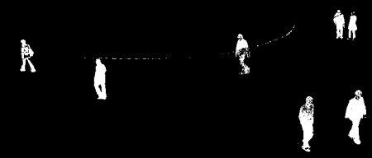

**DATASETS:**

**IMAGES OF THE HAND GESTURES CAPTURED CORRECTLY.**

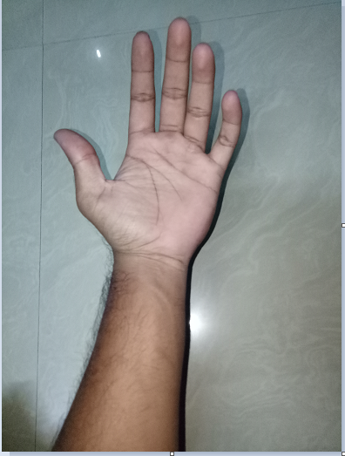

**IMAGES OF THE HAND GESTURES CAPTURED WRONGLY:**

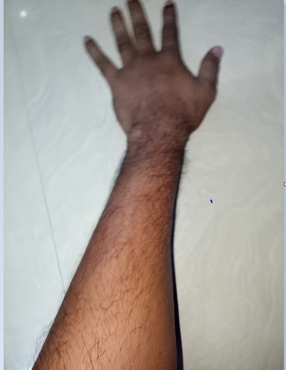

**CONCLUSION:**

The various approaches of hand gesture recognition have been discussed. The proposed method has been presented. The sign for all alphabets A to Z will be recognized using SIFT. The advantage of using the algorithm is high processing speed which can produce better results. The SIFT features in our implementation will compute at the edges which will be invariant to scaling, rotation, addition of noise. These features will be useful due to their distinctiveness, which enables the correct match for key points between different hand gestures. Also computation time will be less. This work can further be extended to text to speechconversion