

Project Report on

**PDF Encrypt and Decrypt**

(PDF Locker and Delocker)

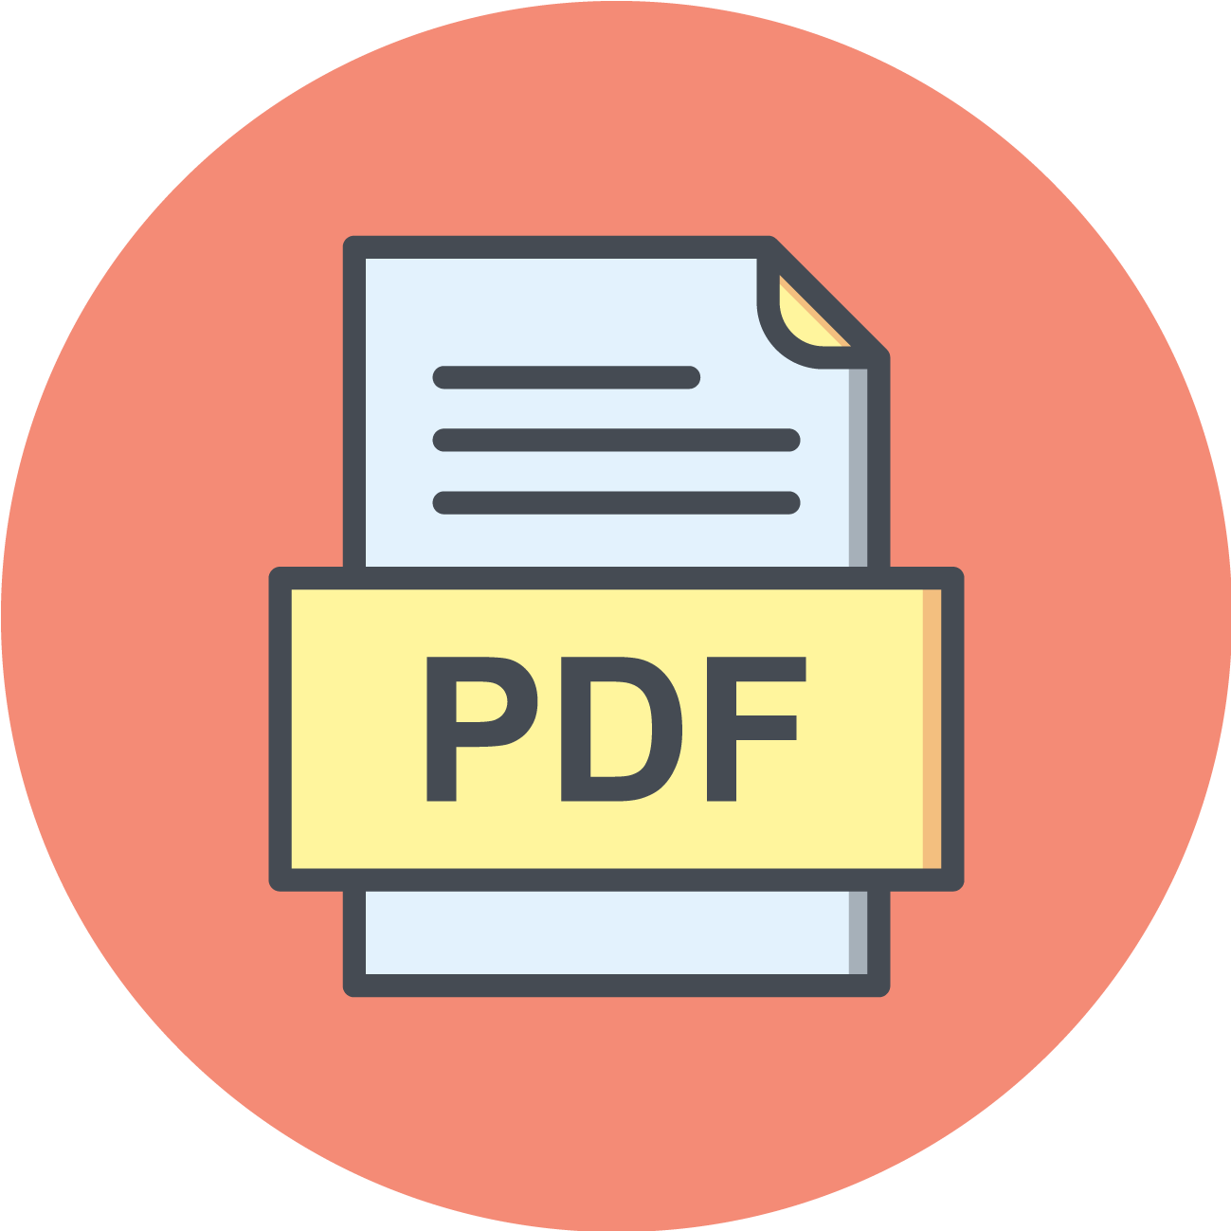

Under esteemed guidance of

Ms. Ashwairya Saxena

(Tkinter Project)

By

Manoj Konda,

NIT Warangal.

**INDEX**

|  |  |
| --- | --- |
| **Sl.No.** | **Topic** |
| 1 | Introduction |
| 2 | Objectives |
| 3 | Background |
| 4 | Hardware and Software Requirements |
| 5 | Coding |
| 6 | Output Screenshot |
| 7 | Future Scope |
| 8 | Conclusion |
| 9 | Bibliography and References |

**INTRODUCTION**

Many files like e-Aadhar, Bank statements and many other PDF files contain private and confidential information. As PDF files are easily shareable, access to that confidential information may lead to cyber crime by criminals. They may hack Bank accounts or they may store our data like fingerprints, contact details, and addresses. So, PDF encryption is important for those types of PDF files. This project Encrypts a PDF with a password as well as Decrypts a PDF file permanently if we enter it's passkey.

**OBJECTIVE**

Our Project aim is to encrypt a PDF file as well as decrypt a PDF file. This encryption protects our Confidential and private information.

**BACKGROUND**

As technology is increasing, People are interested in storing their information and other details digitally i.e., in the form of PDFs, docs, sheets etc., in the cloud (like google drives). This may contain private, Biodata, Fingerprints data, Bank Account information, contact details, addresses . This is private information and this should not be seen by others. So PDF encryption locks PDF with a password of our own. This project is purely user based application to Lock PDFs and Delock PDFs.

In this project **tkinter**(GUI), **tkinter.messagebox**(to display message boxes), **tkinter.filedialog**(to browse files , to choose directory) ,**PyPDF2(**to work with PDF files**)** and **shutil** modules are used for this simple application

**HARDWARE AND SOFTWARE REQUIREMENTS**

|  |  |
| --- | --- |
| **HARDWARE TOOLS** | **MINIMUM REQUIREMENTS** |
| Processor | i5 or above |
| Hard disk | 10GB |
| RAM | 8GB |
| Monitor | 17’’ Coloured |
| Mouse | Optical |
| Keyboard | 122 Keys |

|  |  |
| --- | --- |
| **SOFTWARE TOOLS** | **MINIMUM REQUIREMENTS** |
| Platform | Windows/Linux/MacOS |
| Operating System | Windows/Linux/MacOS |
| Technology | Tkinter-Python |
| Scripting language | Python |
| IDE | PyCharm |

**Libraries Used:**

* PyPDF2
* tkinter
* messagebox, filedialog from tkinter
* shutil

**PDF Encryption & Decryption**

This Project develops an application which asks for PDF file and asks users to enter password. Then asks the user to encrypt or decrypt the PDF file. If the user chooses “encrypt” a password is set for that PDF. If the user chooses “Decrypt” password is removed permanently for that PDF. Finally We can download the resultant PDF.

Using the **Tkinter** module this application is developed. To encrypt and decrypt PDF files **PyPDF2** module is used. To browse for PDF files , choose the directory **filedialog** module is used.To display desktop message boxes (like errors, info, warning) **messagebox** is used.

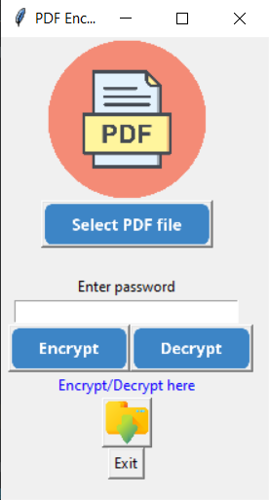

**CODING**

**import PyPDF2**

**from tkinter import \***

**from tkinter import filedialog**

**from tkinter import messagebox**

**import shutil**

**win = Tk()**

**win.geometry("220x380")**

**win.title("PDF Encryption and Decryption")**

**# PNG**

**p1 = PhotoImage(file="images/img1.png").subsample(10)**

**p2 = PhotoImage(file="images/down.png").subsample(15)**

**p3 = PhotoImage(file="images/browse.png").subsample(2)**

**p4 = PhotoImage(file="images/encrypt.png").subsample(2)**

**p5 = PhotoImage(file="images/decrypt.png").subsample(2)**

**p6 = PhotoImage(file="images/uploaded.png").subsample(2)**

**# Title image**

**imglabel = Label(image=p1)**

**imglabel.grid(row=0, columnspan=5)**

**help = Label(win, text="Enter password")**

**help.grid(columnspan=5, row=4)**

**# Password**

**passwd = Entry(win, text="Enter Password", show="*", width=30)**

**passwd.grid(row=5, columnspan=5)**

**ongoing = ""**

**# Browse**

**def browse():**

**global filename**

**filename = filedialog.askopenfile(mode='rb', title="Choose a Pdf file",**

**filetypes=[("PDF", "*.pdf*")])**

**select.configure(image=p6)**

**# PDF locker**

**def encrypt():**

**global ongoing**

**ongoing = "encrypt"**

**global name**

**assert isinstance(filename, object)**

**name = (str(filename).split('/')[-1]).split('.pdf')[0]**

**if filename is not None:**

**fil = PyPDF2.PdfFileReader(filename)**

**out = PyPDF2.PdfFileWriter()**

**for i in range(fil.numPages):**

**out.addPage(fil.getPage(i))**

**if passwd.get():**

**out.encrypt(passwd.get())**

**with open(name + "_encrypted.pdf", 'wb') as filee:**

**out.write(filee)**

**filee.close()**

**passwd.delete(0, "end")**

**messagebox.showinfo("Success", "File encrypted Successfully")**

**messagebox.showwarning("Remember Password", "If you forget Password Encrypt again")**

**pathlabel.configure(text="Click hereto Download the Encrypted PDF file", fg="blue")**

**select.configure(image=p3)**

**win.geometry("260x380")**

**else:**

**messagebox.showerror("Invalid Password", "Password should not be NULL")**

**else:**

**messagebox.showerror("Failed", "Unable to encrypt file")**

**# PDF delocker**

**def decrypt():**

**global ongoing**

**ongoing = "decrypt"**

**global nam**

**assert isinstance(filename, object)**

**nam = (str(filename).split('/')[-1]).split('.pdf')[0]**

**if filename is not None:**

**fil = PyPDF2.PdfFileReader(filename)**

**out = PyPDF2.PdfFileWriter()**

**if fil.isEncrypted:**

**if not passwd.get():**

**messagebox.showinfo("Invalid Password", "Password should not be NULL")**

**elif passwd.get():**

**fil.decrypt(passwd.get())**

**for i in range(fil.numPages):**

**out.addPage(fil.getPage(i))**

**with open(nam + "_decrypted.pdf", 'wb') as filee:**

**out.write(filee)**

**filee.close()**

**passwd.delete(0, "end")**

**messagebox.showinfo("Success", "File Decrypted Successfully")**

**pathlabel.configure(text="CLick here to Download the Decrypted PDF file", fg="blue")**

**select.configure(image=p3)**

**win.geometry("260x380")**

**else:**

**messagebox.showinfo("Decrypted file", "File already decrypted")**

**else:**

**messagebox.showerror("Failed", "Unable to Decrypt file")**

**# download**

**def download():**

**if ongoing == 'encrypt':**

**try:**

**shutil.move(name + "_encrypted.pdf", filedialog.askdirectory())**

**messagebox.showinfo("Downloaded", "Downloaded Successfully")**

**except NameError:**

**messagebox.showinfo("Choose File", "Choose to encrypt")**

**except FileNotFoundError:**

**messagebox.showinfo("File Not Found", "Encrypt/decrypt first")**

**except shutil.SameFileError:**

**messagebox.showinfo("Same File Error", "Download somewhere else")**

**elif ongoing == 'decrypt':**

**try:**

**shutil.move(nam + "_decrypted.pdf", filedialog.askdirectory())**

**messagebox.showinfo("Downloaded", "Downloaded Successfully")**

**except NameError:**

**messagebox.showinfo("Choose File", "Choose to decrypt ")**

**except FileNotFoundError:**

**messagebox.showinfo("File Not Found", "Encrypt/decrypt first")**

**except shutil.SameFileError:**

**messagebox.showinfo("Same File Error", "Download somewhere else")**

**else:**

**messagebox.showinfo("Browse", "Upload PDF file ")**

**pathlabel = Label(win, text="Encrypt/Decrypt here", fg="blue")**

**select = Button(win, image=p3, command=browse)**

**en = Button(win, image=p4, command=encrypt).grid(row=6, column=2)**

**de = Button(win, image=p5, command=decrypt).grid(row=6, column=3)**

**ben = Button(win, image=p2, command=download).grid(row=9, columnspan=5)**

**exi = Button(win, text="Exit", command=exit).grid(row=10, columnspan=5)**

**Label(win).grid(row=5)**

**Label(win).grid(row=3)**

**pathlabel.grid(row=7, columnspan=5)**

**select.grid(row=1, columnspan=5)**

**win.mainloop()**

**OUTPUT SCREENSHOTS**

**PDF ENCRYPT:**

1) Immediately after execution this window is displayed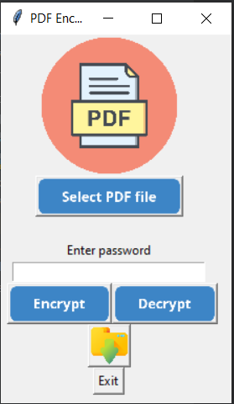

* Select PDf File
* Encrypt
* Decrypt
* Download icon
* Exit

These are the buttons with different functions.

2) When we click “Select PDF File” this enables user to choose PDF file

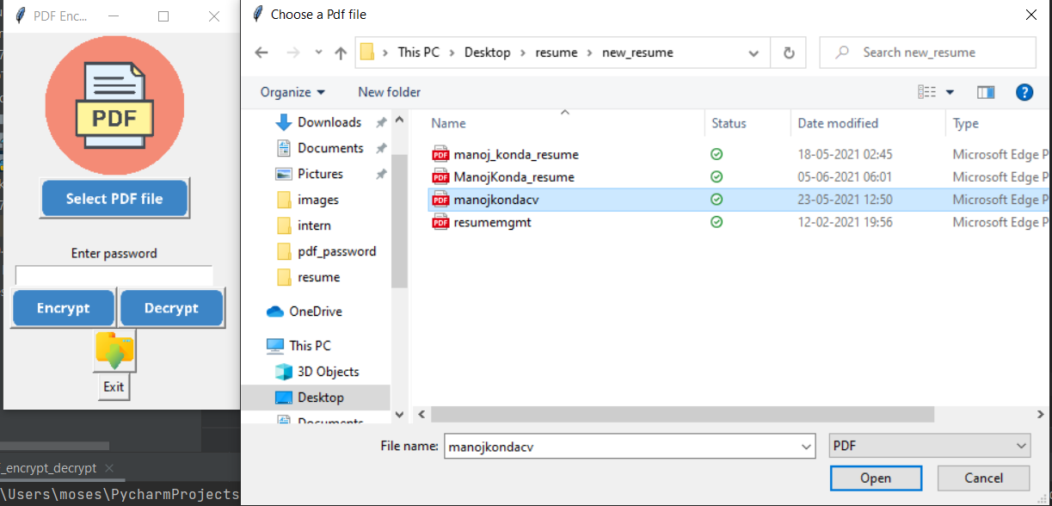

My resume “manojkondacv” contains confidential information I want to keep a password. Now i enter password and I will click on “Encrypt” Button

I have added few features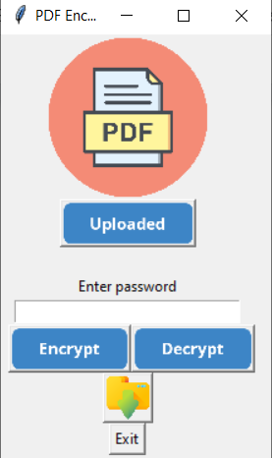

After Uploading PDF file button changes as “Uploaded”

Now We have to enter Password.

3) Enter Password

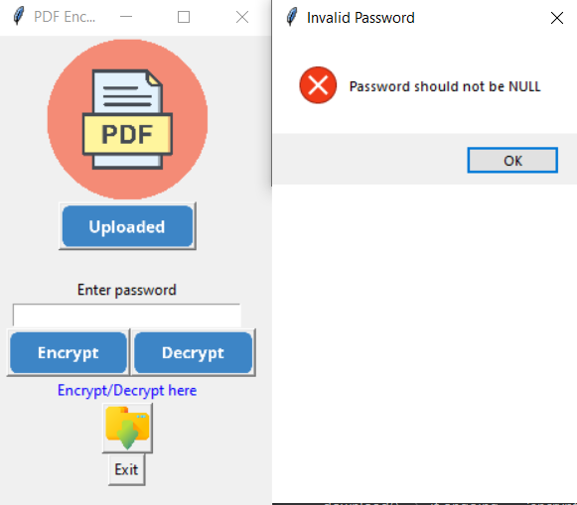

If we click any buttons without entering password

We will get a message box showing an error that the user has not entered password.

After entering the valid password click on “Decrypt”.

4) When I click on “Encrypt” Button

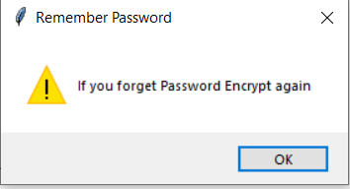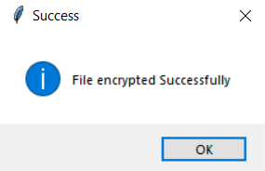

After clicking the “Encrypt” Button, the PDF file will be encrypted.

If the PDF file is not encrypted, an error message box as “File Not Encrypted” is displayed.

5) Download the Encrypted PDF file by clicking on the Download icon and choose destination folder.

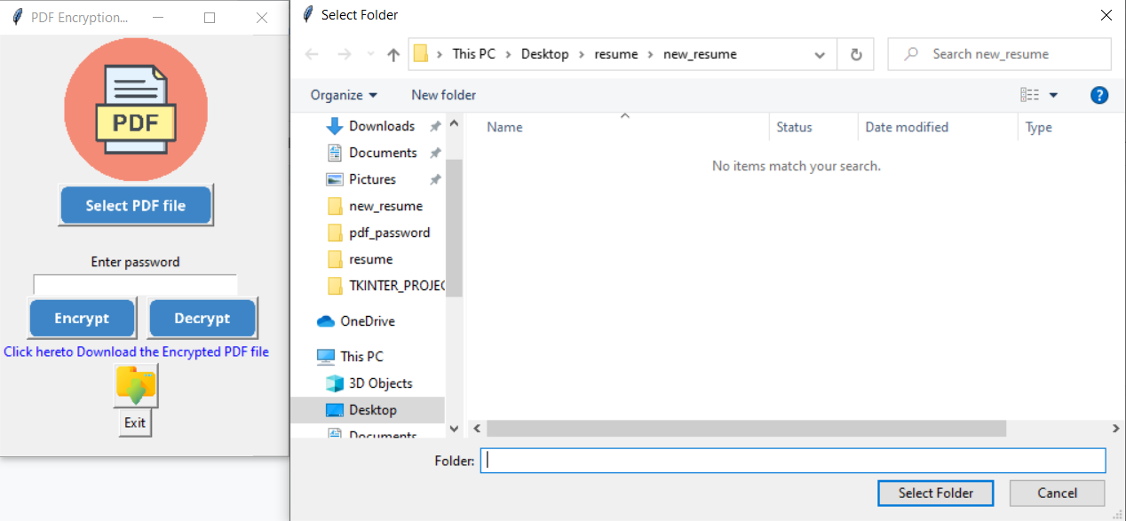

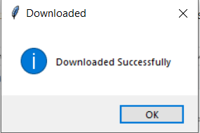

If the file is downloaded then it displays “Downloaded Successfully” as shown.

6) This is the Encrypted PDF file. Opens only when you enter a Valid password.Encrypted PDF Filename will be “filename_encrypted.pdf”

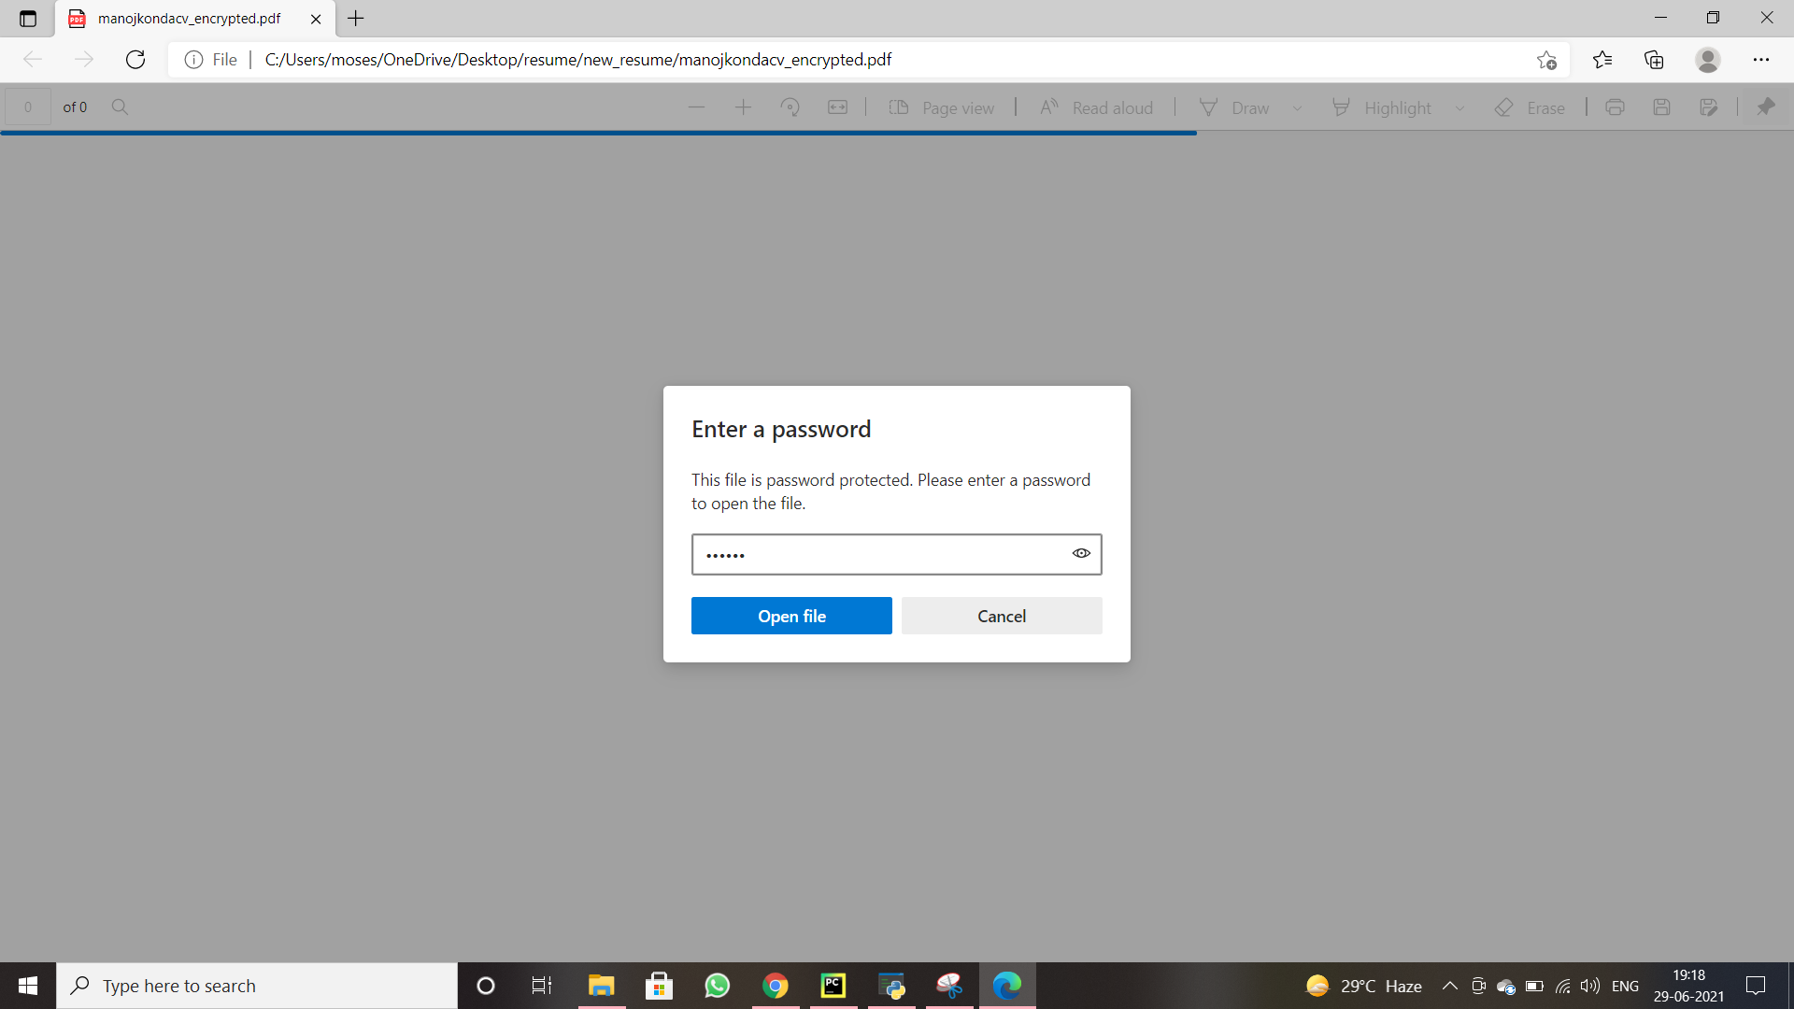

Then it is Opened.

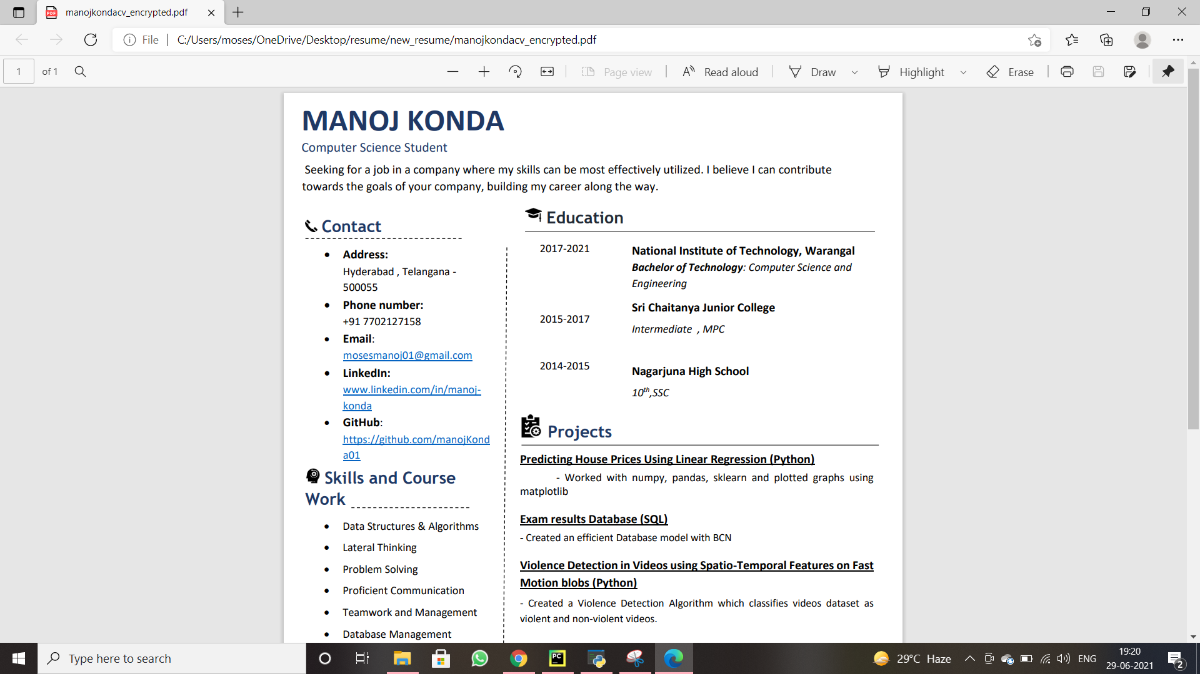

Now let's say I want My resume to be sent to a company. Now I have to decrypt it.

**PDF DECRYPT:**

7) Decrypting the Encrypted file i.e., removing password permanently for an encrypted PDF file.

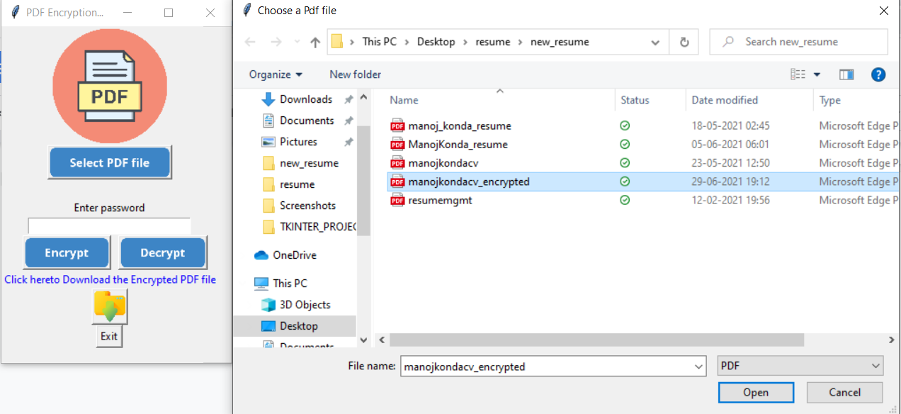

Choose the encrypted file.

8) If the file is encrypted then it is decrypted.

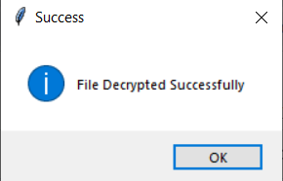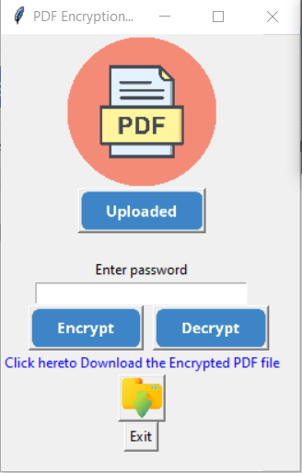

9) Now download the decrypted file by clicking on the download icon. Choose the destination folder.



10) This is the decrypted file . Decrypted filename will be saved as “filename_decrypted.pdf”.

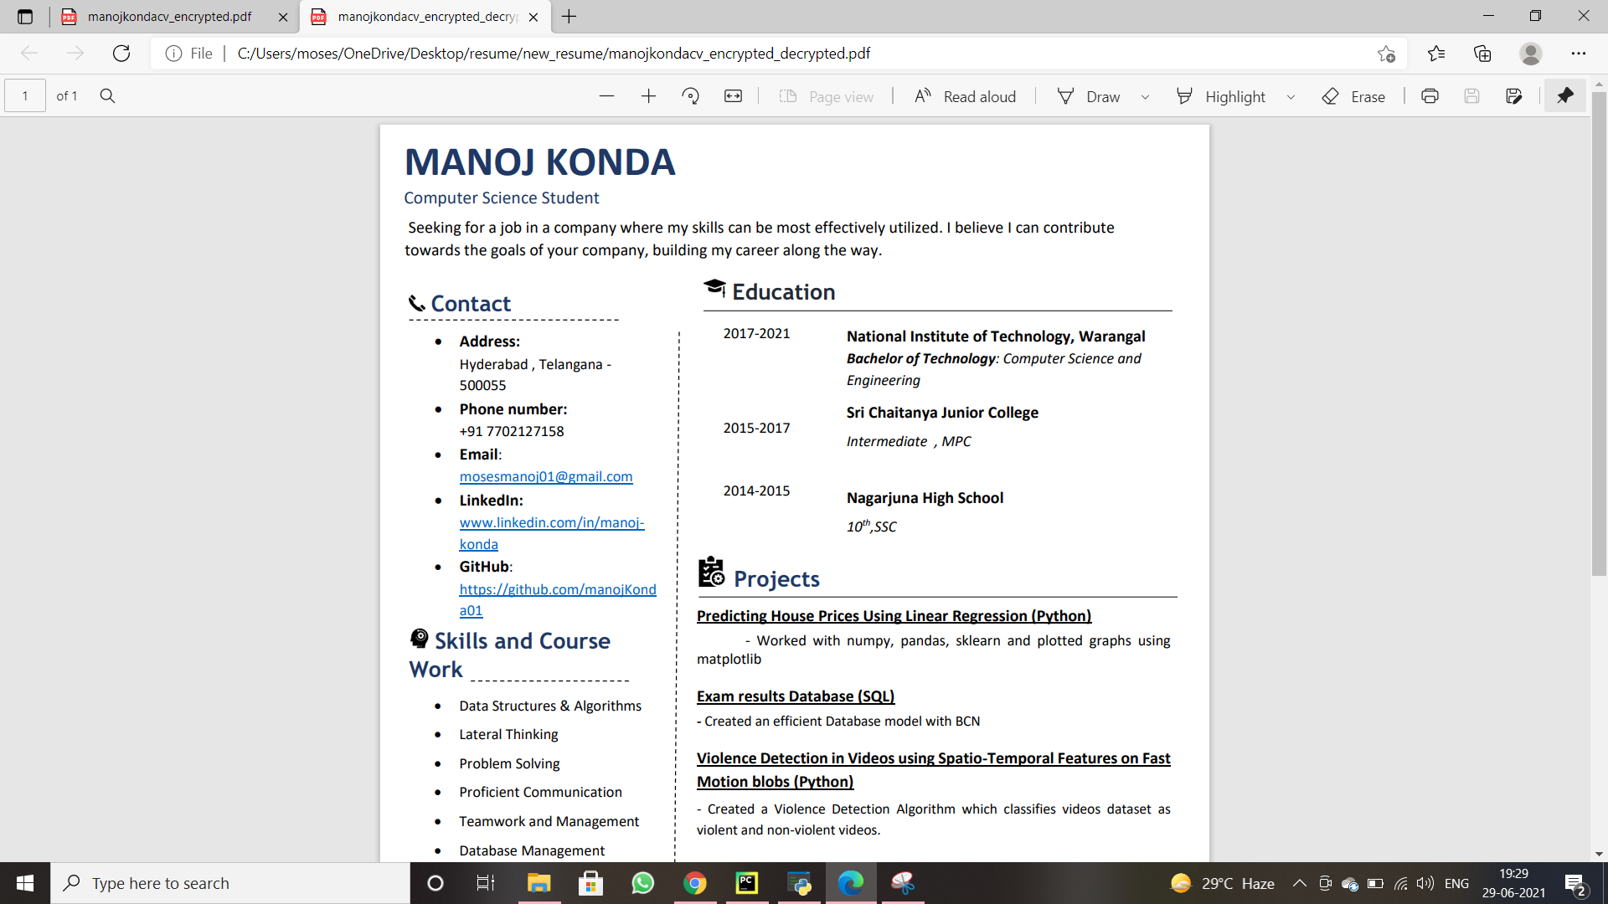

11) I have added few more features like

* If you click the download icon without encrypting/decrypting the file. My method displays as

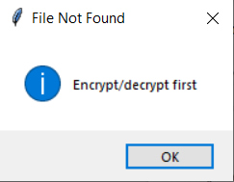

* Password cannot be NULL.

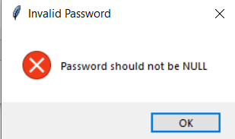

* Finally the Exit button. IF we click on the “Exit” Button Window will be closed.

**FUTURE SCOPE**

Everything is digitized now. Even Documents, PDFs like E-aadhar, PAN, Resume, E-Ration Card etc., are generated as PDF files. These files should be Encrypted. These files contain fingerprints, Bio data, Confidential information. And also PDFs like Bank Statements should be secured with a password. If a PDF file is important and non-sharable then it should be Encrypted (should be protected with a password ).

A GUI application for PDF encryption helps every non coder to encrypt PDF file for his Privacy. This Application does not store any password.

**CONCLUSION**

This Project creates a Desktop GUI Application developed using Python, which asks for PDF files to Encrypt and also decrypts the Encrypted files.

**REFERENCES**

* Guidence(<https://www.geeksforgeeks.org/encrypt-and-decrypt-pdf-using-pypdf2/>)
* Tkinter.filedialog(<https://docs.python.org/3/library/dialog.html>)
* Tkinter.messagebox(https://www.python-course.eu/tkinter_dialogs.php)