3. AMBANI Tiles And Bathware
Date of visit : 25/03/2026
Category : Medium-scale EnterPrise
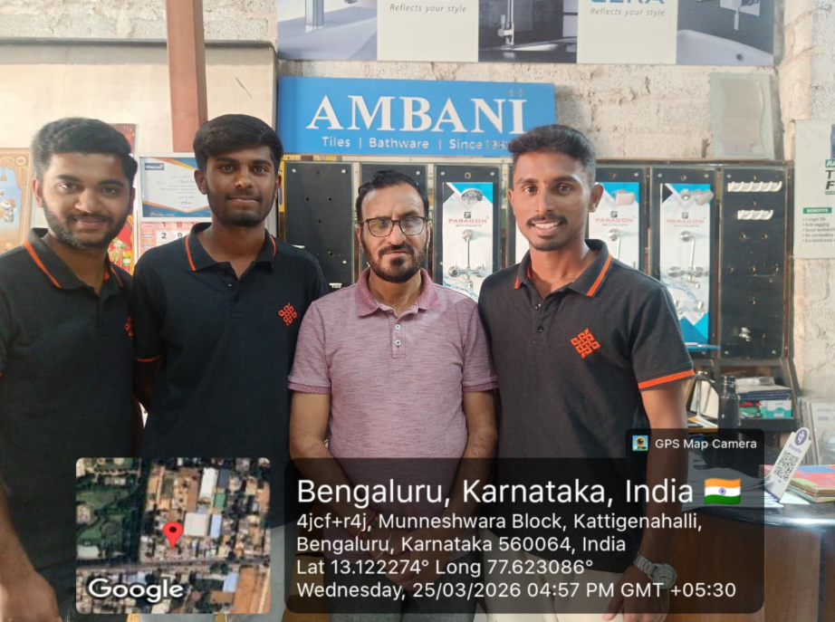
4.HOTEL PANCHAMI
Date of visit : 25/03/2026
Category : Medium-scale EnterPrise
