5. Clique Salon
Date of visit : 25/03/2026
Category : Medium-scale EnterPrise

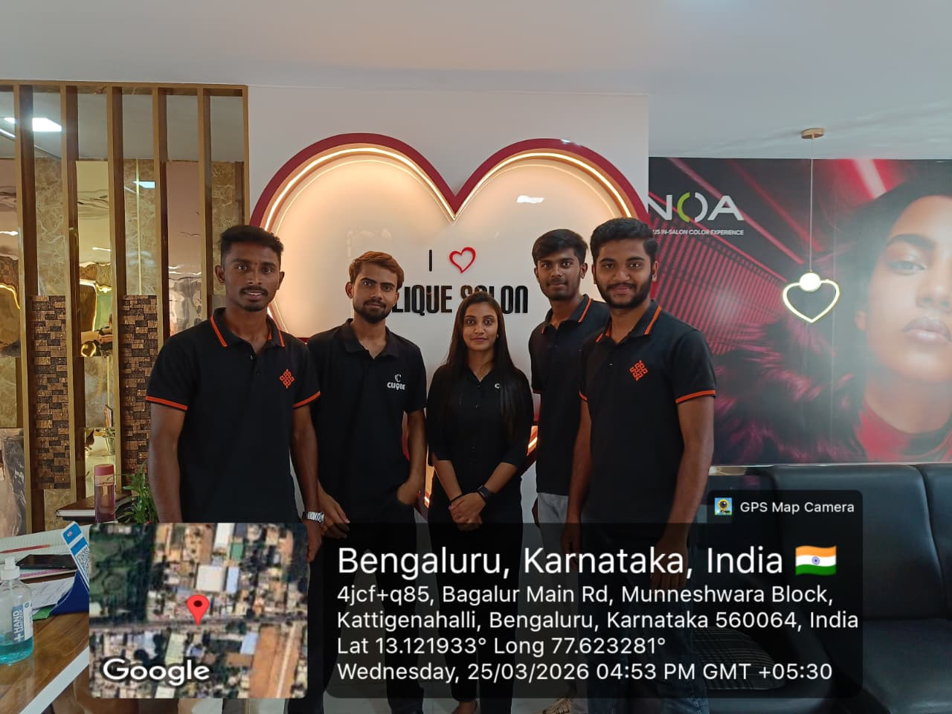

6. Shree Vagmi Stationary
Date of visit : 26/03/2026
Category : Small-scale EnterPrise
