Web Design

Assignment-3

Login form

Manoj Bahadur
18BBTCS063
CSE - ‘A’
A3 – Batch

Code:

<!DOCTYPE html>
<html>
<head>
<link rel="stylesheet" type="text/css" href="login_form.css">
<title>Login Form</title>
</head>
<body>
<form class="box" action="animation.html" method="post">
<img src="avatar.png" class="avatar">
<h1>Login</h1>
<input type="text" name="" placeholder="username" required>
<input type="password" name="" placeholder="password" required>
<a href="loading.html">
<input type="submit" name="" value="Login">
</a>
<div class="forgotpass"><a href="#">Lost your password?</a></div>
<font class="link">Don't have account?</font> <a href="#">Sign up</a>
</form>
</body>
</html>

CSS code: login_form.css

body{
margin: 0;
padding: 0;
font-family: sans-serif;
min-height: 100vh;
background-image: linear-gradient(120deg,#3498db,#8e44ad);
}
.avatar{
width: 120px;
height: 120px;
border-radius: 50%;
position: absolute;
top: -50px;
left: calc(50% - 60px);
}
.box h1{
text-align: center;
margin-bottom: 60px;
font-family: montserrat;
color: #fff;
}
.box{
width: 260px;
background-image: url(dinpattern.gif);
height: 320px;
padding: 80px 40px;
border-radius: 10px;
position: absolute;
left: 50%;
top: 50%;
transform: translate(-50%,-50%);
}
.box input[type="text"],.box input[type="password"]{
border: 0;
background: none;
display: block;
margin: 20px auto;
text-align: center;
border: 2px solid#3498db;
padding: 15px 7px;
width: 200px;
outline: none;
color: white;
border-radius: 24px;
transition: 0.25s;
}
.box input[type="text"]:focus, .box input[type="password"]:focus{
width: 240px;
border-color:#2ecc71;
}
.box input[type="submit"]{
border: 0;
background: none;
display: block;
margin: 20px auto;
text-align: center;
border: 2px solid#2ecc71;
padding: 14px 40px;
outline: none;
color: white;
border-radius: 24px;
transition: 0.25s;
cursor:pointer;
}
.box input[type="submit"]:hover{
background: #2ecc71;
}
.link{
color: white;
}
.forgotpass a{
text-decoration: none;
line-height: 20px;
color: white;
}

a{
color: #4d79ff
}
a:hover{
color: #990000
}

OUTPUT

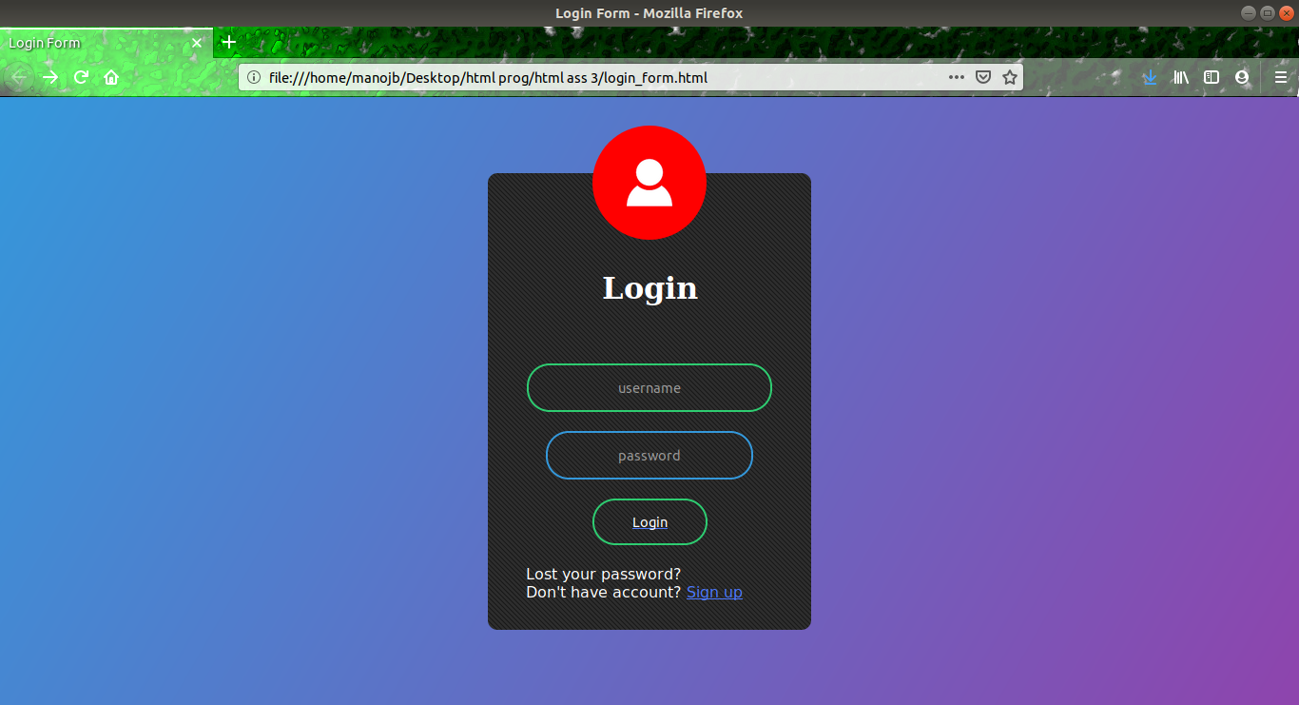

Loading code:

<!DOCTYPE html>
<html>
<head>
<title></title>
<link rel="stylesheet" href="loading.css">
</head>
<body>
<div class="loading">
<span>Logging in...</span>
</div>
</body>
</html>

CSS code- loading.css

body{
margin: 0;
padding: 0;
background: #34495e;
height: 400px;
display: flex;
align-items: center;
justify-content: center;
font-family: "montserrat",sans-serif;
}
.loading{
width: 200px;
height: 200px;
box-sizing: border-box;
border-radius: 50%;
border-top: 10px solid #e74c3c;
position: relative;
animation: a1 2s linear infinite;
}
.loading::before,.loading::after{
content: '';
width: 200px;
height: 200px;
position: absolute;
left: 0;
top: -10px;
box-sizing: border-box;
border-radius: 50%;
}
.loading::before{
border-top: 10px solid #e67e22;
transform: rotate(120deg);
}
.loading::after{
border-top: 10px solid #3498db;
transform: rotate(240deg);
}
.loading span{
position: absolute;
width: 200px;
height: 200px;
color: #000000;
text-align: center;
line-height: 200px;
animation: a2 2s linear infinite;
}

@keyframes a1 {
to{
transform: rotate(360deg);
}
}
@keyframes a2 {
to{
transform: rotate(-360deg);
}
}

OUTPUT

