|  |  |  |
| --- | --- | --- |
| **Activity : remove from cart** | **Start: 9:30 pm** | **Stop: 4:30 pm** |
| * The products are adding to the cart successfully. Adding the checkout button in the single_product.xml. * On clicking the checkout button the cart activity will be opened,in which the products which are added to the cart is displayed.      * The total will be displayed based on the quantity of the products. * The total amount will be calculated in cartactivity class , as the the amount of the each product in activity_cart.xml layout will be added. * On clicking the remove button the elements in the cart will be removed. | | |

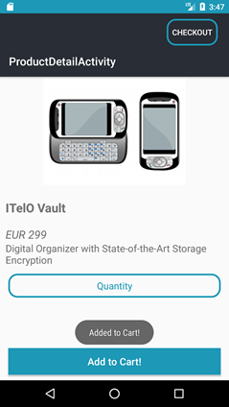

|  |  |  |
| --- | --- | --- |
| **Activity : YummyFood** | **Start: 4:50 pm** | **Stop: 7:30 pm** |
| * Sign In page is Created * List of categories page is created like chicken , mutton, Fish, veg and so on * If the credentials are correctly entered then page directs to the Home page of list of categories page * If it is wrong it shows wrong credentials. * Recycler view is used for the list of Categories. * Picasso library is used to get the images from the database * Floating Cart button is displayed on the page | | |

