|  |  |  |
| --- | --- | --- |
| **Activity : Add to cart** | **Start: 9:30 pm** | **Stop: 3:30 pm** |
| * Add a button in the single product description activity and edit text to enter the quantity of product. On clicking the button add to cart another layout the activity_cart.xml. * In this we used a listview to display the number of items that are added to card. * We create a cart Adapter class with recycler view which contains the list of object called cartitems. The cart items consiste of the product name, product price , product quantity and total price and displays the product name and total price. * The edit text which is used to give the quantity of the products. | | |

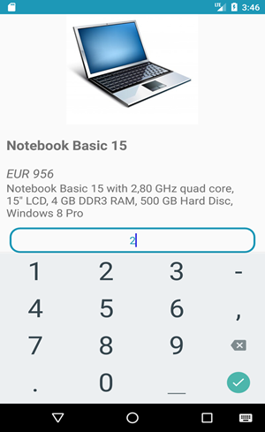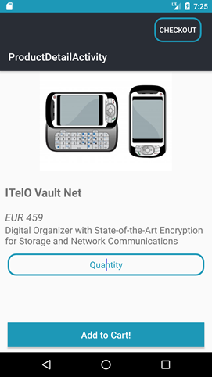

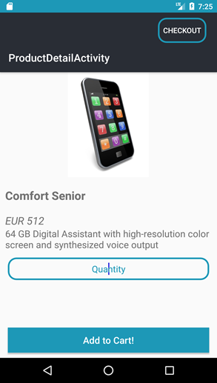

|  |  |  |
| --- | --- | --- |
| **Activity : Project on YummyFood** | **Start: 3:40 pm** | **Stop: 6:40 pm** |
| * Sign Up page with Phone number, Name, password * Database is stored in the Firebase * If the user is already existed it shows the toast message | | |

