Use of autocomplete to write models:

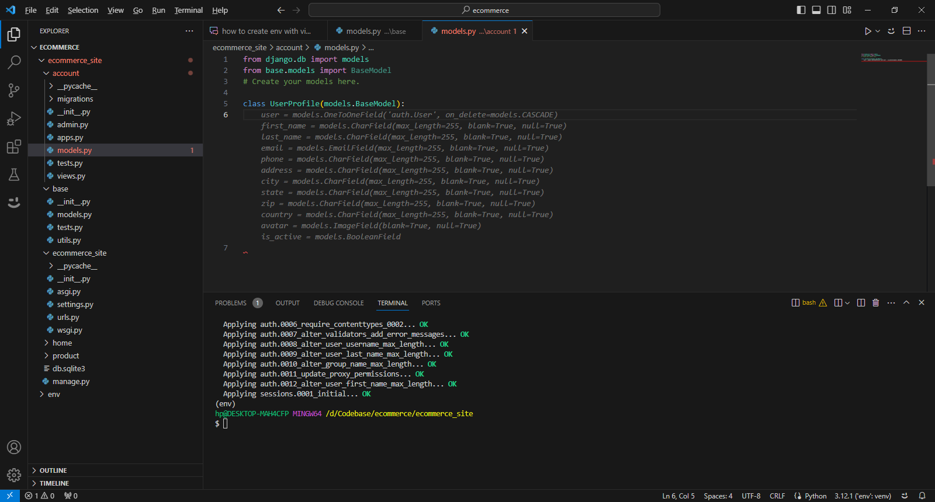

Steps to push code to remote repository:

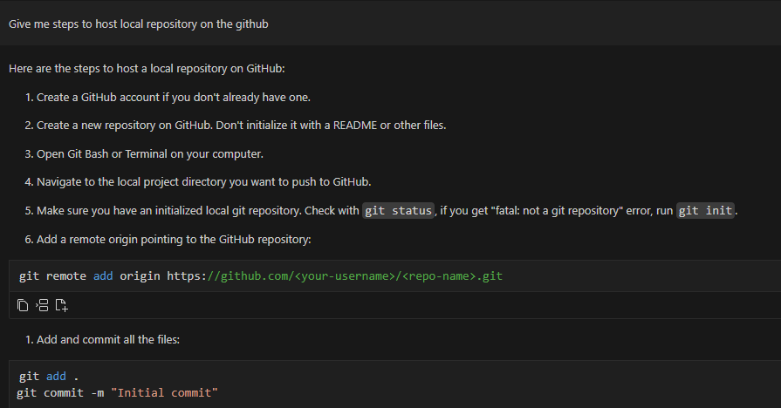

Asked for steps to implement a Django ecommerece site project

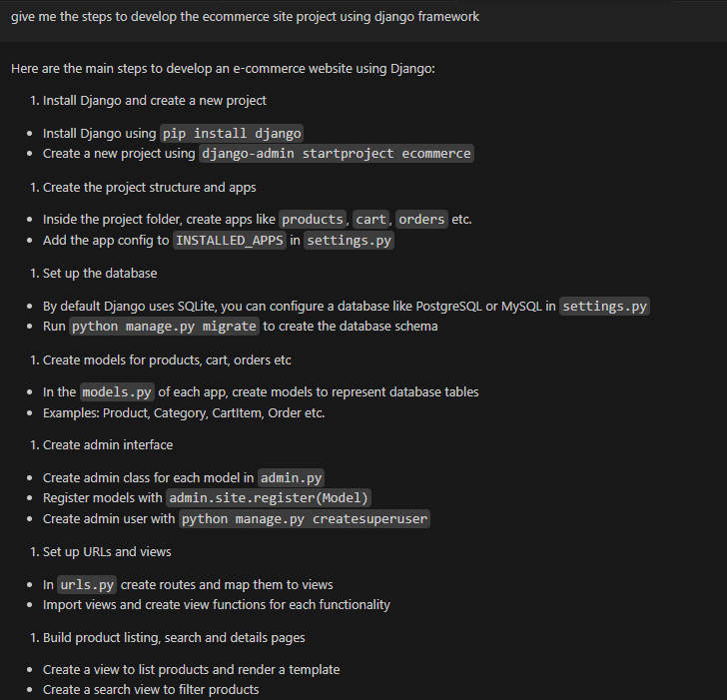

How to implement reset password feature in details:

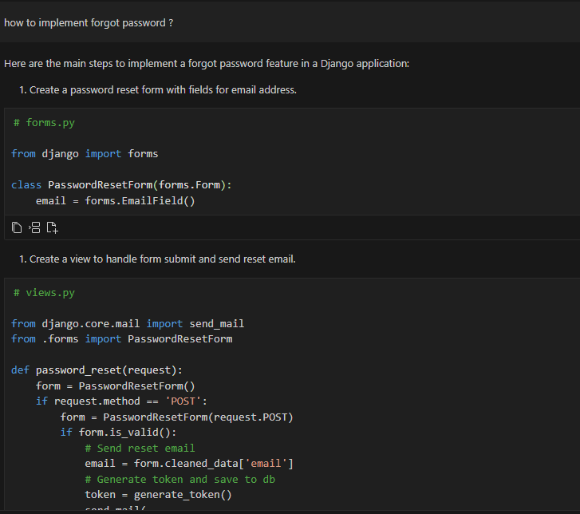

Generate dummy data:

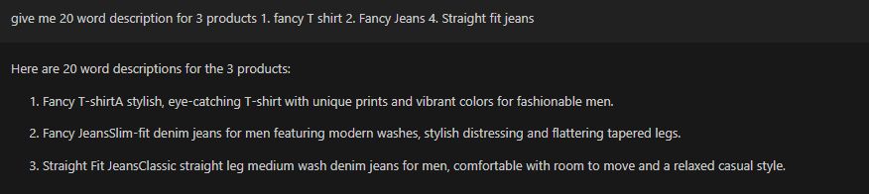

Explain code from view.py

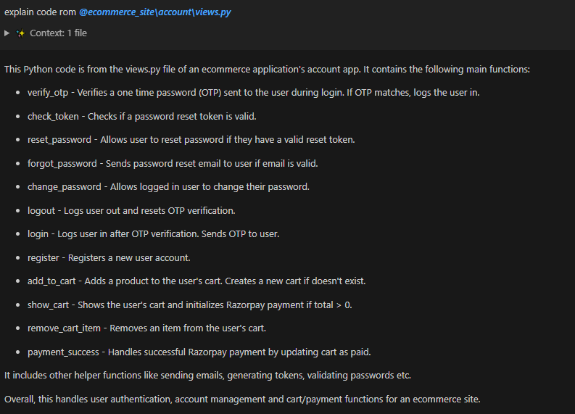

Summary of complete project architecture:

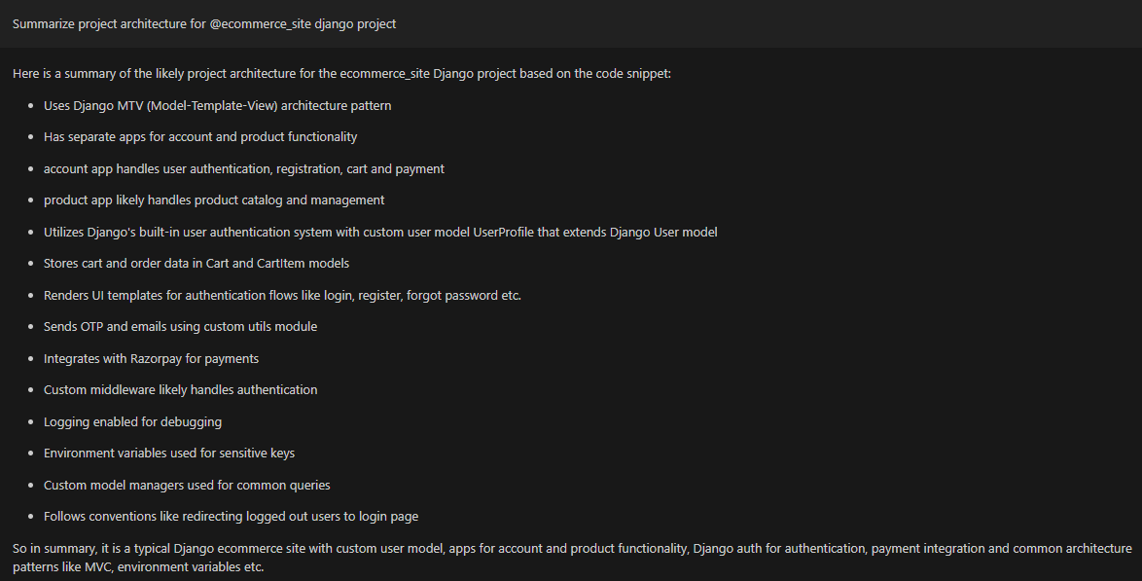

Summary of the view/endpoints/microservices implemented in the project:

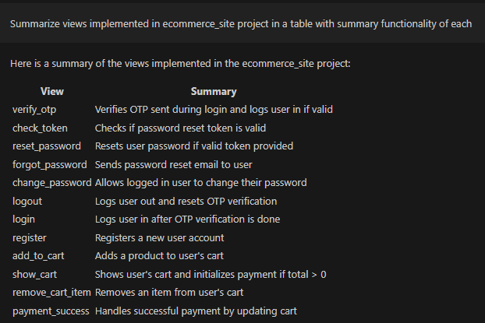

Code conversion from django to flask

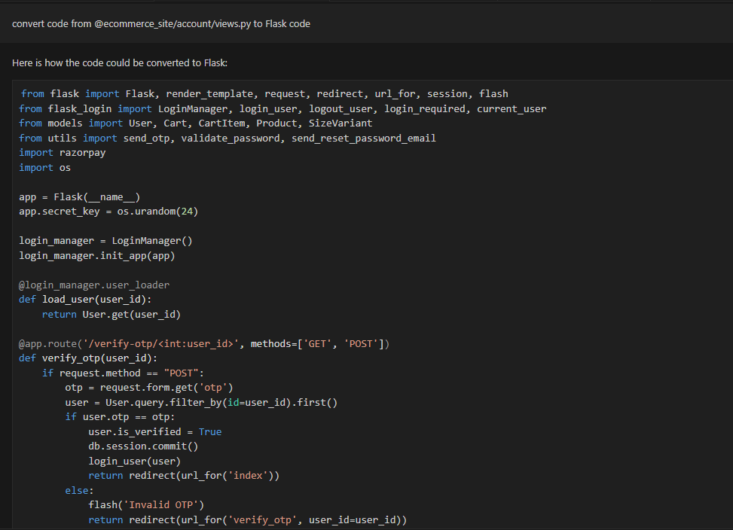

Database schema of the project:

describe database schema using @ecommerce_site/product/models.py and [*@ecommerce_site\account\models.py*](command:cody.chat.open.file?%22d:%5CCodebase%5Cecommerce%5Cecommerce_site%5Caccount%5Cmodels.py:range:0%22)

**Product Models**

**Category**

* id: Primary key
* name: Name of product category
* slug: URL slug for category
* description: Text description of category
* image: Image file associated with category

**Product**

* id: Primary key
* name: Name of product
* slug: URL slug for product
* description: Text description of product
* price: Price of product
* image: Image file for product
* category: Foreign key to Category model

**SizeVariant**

* id: Primary key
* name: Name of size variant e.g. 'Small'
* price: Extra price for size variant
* product: Foreign key to Product model

**Account Models**

**UserProfile**

* id: Primary key
* user: One-to-one field to default Django User model
* phone: User's phone number
* address: User's address
* avatar: User's profile image
* is_active: Boolean indicating if account is active
* is_otp_verified: Boolean indicating if OTP verified
* pwd_reset_token: Password reset token
* otp: One time password field

**Cart**

* id: Primary key
* user: Foreign key to User model
* total_price: Total price of items in cart
* is_paid: Boolean indicating if cart is paid
* is_delivered: Boolean indicating if cart is delivered
* razorpay fields: Payment details

**CartItem**

* id: Primary key
* cart: Foreign key to Cart model
* product: Foreign key to Product model
* quantity: Quantity of product in cart
* price: Price of this item
* size_variant: Foreign key to SizeVariant model

Let me know if you need any clarification or have additional questions!

Code smells:

Implemented the loggers and password validation

