EX.No.2.1 CREATE A 3D SOLID MODEL FROM ISOMETRIC DRAWING
Date: 16-10-2026

AIM
To create a 3D model from the given isometric drawing using the Autodesk Fusion 360 tool.

REQUIREMENTS
- Autodesk Fusion 360
- Windows 10
- 16 GB of RAM (integrated graphics recommended 1 GB or more)
- 2.5 Mbps or faster download; 500 Kbps or faster upload

PROCEDURE

STEP-1: Start the sketch command
Select Sketch > Create Sketch.

STEP-2: Select the Sketch Plane
Select the Front (XZ) Plane.

STEP-3: Create a Rectangle
- Select Sketch > Rectangle > Center Rectangle.
- Hover over the origin (center) of the sketch; the cursor should snap to this location.
- Click once to begin placing the rectangle.
- Press the Tab key and enter 100 mm and 60 mm for the width and height respectively.
- Click again to place the rectangle.
- Click Finish Sketch after completing.

STEP-4: Extrude Rectangle in XZ Plane
- Select Extrude.
- Select the rectangle sketch.
- Click again to place the value.
- Type in the value of 30 mm.
- Press ENTER to accept the value.

STEP-5: Start the sketch command
Select Sketch > Create Sketch.

STEP-6: Select the Sketch Plane
Select the FRONT SURFACE of the rectangular block.

STEP-7: Create a Circle
- Select Sketch > Circle > Center Circle.
- Hover over the origin (center) of the sketch; the cursor should snap to this location.
- Click once to begin placing the circle.
- Press the Tab key and enter the diameter value Ø50 mm.
- Click again to place the circle.
- Click Finish Sketch after completing.

STEP-8: Extrude Circle
- Select Extrude.
- Select the circle sketch.
- Click again to place the value.
- Type in the value of 20 mm.
- Press ENTER to accept the value.

STEP-9: Start the sketch command
Select Sketch > Create Sketch.

STEP-10: Select the Sketch Plane
Select the TOP SURFACE of the rectangle.

STEP-11: Create a Line
- Select the Line command.
- Draw the projections as shown in the diagram (the 45° sloped block, the small square block and the Ø20 circular knob, using the dimensions given).
- Click Finish Sketch.
- Extrude the sketch.

INPUT
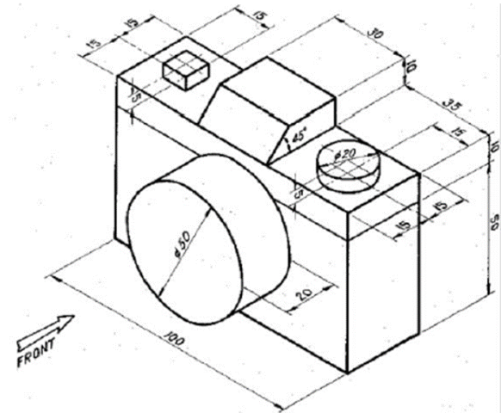
Given isometric drawing

OUTPUT
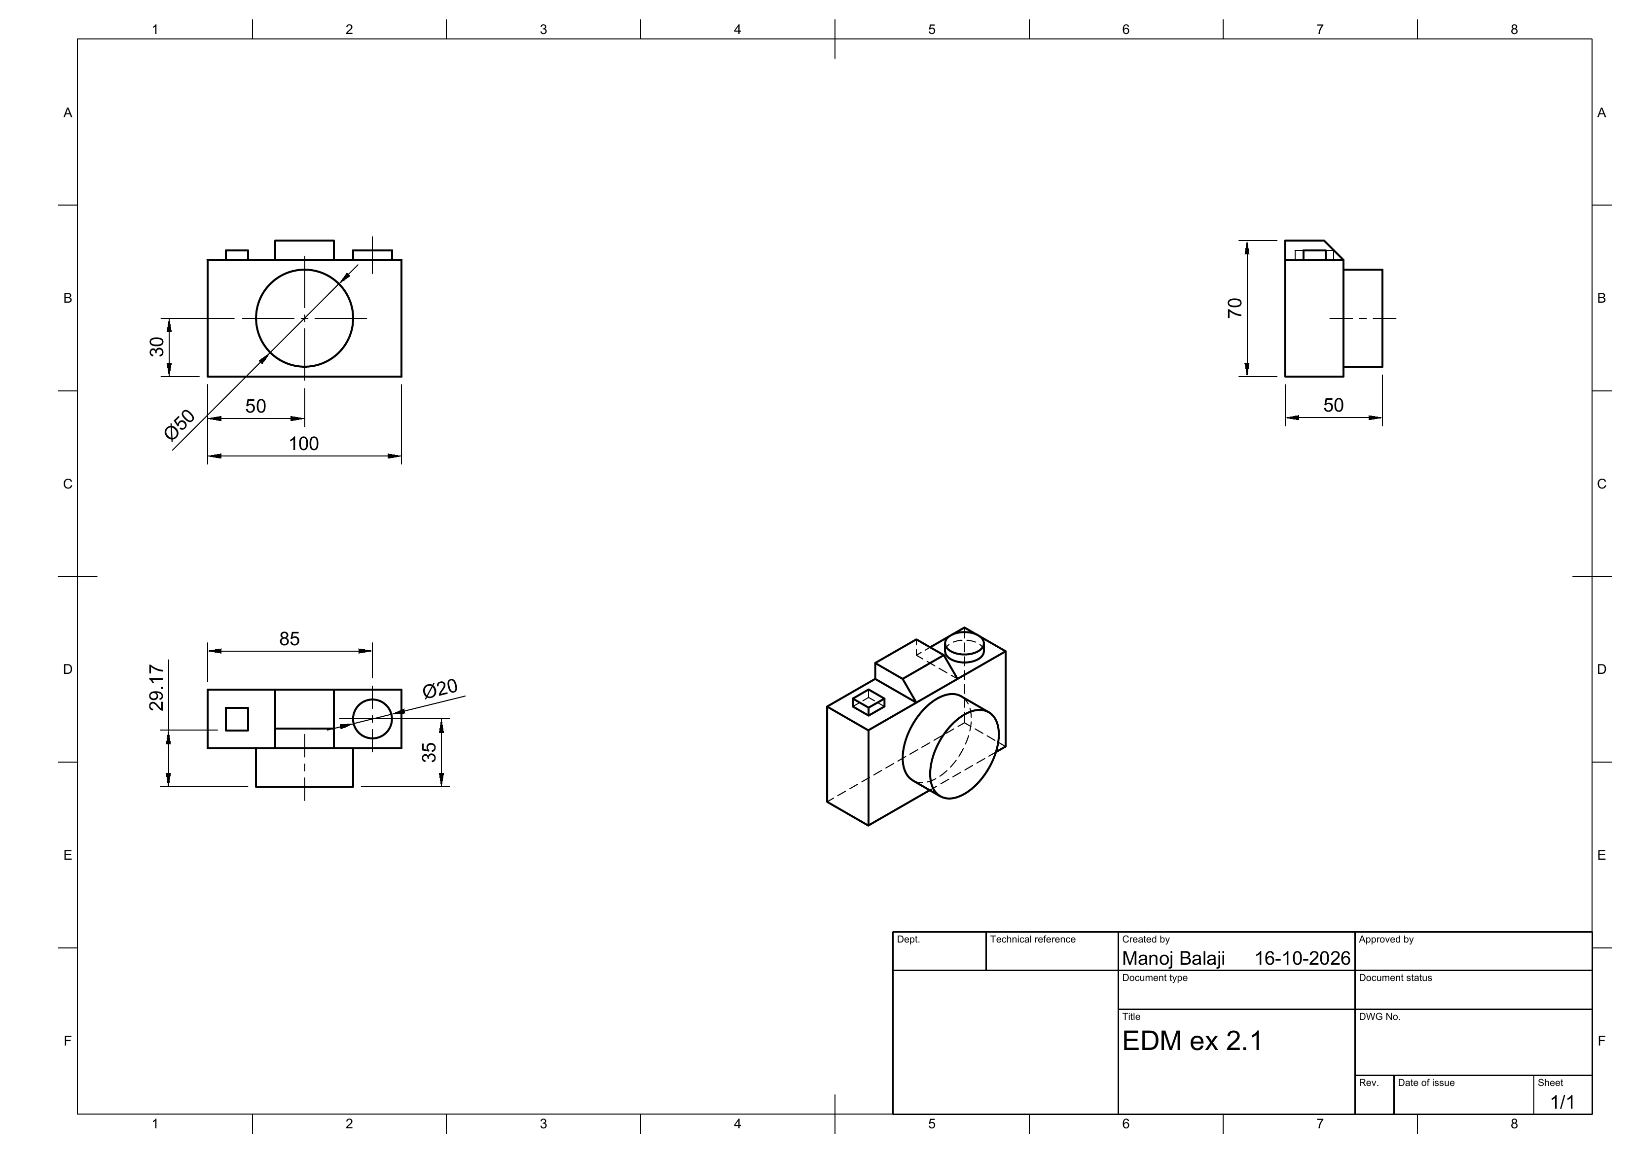
3D model drawing sheet: front, top, side and isometric views

RESULT
Thus, the 3D model is created from the given isometric drawing using Autodesk Fusion 360.

