Hermai Micro-placement: Basic Draft Report
Basic Draft Report | Team 38 | 5 July 2026
1. Executive summary
Hermai asked the team to identify a public-data idea that could become a simple, useful and shareable public-facing product. After reviewing several broad concepts, the work has moved towards two focused ideas. The bridge condition tracker is the main project because it offers stronger public value, deeper historical analysis and a longer useful life. The World Cup Sleep Index is a smaller secondary prototype intended to test fast delivery, personal results and social sharing during a short tournament window.
The draft therefore has two purposes: define the bridge analysis and product direction, and record what has been learned from the completed football prototype. The main gap is that the historical bridge files have not yet been cleaned and matched, so the bridge section currently sets out the analysis plan, product structure and known risks rather than reporting final bridge findings.
2. Client problem and project direction
Hermai's challenge is not simply finding public data. The stronger opportunity is to turn fragmented public information into a product that a normal user can understand within seconds and has a reason to share. The client brief therefore places weight on public utility, simple interaction, a real prototype, launch strategy, ethical use and visible Hermai credit.
2.1 Concept assessment
Criterion | Bridge condition tracker | World Cup Sleep Index | Implication
Public value | High: infrastructure condition and public spending relevance. | Medium: useful mainly as a personal tournament calculator. | Bridge is stronger for the final report.
Shareability | Medium to high if the story uses long-running Poor ratings and traffic. | High during the tournament because results are personal and comparable. | Football is useful as a launch experiment.
Analytical depth | High: historical matching, duration, traffic and agency analysis. | Moderate: time-zone conversion and overlap calculation. | Bridge should receive most analytical effort.
Build difficulty | Moderate: historical files and identifiers must be matched carefully. | Low to moderate: the working prototype already exists. | Run the two ideas on different timelines.
Useful life | High: can be updated annually and reused after the placement. | Low: strongest only while the tournament is active. | Bridge is the primary product.
Decision: keep the bridge tracker as the main deliverable and use the football site as a limited, time-sensitive test of the shareable-product approach.

3. Main project: long-term Poor-rated bridge tracker
3.1 Public problem
A basic map of bridges currently rated Poor is easy to reproduce and already exists in several forms. The stronger public question is how long a bridge has remained in Poor condition, how many vehicles use it and which public body owns or manages it. This creates a clearer story than a state total or a simple nearby search.
3.2 Proposed analysis
The analysis should use annual bridge records and a stable bridge identifier to build a year-by-year history for each structure. The first version should rank records by duration in Poor condition and then use traffic as the main comparison measure. A composite danger score should not be created because the available fields do not measure collapse risk.
Field or metric | Purpose | Main check
Bridge identifier and year | Link the same bridge across annual files. | Check identifier changes, duplicate rows and missing years.
Condition rating | Identify years officially classified as Poor. | Use the published classification and keep the definition visible.
First Poor year | Show when the current or historical Poor period began. | Separate first-ever Poor year from the current consecutive run.
Consecutive Poor years | Find bridges that remained Poor year after year. | Do not treat a missing year as a confirmed Poor year.
Average daily traffic | Rank the public exposure of Poor-rated bridges. | Use the latest available traffic figure and show its year.
Owner or agency | Show the public body connected with the record. | Ownership alone does not explain funding or maintenance decisions.
3.3 Proposed public-facing views
- Longest-running Poor-rated bridges in the latest available year.
- Busiest Poor-rated bridges, ranked by average daily traffic.
- Search and filters by state, county and owner or agency.
- A bridge detail page with a condition timeline, traffic figure and source notes.
- A short definition panel explaining that Poor condition does not by itself mean unsafe.
3.4 Main risks and roadblocks
The largest technical risk is historical record matching. A bridge may be rebuilt, renumbered, omitted for a year or recorded differently across files. The largest communication risk is overstating what the rating means. The final product must use neutral language, avoid calling a bridge dangerous and avoid assigning blame without evidence about budgets, repairs or decision-making.

4. Secondary prototype: World Cup Sleep Index
4.1 Purpose and method
The football prototype was developed as a rapid test of a personal result, national ranking and share card. The 5 July snapshot includes 90 completed matches, 48 fanbases and 180 fanbase-match records. Each match was assigned a two-hour duration and converted into one representative home time zone for each fanbase. The calculation measures the part of each match that overlaps a 23:00-07:00 sleep window.
4.2 Findings
Eighty-four of the 180 fanbase-match records overlapped the sleep window. Thirty-eight fanbases recorded at least some overlap and ten recorded none. The mean and median totals were both close to three hours. Algeria and Morocco reached eight hours, while Croatia reached seven. Algeria ranks first because all four of its counted matches fully overlapped the sleep window; Morocco reached the same total across five matches.
The total-hours ranking is suitable for the headline, but it is partly affected by tournament progression because teams with more matches have more chances to accumulate hours. Average overlap per match should therefore appear beside the headline result. Algeria averages 2.00 hours per match, compared with 1.60 for Morocco and 1.20 for France.
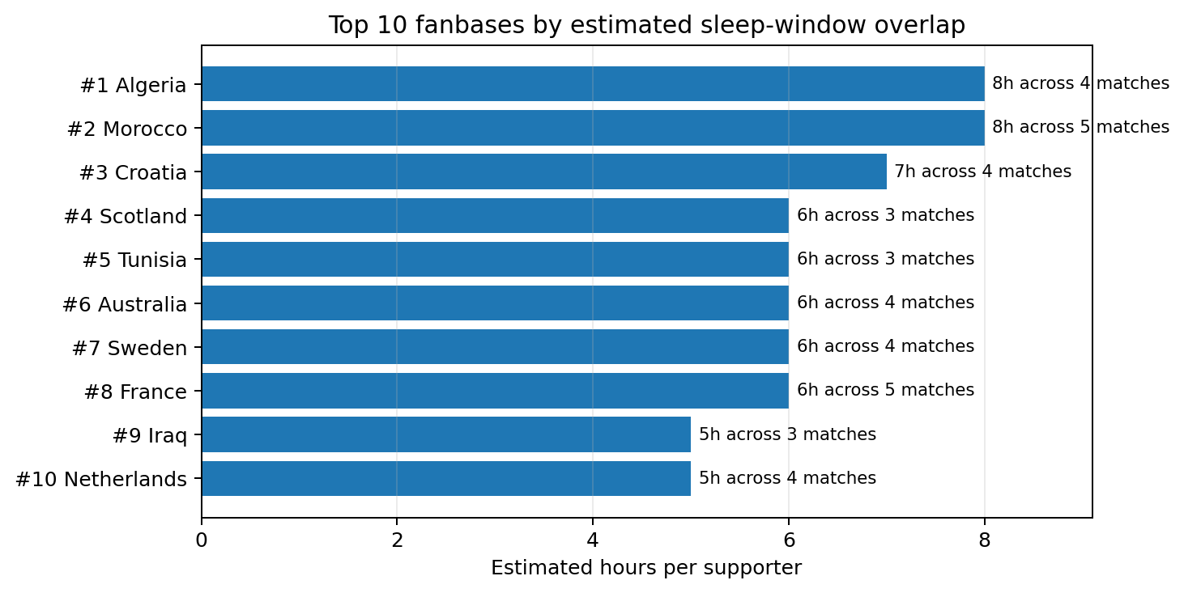
Figure 1. Cumulative result. Labels also show the number of matches counted.
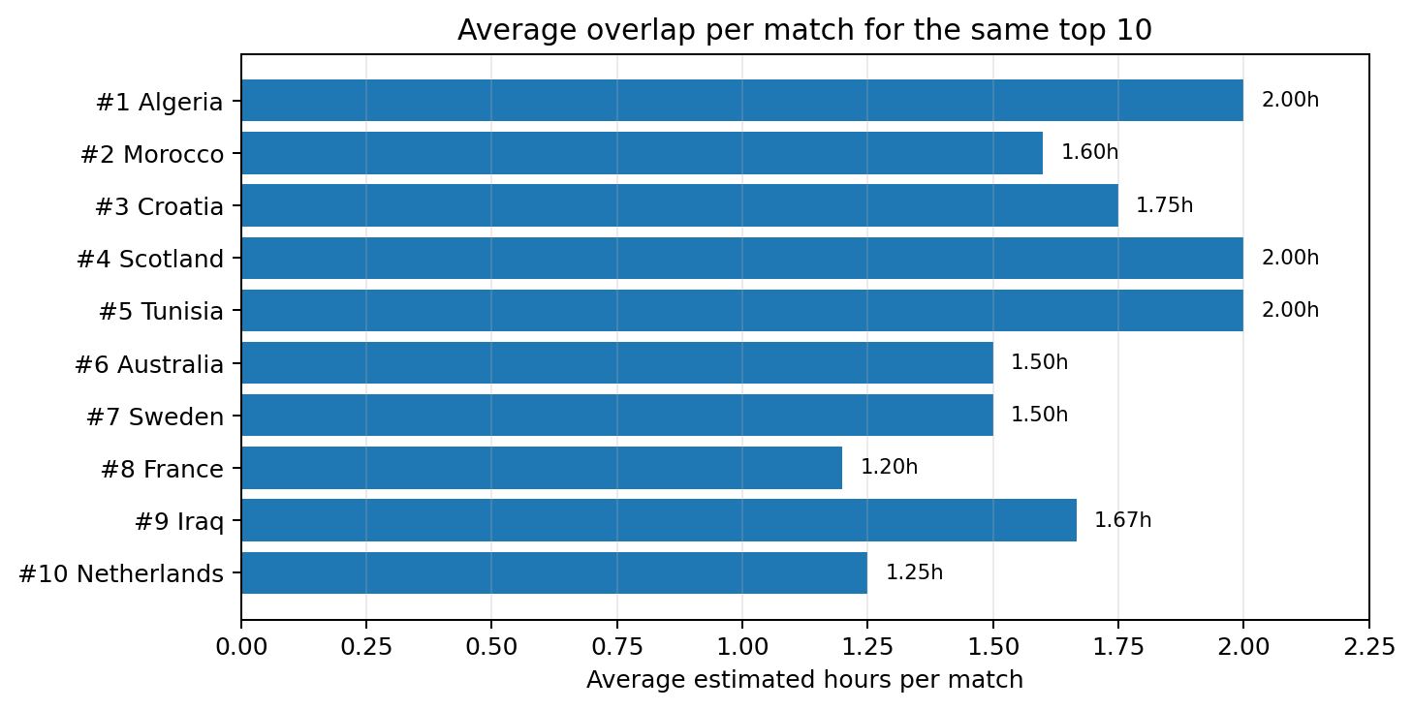
Figure 2. Mean overlap per match for the same ten fanbases.
4.3 Prototype assessment
Current feature | Value | Draft assessment
Fanbase selector and result card | Gives a personal answer immediately. | Keep.
Full ranking and match log | Adds comparison and shows where the total came from. | Keep, but keep the page simple.
Downloadable share card | Creates an image that can travel without the site. | High priority before launch.
Collective total per one million fans | Produces a larger, more memorable number. | Label as a scenario, not an audience measurement.
Hermai credit | Connects the public tool with the data provider. | Keep visible on the result card and footer.
Current launch line: “Algeria supporters have lost 8 hours of sleep each this World Cup. We ranked all 48 fanbases by sleep lost. Find yours: [link].”

5. Recommendations and next steps
Priority | Action | Reason | Draft output
1 | Complete bridge data matching and quality checks. | All historical rankings depend on reliable bridge histories. | Clean longitudinal table and data-quality note.
2 | Produce two bridge rankings: longest-running Poor and busiest Poor. | These are the clearest public-interest angles from client feedback. | Two verified ranking tables and a shortlist of headline records.
3 | Build a small bridge prototype around four or five views. | The brief asks for a real public-facing experience rather than analysis alone. | Ranking page, filters, bridge timeline, definition panel and Hermai credit.
4 | Launch the football site only if the share card and mobile layout are ready in the agreed window. | Its value depends heavily on timing and presentation. | Live URL, launch post and basic event tracking.
5 | Record client feedback and user behaviour for the final report. | The final submission needs evidence of refinement and practical value. | Change log, traffic, selections, downloads and referral sources.
6. Path to the final report
The final report should replace the planned bridge analysis with verified results, show the strongest bridge records and explain how the prototype changed after client review. It should also record whether the football prototype was launched, what users did on the site and what this suggests about shareable public-data products for Hermai.
- Add the cleaned bridge dataset, matching method and validation results.
- Add final bridge findings, source links and screenshots of the live prototype.
- Record client feedback and the changes made after this draft.
- Add simple engagement measures from any live launch or user test.
- Keep the final recommendations specific to Hermai's data and prototyping service.
7. References
- Hermai (2026), Student Consulting Team project brief.
- Chen, K. (2026), client feedback and direction shared with Team 38, 4-5 July.
- FIFA World Cup 2026 fixture schedule used in the Team 38 analysis workbook.
- Team 38 (2026), cleaned schedule, fanbase ranking and match-level sleep-overlap records.
- Federal Highway Administration, National Bridge Inventory annual files (planned source for the bridge analysis).

