**Following is the SQL to create and insert the table**

**Following assignment will perform the below operation.**

1. Add Task
2. Delete Task
3. Mark Task

--

-- Table structure for table `task_mgmt`

--

CREATE TABLE IF NOT EXISTS `task_mgmt` (

`task_Id` int(10) NOT NULL AUTO_INCREMENT,

`TASK_NAME` varchar(100) NOT NULL,

`TASK_DESCRIPTION` varchar(200) NOT NULL,

`TASK_START_TIME` timestamp NOT NULL DEFAULT CURRENT_TIMESTAMP ON UPDATE CURRENT_TIMESTAMP,

`TASK_END_TIME` timestamp NOT NULL DEFAULT '0000-00-00 00:00:00',

`TASK_DURATION` int(11) NOT NULL,

`TASK_PRIORITY` int(2) NOT NULL,

`TASK_COMPLETED` varchar(10) NOT NULL,

PRIMARY KEY (`task_Id`)

) ENGINE=InnoDB DEFAULT CHARSET=latin1 AUTO_INCREMENT=9 ;

--

-- Dumping data for table `task_mgmt`

--

INSERT INTO `task_mgmt` (`task_Id`, `TASK_NAME`, `TASK_DESCRIPTION`, `TASK_START_TIME`, `TASK_END_TIME`, `TASK_DURATION`, `TASK_PRIORITY`, `TASK_COMPLETED`) VALUES

(1, 'requirment Analysis', 'requirment Analysis', '2018-04-29 21:19:23', '2018-04-30 00:00:00', 10, 1, 'Y'),

(2, 'Coding', 'Coding', '2018-04-29 21:19:32', '2018-04-30 00:00:00', 10, 2, 'Y'),

(3, 'asff', 'ssaaf', '2018-04-29 21:19:23', '2018-04-29 21:19:23', 10, 1, 'Y');

**Add the task using below form**

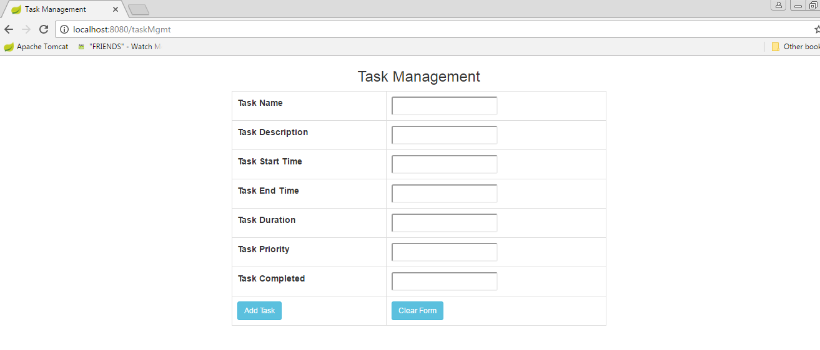

**Delete and mark completed Task**

