MCP Hub
Solution Design Document

Version | 4.0
Status | CONFIDENTIAL — Client Distribution
Date | August 13, 2026
Covers | Architecture · Authentication · Authorization · Operations

Executive Summary
The MCP Hub is a zero-trust control plane for AI agent-to-service authentication. It provides a single gateway that centralises server discovery, cryptographic authentication, intelligent routing, and structured audit — eliminating bespoke per-agent integration code across all backend services.
An agent presents a signed hub JWT to POST /discover. The hub validates it, runs an LLM-guided routing step to select the best-fit MCP server, and mints a short-lived scoped token for it. The agent calls the MCP server directly over Streamable HTTP using that token — the hub is not in the data path for tool calls.

Design Decision | Rationale
RS256 asymmetric JWT signing | Private key stays in the hub. MCP servers receive only the public key and can verify tokens — but cannot forge them. A compromised MCP server cannot impersonate the hub.
Per-server audience scoping (aud = server_id) | Each JWT is bound to one server. A stolen token is unusable on any other server. Blast radius = 1 server × 1 hour.
Multi-provider auth (local / Azure AD) | Local mode: RS256 hub tokens, HS256 chat tokens, or static API key. Azure mode: Entra ID OIDC — no local keys required. Switch via AUTH_PROVIDER env var.
LangGraph ReAct routing agent | New instance per /discover request prevents concurrent state collision. LLM selects best server by capability; falls back to first active server if unavailable.
4-way observability fan-out | Every event written to in-memory deque, stdout, JSONL file, and MySQL simultaneously. MySQL failure permanently disables that sink — other three remain active.

Table of Contents

1 | System Architecture
1.1 | Architecture Overview
1.2 | Component Roles
1.3 | Layer Communication Reference
2 | Authentication
2.1 | Auth Provider Configuration
2.2 | Token Verification Flow
2.3 | JWT Token Lifecycle & Key Infrastructure
2.4 | Server Discovery & Token Scoping
2.5 | MCP Server JWT Validation
3 | Authorization
3.1 | Role Model
3.2 | Per-Tool RBAC Enforcement
3.3 | Credential Isolation
4 | Hub Service
4.1 | Server Registry
4.2 | LLM-Based Routing
4.3 | Observability & Audit
4.4 | Discovery API & Event Model
5 | MCP Integration
5.1 | Streamable HTTP Transport
5.2 | Chat Service Integration
6 | Operations & Deployment
6.1 | Environment Variables
6.2 | Production Readiness Checklist
6.3 | Security Reference
6.4 | Key Files Reference

1. System Architecture
The MCP Hub sits between AI agents and backend services. It handles authentication, server discovery, and routing so that agents can use any registered MCP server without knowing its endpoint, credentials, or capabilities in advance.
1.1 Architecture Overview
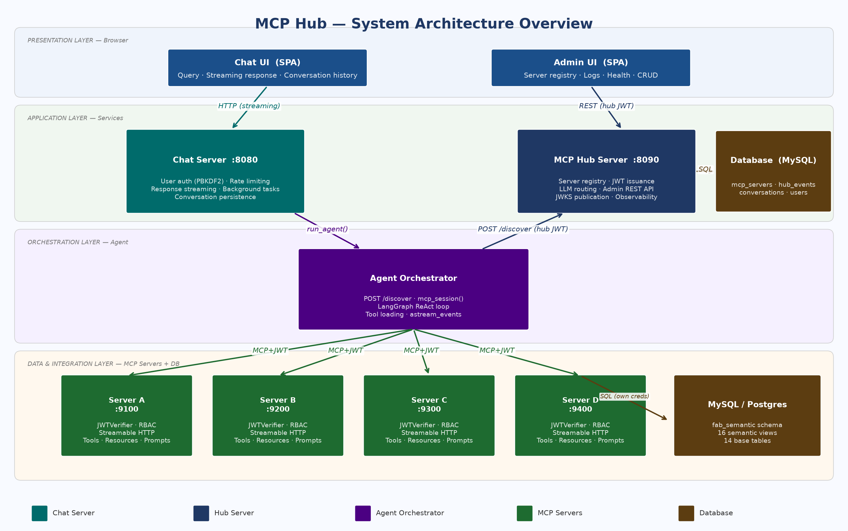
Figure 1 — System Overview: Layers, Components, and Data Flows
1.2 Component Roles
Component | Role | Port
Chat UI (SPA) | Browser query interface — submits queries, displays streaming responses | —
Admin UI (SPA) | Hub management — server registry, event logs, health, CRUD | —
Chat Server | User auth (PBKDF2-SHA256); session management; response streaming to browser | 8080
MCP Hub Server | Server registry, JWT issuance, LLM routing, JWKS, event logging | 8090
Agent Orchestrator | LangGraph ReAct loop; calls /discover, opens MCP sessions, invokes tools | —
MCP Servers | FastMCP servers exposing domain tools over Streamable HTTP with JWT auth | 9100
MySQL | Registry (mcp_servers), events (hub_events), conversations, users | 3306

NOTE — Transport Protocol
All agent-to-MCP-server communication uses Streamable HTTP (POST /mcp). Every request carries an Authorization: Bearer <token> header — not just the initial handshake. The session is tracked via an Mcp-Session-Id header returned during initialize.

1.3 Layer Communication Reference
Each boundary in the stack has a fixed HTTP contract. The table below lists the method, mandatory headers, request body shape, and response shape for every layer transition. No credential or header passes through more than one boundary.
Boundary | Method & URL | Request | Response
Browser → Chat Server | POST /login | Body: {"username":"alice","password":"..."}  Content-Type: application/json | {"access_token":"<hub JWT>","token_type":"bearer","sub":"alice","roles":["agent"]}  Sets HttpOnly cookie: session=<token>
Browser → Chat Server | POST /messages | Cookie: session=<hub JWT>  Body: {"query":"..."}  Content-Type: application/json | 200 OK (task created); events streamed via GET /sse or polled via GET /poll
Agent → Hub Server | POST /auth/login | Body: {"username":"...","password":"..."}  Content-Type: application/json | {"access_token":"<RS256 JWT>","token_type":"bearer","sub":"...","roles":[...]}
Agent → Hub Server | POST /discover | Authorization: Bearer <hub JWT>  Content-Type: application/json  Body: {"intent":"customer C007 loyalty status"} | {"servers":[{config + "server_token":"<RS256 JWT aud=server_id>"}],"method":"agent","reason":"...","hub_metadata":{...},"auth_meta":{...}}
Agent → MCP Server | POST /mcp (initialize) | Authorization: Bearer <server JWT>  Accept: application/json, text/event-stream  Content-Type: application/json  Body: JSON-RPC initialize | Header: Mcp-Session-Id: <uuid>  Body: {"result":{"protocolVersion":"2024-11-05","capabilities":{},"serverInfo":{"name":"..."}}}
Agent → MCP Server | POST /mcp (tools/call) | Authorization: Bearer <server JWT>  Mcp-Session-Id: <uuid>  Body: JSON-RPC tools/call with name + arguments | {"result":{"content":[{"type":"text","text":"{...result JSON...}"}]}}
MCP Server → MySQL | SQL query (SQLAlchemy) | Credentials: MYSQL_USER / MYSQL_PASSWORD  Parameterised query against semantic view | Result rows from customer_360_view, pricing_view, etc.

NOTE — Credential isolation at every boundary
Authorization: Bearer in the agent→MCP request carries the per-server JWT — not the hub JWT or any MySQL credential. MYSQL_USER/MYSQL_PASSWORD are never forwarded beyond the MCP server process boundary.

2. Authentication
Authentication is centralised in hub_service/auth.py. It supports multiple providers (local RS256/HS256, Azure AD/Entra ID, static API key) and enforces a strict verification priority chain on every hub API call.
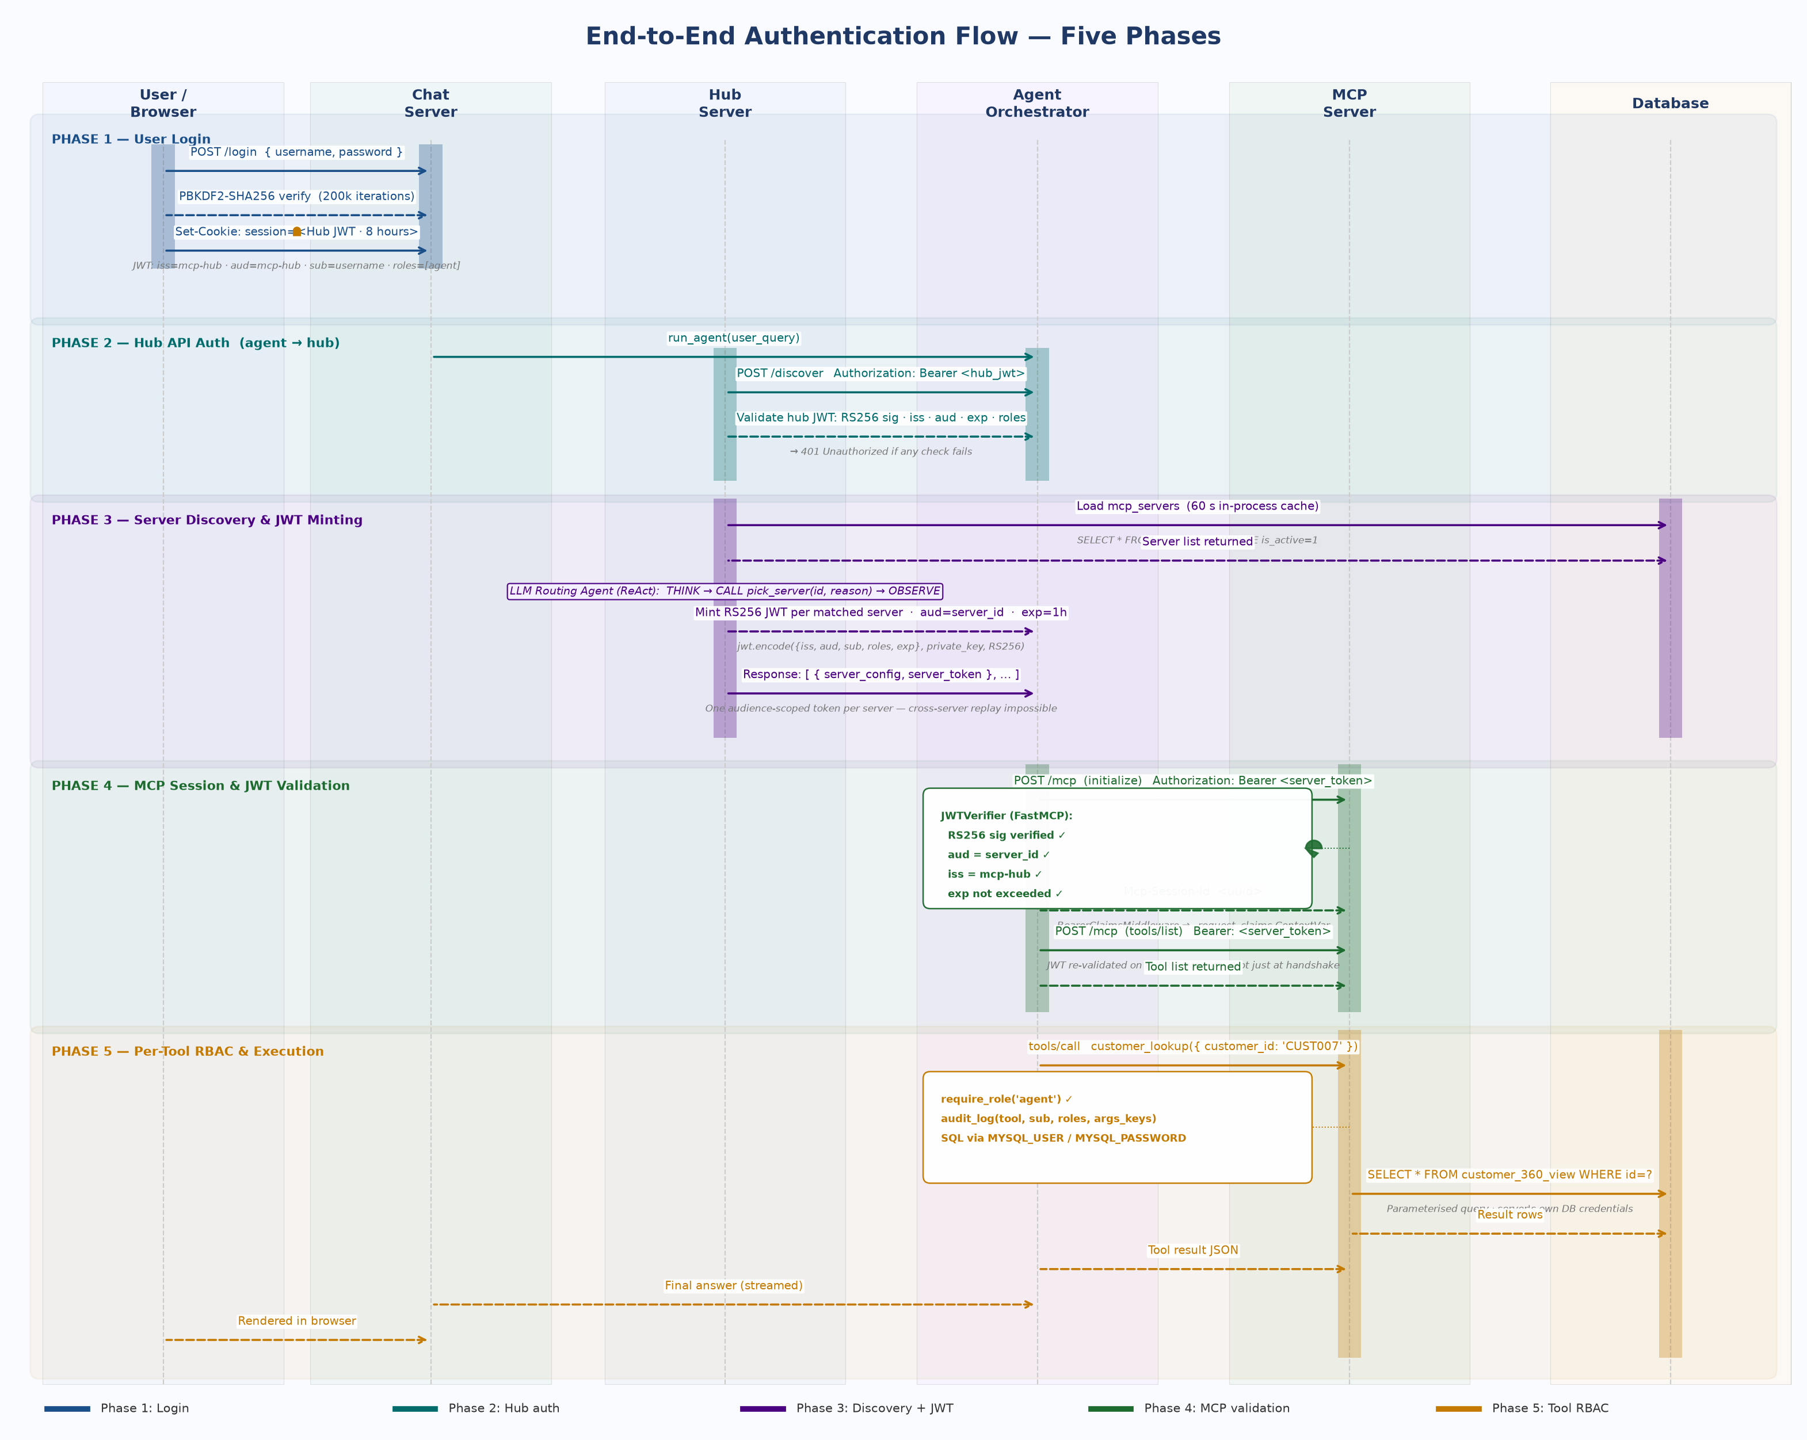
Figure 2 — End-to-End Authentication Flow
2.1 Auth Provider Configuration
Two top-level flags in hub_service/auth.py govern all auth behaviour. AUTH_PROVIDER selects the trust anchor. AUTH_ENABLED can disable all checks for local development only — never set false in production.
AUTH_PROVIDER | Trust Anchor | Tokens Accepted | When to Use
local (default) | Hub RSA private key | RS256 JWT (hub-minted) · HS256 JWT (JWT_SECRET) · static HUB_API_KEY | Self-hosted; no external identity provider
azure | Azure AD / Entra ID JWKS | Microsoft-issued OIDC tokens (RS256) | Enterprise; existing Azure AD tenant
(disabled) | None — AUTH_ENABLED=false | All requests pass as anonymous admin | Local dev only — never staging/production

# hub_service/auth.py — loaded at module import
AUTH_ENABLED = os.environ.get('AUTH_ENABLED', 'true').lower() in ('1','true','yes')
AUTH_PROVIDER = os.environ.get('AUTH_PROVIDER', 'local') # 'local' | 'azure'
# local provider
HUB_API_KEY = os.environ.get('HUB_API_KEY', '') # static pre-shared key
JWT_SECRET = os.environ.get('JWT_SECRET', '') # HS256 shared secret
# azure provider
AZURE_TENANT_ID = os.environ.get('AZURE_TENANT_ID', '')
AZURE_CLIENT_ID = os.environ.get('AZURE_CLIENT_ID', '')

2.2 Token Verification Flow
verify_token() implements a strict priority chain. Steps are tried in order and the first match wins. Algorithm routing (Step 3) reads the JWT header without signature verification to detect RS256 vs HS256 before choosing the path.
# verify_token() priority chain — hub_service/auth.py
Step 0 AUTH_ENABLED = false → pass, claims = {sub: anonymous, roles: [admin]}
Step 1 AUTH_PROVIDER = azure → _verify_azure() # OIDC via Microsoft JWKS
Step 2 token == HUB_API_KEY → pass, claims = {sub: api-key-user, roles: [...]}
Step 3 JWT header alg = RS256 → _verify_jwt_rs256() # sig · iss · aud · exp
Step 4 JWT_SECRET is configured → _verify_jwt_local() # HS256 sig · exp
Step 5 RS256 last resort → _verify_jwt_rs256() # unknown alg, try anyway
Step 6 _DEV_MODE_ACTIVE → pass, claims = {sub: dev, roles: [admin]}
Step 7 No match → 401 Unauthorized

WARNING — Dev Mode — Exact Activation Conditions
_DEV_MODE_ACTIVE fires only when ALL four hold simultaneously:
1. AUTH_ENABLED = true
2. AUTH_PROVIDER = local
3. HUB_API_KEY is not set
4. JWT_SECRET is not set
Hub emits a ⚠ startup WARNING. Setting JWT_SECRET is the minimum to exit dev mode.
RSA key files are auto-generated on startup but do NOT by themselves exit dev mode.

2.3 JWT Token Lifecycle & Key Infrastructure
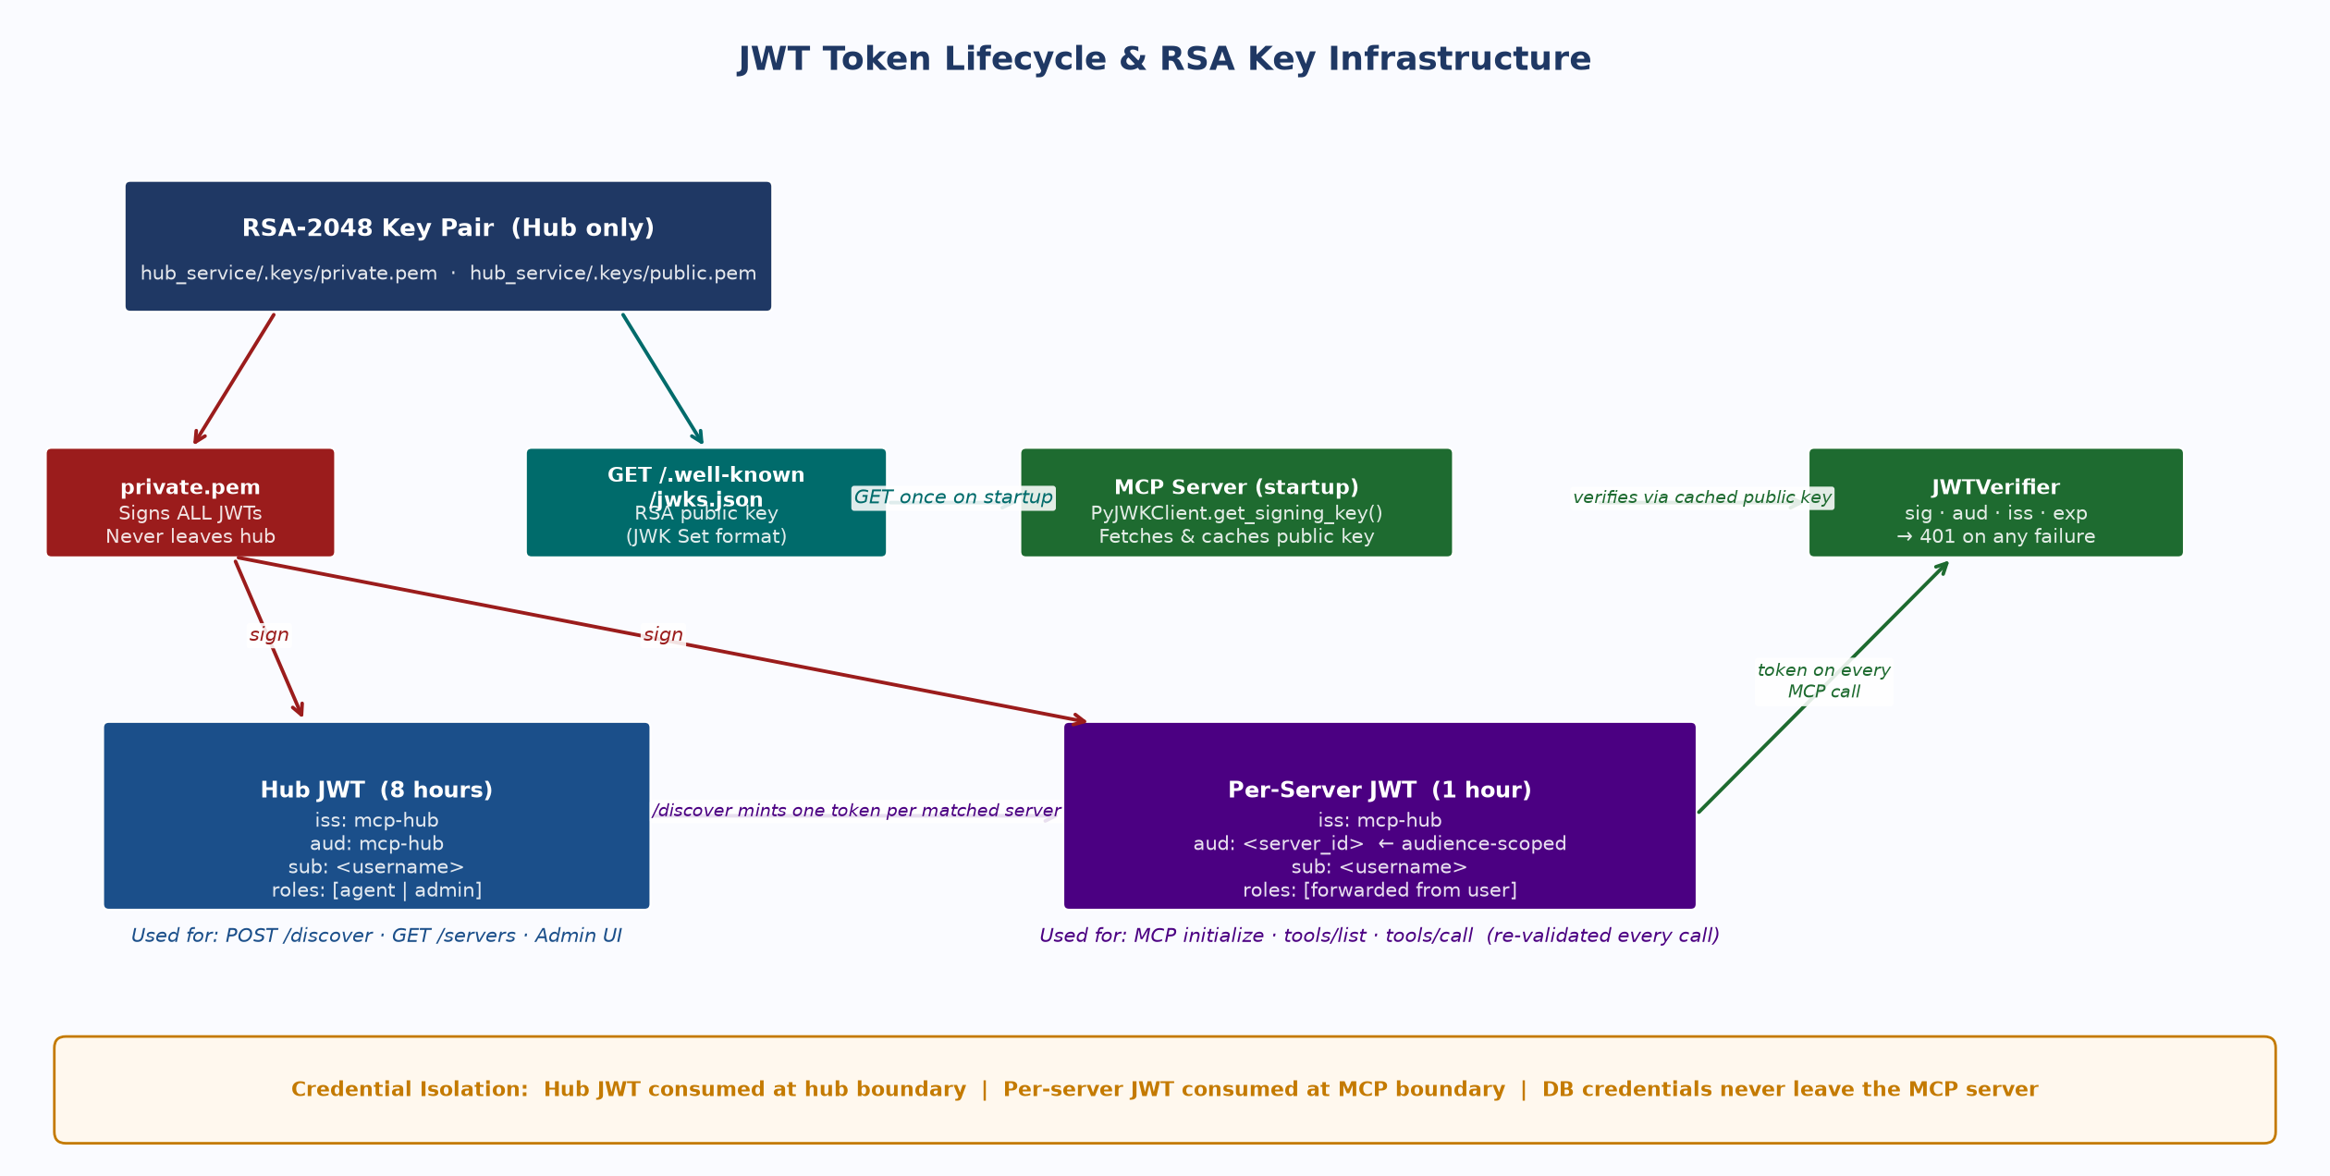
Figure 3 — JWT Token Lifecycle & RSA Key Infrastructure
The hub generates a 2048-bit RSA key pair on first startup (hub_service/.keys/private.pem and public.pem). The private key signs all tokens and never leaves the hub process. The public key is published at GET /.well-known/jwks.json with a kid (Key ID) header that enables key rotation without downtime.
# JWKS endpoint — GET /.well-known/jwks.json
{ "keys": [{ "kty":"RSA", "kid":"hub-rsa-1", "use":"sig", "alg":"RS256",
"n":"<base64url modulus>", "e":"AQAB" }] }
# Token minting CLI — development and testing
python hub_service/auth.py --sub agent --roles agent --hours 24
python hub_service/auth.py --sub admin --roles admin,agent --hours 8
# Key rotation: update HUB_JWT_KID → restart hub → wait 1h for old tokens to expire

2.4 Server Discovery & Token Scoping
When an agent calls POST /discover, the hub validates the caller's hub JWT, runs LLM-based routing to select the best-fit server, then mints a separate short-lived JWT for each matched server. Each token is bound exclusively to its target:
# hub_service/auth.py generate_server_token()
payload = {
'iss': 'fab-mcp-hub', # must match MCP_JWT_ISSUER on MCP server
'aud': server_id, # only this server accepts this token
'sub': caller_sub, # forwarded from hub JWT — never elevated
'roles': caller_roles, # forwarded from hub JWT — never elevated
'server_id': server_id, # additional claim for MCP server filtering
'exp': now + 3600, # 1 hour — shorter than hub session (8h)
}

SECURITY — Why Per-Server Audience Scoping
Each JWT carries aud = server_id. Server B rejects a token intended for Server A because the audience claim does not match.
Blast radius of any single token compromise: 1 server × 1 hour.
A single token valid on all servers would create unlimited cross-service blast radius.

2.5 MCP Server JWT Validation
MCP servers run two middleware layers in sequence on every Streamable HTTP request. FastMCP's JWTVerifier handles cryptographic validation; BearerClaimsMiddleware decodes the already-verified claims into a per-request ContextVar for RBAC — without a second JWKS round-trip.
# mcp_server/server.py — middleware registration (order matters)
# Layer 1 — FastMCP JWTVerifier (cryptographic validation)
verifier = JWTVerifier(
jwks_uri = f'{HUB_URL}/.well-known/jwks.json', # fetches RSA public key from hub
issuer = os.environ['MCP_JWT_ISSUER'], # must match HUB_JWT_ISSUER
audience = os.environ['MCP_SERVER_ID'] # must match aud in token
) # returns HTTP 401 on: invalid sig | wrong aud | wrong iss | expired
# Layer 2 — BearerClaimsMiddleware (decode for RBAC — no 2nd JWKS call)
class BearerClaimsMiddleware(BaseHTTPMiddleware):
async def dispatch(self, request, call_next):
token = request.headers.get('Authorization','').removeprefix('Bearer ').strip()
payload = jwt.decode(token, options={'verify_signature': False})
_request_claims.set({'sub': payload['sub'], 'roles': payload.get('roles',[])})
return await call_next(request)

3. Authorization
Authorization operates at two levels: hub-side RBAC (role checked on every hub API call) and per-tool RBAC inside each MCP server (role enforced before any business logic executes).
3.1 Role Model
Role | Hub Access | MCP Tool Access | Typical Holder
admin | All endpoints — /discover · /servers · /health · /api/hub/* (full CRUD) | All tools — bypasses role checks (admin is implicit in require_role) | Operator / admin login
agent | POST /discover · GET /servers · GET /health | Tools annotated require_role('agent') or require_role('agent','admin') | AI agent / orchestrator process
readonly | GET /servers · GET /health only | Read-only tools only | Monitoring system / audit consumer

NOTE — Role Forwarding — No Elevation
Roles from the hub JWT are copied unchanged into every per-server JWT — never elevated. An agent presenting an 'agent' hub token always gets 'agent' server tokens. The hub cannot be tricked into issuing elevated server tokens.

3.2 Per-Tool RBAC Enforcement
Every tool function calls require_role() as its first statement — before any I/O, database access, or input validation. Claims come from BearerClaimsMiddleware via ContextVar.
# Standard tool pattern — mcp_server/tools.py
@mcp.tool()
def customer_360(customer_id: str) -> dict:
require_role('agent', 'admin') # 1st: before any I/O
audit_log('customer_360', # 2nd: logs keys NOT values (PII)
args={'customer_id': customer_id})
if not customer_id or len(customer_id) > 50:
raise ValueError('customer_id: 1-50 chars')
return db.query_one(
'SELECT * FROM customer_360_view WHERE id = %s',
(customer_id,) # parameterised query — never string-format user input
)

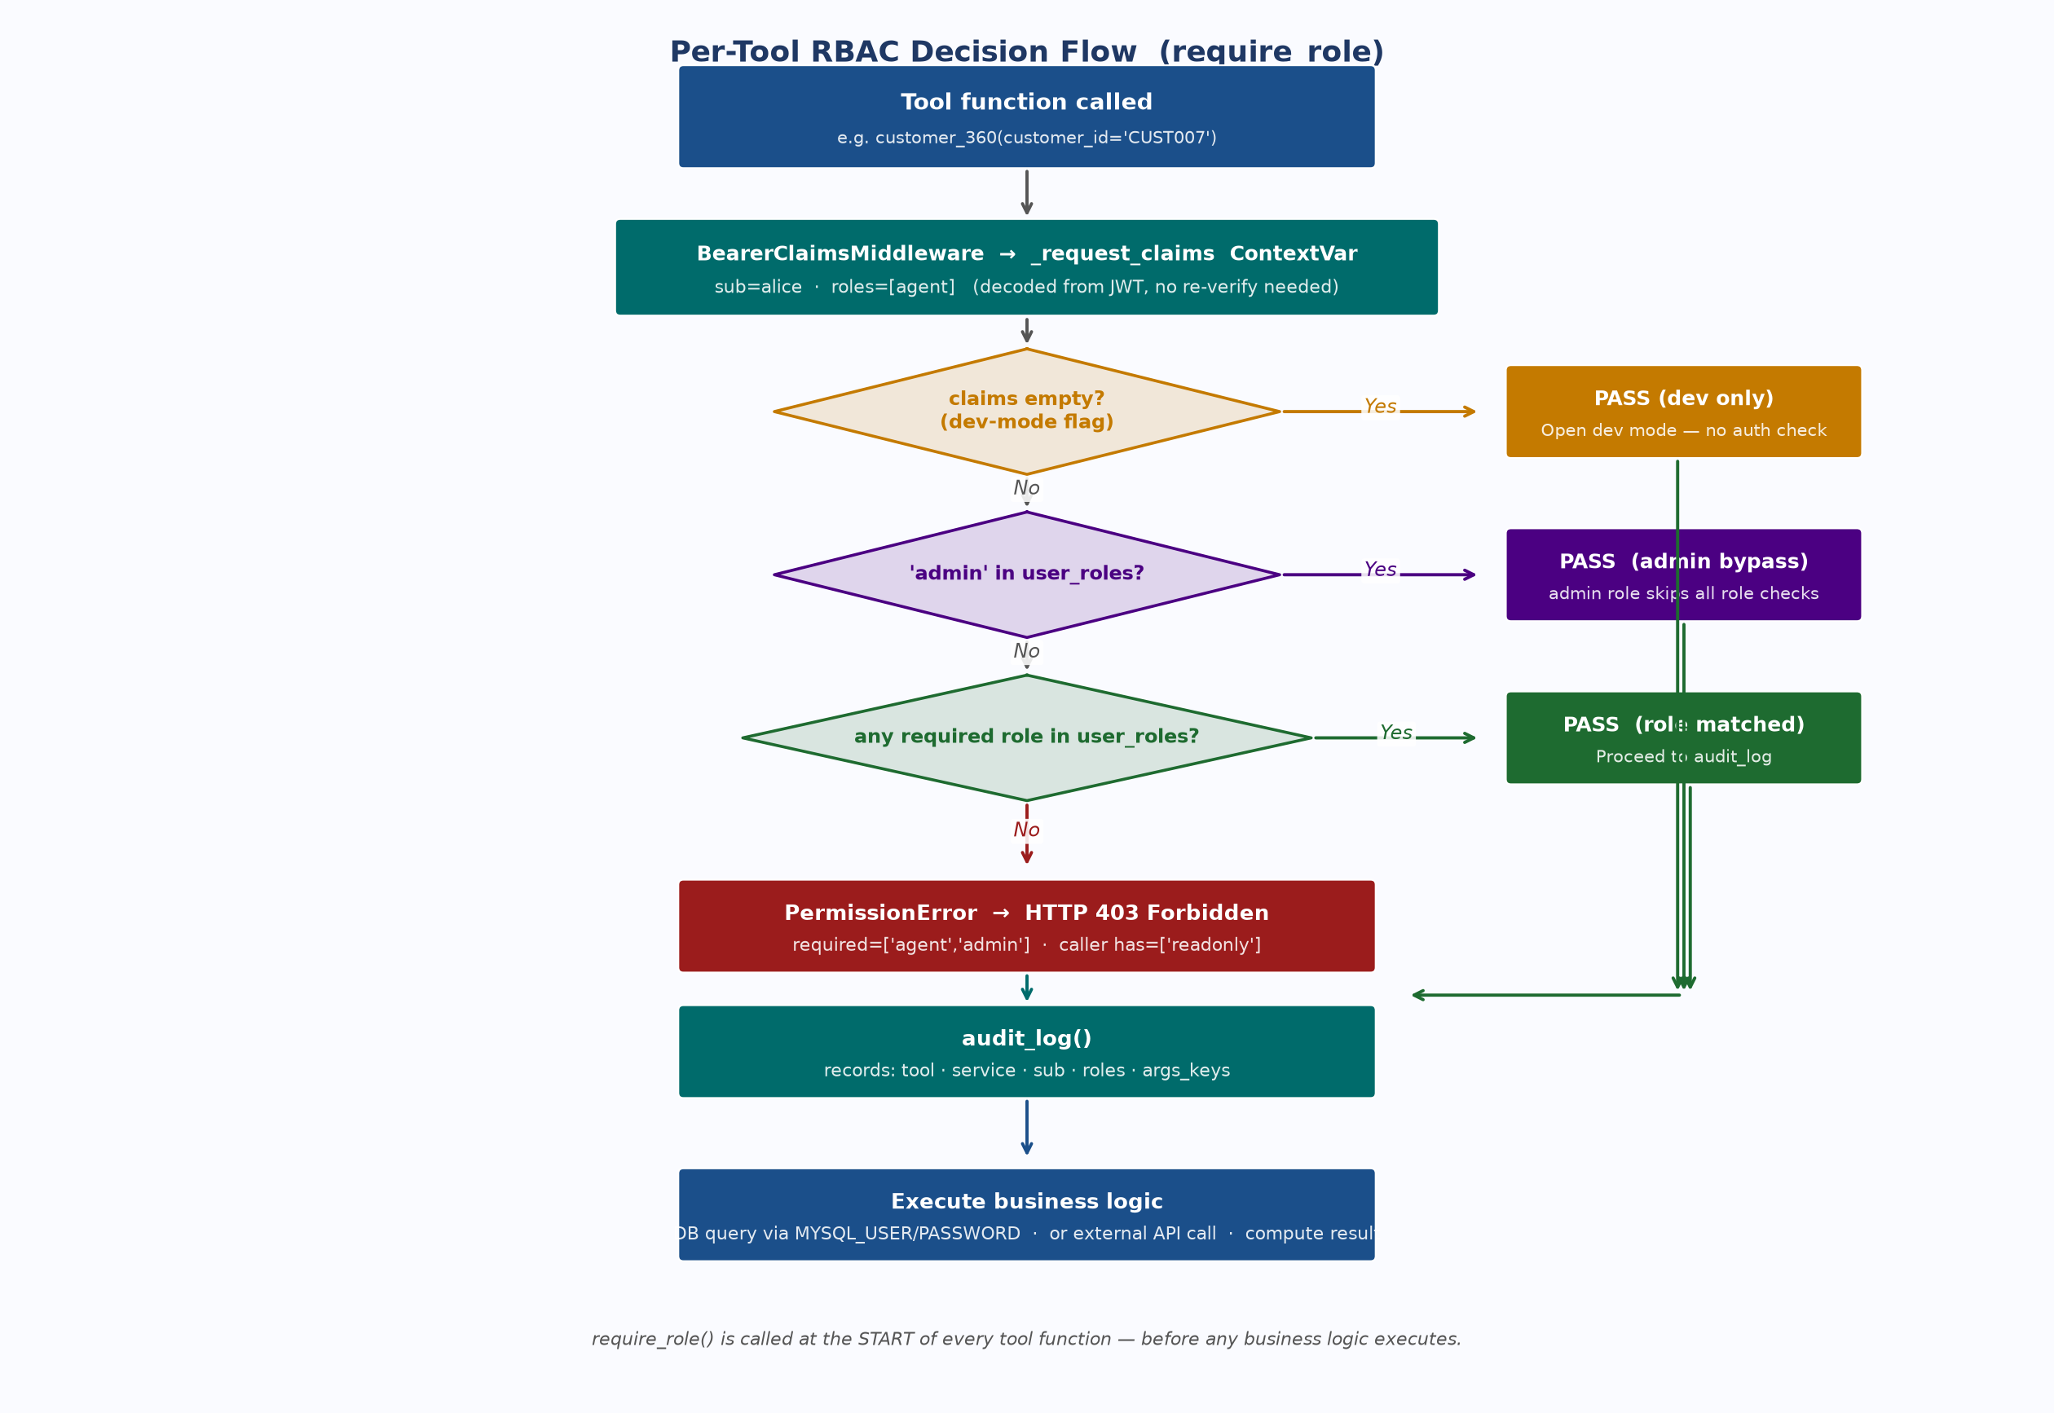
Figure 4 — Per-Tool RBAC Decision Flow
3.3 Credential Isolation
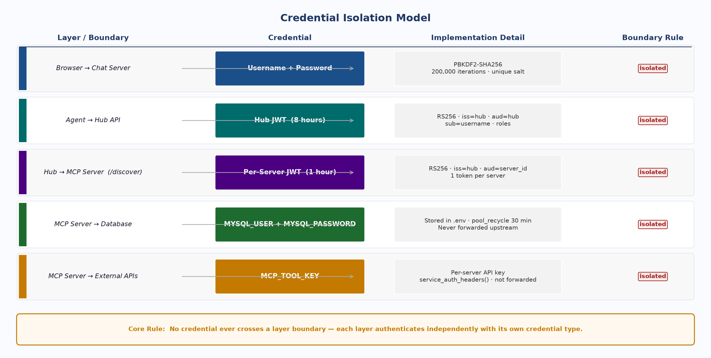
Figure 5 — Credential Isolation: No Credential Crosses a Layer Boundary
Layer | Credential Used | Valid Scope | Never Forwarded To
Browser → Chat Server | Hub JWT (8h, HttpOnly cookie) | Chat server session only | MCP servers · MySQL · external APIs
Agent → Hub | Hub JWT (8h, Authorization header) | /discover · /servers · /health | MCP servers · MySQL · external APIs
Agent → MCP Server | Per-server JWT (1h, aud = server_id) | Single MCP server only | Hub · MySQL · other MCP servers
MCP Server → MySQL | MYSQL_USER / MYSQL_PASSWORD | DB queries inside MCP server | Agent · Hub · browser
MCP Server → External APIs | MCP_TOOL_KEY (env var) | Tool-specific HTTP calls | Agent · Hub · browser

4. Hub Service
The hub (hub_service/hub_server.py) is the operational core. It owns the server registry, issues JWTs, routes discovery requests via an LLM agent, and records every event to four simultaneous sinks.
4.1 Server Registry
The registry is a MySQL table (mcp_servers) seeded from mcp-hub.json via seed_hub_db.py. Servers can be added, edited, disabled, or probed through the admin UI or REST API. A 60-second in-process cache minimises MySQL round-trips; POST /api/hub/refresh busts it immediately.
# hub_service/mcp-hub.json — declarative source (seeded into MySQL)
{
"servers": [{
"id": "fab-customer-server",
"endpoint": "http://mcp-customer:9100/mcp",
"transport": "streamable-http",
"capability": "customer data — 360 view, order history, loyalty",
"skills": ["customer lookup", "order history", "loyalty points"],
"is_active": true
}]
}

Endpoint | Auth | Purpose
GET /health | Public | Service status, hub metadata, registered server count
GET /.well-known/jwks.json | Public | RSA public key in JWK Set format for MCP server verification
POST /auth/login | Public | username+password → RS256 JWT (8h); entry point for agent auth
POST /discover | agent | admin | LLM routing → server selection → per-server JWT minting
GET /servers | agent | admin | Full active server list with capabilities and skills
GET /api/logs | admin | Structured event log — MySQL primary, in-memory fallback
POST /api/hub/refresh | admin | Bust 60-second registry cache immediately
CRUD /api/hub/servers/* | admin | Add, edit, enable/disable, delete, probe server entries

4.2 LLM-Based Routing
Every POST /discover creates a fresh LangGraph ReAct agent instance. The agent receives all active servers' capability, skills, description, and examples, then reasons about which server best fits the query. A new instance per request is required — sharing one across concurrent calls corrupts internal message state.
# hub_server.py — routing
def _agent_route(query, servers):
tool = _make_routing_tool(servers) # stateless pick_server tool
agent = create_react_agent(llm, [tool]) # fresh instance per request
result = agent.invoke({
'messages': [('user', routing_prompt(query, servers))]
}) # LLM: THINK → CALL pick_server → OBSERVE
return extract_selected_ids(result)

NOTE — Routing Fallback
If the LLM is unavailable (timeout, model not loaded, network error), the hub falls back to returning the first active server in the registry. Monitor routing.method='fallback' events in GET /api/logs to detect LLM availability issues.

4.3 Observability & Audit
Every log_event() call fans out to four sinks simultaneously. MySQL is permanently disabled after the first failure — retrying on every event call would add latency to every HTTP request.
Sink | Access | Failure Behaviour
In-memory deque (500 entries) | GET /api/logs | Never fails — oldest entries evicted
stdout | docker logs / console | Never fails
logs/hub.log (JSONL) | tail / log aggregator | Silently skips if directory not writable
MySQL hub_events | GET /api/logs primary | Permanently disabled on first error; restart hub to re-enable

Event Type | When Emitted | Key data Fields
auth | Every token check | valid · sub · roles · token_type · iss · provider · endpoint · method
request | Every HTTP request | method · path · status · latency_ms
routing | Server selection | method(agent|first_match) · server_ids · reason · intent · sub
request_detail | POST /discover handler | Full req/resp headers + body · auth_sub · auth_roles (verbose trace)
admin | Server CRUD actions | action(create|update|delete_server) · server_id · changed_by
error | Runtime exceptions | message · traceback

4.4 Discovery API & Event Model
Section 4.4 provides the complete data model: the mcp_servers registry schema, the hub_events audit table, the POST /discover request and response contracts, and an explanation of how each layer connects through the hub.
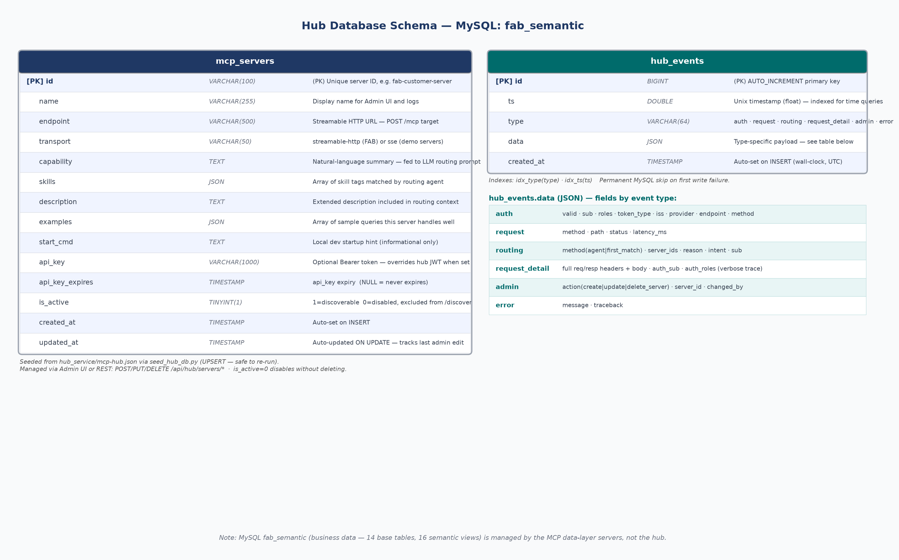
Figure 7 — Hub Database Schema: mcp_servers and hub_events tables
mcp_servers — Registry Table Schema
The mcp_servers table is the single source of truth for all registered backends. It is seeded from hub_service/mcp-hub.json via scripts/seed_hub_db.py (UPSERT — safe to re-run). All fields except id, name, and endpoint have safe defaults; is_active=0 disables a server without deleting it.
Column | Type | Purpose
id | VARCHAR(100) PK | Unique server identifier. Used as JWT aud claim and MCP_SERVER_ID.
name | VARCHAR(255) | Human-readable display name shown in Admin UI and logs.
endpoint | VARCHAR(500) | Full HTTP URL for POST /mcp calls, e.g. http://mcp-customer:9100/mcp.
transport | VARCHAR(50) | 'streamable-http' (FAB data servers) or 'sse' (demo servers). Controls which MCP client is used.
capability | TEXT | Natural-language summary of server capabilities. Included verbatim in the LLM routing prompt.
skills | JSON (array) | Array of skill tags (e.g. ['customer lookup', 'order history']). Used by routing agent for semantic matching.
description | TEXT | Extended description providing additional routing context for edge cases.
examples | JSON (array) | Array of sample query strings this server handles well. Helps LLM routing identify intent.
start_cmd | TEXT | Local development startup command. Informational only — not used at runtime.
api_key | VARCHAR(1000) | Optional static Bearer token. When set, overrides hub-minted JWT for agent→MCP authentication.
api_key_expires | TIMESTAMP | Expiry for api_key. NULL means the key never expires. Hub does not enforce this — checked manually.
is_active | TINYINT(1) | 1 = included in /discover responses. 0 = disabled and excluded, but row is retained for history.
created_at | TIMESTAMP | Auto-set on INSERT. Tracks when the server was registered.
updated_at | TIMESTAMP ON UPDATE | Auto-updated on every change. Tracks last admin edit.

NOTE — Changelog table
Every CREATE / UPDATE / DELETE action on mcp_servers is also recorded in mcp_server_changelog (server_id · action · changed_by · before_state JSON · after_state JSON). This provides a full audit trail of registry changes without overwriting the live row.

POST /discover — Request & Response
POST /discover is the primary integration point. It accepts a natural-language intent, routes it to the best-fit server, and returns a scoped JWT alongside all connection details the agent needs.
# POST /discover — request body (Pydantic DiscoverRequest)
{ "intent": "what is the loyalty score for customer C007?" }
# Required headers
Authorization: Bearer <hub JWT> # RS256, exp=8h, iss=fab-mcp-hub
Content-Type: application/json
# Response body (DiscoverResponse) — key fields
{
"servers": [
{
"id": "fab-customer-server",
"name": "FAB Customer Intelligence MCP Server",
"endpoint": "http://mcp-customer:9100/mcp",
"transport": "streamable-http",
"capability": "customer 360 data, order history, loyalty score",
"skills": ["customer lookup", "loyalty points", "order history"],
"server_token": "<RS256 JWT — aud=fab-customer-server, exp=now+3600>"
}
],
"method": "agent", // "agent" = LLM routed | "first_match" = LLM unavailable
"reason": "Server handles customer 360 and loyalty queries",
"hub_metadata": { "hub_name":"FAB MCP Hub", "version":"3.0", "server_count":2 },
"auth_meta": { "sub":"alice", "roles":["agent"], "token_type":"jwt", "exp":1720000000 }
}

hub_events — Audit Table Schema
Every hub operation — authentication, routing, HTTP request, admin action, error — is written to hub_events as a structured JSON row. The data column stores the full event dict so any event type can be queried by field name using MySQL JSON path expressions (e.g. data->>'$.sub').
Column | Type | Purpose
id | BIGINT AUTO_INCREMENT PK | Monotonically increasing event ID.
ts | DOUBLE (indexed) | Unix timestamp as float. Indexed (idx_ts) for range queries.
type | VARCHAR(64) (indexed) | Event category — auth · request · routing · request_detail · admin · error. Indexed (idx_type).
data | JSON | Full event payload. Fields vary by type (see table below).
created_at | TIMESTAMP | Wall-clock insert time. ts is always populated; created_at is the DB default.

Event Type | data Fields | Notes
auth | valid · sub · roles · token_type · iss · provider · endpoint · method · bearer_token | Logged on every hub API call. token_type: jwt | apikey | dev.
request | method · path · status · latency_ms | Logged by _RequestLogMiddleware for every HTTP request.
routing | method · server_ids · reason · intent (capped 120 chars) · sub | method=agent (LLM) or first_match (fallback). server_ids is a list.
request_detail | endpoint · request_headers · request_body · response_status · response_headers · response_body · auth_sub · auth_roles | Verbose trace of /discover. Useful for debugging routing decisions.
admin | action · server_id · changed_by | Written on every server create/update/delete. action: create_server | update_server | delete_server.
error | message · traceback | Unhandled exceptions. Traceback is truncated if too long.

WARNING — tool_audit events — hub vs. MCP side
tool_audit events (tool name, args_keys, sub, roles) are written by audit_log() in datalayer-as-service/mcp_server/auth.py — inside the MCP server process, not the hub. They are NOT written to hub_events. They appear in the MCP server's stdout only. To centralise MCP-side audit, configure log shipping from the MCP server container.

5. MCP Integration
MCP servers expose domain tools over Streamable HTTP. The agent opens a session, attaches a scoped JWT on every request, and executes tool calls inside a LangGraph ReAct loop.
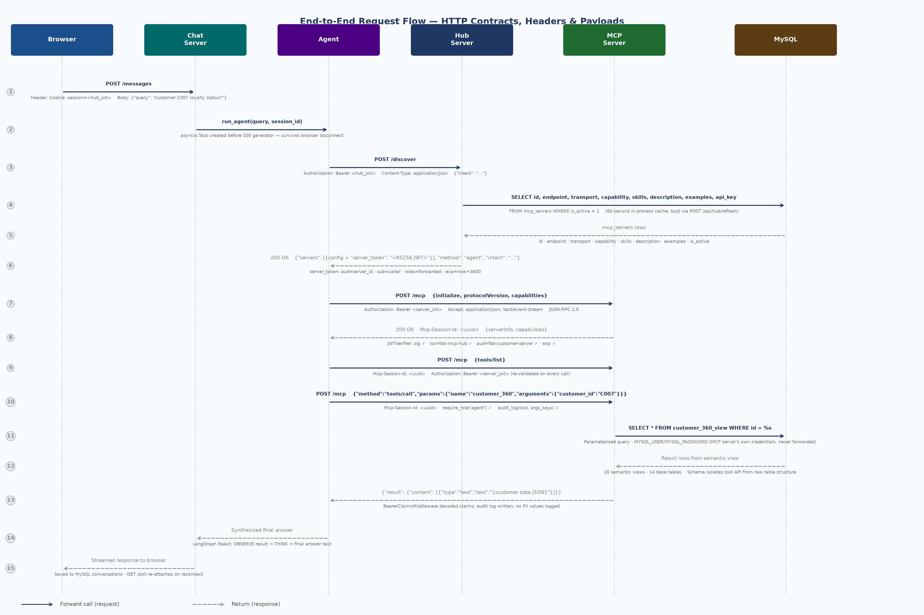
Figure 8 — End-to-End Request Flow: HTTP Contracts, Headers & Payloads at Each Layer Boundary
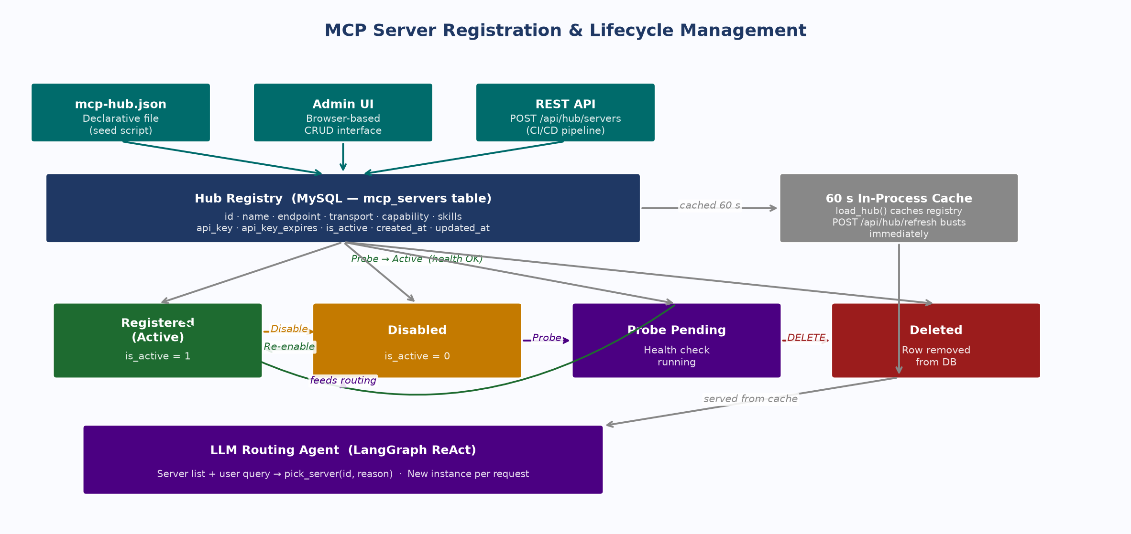
Figure 9 — MCP Server Lifecycle: States and Transitions
5.1 Streamable HTTP Transport
Streamable HTTP (POST /mcp) is the only MCP transport used in this stack. The agent negotiates a session ID during initialize and attaches it — along with the Authorization header — to every subsequent call.
# agent.py mcp_session() — Streamable HTTP
async with streamablehttp_client(
server['endpoint'], # e.g. http://mcp-customer:9100/mcp
headers={'Authorization': f'Bearer {server_token}'}
) as (read, write, _):
async with ClientSession(read, write) as session:
await session.initialize() # POST /mcp → returns Mcp-Session-Id header
tools = await session.list_tools()
result = await session.call_tool('customer_360', {'customer_id': 'C001'})

Header | Required | Value / Notes
Content-Type | Yes | application/json
Accept | Yes | application/json, text/event-stream — both MIME types required; FastMCP returns 406 if either is missing
Authorization | Yes | Bearer <per-server JWT> — present on EVERY request, not just initialize
Mcp-Session-Id | After initialize | UUID returned in initialize response header; must be included on tools/list and tools/call

MCP JSON-RPC 2.0 Message Format
The Streamable HTTP transport carries MCP's JSON-RPC 2.0 protocol. There are three message types in the agent lifecycle: initialize (mandatory first call), tools/list (optional capability discovery), and tools/call (tool execution).
# 1. initialize — mandatory first call on every new session
# POST /mcp Authorization: Bearer <server JWT> Accept: application/json, text/event-stream
{ "jsonrpc":"2.0", "id":"probe-init", "method":"initialize",
"params": { "protocolVersion":"2024-11-05", "capabilities":{},
"clientInfo": {"name":"mcp-client","version":"0.1"} } }
# Response — 200 OK + header Mcp-Session-Id: <uuid>
{ "jsonrpc":"2.0", "result": {
"protocolVersion":"2024-11-05", "capabilities": {"tools":{},"resources":{},"prompts":{}},
"serverInfo": {"name":"FAB Customer Intelligence MCP Server","version":"1.0"}
}, "id":"probe-init" }

# 2. tools/list — discover available tools (optional; agent.py always calls this)
# POST /mcp Mcp-Session-Id: <uuid> Authorization: Bearer <server JWT>
{ "jsonrpc":"2.0", "id":2, "method":"tools/list", "params":{} }
# 3. tools/call — execute a tool
# POST /mcp Mcp-Session-Id: <uuid> Authorization: Bearer <server JWT>
{ "jsonrpc":"2.0", "id":"call-customer_360", "method":"tools/call",
"params": { "name":"customer_360", "arguments": {"customer_id":"C007"} } }
# Response
{ "jsonrpc":"2.0",
"result": { "content": [{"type":"text","text":"{\"customer_id\":\"C007\",...}"}] },
"id":"call-customer_360" }

NOTE — Session reuse within one agent loop
A single agent invocation for one user query opens one MCP session (one initialize call). The LangGraph ReAct loop may call tools/call multiple times within that session — each carrying the same Mcp-Session-Id and a refreshed Authorization header. The session ends when the agent context manager exits.

WARNING — Token Renewal on 401
When a 1-hour per-server JWT expires mid-session the MCP server returns HTTP 401.
Renewal: (1) call POST /discover again with the hub JWT to mint a fresh server token, (2) open a new MCP session with the new token.
Do not attempt to reuse the expired token or the existing Mcp-Session-Id — both are rejected.

5.2 Chat Service Integration
The chat server (chat_service/chat_server.py) provides the browser interface. It authenticates users with PBKDF2-SHA256, holds hub JWTs in session cookies, and runs the agent as a background asyncio.Task so browser disconnects do not abort in-progress agent work. The final answer is always saved to MySQL.
Endpoint | Purpose | Notes
POST /login | PBKDF2 verify → hub JWT (8h) as HttpOnly cookie | Rate-limited: 10 attempts/15 min per username → HTTP 423
GET /sse | Open long-lived streaming connection for response events | Background task survives browser disconnect
POST /messages | Submit query → launch run_agent() asyncio.Task | Task created before SSE generator — decoupled lifetimes
GET /poll | Re-attach to running task; retrieve missed events | Used on reconnect after disconnect
GET /conversations | User conversation history from MySQL | Paginated; requires valid session cookie

6. Operations & Deployment
Configuration reference, production readiness checklist, security properties summary, and key files index.
6.1 Environment Variables
NOTE — Startup-time variables
Variables in the Hub Auth group are read by hub_service/auth.py at module import time. Changes require a hub process restart.

Variable | Service | Required | Description
AUTH_ENABLED | Hub Auth | No | true (default). false = all requests pass as anonymous admin — never production.
AUTH_PROVIDER | Hub Auth | No | local (default) or azure. local: RS256/HS256/API-key chain. azure: Entra ID OIDC.
HUB_API_KEY | Hub Auth | No | Static pre-shared key accepted as Bearer token. Roles from HUB_API_KEY_ROLES.
HUB_API_KEY_ROLES | Hub Auth | No | Comma-separated roles for HUB_API_KEY callers (default: agent).
JWT_SECRET | Hub Auth | No | Shared HMAC secret for HS256 JWT verification. Setting this exits dev mode.
HUB_JWT_ISSUER | Hub Auth | No | iss claim in hub-minted tokens (default: fab-mcp-hub). Must match MCP_JWT_ISSUER.
HUB_JWT_KID | Hub Auth | No | kid in JWT header and JWKS (default: hub-rsa-1). Increment on RSA key rotation.
HUB_PRIVATE_KEY_PATH | Hub Auth | No | RSA private key PEM path (default: hub_service/.keys/private.pem).
HUB_PUBLIC_KEY_PATH | Hub Auth | No | RSA public key PEM path (default: hub_service/.keys/public.pem).
HUB_JWKS_URL | Hub Auth | No | Override JWKS URL when hub is behind a load balancer or API gateway.
AZURE_TENANT_ID | Hub Auth | If azure | Azure AD tenant GUID or domain. Required when AUTH_PROVIDER=azure.
AZURE_CLIENT_ID | Hub Auth | If azure | App registration Client ID — expected JWT audience for Entra ID tokens.
MCP_AUTH_ENABLED | MCP Server | Yes | true in all non-dev environments. false = completely open, no JWT checks.
MCP_SERVER_ID | MCP Server | Yes | Unique server ID matching registry id field. Used as expected JWT audience.
HUB_SERVER_URL | MCP Server | Yes | Hub base URL for JWKS fetch: https://hub.internal:8090
MCP_JWT_ISSUER | MCP Server | Yes | Expected JWT issuer. Must match HUB_JWT_ISSUER on hub.
MCP_TOOL_KEY | MCP Server | If ext. | API key for MCP-server-to-external-API calls. Never forwarded to agent or hub.
MYSQL_HOST | Hub + MCP | Yes | Database host (default: 127.0.0.1).
MYSQL_PORT | Hub + MCP | Yes | Database port (default: 3306).
MYSQL_USER | Hub + MCP | Yes | DB username — separate user per service with minimum required privileges.
MYSQL_PASSWORD | Hub + MCP | Yes | DB password — store in secrets manager, never in source control.
MYSQL_DATABASE | Hub + MCP | Yes | Target database name (e.g. fab_semantic).
CHAT_USERS | Chat | Yes | Comma-separated user:password pairs for initial user seeding.
OLLAMA_BASE_URL | Hub | If LLM | LLM endpoint for routing agent (default: http://localhost:11434/v1).
HUB_JWT_EXPIRY_HOURS | Hub | No | Hub login token expiry in hours (default: 8). Per-server tokens are always 1h.

6.2 Production Readiness Checklist
Area | Check | ✓
Auth | AUTH_PROVIDER configured and tested | [ ]
Auth | JWT_SECRET or HUB_API_KEY set — hub not in dev mode | [ ]
Auth | MCP_AUTH_ENABLED=true on all MCP servers | [ ]
Auth | MCP_SERVER_ID matches id field in registry | [ ]
Auth | MCP_JWT_ISSUER matches HUB_JWT_ISSUER | [ ]
Auth (Azure) | AZURE_TENANT_ID and AZURE_CLIENT_ID set if AUTH_PROVIDER=azure | [ ]
Keys | RSA key pair exists; private.pem readable only by hub process | [ ]
Keys | HUB_JWT_KID set and matches kid value in JWKS response | [ ]
Keys | /.well-known/jwks.json reachable by all MCP servers via HTTPS | [ ]
Secrets | .env and *.pem files excluded from git (.gitignore verified) | [ ]
Secrets | All secrets in vault / secrets manager — not in plaintext files | [ ]
Network | TLS/HTTPS on all inter-service endpoints | [ ]
Network | JWKS endpoint served over HTTPS (plain HTTP allows MITM) | [ ]
Network | MCP server ports not publicly reachable — hub-internal only | [ ]
Database | MYSQL_PASSWORD in secrets manager — not in plaintext config | [ ]
Database | hub_events table created and indexed | [ ]
Observability | logs/ directory writable by hub process | [ ]
Observability | Log aggregator ingesting logs/hub.log (Splunk / ELK / CloudWatch) | [ ]
Operations | GET /health monitored by infrastructure health check | [ ]
Operations | Rate limiting on /login active and tuned | [ ]

6.3 Security Reference
Security Properties
Property | Implementation | Threat Mitigated
Token forgery prevention | RS256 asymmetric — private key never leaves hub process | Forged tokens rejected at signature verification on every MCP server
Cross-server token replay | Per-server aud claim — servers reject mismatched audience | Stolen token from Server A is unusable on Server B
Short token exposure window | MCP tokens expire in 1 hour; re-mint via POST /discover | Limits damage duration from interception
Credential isolation | Each layer uses its own credential type; none forwarded across boundaries | One compromised component cannot access other layers
Password hardening | PBKDF2-SHA256, 200,000 iterations, unique 16-byte salt per user | Offline dictionary attack; rainbow tables
Brute-force protection | 10 failed logins per username per 15 min → HTTP 423 | Online brute-force / credential stuffing
PII in logs | audit_log() records argument key names only — never values | Customer data stays out of log streams and SIEM
Secrets in version control | .gitignore covers .env · private.pem · public.pem | Credentials exposed in git history
Hub dev mode open access | ⚠ WARNING at startup; exits when JWT_SECRET or HUB_API_KEY set | Silent open-admin access surviving into production
Azure token forgery | PyJWKClient fetches Microsoft JWKS; RS256 sig verified against tenant keys | Forged Entra ID tokens rejected at signature verification

Anti-Patterns
Anti-Pattern | Risk | Correct Approach
HS256 as sole JWT signing mechanism | Any component with JWT_SECRET can forge tokens | RS256 — servers hold public key only; cannot sign
Single JWT valid on all MCP servers | Full cross-service blast radius on token theft | Per-server aud-scoped JWTs from /discover
Shared routing agent across requests | Concurrent state interleaving → wrong server selected | New LangGraph agent instance per /discover call
Full JWT value in logs | Bearer credential accessible in log streams / SIEM | Log sub and roles from decoded payload only
MCP servers publicly reachable | Callers bypass hub auth entirely — skip /discover | Hub-internal network access only
AUTH_ENABLED=false in staging | Staging config leaks into production | AUTH_ENABLED=true always; explicitly test auth flow

6.4 Key Files Reference
File | Role | Notes
hub_service/hub_server.py | FastAPI hub — registry, JWT, routing, Admin UI | Entry point; imports auth.py, db.py, observability.py
hub_service/auth.py | Hub auth service — token minting, JWKS, multi-provider verification | Exports: verify_token · generate_token · generate_server_token · get_jwks
hub_service/db.py | SQLAlchemy engine factory | pool_recycle=1800; .env loaded at import
hub_service/observability.py | 4-way event fan-out (memory · stdout · file · MySQL) | MySQL permanently disabled on first failure
hub_service/.keys/private.pem | RSA private key — signs all JWTs | Never commit to git. Path: HUB_PRIVATE_KEY_PATH
hub_service/.keys/public.pem | RSA public key — served at JWKS endpoint | Path: HUB_PUBLIC_KEY_PATH
hub_service/mcp-hub.json | Declarative server registry source | Seeded into MySQL via seed_hub_db.py
chat_service/chat_server.py | Chat UI server — user auth, streaming, conversation history | PBKDF2 auth; response streaming to browser; asyncio.Task
agent.py | LangGraph ReAct orchestrator | Hub discovery; mcp_session(); astream_events(v2)
datalayer-as-service/mcp_server/auth.py | MCP-side RBAC — require_role(), audit_log(), BearerClaimsMiddleware | ContextVar-based claim injection; no 2nd JWKS fetch
datalayer-as-service/mcp_server/server.py | FastMCP server setup + middleware wiring | JWTVerifier + BearerClaimsMiddleware registration
datalayer-as-service/mcp_server/tools.py | MCP tool implementations (@mcp.tool) | Queries semantic views — not raw base tables
scripts/seed_hub_db.py | Idempotent DB seeder | UPSERT from mcp-hub.json; safe to re-run
datalayer-as-service/.env | MySQL + MCP server secrets | Never commit to git
logs/hub.log | JSONL structured event log | Line-buffered; persists across restarts

MCP Hub — Solution Design Document | Version 4.0 | August 13, 2026 | CONFIDENTIAL

