# The jgraph project

‘**jgraph**’ is a Java Swing project. It is a pure java application written using plain Java 8 features. It does not use external libraries. It requires a Java Runtime (JRE *version 8 and above*). It allows users to build and plot mathematical expressions (*functional, parametric or polar*) and apply calculus to the functions. The main application console allows users to select one of the following function types

* Functional

*Example:* ***y = 2x + cos(x)***

* Parametric

*Parametric form is a pair of equations where x and y are both functions of s.*

*Example:* ***y = cos(s)****;* ***x = sin(s)***

* Polar

*This form uses r and Ɵ (r is the distance from origin and Ɵ is the angle that r makes with the horizontal axis). Example:* ***r = 2Ɵ***

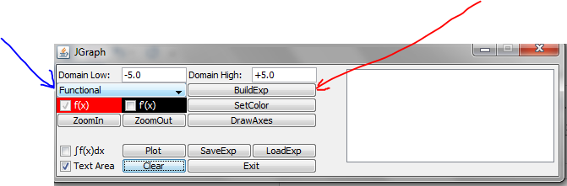

After selecting the function type as explained above, a user should click on the button labelled **BuildExp** (*button pointed at by red arrow*) to build expressions through ExpressionBuilder. An expression contains terms – simple or complex.

A **simple** term has a coefficient and an exponent – for e.g. **2*x*2**. In the above case the coefficient is 2 and the exponent is 2. Let’s build this as shown in case1.

ExpressionBuilder (case 1):

Let’s use **ExpressionBuilder** to build an expression that has a simple term 2*x*2. Click the ‘**BuildExp’** button in the Fig 1. This will open up a new UI (shown below)

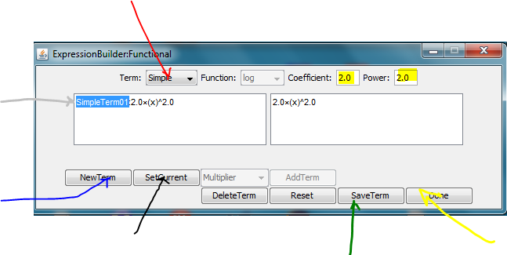

Select ‘**Simple’** from the drop down list (*red arrow*). Edit the ‘**Coefficient’** and the ‘**Power’** to values shown above. Click the button labelled ‘**NewTerm’** (*blue arrow*). The new expression 2*x*2 now appears in the left text area. Now select SimpleTerm01 (*by double clicking on it*) in the left text area (*grey arrow*). Click on the button labelled ‘**SetCurrent’** (*black arrow*). The expression is copied in the right text area. Click on button labelled ‘**SaveTerm’** (*green arrow*) followed by clicking on the button labelled ‘**Done’** (*yellow arrow*). The ExpressionBuilder window closes. The saved expression appears in the main console application (*as shown below*).

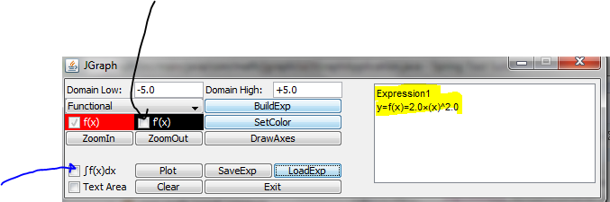

Click on button labelled ‘**Plot**’ to plot the function on a Cartesian plane frame. Optionally select the checkbox labelled **f’(x)** (*black arrow*) to plot the first derivative of the function. Optionally select the checkbox labelled **ʃf(x)dx** (*blue arrow*)to calculate and paint the area bounded by the function and the x-axis. See the results on the Cartesian plane below.

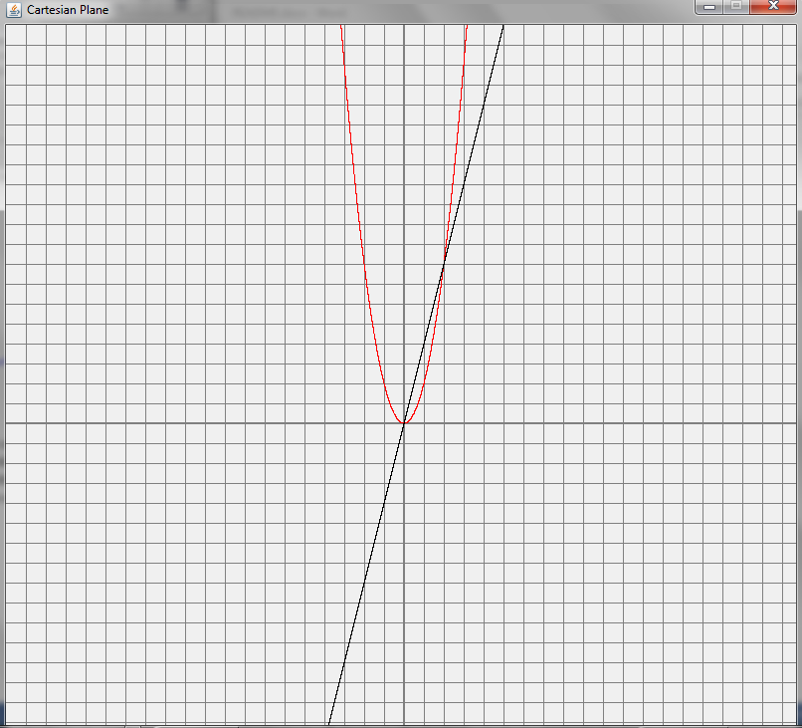

The function 2x2 is plotted in red; its derivative *d/dx(2x2)* is plotted in black. A little intuition shows that by selecting a negative coefficient (in Fig 1 ) the parabola would appear inverted. Selecting 0 for power (in Fig 1) would plot a line parallel to x-axis.

A complex expression could be one of the 3 trigonometric functions (*sin, cos or tan*), the hyperbolic trigonometric functions (*sinh, cosh or tanh*), the inverse trigonometric functions (*arcsin, arccos or arctan*), log10 function (*base 10*), lne function (*base e*), power function (*xx*), square-root, cube-root, ex or ex-1 or a combination of all of the above to make something like shown below (*functional form*):

cos(sin(*x*)) + *x*ln(*x*) + 5*x*

Let’s build this complex expression as shown in case2.

ExpressionBuilder (case 2):

Let’s build a complex expression cos(sin(*x*)) + *x*ln(*x*) + 5*x*. Select **Functional** in Fig 1.

Build the following individual expressions (simple and complex) using the ExpressionBuilder interface. The order in which they are built does not matter.

Table

|  |  |  |  |  |
| --- | --- | --- | --- | --- |
| **Term** | **Coefficient** | **Power** | **Function** | **Result** |
| Simple | 1.0 | 1.0 | --- | x |
| Simple | 5.0 | **0.0** | --- | 5 |
| Complex | 1.0 | 1.0 | cos | cos(x) |
| Complex | 1.0 | 1.0 | sin | sin(x) |
| Complex | 1.0 | 1.0 | ln | ln(x) |
| Complex | 1.0 | 1.0 | x^x | xx |

For each item select either ‘**Simple’** or ‘**Complex’** as the table shows and click on the button labelled ‘**NewTerm’**

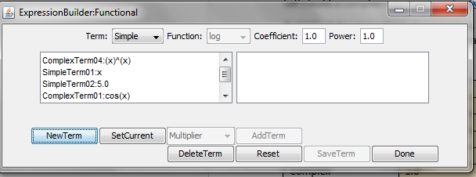

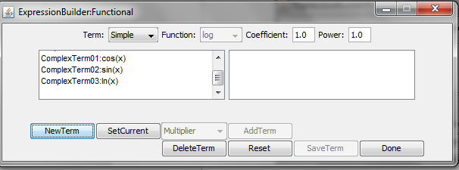

The question is how do we construct **cos(sin(x))** from individual cos(x) and sin(x) functions and similarly 5x from x^x and 5 here.

Select ComplexTerm01 (*by double clicking on it*) in the left text area. Next, click on ‘**SetCurrent’**. This action copies cos(x) in the right text area.

*Note: Depending on the order in which one creates these (simple and complex) terms your complex term cos(x) could have a different position number (in this case it is ComplexTerm****01****)*.

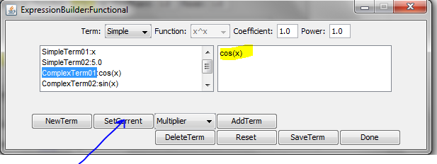

Then select ComplexTerm02 (*by double clicking on it*) in the left area. Select ‘**Argument’** from the drop down list (*blue arrow*). Click on button labelled ‘**AddTerm’** to change cos(s) into cos(sin(x); refer to the right and left text areas. Click on ‘**SaveTerm**’.

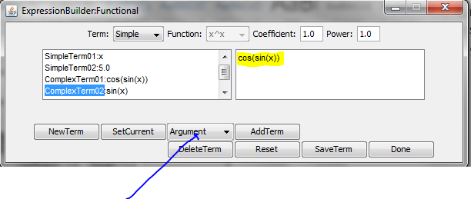

Now select ComplexTerm03 (*by double clicking on it*), click in ‘**SetCurrent**’ to copy it into right text area.

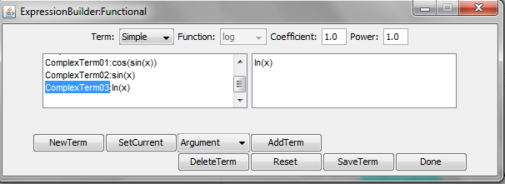

Select SimpleTerm01 (*by double clicking on it*) and select ‘**Multiplier’** from the drop down list (*blue arrow*). Click on ‘**AddTerm’** to change ln(x) into xln(x) (*refer to right and left text areas*). Click on ‘**SaveTerm**’.

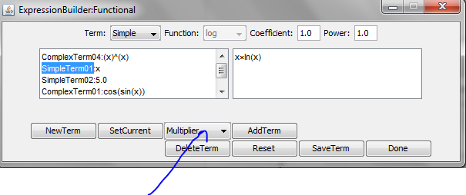

At this point your expression generated so far is cos(sin(x)) + *x*ln(x). We still need the term 5x.

Last step is to create 5x out of x^x and 5. Select ComlexTerm04 (*by double clicking on it*), click on ‘**SetCurrent’**. This should copy x^x (*x raised to x i.e. xx*) to right text area.

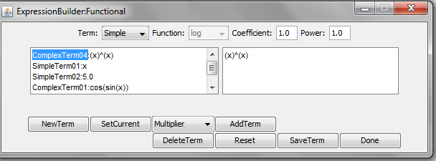

Select SimpleTerm02 (*by double clicking on it*) and select ‘**Argument’** from the drop down list (*blue arrow*). Click on ‘**AddTerm’** to change x^x into 5^x (*refer to right and left text areas*). Click on ‘**SaveTerm**’.

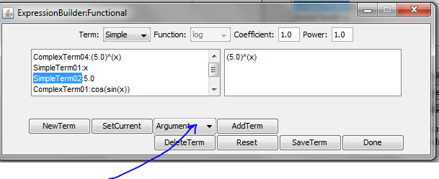

Click on the button labelled ‘**Done’** to close the ExpressionBuilder UI. The control is returned back to the main application console frame. It shows the recently built expression in the text area (*as shown*). 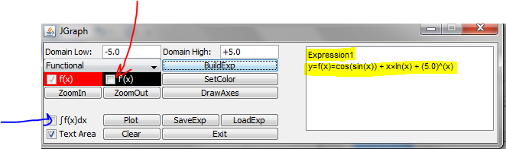

Click on Plot to plot function. Optionally you could check the checkbox labelled f’(x) (*see red arrow*) for plotting the first derivative of the function and the checkbox labelled **ʃf(x)dx** (*blue arrow*)to calculate and paint the area bounded by the function and the x-axis. Click on Plot to see the results on the Cartesian plane (*see below*).

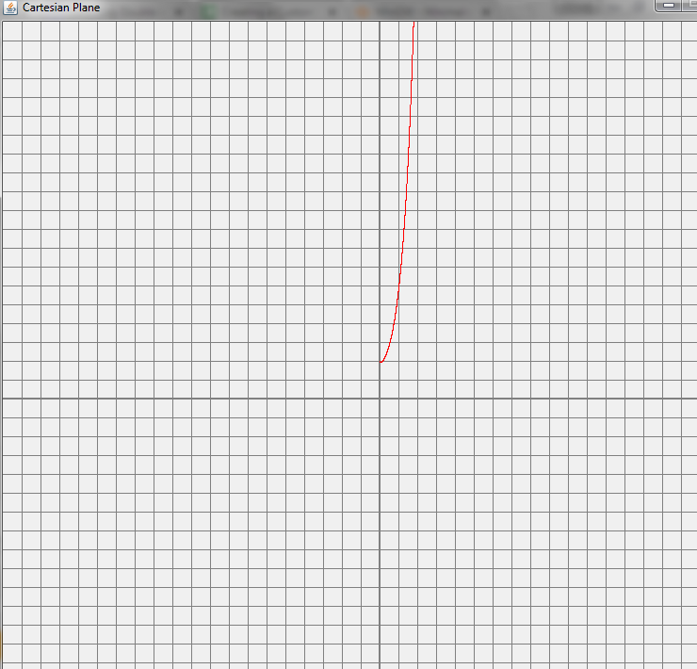

How to:

How do you build an expression that plots parallel to y-axis? In short how do build an expression to reflect x = k (where can k is a real number positive or negative).

The trick is to use the parametric form

x = 1.0 (*or any real number*)

y = any simple or complex expression

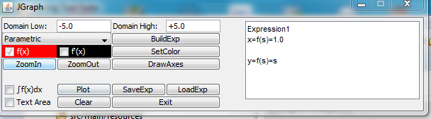

Additional Features:

* You could select custom colors for your f(x) and f`(x). Refer to **‘SetColor’** button in Fig 1.
* You could save an expression and load it later (even after application restart). Refer to ‘**LoadExp’** and ‘**SaveExp’** buttons in Fig 1.
* You could zoom in and zoom out on the Cartesian plane. Refer to ‘**ZoomIn’** and ‘**ZoomOut’** buttons in Fig 1.