AI Based Road Safety and Accident Prediction
AI-Based Road Safety and Accident Prediction System that helps in predicting the possibility of road accidents using machine learning techniques. The system analyzes different factors such as weather conditions, road type, visibility, vehicle type, speed, alcohol involvement, mobile usage, and traffic-related parameters. Based on these inputs, the system predicts whether an accident may occur and also indicates the road condition status as good or risky. This helps users understand potential dangers and take preventive measures to improve road safety.
In the existing system, road safety decisions are mostly based on manual observation and basic traffic rules. Drivers depend on experience, road signs, and weather reports, but these methods do not analyze multiple factors together. There is no intelligent prediction system to estimate accident probability before it happens. Because of this, accidents may occur even on good roads due to human errors, over speeding, poor visibility, or environmental conditions. The existing approach lacks automation, data-driven analysis, and early warning mechanisms to reduce accident risks.
The proposed system introduces a machine learning-based solution that predicts accident chances using trained models such as Random Forest and Decision Tree algorithms. The admin uploads and preprocesses the dataset, and the system trains the model using historical accident data. Users enter speed and select conditions like weather, road condition, and vehicle type, and the system predicts whether an accident is likely to occur. The system also displays road condition status and stores prediction history for both users and admin monitoring. This AI-based approach improves accuracy, provides early warnings, and helps in making better road safety decisions.

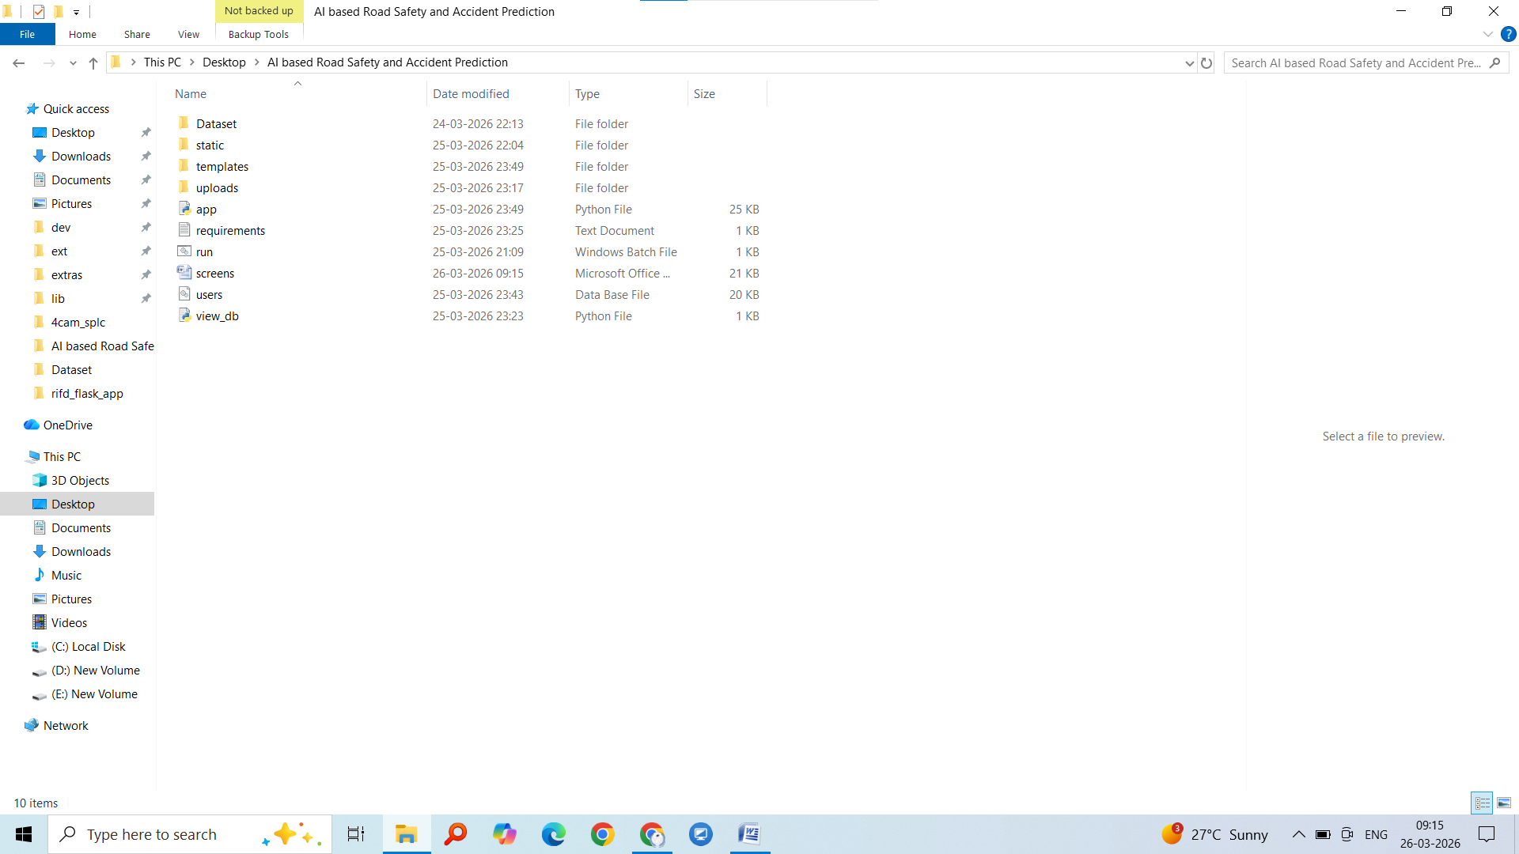
Click on run.bat to run the project
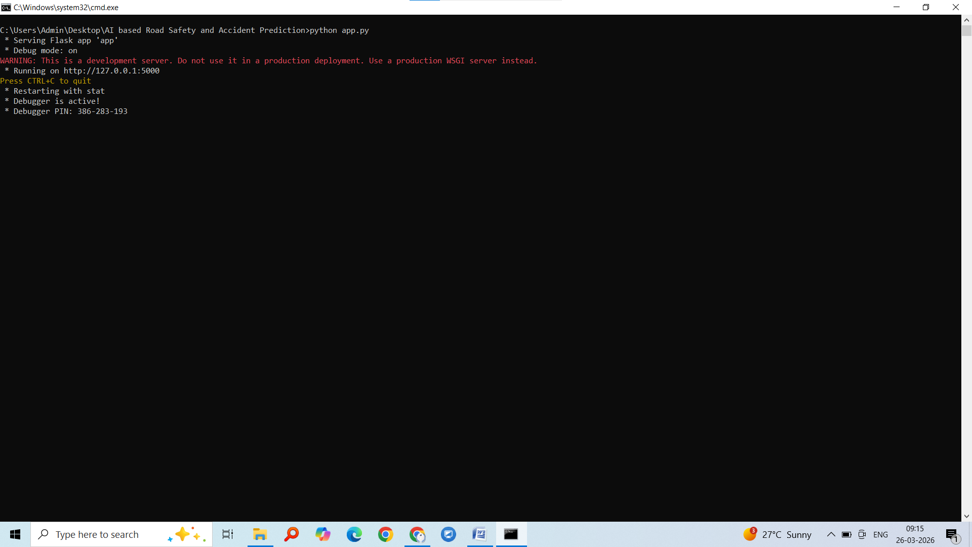
Copy url http://127.0.0.1:5000 and paste on browser


Click on admin login username ‘admin’ password ‘admin’
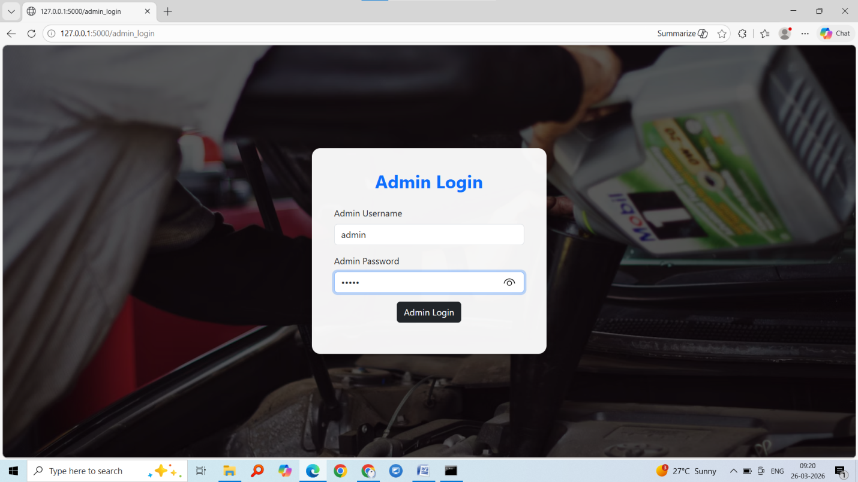
Enter username and password then click on admin login
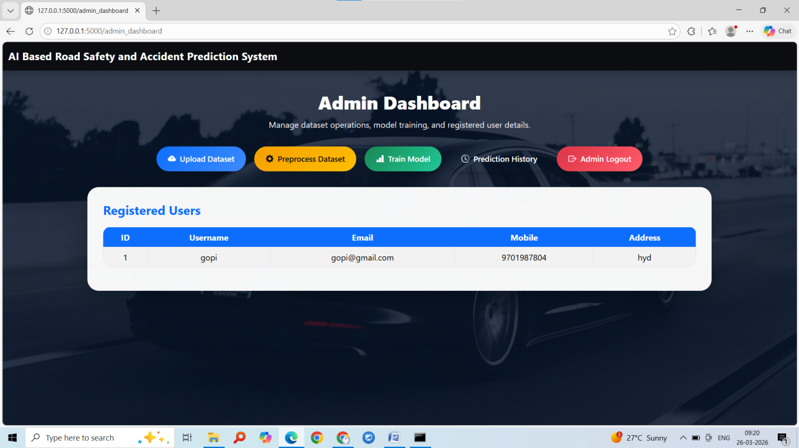
Admin dashboard click on upload dataset
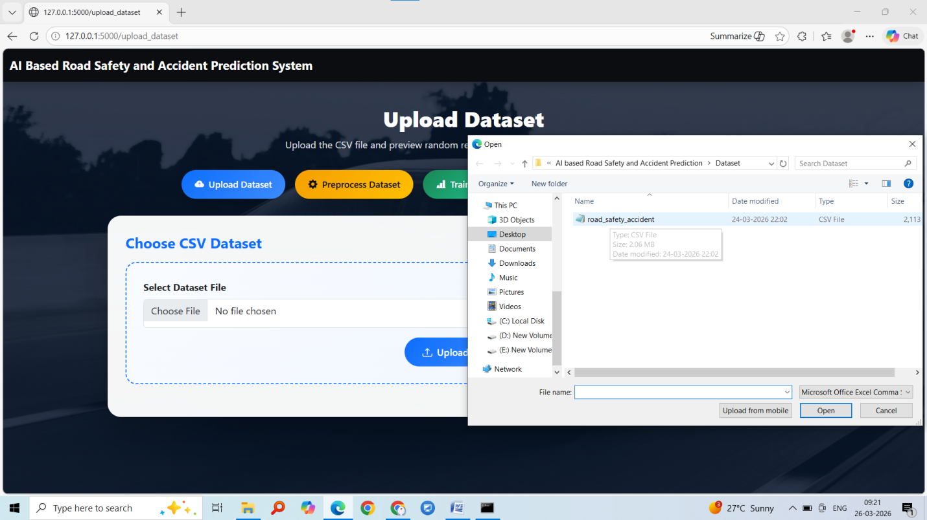
Upload dataset and check sample records in dataset
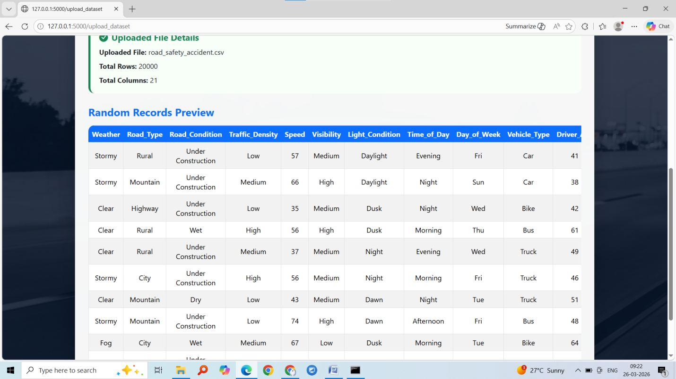
Click on next module
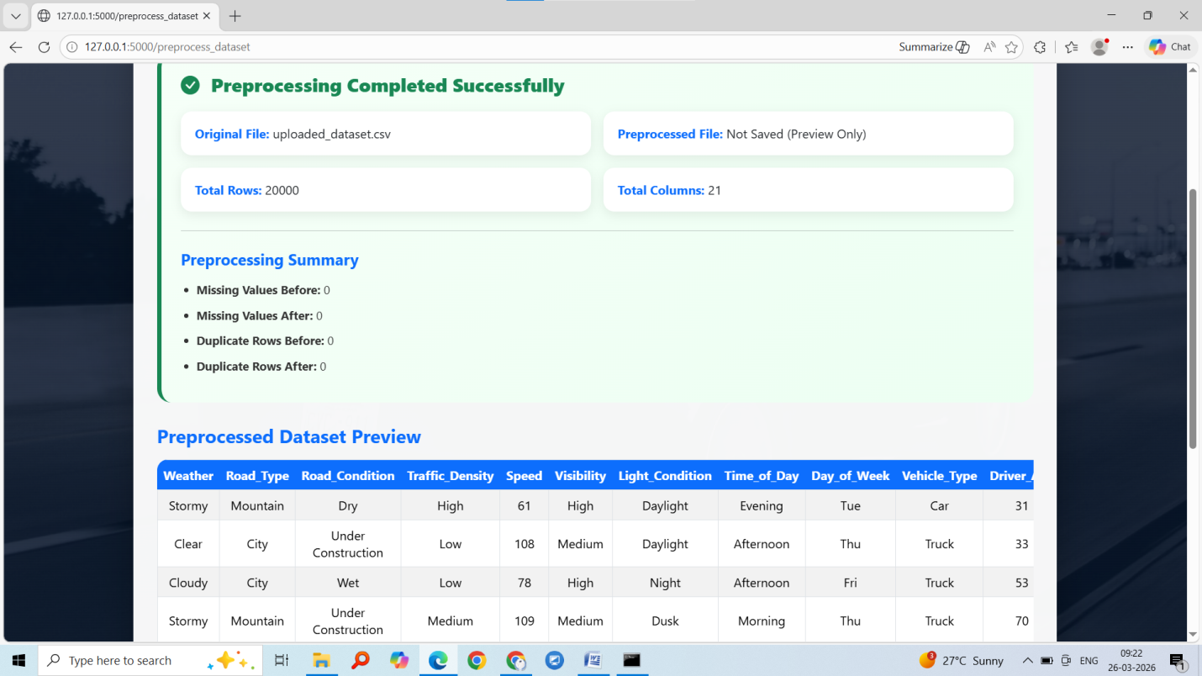
Click on next module
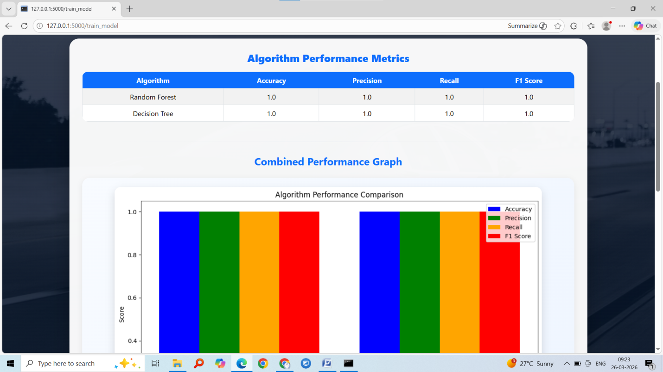
The table displays four evaluation metrics: Accuracy, Precision, Recall, and F1 Score for both Random Forest and Decision Tree algorithms. In the result, both algorithms achieved a value of 1.0 for all metrics. This means the models predicted the accident data perfectly on the given dataset. Accuracy indicates the overall correctness of predictions, Precision shows how many predicted accidents were actually correct, Recall indicates how well the model identified actual accident cases, and F1 Score is the balanced measure of Precision and Recall.
The combined performance graph visually compares these metrics for both algorithms. Each color bar represents one metric such as accuracy, precision, recall, and F1 score. Since all values are equal to 1.0, the bars appear at the same height, showing both algorithms performed equally well. Based on this result, either algorithm can be used for prediction, but Random Forest is generally preferred because it is more stable and handles real-world data better.
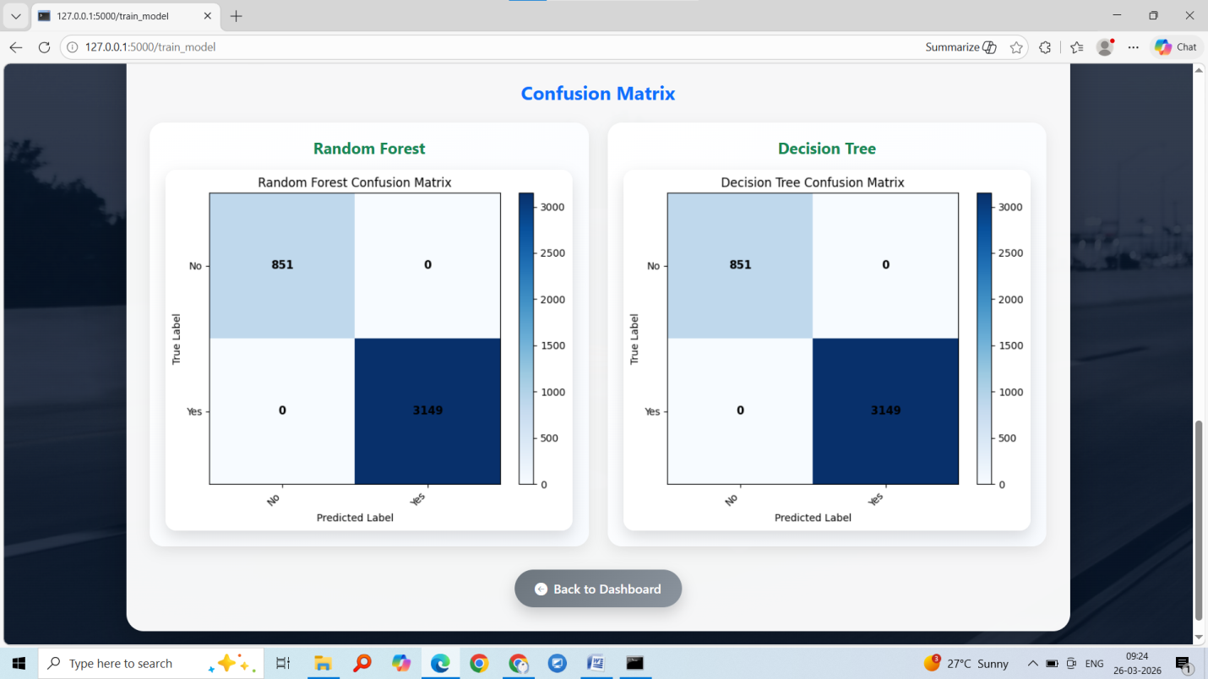
The confusion matrix shows the performance of the Random Forest and Decision Tree models in predicting road accidents. The rows represent the actual values (No accident, Yes accident) and the columns represent the predicted values. In both models, 851 “No accident” cases were correctly predicted as No, and 3149 “Accident” cases were correctly predicted as Yes, while there are 0 incorrect predictions in the off-diagonal cells. This means the models did not make any false predictions, indicating perfect classification performance on the dataset. Therefore, both Random Forest and Decision Tree algorithms correctly identified all accident and non-accident cases, resulting in very high accuracy and reliable prediction capability.

Click on logout and register as user
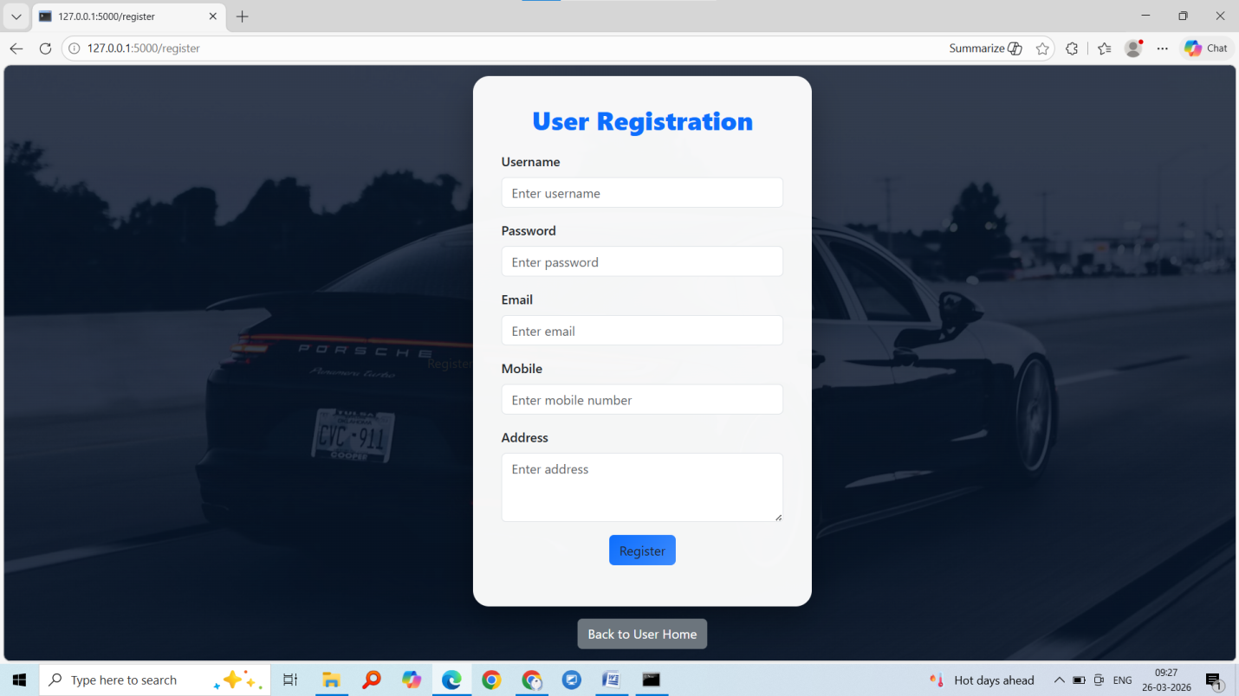
After registration complete click on user login
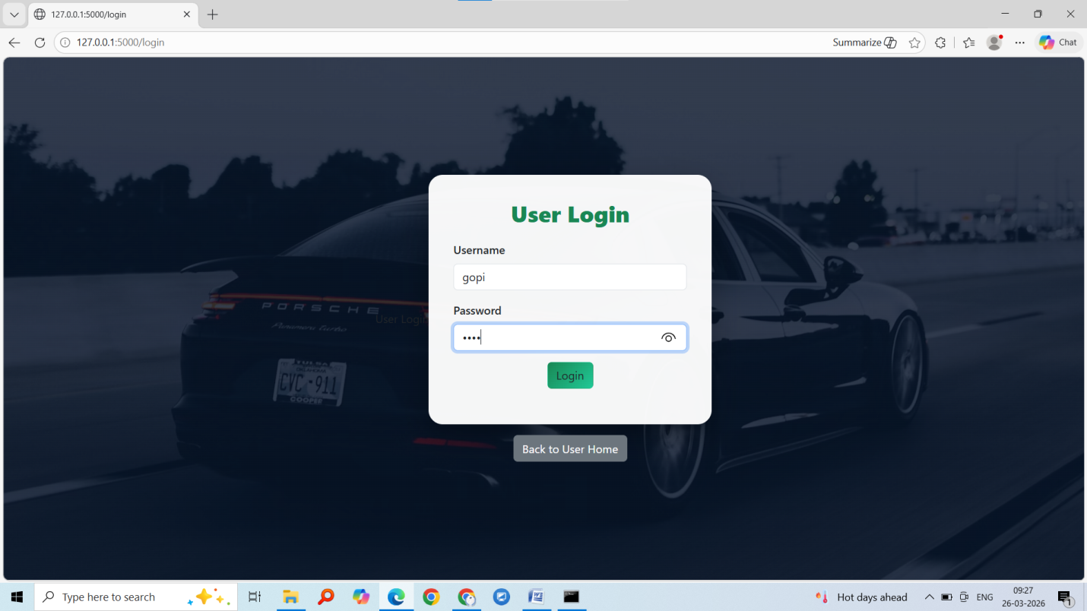
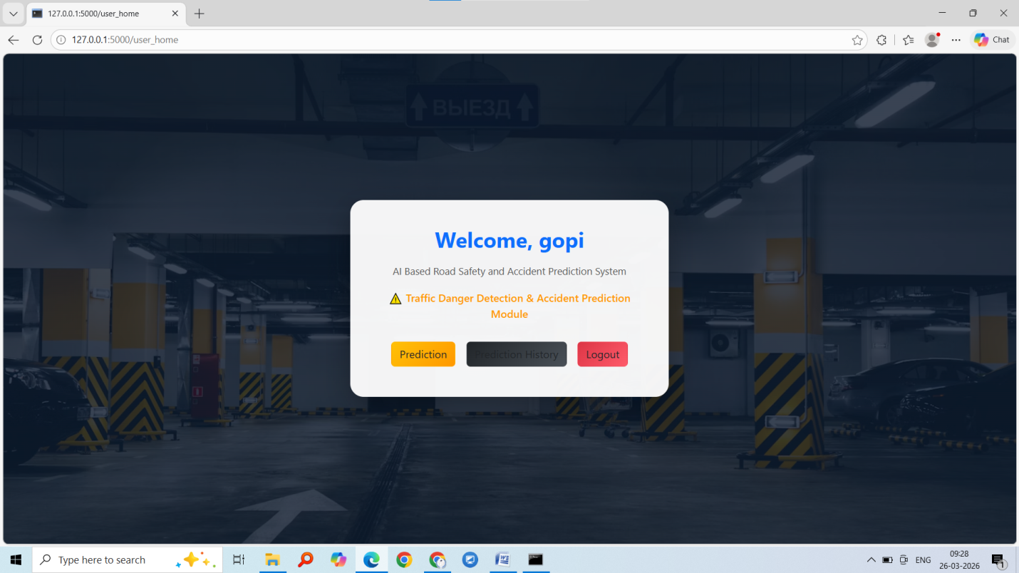
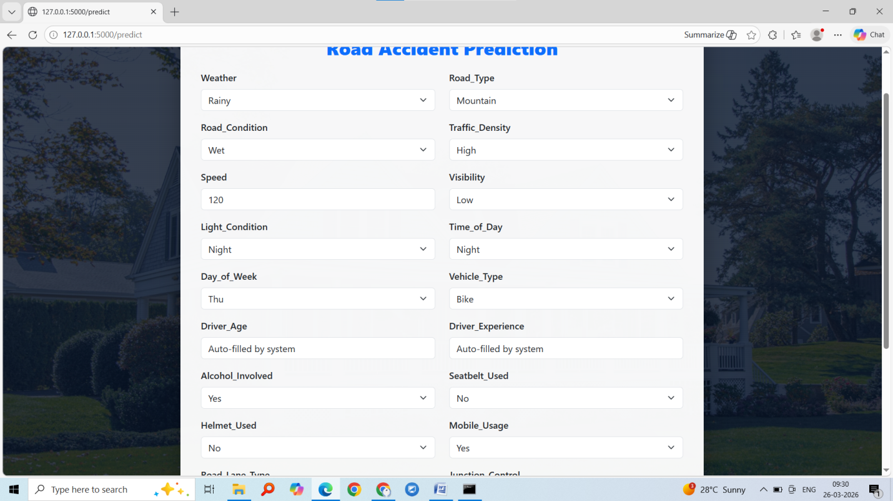
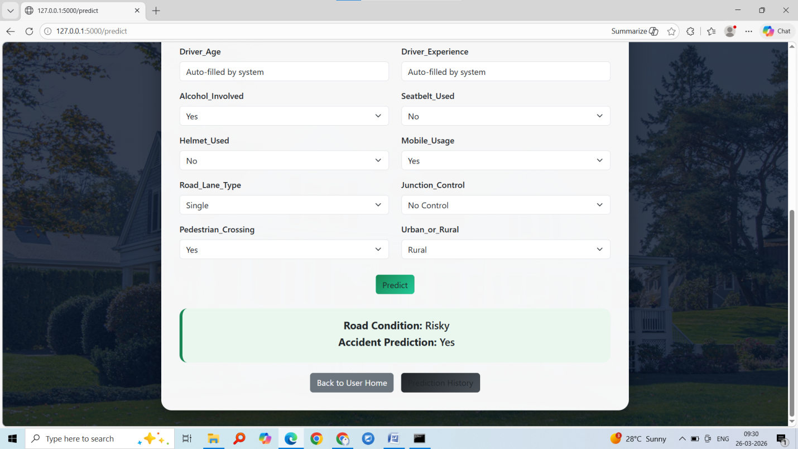
Click on prediction history
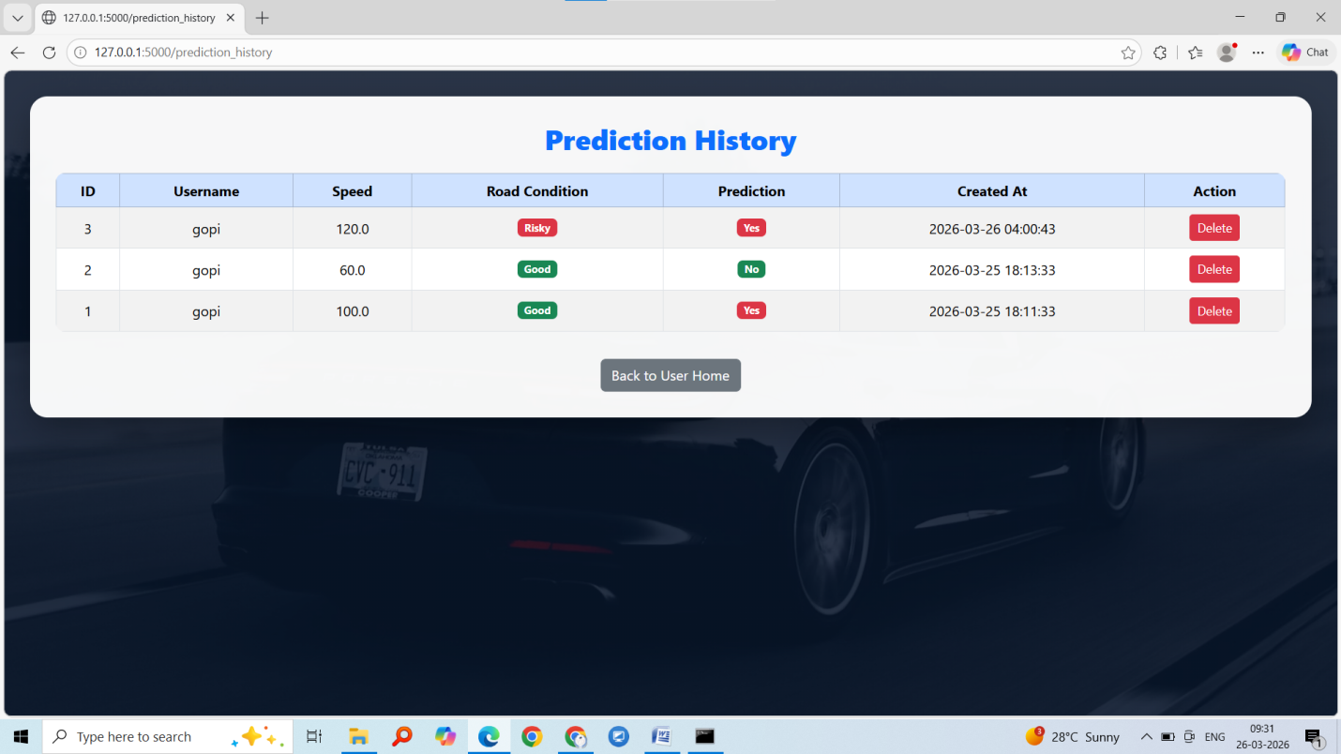
User side prediction history clicks on logout and login as admin and check admin prediction history

