# HW#2: Design a Digital Stopwatch with Start/ Stop and Reset Functions

## Manoj Gulati (Ph.D.1327)

## Course: Smart Electronics System Design Paradigm

## Instructor: Mr. Kishore Narang

**AIM:** Goal of this design project is have a thorough understanding of design principles and make note of facts which have to be taken care of while designing electronic systems.

**Block wise description:**

1. **Clock Generating Block (NE555 Timer)**

NE-555 is driven in astable multivibrator mode governed by design equations as stated below. This block is used to generate 1Hz clock to drive out stop watch circuit. The clock fed in to first counter circuit is provided through an AND gate controlled a switch to START and STOP the stop watch. A T-Flip Flop is used to toggle polarity of this switch which controls the CLOCK feeding. This whole step of including T-FF is to avoid any glitches in the switching action.

Circuit Diagram for NE-555 Timer IC in astable mode is shown below.





Figure: IC NE555 in astable mode.

1. **Counter circuit IC4026**

This block consists of six decade counters used with a purpose of doing the counting action in HH:MM:SS having 24 hourly display pattern. This also consists of IC4082 quad input AND gate to do the counter reset based on sequence match e.g. resetting seconds counter after 59 and hours counter after 24. The first counter in this block is driven by 1Hz clock from NE555 timer IC. This block is also having a common RESET function in order to reset all the counters with a same push button. This function is implemented by feeding overflow reset and RESET through a dual input OR gate in to Pin No. 15 of all the counters.

The labelled Pin diagram of CD4026 is shown below.

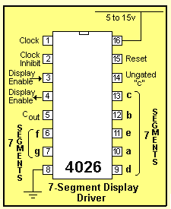

1. **7 Segment Modules**

Six 7-segment modules are used to display stop watch action in HH:MM:SS format. Having 7 control signals for 7 LEDs and all the LEDs are connected with 100 ohm series resistor to limit the current being fed in to these LED segments.

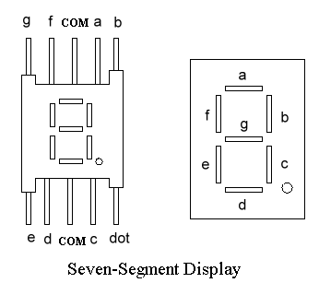

1. **Schmitt Trigger Based RESET Function**

In order to avoid any glitches in the reset action and to provide hardware de-bouncing. This circuit actually takes an input signal and maintains the output for a certain time period and then goes back to low state.

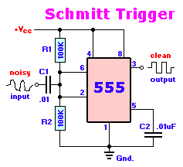

1. **Power Supply**

Power supply to all pins and also un-invoked pins is fed through standard signal inputs which are mounted using a standard BERG connector to +5V and GND.

1. **ICs**

* IC CD4026: Decade Counter IC is used for counter action. Another important fact is that it also contains inbuilt BCD to 7-segment driver for controlling 7-segment displays.
* IC 7408: This is quad dual-input AND gate IC being used for controlling START/STOP function of this stop watch.
* NE555: This is used for Schmitt trigger as well as for generating clock for counter circuit.
* IC 4027: This is a JK FF being used to implement T-FF for controlling START/STOP switch.
* IC 74HC32N: This IC is a dual-input OR gate IC used to control provide dual reset function to counter ICs. One is through overflow due to counters and second is due to manual resets.
* IC 4092N: This IC is used to do the overflow action whenever a minute counter reaches 59 or hour counter reaches 24 this will make a reset.

**NB: All these ICs are available in local markets.**