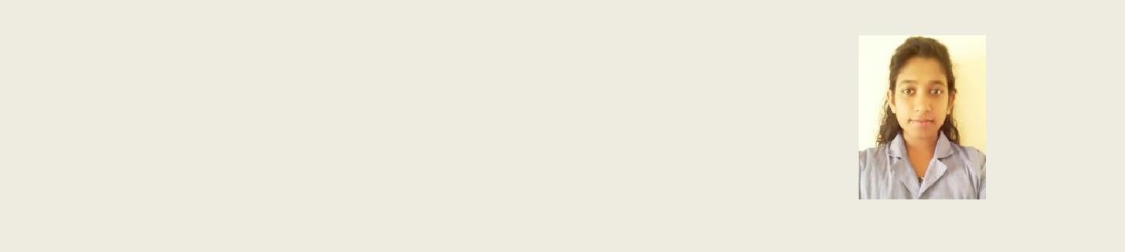
D.M.G Dileesha

‘Welsiri’
Dematapitiya

Walasgala 076-7784594 dileeshadmg@gmail.comX

Profile

My ultimate objective is to serve my work place at my best through the application of my academic knowledge and skills. I am a versatile IT undergraduate, possessing strong motivational
drive to succeed in the industry.

Work Experience

Intern – Quality Assurance - November 2015 – Present
VirtusaPolaris
Colombo – 09

Higher Educational Qualifications

Undergraduate in BSc Special (Hons) in Information Technology at Sri Lanka Institute of Information Technology (2nd year completed)

Projects

Stock and sales management system – Kodithuwakku Tyre Center , Matara (2nd year 2nd semester group project )

o Handling the stock , considering the re-order level o Manage employee and customer details

o Manage sales , transactions accurately o Generate reports on specific areas
o Backup and restore of database

Language : Java
IDE : Netbeans 7.4 , XAMPP server
Database : MySQL
Reports : iReport

❖ Online Taxi rental system (2nd year 1st semester group project)

o Handling vehicle categories o Handling packages
o Forums
o Employee management

Language : Java

IDE : Netbeans7.4
Database : MySQL
Baby Tracking Mobile Application
Hybrid Technology

Professional Qualifications

Successfully completed Diploma Level in Higher Educational Qualification in BCS (British Computer Society)

Skills & Competences

Familiar Technologies

Languages : Java, C#, C++
Database : MySQL, Microsoft Sql

Web : CSS, HTML5, PHP

Tools and utilities : Visual Studio 2010 /2012, SQL server 2008/2012, NetBeansIDE7.4, XAMPP, Aptana Studio
Other : User interface designing, Object Oriented Programming, Design Patterns

Successfully completed the Spoken English Skills Development Programme at the
‘Excellent English School’
Language skills

Reading
Writing
Speaking
Sinhala
Excellent
Good
Excellent
English
Excellent
Fluent
Fluent

Educational Qualifications

I.G.C.S.E (Edexcel) Ordinary Level, Leeds International School,June 2011

Mathematics
:
A*
Physics
:
A*
Human Biology
:
A
Chemistry
:
A
Biology
:
A
Sinhala
:
A
English
:
D
ICT
:
D

G.C.E. (Edexcel) Advanced Level, Leeds International School, 2013

Biology
:
C
Chemistry
:
C
Physics
:
D

Personal Information
Name in Full
: Dore Mure Gamage Dileesha
Name with Initials
:
D.M.G. Dileesha
Residential Address
:
‘Welsiri’, Dematapitiya, Walasgala.
Male or Female
:
Female
Date of Birth
:
24th January, 1997
Age
:
19 years
Nationality
:
Sri Lankan
Religion
:
Buddhism
N.I.C. Number
:
975242196V
Civil Status
:
Unmarried

Non Related Referees

Mr. K.A.P.M.K. Hettiarachchi
Director of Studies,

‘Excellence English School’,
Nakulugmauwa
Tel: 0777 147892/0602427157

Mrs. Madhushani Tilakarathna

Tel: 0723 683683/0112613531

I hereby declare that the above furnished information is true and accurate to the best of my knowledge.

.................................................. ..............................................................

Date D.M.G.Dileesha

