Download the code from GitHub

**Starting the Spring Boot Application:**

First compile the spring-boot-login project, using command prompt. Using **mvn clean install**



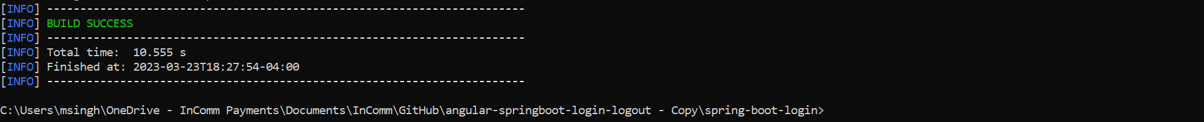

Once the build is successful, now you can import the project in eclipse if you want. Otherwise, it is not required. In case if you want to make any changes and test, it will be helpful.

Open Eclipse. Click File-> Import -> Select Existing Maven Projects -> Then click Next .

Now specify the location of project and then click finish.

Now let’s start the spring boot service. Right click on the LiftRankingApplication.java -> Run As -> Java Application.

The spring boot application is now and running on port 8080.

**Starting the Angular Front End in Visual Studio:**

Open the visual studio editor. Click on Open a local folder.

In the terminal window enter the command **npm install**. If npm install doesn’t work then give **npm install –force**.

With this command , the node package manager will download all the required dependencies.

Now let’s try running the application using **npm start**.

This shows the application front end application is up and running.

Open the browser with **localhost:4200**

