Flow :-  
Step 1:-  
Controller  
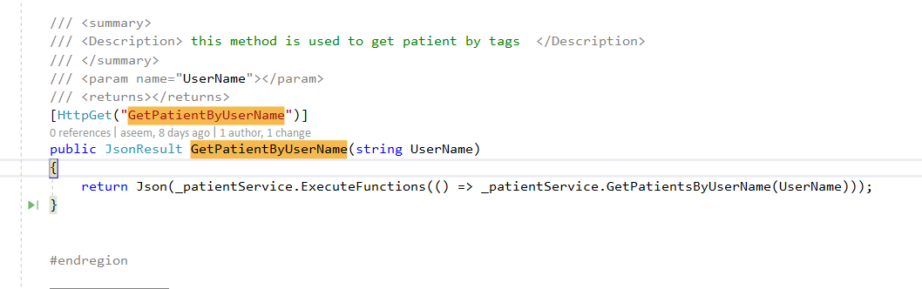

Step 2:-  
Patient Service (Get Patient by user Name Actually we get Phone Number)

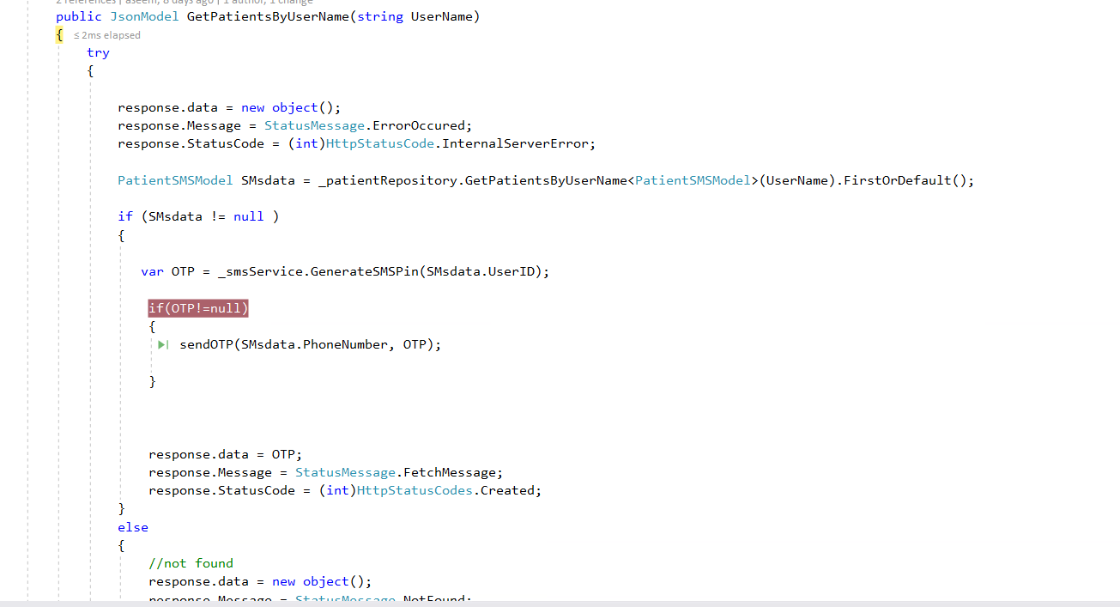

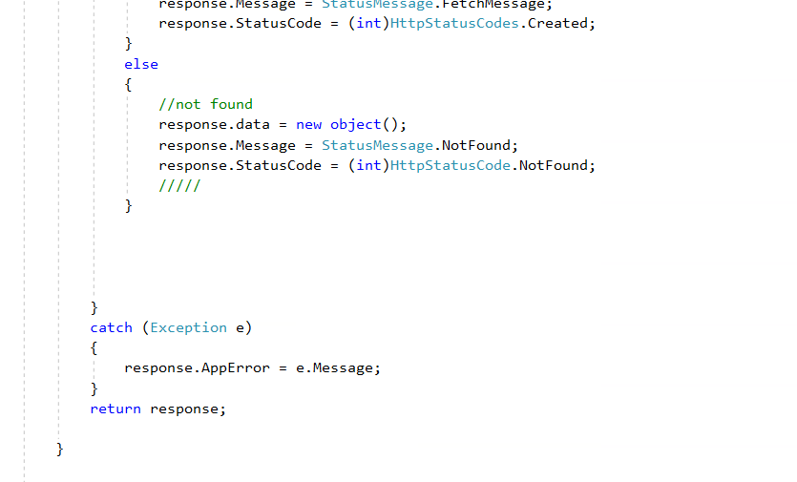

Repo   
(Get Patient Detail with Register Phone-Number )

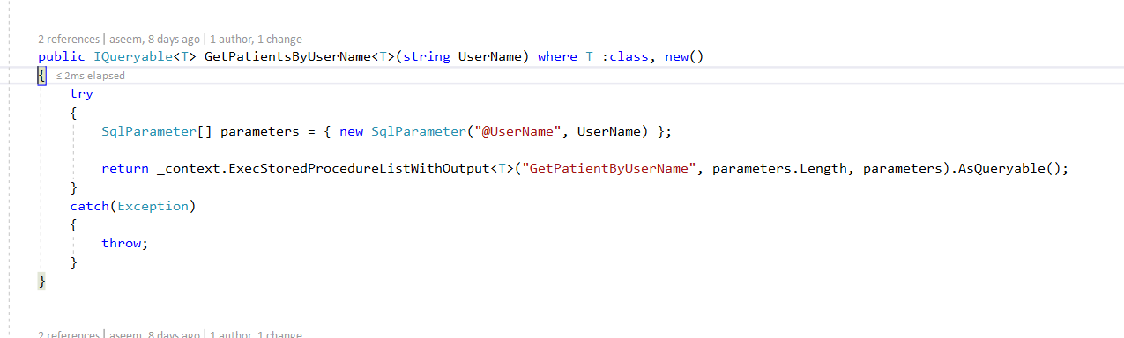

SMS Service

For Generating the OTP.

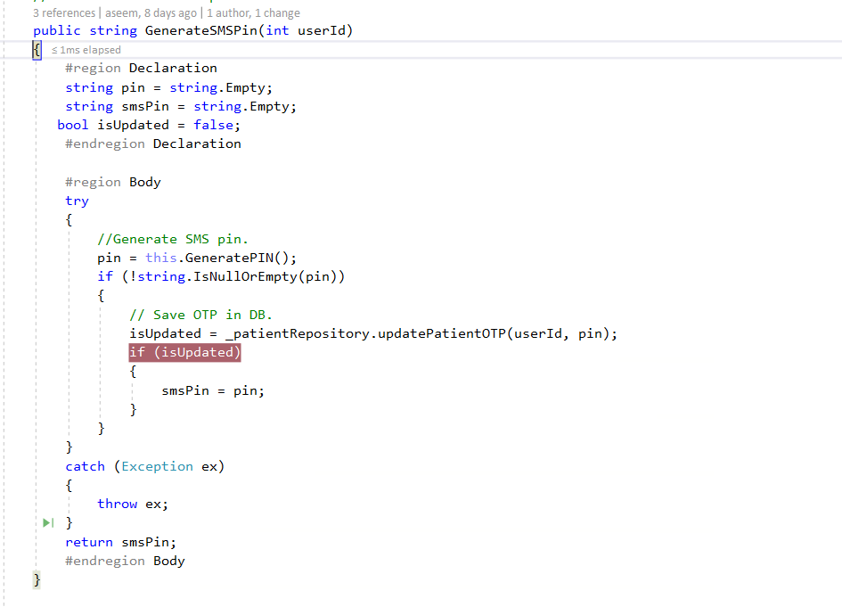

Repo  
After Generate OTP We update into db.

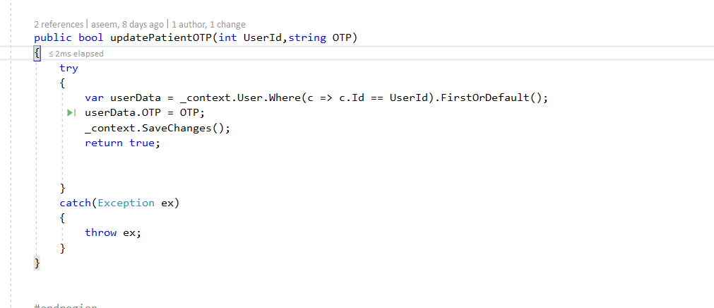

Again come to Patient Service and call send OTP Method.

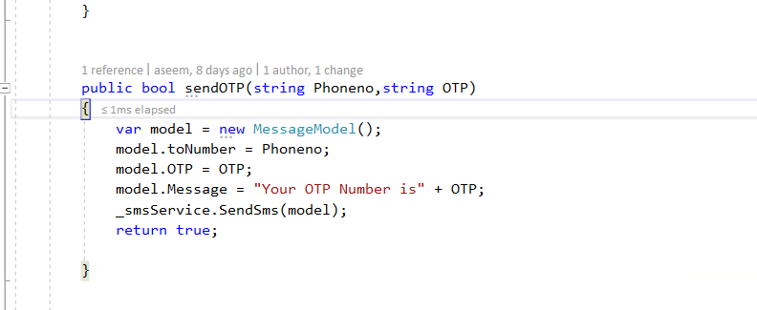

SMS Service   
Here We have to fetch key and send SMS.

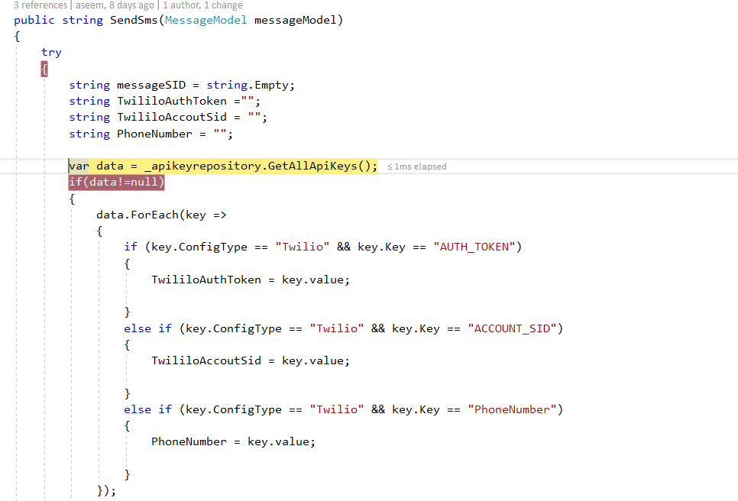

Repo   
Fetching Key

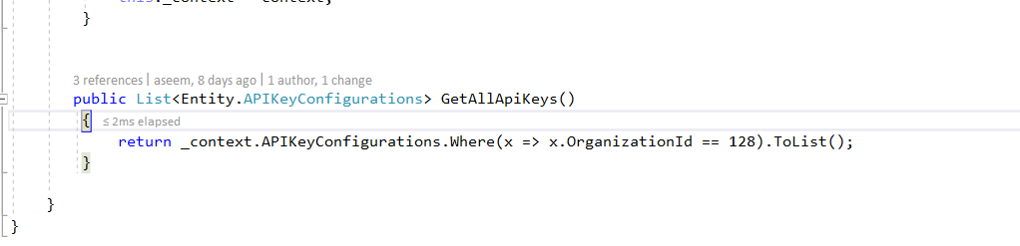

SMS Service   
All Method for send SMS

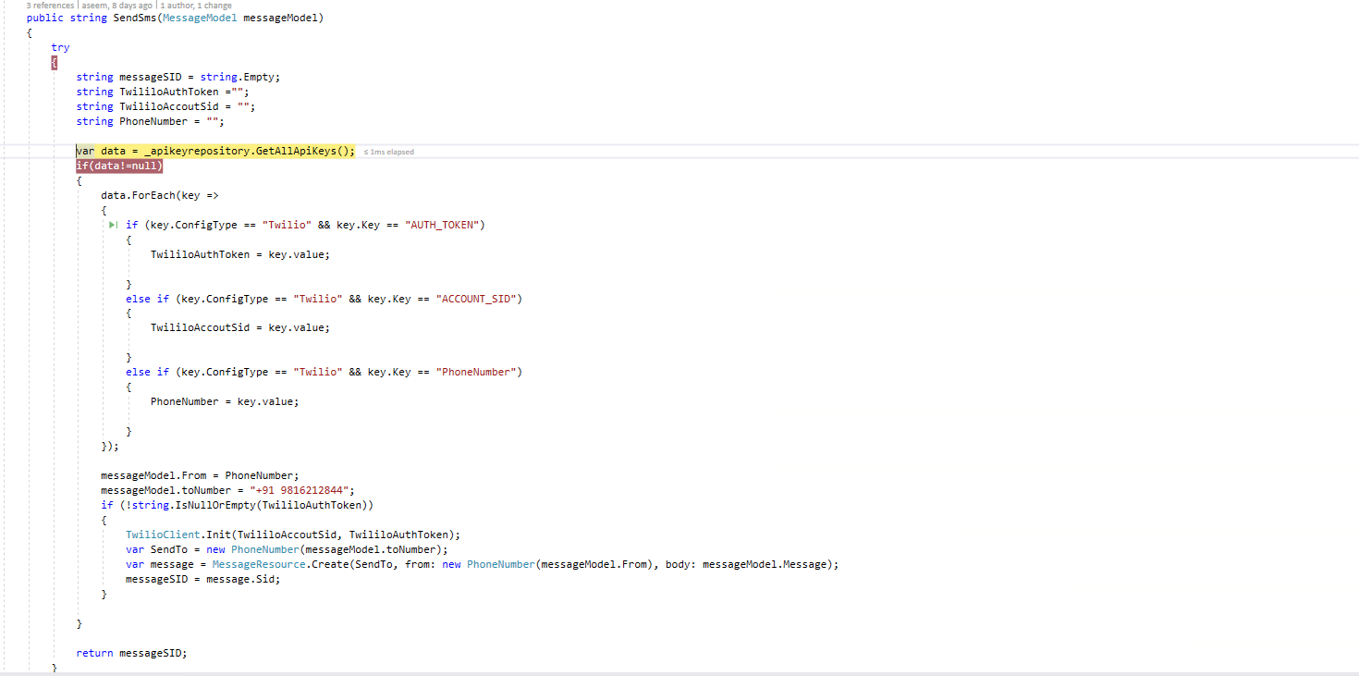

SMS Received in Mobile

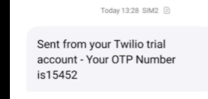

Data Table Of Key Store  
