

Professional Certificate of Competency in Electrical Power System Fundamentals for Non-electrical Engineers (CEN)

Student full name: | Manoj Kalra
I certify that the attached assessment is my own work and that any material drawn from other sources has been acknowledged.
Copyright in assessments remains my property, however I grant permission to the Engineering Institute of Technology (EIT) to make copies of assessments for assessment, review and/or record keeping purposes.
I note that the EIT reserves the right to check my assessment for plagiarism.
Should the reproduction of all or part of an assessment be required by the EIT for any purpose other than those mentioned above, appropriate authorisation will be sought from me on the relevant form.
Please place a tick () in the box below to indicate that you have read, understood, and certify the above statement.
Please include this page in/with your submission.
Any electronic responses to this submission will be sent to your Moodle account.
AGREEMENT DATE: 25 Sep 2024
Marks (%) |  |  | Satisfactory / Not Satisfactory
Assessor: |  |  | Date:
Overall feedback: |  | Please see feedback next to the respective answers

Guidelines for Students
How is this assessed?
After completion of this assessment, you will be given a result of ‘Satisfactory’ or ‘Not Satisfactory’. The assessor will give you feedback via Moodle and you will have an opportunity to submit additional evidence, if you have received a ‘Not Satisfactory’ result.
You will be allowed one (1) opportunity to resubmit the same assessment task, if required.
For a ‘Satisfactory’ result in this assessment, all questions must be answered to a satisfactory standard and you must achieve an overall mark of 60% or above.
Once all assessment tasks for have been completed, you will be given a final result of ‘Competent’ or ‘Not Yet Competent’. If you are deemed ‘Not Yet Competent’ in a course after all resubmission attempts, you will be required to re-sit the course.

How is this assessment task assessed?
For a result of ‘Satisfactory’ in this assessment task, all assessment criteria (as indicated on page 4) must be completed to a satisfactory standard.
Where a critical question is identified, you must receive a mark of 100% for these questions before a ‘satisfactory’ result can be awarded, regardless of the overall mark achieved.
At Certificate level, a ‘satisfactory’ standard, as stipulated by the Australian Qualifications Framework, means that you will demonstrate the application of knowledge and skills:
- with depth in areas of specialisation, in contexts subject to change
- with initiative and judgment in planning, design, technical or management functions with some direction
- to adapt a range of fundamental principles and complex techniques to known and unknown situations
- across a broad range of technical or management functions with accountability for personal outputs
- personal and team outcomes within broad parameters
Assessors also make decisions based on the following considerations:
- all parts of this assessment have been completed to a standard that satisfactorily meets the requirements set out in the assessment criteria (as per the course outline).
- the assessment evidence provided is the student’s own work, except as appropriately acknowledged by the use of referencing.
- the evidence is recent and the student’s knowledge is up-to-date

Assessment Instructions:
- You must answer ALL questions.
- Please ensure you complete your answers in a blue font (not red or black).
- The best marks can be earned by giving concise, brief answers that address the questions.
- You must reference all content used from other sources including course materials, slides, diagrams, etc. Do not directly copy and paste from course materials or any other resources.
Refer to the referencing section of the EIT eLibrary on Moodle for referencing guides.
- Use this document for completing your answers by typing the answers after each question without deleting the question. Make sure that you preserve the original question number format.
- Do not add extra pictures, etc. as annexures; instead, paste them directly into this answer sheet. Hand-drawn sketches can be inserted after scanning but please ensure that the file size does not become big (more than 10 MB). You must refer to all diagrams and pictures, etc. that you have drawn or pasted in.
- When saving your document (must be Word format), ensure you include your name in the title: COURSECODE_ASSESSMENTTYPE_VERSION#_YOURNAME
E.g. CEN_M1-5_Assessment1_v1_JohnSmith
Modules: | 1-5
Assessment type: | Assessment 1
Version: | 1
Total marks: | 50 marks

Learning outcomes covered in this assessment:
Module 1: Basic Concepts
Module 2: Electrical Generation, Transmission and Distribution
Module 3: Electrical Distribution
Module 4: Electrical Measurements and Instrument Transformers for Switchgear
Module 5: Earthing and lightning protection
Part 1: Short-answer Questions (36 marks)
Q1 | - Define Ohm’s law.  - Write its equation. | (2 marks)
A1 | Student answer:  - The current flowing between 2 pins of a conductor is directly proportional to the voltage across those 2 points.  - I ∝ V; I = V/R
F1 | Assessor feedback
Q2 | List any two advantages of three phase systems over single-phase systems | (2 marks)
A2 | Student answer:  - For a given form factor, a three-phase system gives more power output compared to single phase system.  - Three phase systems have better efficiency compared to single phase systems.
F2 | Assessor feedback
Q3 | Fill in the blanks.  Losses are ____ in High Voltage Transmission compared to Medium Voltage Distribution (more/less) | (2 marks)
A3 | Student answer:  Losses are ___Less_ in High Voltage Transmission compared to Medium Voltage live under fault conditions.
F3 | Assessor feedback
Q4 | List any two considerations that determine the optimal site location for a power station | (2 marks)
A4 | Student answer:  - Power station should be near to energy resource.  - Power station should be close to the power infrastructure so that power feeding to grid is easy.
F4 | Assessor feedback
Q5 | Identify four renewable energy technologies | (2 marks)
A5 | Student answer:  - Wind Energy  - Solar Energy  - Biomass Energy  - Water Energy
F5 | Assessor feedback
Q6 | List any two benefits of HVDC transmission over HV AC Transmission | (2 marks)
A6 | Student answer:  - HVDC transmission is more efficient than HVAC.  - HVDC transmission is better for long distance transmission , compared to HVAC.
F6 | Assessor feedback
Q7 | True or False?  A radial power distribution provides reliable power supply to urban/city-based customers. | (2 marks)
A7 | Student answer: False
F7 | Assessor feedback
Q8 | List any two functions of substations | (2 marks)
A8 | Student answer:  - Substation provides Step up or Step-down facility using the transformers.  - Substation switch transmission and distribution into and out of the grid system using switchgears.
F8 | Assessor feedback
Q9 | List the two mounting arrangements for distribution transformers used to supply residential customers | (2 marks)
A9 | Student answer:  - Pole mount  - Padmount
F9 | Assessor feedback
Q10 | State any two advantages of indoor metal enclosed switchgear | (2 marks)
A10 | Student answer:  - Indoor metal enclosed switchgear are protected against weather and dust.  - Indoor metal enclosed switchgear are protected against direct lightening hit.  - Need less maintenance.
F10 | Assessor feedback
Q11 | Fill in the blanks:  - An ammeter has a ____ internal resistance. (low/high)  - A voltmeter has a ____ internal resistance. (low/high) | (2 marks)
A11 | Student answer:  - An ammeter has a LOW internal resistance. (low/high)  - A voltmeter has a High internal resistance. (low/high)
F13 | Assessor feedback
Q12 | List any two benefits of smart meters | (2 marks)
A12 | Student answer:  - They provide two way communication method to read the meter consumption remotely, and control the meter features remotely.  - Provide the facility to the residential customers to use the TOU tariff, so that different rates can be applied for the particular duration of the day, each day , for the consumption of energy during that specific duration.
F12 | Assessor feedback
Q13 | True or False?  A direct contact shock is touching an exposed conductive part that has become live under fault conditions. | (2 marks)
A13 | Student answer:  False
F13 | Assessor feedback
Q14 | What is the main reason for earthing the transformer neutral with resistance? | (2 marks)
A14 | Student answer:  By earthing the transformer neutral with resistance, we can limit the magnitude of earthing current.
F14 | Assessor feedback
Q15 | What is the main contributing factor for the overall earth resistance value? | (2 marks)
A15 | Student answer:  Soil is the main contributing factor for the overall earth resistance value.
F15 | Assessor feedback
Q16 | Fill in the blanks.  Soil resistivity measured when the soil is moist will give a _____ resistivity reading compared to the measurement when soil is dry. (higher/lower) | (2 marks)
A16 | Student answer:  Soil resistivity measured when the soil is moist will give a LESS resistivity reading compared to the measurement when soil is dry. (higher/lower)
F16 | Assessor feedback
Q17 | What is the function of a Metal Oxide Varistor? | (2 marks)
A17 | Student answer:  The function of Metal Oxide Varistor (MOV) is to absorb the surge energy and conduct it through ground, without letting it flow through the protected equipment.
F17 | Assessor feedback
Q18 | What is the angle of protection in a typical cone of protection scheme using a mast for lighting protection of structures? | (2 marks)
A18 | Student answer:  The angle of protection in a typical cone of protection scheme using a mast for lighting protection of structures is 30 deg to 60 deg.
F18 | Assessor feedback

Part 2: Practical (14 marks)
Q19 | Use the tool (link below):  https://www.physicsclassroom.com/Physics-Interactives/Electric-Circuits/Circuit-Builder/Circuit-Builder-Interactive  Once opened, use the tools at the bottom of the screen to build a circuit. Simply select a resistor, wire or ammeter (the rectangular box) and tap or click in the workspace where you wish it to be located.  Build the circuit shown with three resistors (1, 2, 3), four ammeters (rectangular boxes) and a battery.  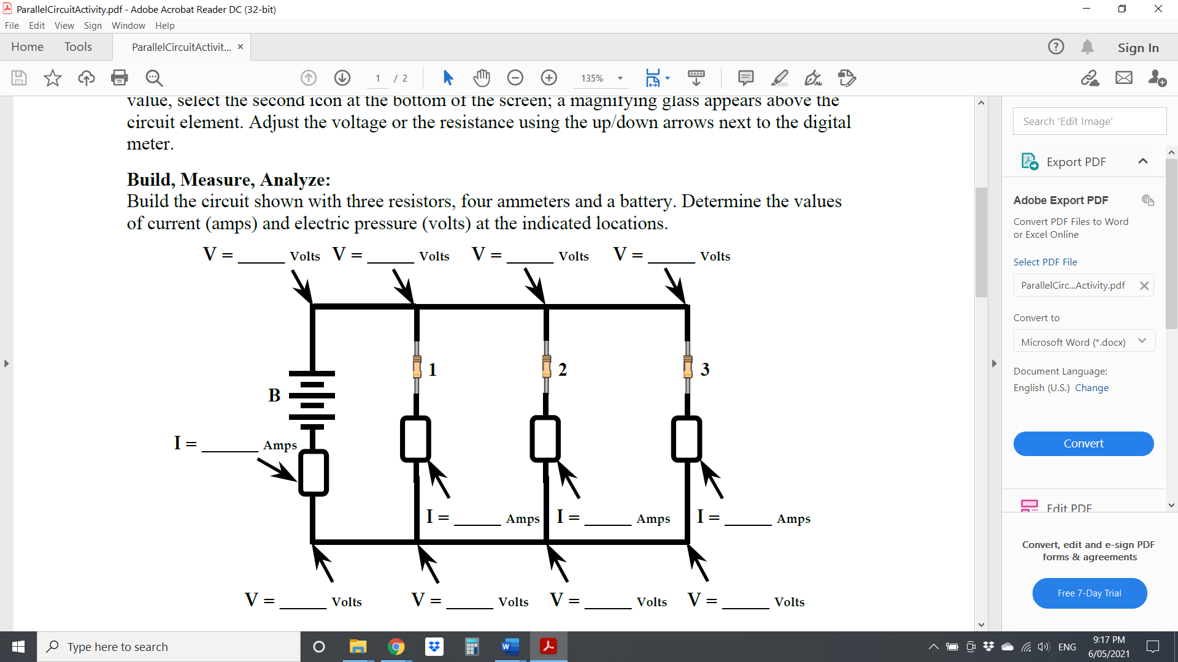  To change the voltage or resistor value, select the second icon at the bottom of the screen. A magnifying glass appears above the circuit element. Adjust the voltage or the resistance using the up/down arrows next to the meter.  - Set batery voltage to 10V; Resistors 1, 2 and 3 all equal to 5 ohms. Determine the values of currents at the indicated locations in the diagram above.  - How does the current in the battery (IB) compare to the summative current in the three resistors (I1 + I2 + I3)?  - Change the value to Resistor 1=6 ohms, Resistor 2 = 12 ohms and Rsistor 3= 18 ohms. Leave the voltage as is. Determine the values of currents at the indicated locations in the diagram above. | (4+4+6=14marks)
A19 | Student answer:  - Current returning to the battery is 6A.  - Current flowing through Resistor1 is 2A.  - Current flowing through Resistor2 is 2A.  - Current flowing through Resistor3 is 2A.  - Current in the battery IB is equal to the sum of I1, I2, I3 = 6A  - Current returning to the battery is 3.1A.  - Current flowing through Resistor1 is 1.7A.  - Current flowing through Resistor2 is 0.8A.  - Current flowing through Resistor3 is 0.6A
F19 | Assessor feedback

END OF ASSESSMENT

