Calendar:

Change Working Time
Go to Project-> Change Working Time: It gives the calendar popup option.
Three available Calendar options. If you want custom calendar, then select Create New Calendar.
This New Calendar can be set as Project calendar by:
Project-> Project Information-> Calendar
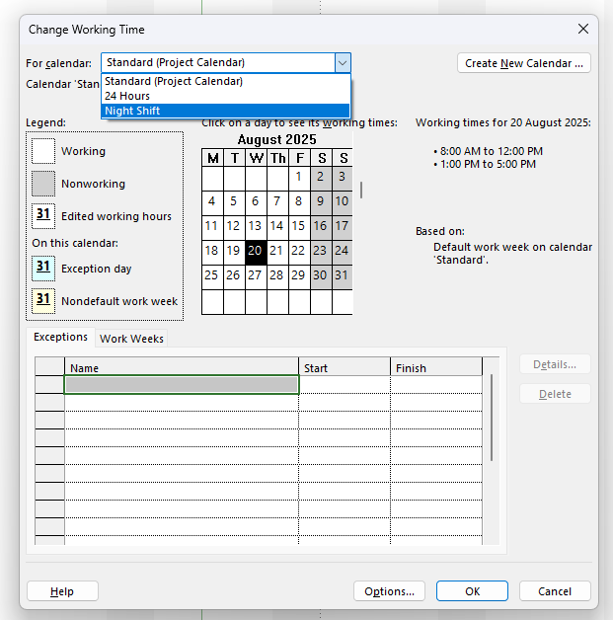

View:
Represents the information in different ways, don’t manipulate the information.

Module 6:
Duration and Work Formula:

Duration:
The length of the task from start to End.

Work:
Person hours required to finish the task.

Units:
Percentage of resource’s available time committed to the task.
100%= 1 unit
50% = 0.5 units
One third = 0.33 unit
Duration = Work/Units

i.e.” 40 hours to finish task, for 1 resource working full time:
Duration = W/U = 40/1 = 40 hours
What if resource is available for 50%
Then Duration = 40/0.5 = 80 Hours.

Shortcut for Task Linking:
Select the tasks, press: CTRL+F2: It will link the tasks in Finish to Start way linking.

Summary Tasks:
On Gantt Chart is it shown by down black bracket over the list of tasks under Summary Tasks.
Select the tasks-> Go to Task menu-> select ‘Summary’
View->Outline: for expand or collapse on different level.
Format-> check box for ‘Summary Tasks’ will hide or show summary task, and only display tasks.
Format-> Project Summary Task’ : Root level Summary task , which present the entire Project, can be shown by checking the ‘Project Summary Task’ in the Format section.
Other option is by selecting the task-> Indenting/Outdenting it from Task menu. To be careful with this method
Imp:
- Directly modify the summary task duration. Gantt Chart shows the time gap or overtime by teel or red colour.
- When you remove or delete the Summary Task, all sub tasks are also deleted. But to outdent the summary task if only summary task is to be deleted.
- Can be recognized by small rectangle.

Milestone:
- No duration of the task- make duration 0 days to convert to milestone.
- No effect on scheduling.
- Milestone are presented as diamond shape.
- Click on the task below, where you want to add milestone task. And click on Task->Milestone: it adds the milestone to the plan.

Task Linking:
- When referencing the tasks in Predecessor section manually, task numbers are used not WBS numbers.
- Don’t link Summary Tasks and don’t assign resources or duration to summary tasks.
- Link button and Editing Predecessor are equally appropriate.
- Check no overlocation red indicators are there.
- Some tasks may have special data constraints, they have special indicator. Edit the dates manually.

Recurring Tasks:
- Task Drop down and select recurring task, where you want to insert.
- Special icon- recurring.
- Frequent cause of over allocation- To overcome you may change the duration to 0.
- Recurring task has the high priority, so project will not delay recurring task.
- Can not convert existing task to recurring task.

Task Formatting:
- Text Styles: Go to Format->TextStyles: Select Item to change.

Tips:
- CTRL + N- New file open
- CTRL+O- Open existing file
- CTRL+Home- bring the cursor to very first cell

