Marrakech
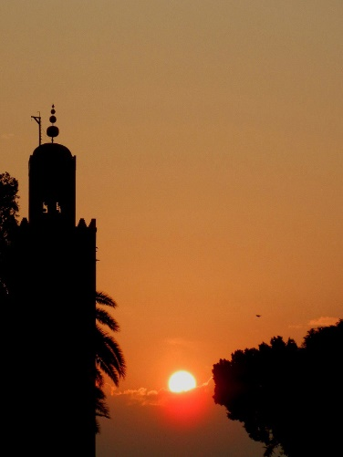
Marrakech or Marrakesh is known as the "Ochre city", and is the most important former imperial city in Morocco's history. The city of Marrakesh is the capital of the mid-southwestern economic region of Marrakech-Tensift-Al Haouz, near the foothills of the snow-capped Atlas Mountains. It is the fourth largest city in Morocco.
Image 1: Sunset
Like many Moroccan cities, the city of Marrakech comprises both an old fortified city (the médina) and modern neighborhoods, the most prominent of which is Gueliz
Marrakech has the largest traditional market (souk) in Morocco and also has one of the busiest squares in Africa and the world, Djemaa el Fna. The square bustles with acrobats, story-tellers, water sellers, dancers and musicians. By night food stalls open in the square turning it into a huge busy open-air restaurant.
The Koutoubia Mosque is the largest mosque in Marrakech, Morocco. The minaret was completed under the reign of the Almohad Caliph Yaqub al-Mansur (1184-1199) and was used as the model for the Giralda of Seville and for the Hassan Tower of Rabat.
Prior to the advent of the Almoravids in the 11th century, the area was ruled from the city of Aghmat. The Almoravid leader, Yusuf ibn Tashfin decided Aghmat was becoming overcrowded and chose to build a new capital. He decided to build it in the plains near the Tensift River. He chose the site of Marrakech, because it was in neutral territory between two tribes who were vying for the honor of hosting the new capital. There is a doubt about the actual foundation date, Ibn Khaldun and Ibn Abi Zar give it as 1062 by Yusuf ibn Tashfin while Ibn Idhari wrote that the work started in May 1070, but Abu-Bakr was recalled to the Sahara to put down a rebellion in January 1071 and the city was completed by his deputy and eventual successor Yusuf ibn Tashfin. The city experienced its greatest period under the leadership of Yaqub al-Mansur, the third Almohad sultan. A number of poets and scholars entered the city during his reign and he began the construction of the Koutoubia Mosque and a new kasbah.
Prior to the reign of Moulay Ismail, Marrakech was the capital of Morocco. After his reign, his grandson moved the capital back to Marrakech from Meknès.
For centuries Marrakech has been known for its "seven saints". When sufism was at the height of its popularity, during the reign of Moulay Ismail, the festival of the seven saints was founded by Abu Ali al-Hassan al-Yusi at the request of the sultan. The tombs of several renowned figures were moved to Marrakech to attract pilgrims in the same way Essaouira did at that time with its Regrega festivals. The seven saints (sebaatou rizjel) is now a firmly established institution, attracting visitors from everywhere. The seven saints include Sidi Bel Abbas (the patron saint of the city), Sidi Muhammad al-Jazuli, Sidi Abu al-Qasim Al-Suhayli, Cadi Ayyad ben Moussa, Abdelaziz al-Tebaa and Abdallah al-Ghazwani.
Marrakech was dominated in the first half of the 20th century by T'hami El Glaoui, "Lord of the Atlas", and Pasha of Marrakech. The poet of the city was Mohammed Ben Brahim and his favorite place was café Al-Masraf. The poems and songs of Ben Brahim are still known by heart by many Marrakshi.

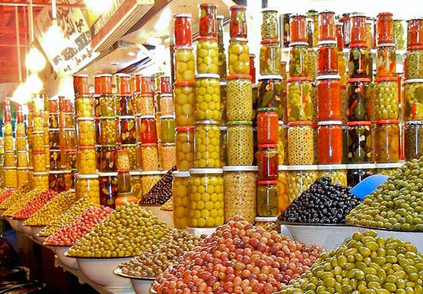
Image 2: Olives in the Market

Image 1: Sunset 1
Image 2: Olives in the Market 2

