Unexpected Meter Events / Alarms
- Unexpected overcurrent detected event for SP meter
- Unexpected main contactor reconnect failure event for SP meter

Metrology Behaviour
- Clarification that there is no padding of zero data to mask the issue. Great outcome. This will not impact billing at a later date.

Neutral current
- No issue with line or neutral wiring, though it may affect neutral readings only.
- Recommend installing one SP with neutral line and out to test the neutral measuring feature of the Itron meters

Meter Programming & Auto Disconnect
- Comparison of 1Ph vs 3Ph behaviour:
  - Default program applied.
  - Disconnect settings flagged as failed.
  - Meter programmed with auto disconnect enabled and appropriate meter program approved.
  - Remote disconnect event lockout is disabled.
- The SP meter entered an alarm state due to load being present while auto disconnect was enabled?
- Key question:
  - Why did the meter disconnect post meter programming? Was it due to auto disconnect was enabled remotely?
  - Would the same behaviour occur if auto disconnect was enabled via the meter program and then issued to the meter via meter program change, if auto disconnect was the issue?

Hardware & Configuration Constraints
- Only 2 element single phase 2 element meters will have a dry 31.5 A contactor.
- This is noted as an issue because both 1Ph and 3Ph meters typically require a wet 31.5 A contactor.

Mapping & Measurement Issues
- Mapping issue identified on demand PQ read:
  - Active current should be zero on 1Ph.
  - 3Ph readings are correct.
- Meter limitations identified:
  - Does not provide error status.
  - Does not provide terminal cover removal status on meter LCD
  - Does not indicate 4 quadrant metering.
  - Meter height identified as an installation issue, not a meter fault.

External antenna port.
- Having a Gromit to cover the external antenna port is not viable solution. When an external antenna is installed, the connector will be exposed which could be viewed as a risk. External antenna port needs to be covered and not exposed.

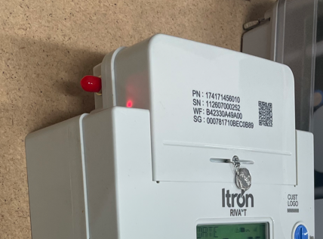

Follow Up / Action Item
- Confirm with Stephen whether, during a meter program update, the NIC only changes the delta or if it pushes the entire program.
- Confirm why the SP meter disconnected post meter program change. This is a critical issue that needs to be confirmed why it occurred. This needs to be confirmed prior to the meters being installed in the field. We cannot risk the site being disconnected and the meter moving to an arm state. Sending out a field tech to reconnect the meter is not a solution if there is an issue.
- Ensure that field laptops have the appropriate software to interrogate meters and NIC

