Contents
Important Info and Links 3
Table 68 (2116) – Relay Settings 4
Reset Password Lockout On Power Fail 4
Load Control relay 4
PQ Polling 4
Event Details: 4
NIC Seal Definition: 4
U1300 and U3400: 4
DLMS: 5
AMI Meters Type: 5
Meter Variants 5
Meter NIC Variants: 6
Meter SW Tools version: 7
Production Firmware: 7
Full Forms: 7
Links: 8
NMI Convention: 8
HAN Important Points: 8
QOS Voltage and Persistence Time Values: 9
L&G Meters 9
Voltage Failure Observation L&G Meters: 9
Secure Meters: 9
Troubleshooting: 10
Network Center Command: 10
Important List for New Joiner: 11
List of Access Requests: 11
Automation Setup: 11
Hardware Config: 11
How to run memory in loops: 12
NIC Mismatch Schedule Job: 12
Runs every Sunday: 12
M-Cubed Terminal Commands: 12
M-Cubed Product Key: 12
M-Cubed KDF Flies Path: 12
Lab Version Product Key: 12
Production Product Key: 12
Production KDF Files: 12
Test Meters KDF Files: 12
FSU SAM Credit Update for FSU 4.0: 12
GMI Event Codes: 14
Email Subjects: 16
UIQ Read Flags Table: 16
CityEdge/SSLS: 17
Minimum functionality requirements 17
GIT 17
Useful Git Commands: 17
Basic Git Commands: 25
Steps to Start with Git Fresh: 28
Cloning Existing Repo: 29
Push: 29
Pull: 29
Postgre Installation Issue: 29
Python Selenium Learning 29
Screenshot with address bar: 29
Python Installation: 30
Python CMD Command 30
Python Tricks: 30
RDP User account add: 31
Remote Desktop Users: 31

Important Info and Links

Information Related | C1219 Table
QoS | Table 50/2098
Phase Detection- Power Factor | Table 28- use this table data conversion- L/Tools/Table 28
Temperature | Table 2072  Table 2072 Offset 18 length 2 Bytes,
Reboot the meter | Run Procedure c1219  Provide Procedure Number- 1  No other parameter required.
LC control command | Table 2074
Meter FW Version | 1. Read Table Offset 1. Table 2060, from Offset 0: 16 bytes Status code: SUCCESS 53 30 30 32 36 31 2d 30 35 2e 30 35 2e 52 35 34
Meter Device Name | 2. Read Table  2. Table 5: 20 bytes  Status code: SUCCESS  42 35 32 36 39 38 34 34 20 20 20 20 20 20 20 20  20 20 20 20
LP Enable/Disable  35- Enable  15- Disable | Table 63, offset 0, length 1
Extended LC RSM 2 and 3 configuration table (All FFF……………..) | MFG Table 85(2133)
Table 68 (2116) – Relay Settings  Offset-6, length-6. | Primary Group ID  Secondary Group ID  Tertiary Group ID
Reset Password Lockout On Power Fail | 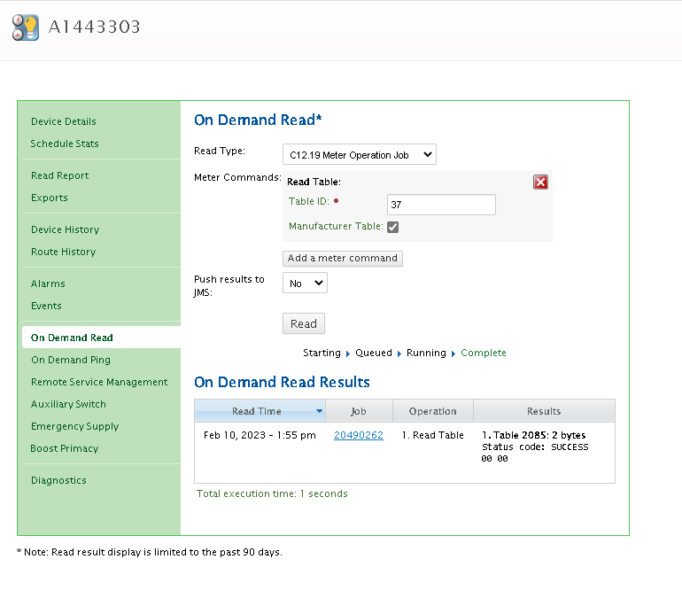  Write True to this value  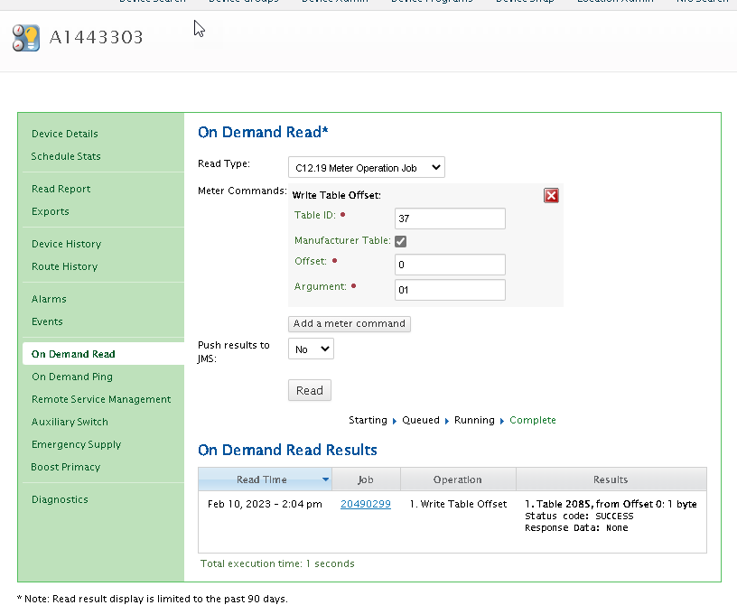
Load Control relay | Table 2114
PQ Polling | Table 95 (MFG)

Documents Links:
- Test Plan Reference:
L:\Documents\Project Documents\Test Planning References
- Market System ToolBox:Download All Meter NIC, FW Combnation
UIQ Reprogramming Configuration - Citipower MST Applications
CIS Report - Citipower MST Applications
- From Fabian- UE Meter Programs:  5min
- VPN Program : L:\Temp\LJ on T MKT\00-AMI TAG\Phase2B meter programs
- Meter Auto Disconnect for All Meters type: WI-XXXX Enable Disable Auto Disconnect for Meters.docx
- QRG_MOG: QRG_MOG.docx

Event Details:
Event ID: | Event Text
30152 | Service Disconnect open due to auto-disconnect for  meter 00:13:50:03:00:1c:36:bb - asynchronous alert  from meter. | Auto-Disconnect

NIC Seal Definition:

U1300 and U3400:
Existing program: | Opt Table Offset Length  6 200 30  22 0 6  33 0 89  53 4 2  61 0 0  62 0 0  75 0 48  2106 0 39  2107 0 43  2116 0 1  2074 0 1554
SHA-1 Hash: | 0x230EBF6630A6CD7535999C2FE95C2206922030AB

U1200 and U3300:

Existing program: | Opt Table Offset Length  6 200 30  22 0 6  33 0 89  53 4 2  61 0 0  62 0 0  75 0 48  2106 0 39  2107 0 43  2116 0 1  2114 0 40
SHA-1 Hash: | 0xD59F9159DA4C1ED841BF0CC9EE5C5709BE759B16

DLMS:

Existing program: | Class:Instance:Attribute  7:1.0.99.1.128.255:3  7:1.0.99.1.128.255:2  7:1.0.99.1.0.255:4  7:1.0.98.128.6.255:3  7:1.0.98.128.6.255:2  1:1.0.0.2.1.255:2
SHA-1 Hash: | 0xEB4009605255114DE954E2FFB8BE4438698D0D31

AMI Meters Type:
There are two types of AMI meters:
- Single phase:
Two variants: 1 element and 2 elements
- Multi-phase:
Direct Connect (or Whole Connect)
Current Transformer Connect
In early 2006, the Victorian Government formally endorsed the deployment of Advanced Metering Infrastructure (AMI) to all Victorian electricity customers consuming less than 160MWh per annum

Meter Type definitions:
Meter Type | Formal Name (AEMO) | Interval Data | Read Method | Accuracy Class | Typical Customer / Use Case | Common Notes
Type 1 | Large Interval Meter | ✅ Yes | Remote | Very High (≈ 0.2%) | Power stations, transmission nodes, very large industrial sites | High-accuracy CT/VT metering; used at transmission level [energy-rul...emc.gov.au]
Type 2 | Large Interval Meter | ✅ Yes | Remote | High (≈ 0.5%) | Large distribution-connected industrial customers | CT/VT connected; slightly relaxed accuracy vs Type 1 [energy-rul...emc.gov.au]
Type 3 | Large Interval Meter | ✅ Yes | Remote | Medium (≈ 1.0%) | Shopping centres, hospitals, large LV customers | Whole-current or CT connected; still interval settlement [energy-rul...emc.gov.au]
Type 4 | Smart Meter (AMI) | ✅ Yes | Remote | Residential / SME | Residential homes, SMEs, solar, EV, batteries | Default modern meter; supports TOU, demand, export storage [markets-po...emo.com.au], [energy-rul...emc.gov.au]
Type 4A | Small Customer Advanced Meter | ✅ Yes | Remote | Similar to Type 4 | Early smart meter installs (pre-Dec-2017) | Transitional classification in NER/MSATS history [markets-po...emo.com.au]
Type 5 | Manually Read Interval Meter | ✅ Yes | Manual | Moderate | Legacy business TOU customers | 30-min data but no comms; phased out [markets-po...emo.com.au], [energy-rul...emc.gov.au]
Type 6 | Accumulation Meter | ❌ No | Manual | Basic | Older residential / flat tariff customers | Total kWh only; no TOU, solar, or demand support [markets-po...emo.com.au], [energy-rul...emc.gov.au]
Type 7 | Unmetered Supply | ❌ No | Calculated | N/A | Street lighting, traffic lights | Energy derived from load tables and run-hours [aemo.com.au]
Type 8A | SSP Meter – Large Customer | ✅ Yes | Remote | High | Embedded networks, large EV charging | Secondary Settlement Point (SSP) only [aemo.com.au]
Type 8B | SSP Meter – Small Customer | ✅ Yes | Remote | SME | Residential EV charger behind meter | Can only exist as SSP to a Type 4 primary meter [aemo.com.au]
Type 9 | Alternative Metering Installation | ✅ Yes | Remote | Purpose-specific | Public lighting, street furniture | Approved alternative metering; often replaces Type 7 [aemo.com.au]

Meter Class | Max Permissible Error (Typical) | Accuracy Level | Typical Meter Type(s) | Typical Use Case
Class 0.2 | ±0.2% | Very High | Type 1 | Transmission nodes, generators, very large industrial sites [energy-rul...emc.gov.au]
Class 0.5 | ±0.5% | High | Type 1, Type 2 | Large industrial & HV customers [energy-rul...emc.gov.au]
Class 1.0 | ±1.0% | Medium | Type 3, some Type 4 | Large LV sites, SMEs [energy-rul...emc.gov.au]
Class 1.5 | ±1.5% | Standard | Type 4, Type 6 | Residential smart & accumulation meters [energy-rul...emc.gov.au]
Class 2.0 | ±2.0% | Basic | Legacy Type 6 | Older residential meters (grandfathered) [energy-rul...emc.gov.au]

Meter Type | Interval Data | Typical Meter Class | Accuracy Importance Level
Type 1 | Yes | 0.2 – 0.5 | Critical (market settlement)
Type 2 | Yes | 0.5 | Very High
Type 3 | Yes | 1.0 | High
Type 4 | Yes | 1.0 – 1.5 | Medium
Type 5 | Yes | 1.0 – 1.5 | Medium
Type 6 | No | 1.5 – 2.0 | Basic
Type 7 | N/A | N/A | Calculated
Type 8 / 9 | Yes | 1.0 – 1.5 | Medium–High

Meter Variants
- 10Mx - 1 element meter with no contactor
- 11Mx - 1 element meter with 1 load contactor
- 12Mx - 2 element meter
- C0Mx - 3 phase CT meter
- 30Mx - 3 phase Direct Connect meter
- 31Mx - 3 phase Direct Connect meter with 1 load contactor

Meter Program Location:

Org | Location | Remarks
UE | Program certificate | L+G, 5 Min , CAT1
UE | V3 R59 Programs | L+G, 5 Min , CAT4, TestCertificate
UE | L6a-C#-V3 | L+G, 5 Min , CAT6a, TestCertificate

Meter Naming Conventions:

VPN L&G
  - VPN L&G meter numbers/name has 8 alpha-numeric characters
  - VPN L&G Single Phase meters starts with “A” or “F”
  - VPN L&G Three Phase meters starts with “B”
VPN Secure
  - VPN Secure meter numbers/name has 8 alpha-numeric characters
  - VPN Secure Single Phase meters starts with “CZ”
  - VPN Secure Three Phase meters starts with “DZ”

UE L&G
  - UE L&G meter numbers/name has 7 numeric characters
  - UE doesn’t purchase and CAT2 and CAT3 meters from L+G
  - For CT as well, UE maintains one supplier..need to check who?
UE Secure
  - UE Secure meter numbers/name has 7 numeric characters

Meter Model Code Naming Convention (VPN):
The VPN AMI Meter Model Code is 9-character alpha-numeric comprising of the physical variant, manufacturer and factory configuration of each AMI meter as shown below:
More details of the meter model code can be found in the latest version of the “Meter Model Codes Version“ document
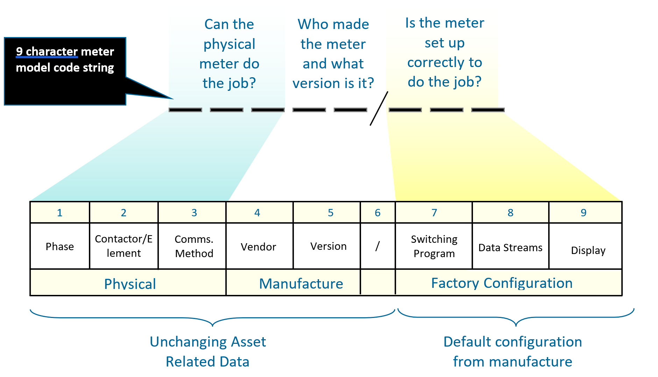

Meter Variants:

10Mxy - 1 element meter with no contactor
11Mxy - 1 element meter with 1 load contactor
12Mxy - 2 element meter
C0Mxy - 3 phase CT meter
30Mxy - 3 phase Direct Connect meter
31Mxy - 3 phase Direct Connect meter with 1 load contactor
where
x = Vendor (L = L&G, P=PRI/Secure)
y = hardware version (1 to 5)

UIQ Prod Naming Conventions:

https://networkportal.sharepoint.com/sites/ENSDHub/Communication%20Networks%20Quality/Forms/AllItems.aspx?csf=1&web=1&e=mnHdd9&CID=4caad852%2Df67a%2D41a0%2D9f09%2D9411e412fbbb&FolderCTID=0x0120009A07B6F896FB9B48A3DB895EB292CF86&id=%2Fsites%2FENSDHub%2FCommunication%20Networks%20Quality%2FAMI%20Network%20Operations%2F03%20Device%20Configuration%20Management%2F02%20WorkInProgress%2FUIQ%20Naming%20conventions

UE Customer Input Document Link:
EN/SD Hub - Metering (CPPAL) - Meter Contract Customer Input for L&G - All Documents

L&G Meter Variants (VPN):

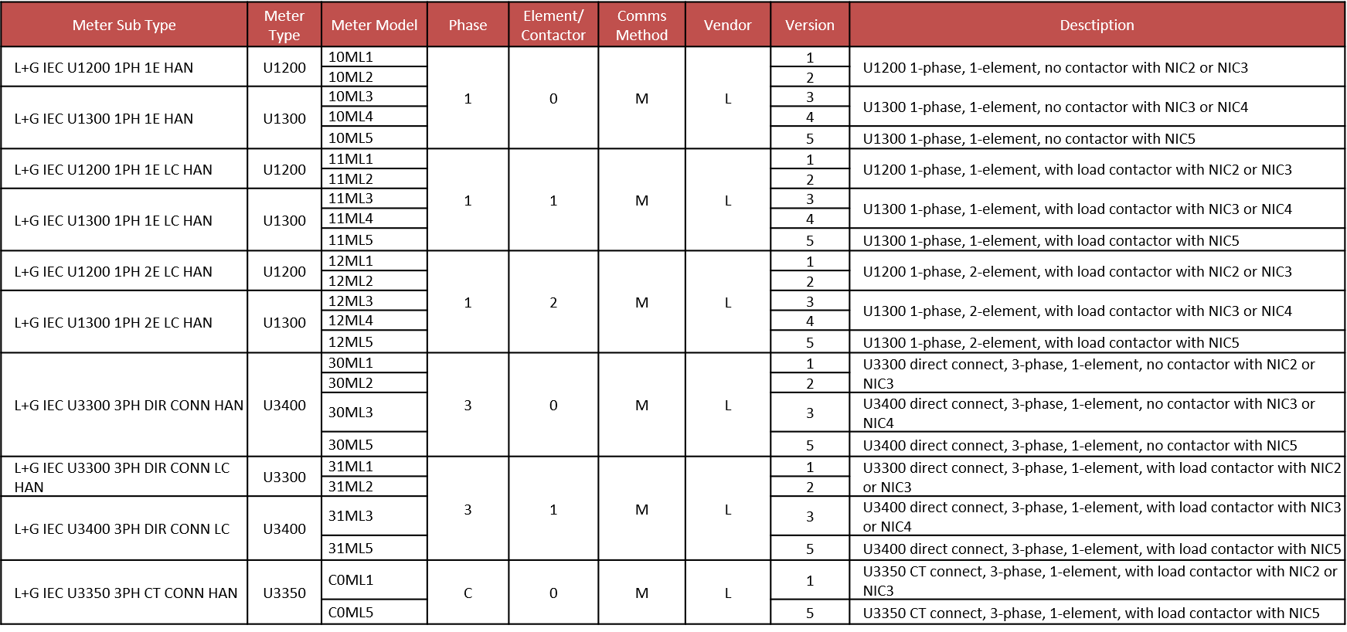

Secure Meter Variants (VPN):

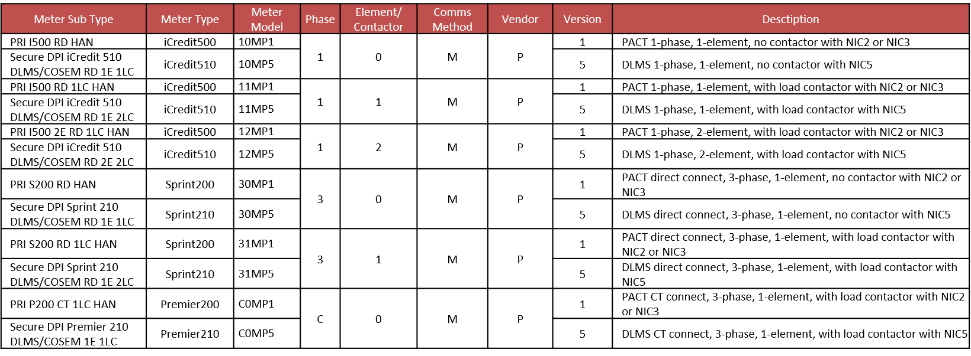

Meter Model Code Naming Convention (UE):

The UE AMI Meter Model Code is 8-character alpha-numeric comprising of the physical variant, manufacturer and factory configuration of each AMI meter as shown below:
The UE AMI Meter Model Code is 8-character alpha-numeric comprising of the physical variant, manufacturer and factory configuration of each AMI meter as shown below:
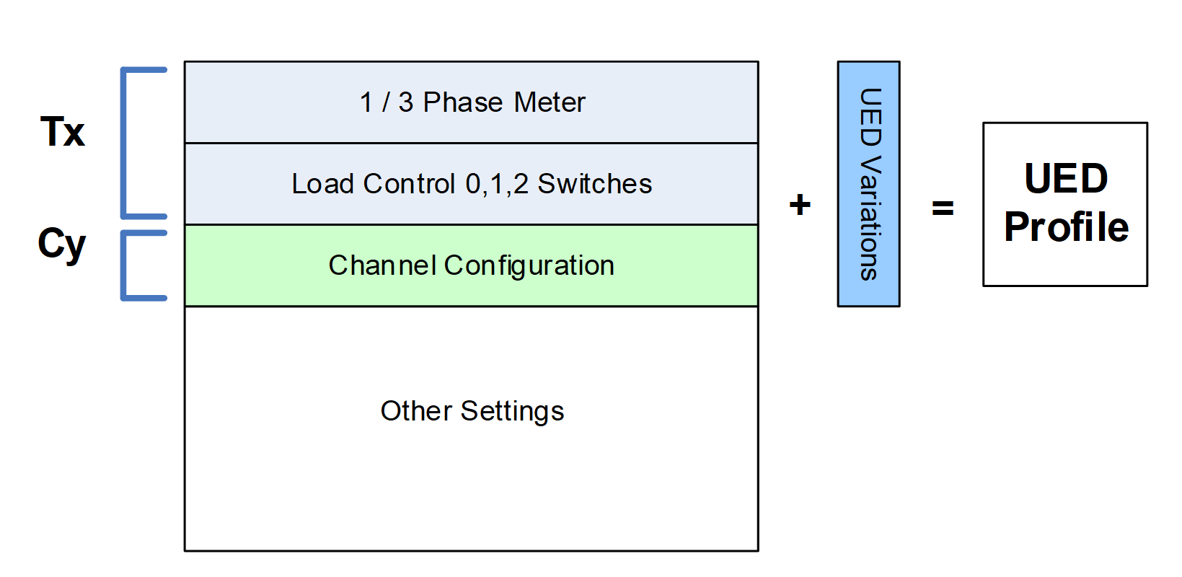
The full list of settings for UED is defined in Appendix A - Meter Settings.

Configuration Files

Files names use the format: 00LXCY V0Z¹ where Z indicates the profile version number.
UE will produce profiles for each profile cover the following variations:
- Distributor: UE
- Delivery: Factory / Remote
The files are no longer embedded in this document as was past practice. Files will be provided separately and stored / packaged to distinguish between distributor and delivery method
Files created for factory loading produced as follows:
- Immediate² profiles: 000L1C1-V03, 000L2C1-V03,000L3C5-V03, 000L4C1-V01, 00L5a C1-V04 & and 00L6aC3-V07 & 00L6bC3-V04
Files created for remote loading from UIQ are produced as follows:
- Immediate profiles: All configurations (26)

L&G Meter Variants (UE):

Secure Meter Variants (UE):

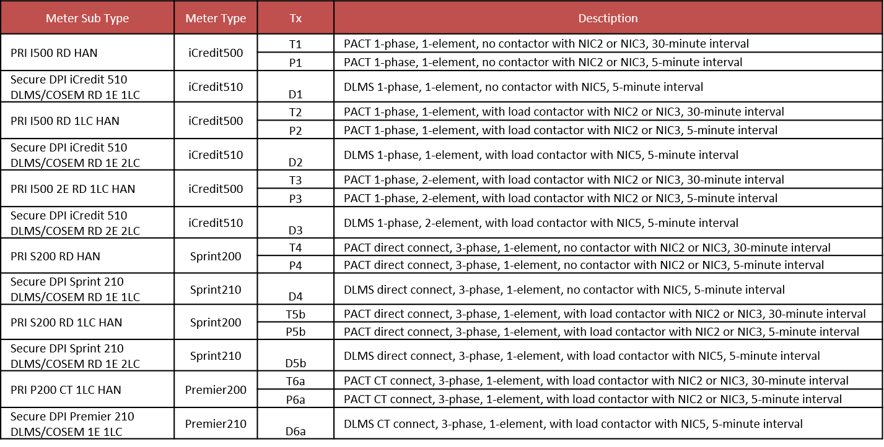

NIC (UtilOS) Firmware:

  - NIC firmware are hardware-specific
  - NIC firmware version indicates a lot of information on the NIC like device type, hardware generation, Zigbee capability
  - Examples: 03.12.5009.03 : is for an AP or Relay, 03.12.0009 : is for a meter NIC, Gen 2 (NIC2)
  - Within CP/PAL/UE it is common to truncate the NIC firmware version for ease of discussion (e.g. 3.12.9, 312.9c)
  - Itron don’t always follow their version convention. Zigbee capability on some NIC firmware version can only be known via the firmware filename.
  - Always consult the NIC firmware release notes for full details
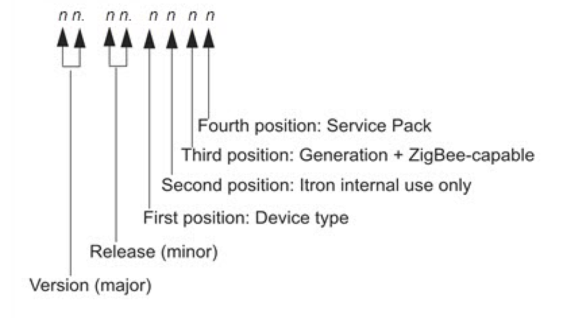

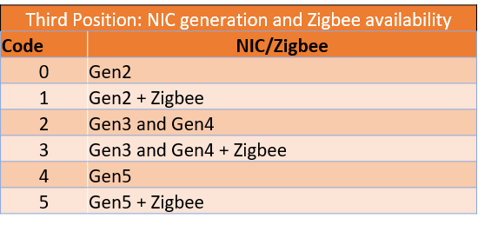
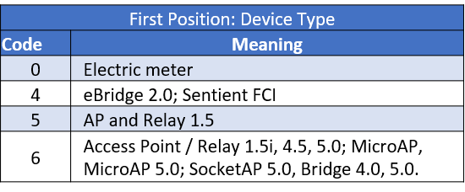



Factory Default Programs – CP/PAL L&G:

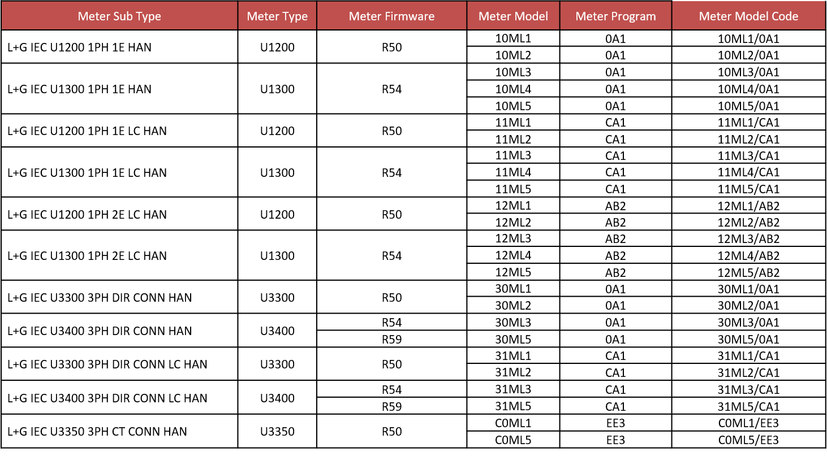

Factory Default Programs – CP/PAL Secure:

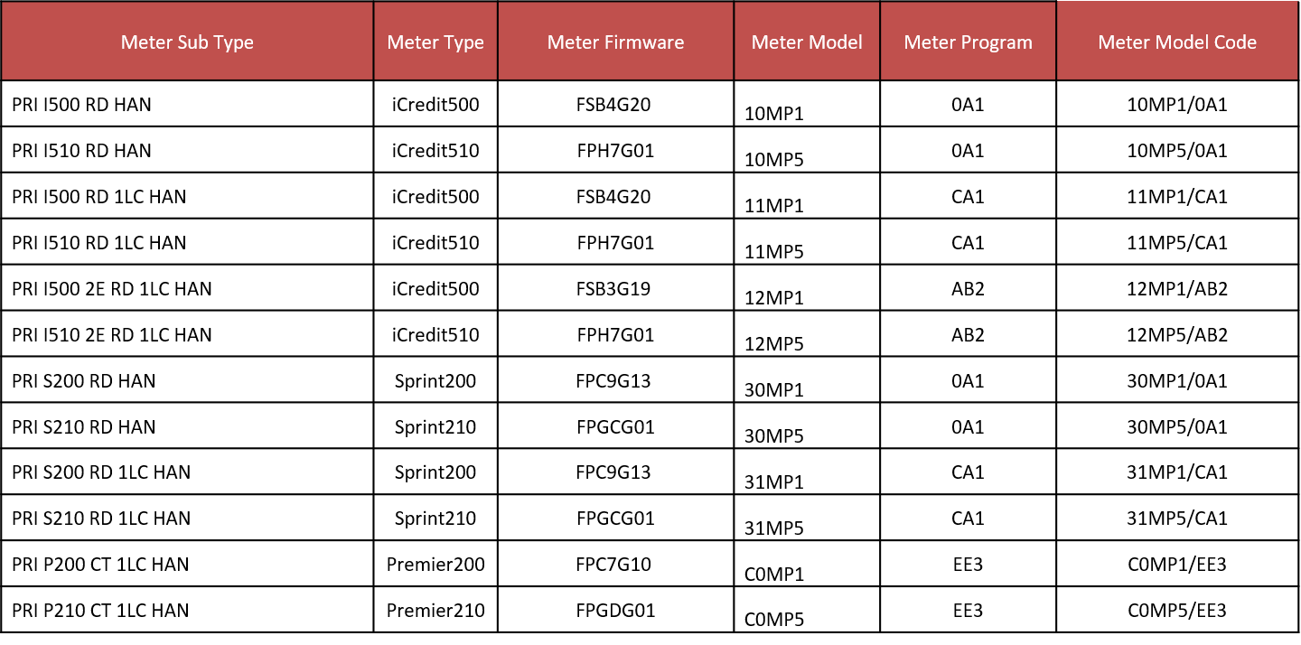

Factory Default Programs – UE L&G:
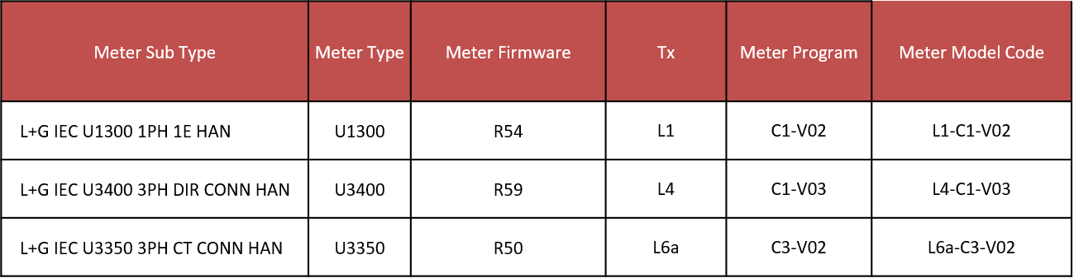

Factory Default Programs – UE Secure:
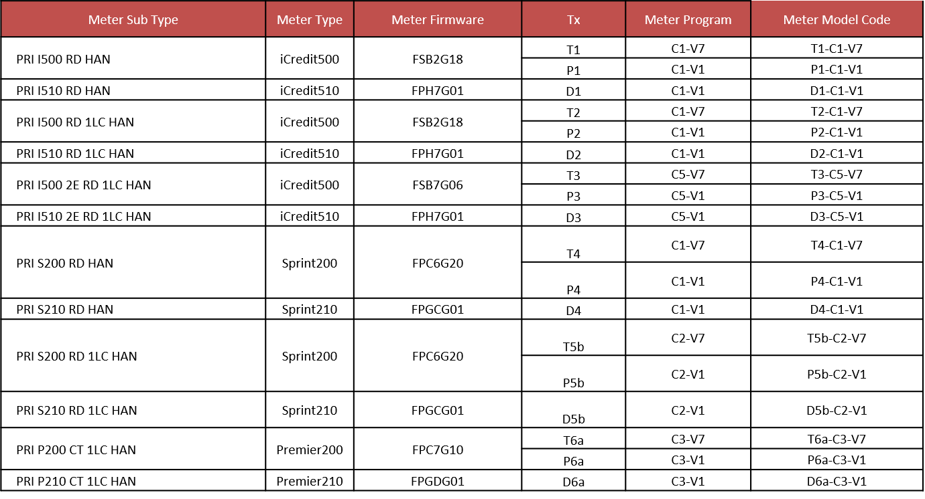

Meter NIC Variants:

VPN- L&G
 | Meter HW | NIC Architecture | NIC HW | Meter FW | NIC FW
10ML, 11ML, 12ML | U1200 | ARM, AKIO | NIC 220 | R50 | 3.12.9-5.4.13
 |  |  | NIC 320 | R50 | 3.12.9c- 5.4.33
30ML1, 30ML2, 31ML1, 31ML2 | U3300 | ARM, AKIO | NIC 220 | R50 | 3.12.9-5.4.13
 |  |  | NIC 320 | R50 | 3.12.9c- 5.4.33
C0ML1 | U3350 | AKIO | NIC 320 | R50 | 3.12.9c- 5.4.33
 |  |  | NIC 420 | R50 | 3.12.9c- 5.4.33
CAT6 (LC): No CAT6 without LC | U3350 | AKIO | NIC320 | R50 | 5.4.33
10ML, 11ML, 12ML  Mostly they start with 10ML3/11ML3/12ML3, as NIC3 else there will be sticker for NIC420 | U1300 | AKIO, RNI | NIC 320 | R54 | 3.12.9c- 5.4.33
 |  |  | NIC 420 | R54 | 3.12.9c- 5.4.33
10ML5,11ML5,12ML5 all have NIC5 |  |  | NIC 520 | R54 | 4.8.2c-5.4.53
CAT1, CAT3 (no CAT2) | U1300 | RNI | NIC 520 | R54 | 5.4.53
30ML3,31ML3 and above (NIC 3 or 4) | U3400 | AKIO, RNI | NIC 320 | R54 | 3.12.9c- 5.4.33
 |  |  | NIC 420 | R54 | 3.12.9c- 5.4.33
30ML5, 31ML5 |  |  | NIC 520 | R59 | 4.8.2c-5.4.53
CAT4 | U3400 |  | NIC 520 | R54 | 5.4.53
DLMS (UE/VPN)
 |  |  | NIC Type | Meter FW
CAT1/10MP | 501 |  | NIC 520
CAT2/11MP | 502 |  | NIC 520
CAT3/12MP | 503 |  | NIC 520
CAT4/30MP | 504 |  | NIC 520
CAT5a/31MP (1LC) | 505 |  | NIC 520
CAT5b/31MP (2 LC) | 506 |  | NIC 520
CAT6/C0MP | 507 |  | NIC 520
PACT (UE/VPN)
CAT1/10MP | 501 | ARM/AKIO | NIC 220/NIC 320
CAT2/11MP | 502 | ARM/AKIO | NIC 220/NIC 320
CAT3/12MP | 503 | ARM/AKIO | NIC 220/NIC 320
CAT4/30MP | 504 | ARM/AKIO | NIC 220/NIC 320
CAT5a/31MP (1LC) | 505 | ARM/AKIO | NIC 220/NIC 320
CAT5b/31MP (2 LC) | 506 | ARM/AKIO | NIC 220/NIC 320
CAT6/C0MP | 507 | AKIO | NIC 320

From Customer Input Document:
Meter Category | PHASES/connect Type | Meter Type Code  UED
1 | 1ph, 2 wire / Direct Connect (single phase, single element) | 501
2 | 1ph, 2 wire / Direct Connect (single phase, single element, with 31.5A load control) | 502
3 | 1ph, 2 wire / Direct Connect (single phase, two element, with 31.5A load control) | 503
4 | 3ph, 4 wire / Direct Connect (3 phases with no load control) | 504
5a | 3ph, 4 wire / Direct Connect (3 phases with 31.5A load control) | 505
6a | 3ph, 4 wire Low Voltage Transformer Connect (3 phase CT connect) | 507

NIC HW | NIC Architecture | Production FW
NIC 220 | ARM | 3.12.9- 5.4.13
NIC 320, NIC 420 | AKIO | 3.12.9c- 5.4.33
NIC 520 | RNI | 4.8.2c- 5.4.53
 | RNI (DLMS meters) | 5.4.50- 5.4.53

Meter SW Tools version:
Software Name | Latest Version in Lab | Latest Version in Prod/MOG
M-Cubed | V8.1.3.1340 | V 8.1.3.1340
CATT | V7.7.12 | V7.0.20/7.7.12
EMPWin+ | V6.7.10 | V4.1.14
MVLTxi | 1.1.0.5 | 1.1.0.5
Calegration | V1.8.10.0 | V1.8.10.0
CalSoft | V2.9.1.0 | V2.9.1.0

Production Firmware:

Secure
Meter Code | Meter Sub-Type | Meter Firmware
10MP5 | Secure DPI iCredit 510 DLMS/COSEM RD 1E 1LC | FPH7G01
11MP5 | Secure DPI iCredit 510 DLMS/COSEM RD 1E 2LC | FPH7G01
12MP5 | Secure DPI iCredit 510 DLMS/COSEM RD 2E 2LC | FPH7G01
30MP5 | Secure DPI Sprint 210 DLMS/COSEM RD 1E 1LC | FPGCG01
31MP5 | Secure DPI Sprint 210 DLMS/COSEM RD 1E 2LC | FPGCG01
C0MP5 | Secure DPI Premier 210 DLMS/COSEM 1E 1LC | FPGDG01

Meter Programming:

- File types are different for each meter type and download method
- Local: L&G (MCD file), PACT (TAR file), DLMS (TAR file)
- Remote: L&G (XML file), PACT (TAR file), DLMS (XML file)

Meter FW upgrade Observations:

U1300 upgrade from R54 to R66:
<Relay Value=”0”>
- RippleIgnoreTimeTableDaely Value
- IgnoreTimeTabledelayVisibility Vale
<Relay>
- Randomisation Value
- RippleRelayPresentMask Value
Above parameters were seen to be added after the upgrade from R54 to R66.
Reply from L+G: The additional ripple configurations in R66 are the extended ripple configuration tables that do not exist in R54. These are mfg. table 82. These table were added in the FW versions post R54. The functionally is not enabled post upgrade, i.e. no impact.

- Groups shall provide for a minimum of 20 primary groups (for use by Distributors), 200
secondary groups (for use by Distributors) and 200 tertiary groups (for use by Retailers).

Full Forms:

AMI | ADVANCED METERING INFRASTRUCTURE
MAFS | Minimum AMI Functionality Specification (Victoria)
NEM | National Electricity Market
NER | National Electricity Rules
NEL | National Electricity Law
NEMMCO | National Electricity Market Management Company Limited: CAN  072 010 327, the company which operates and administers the market in accordance with  the National Electricity Rules
TALQ – | TALQ Consortium is the body that defines a globally accepted standard for management software interfaces to control and monitor heterogeneous outdoor lighting networks.
NEMA – National Electrical Manufacturers Association | National Electrical Manufacturers Association is the body that defines standards for electrical and medical equipment.
GMM- meters | Generator Monitor Meter
LV DERMS | low-voltage distributed energy resource management systems
ESI | Energy Service Interface
NIC | Network Interface Card
SEP (1.0, 1.1) | Smart Energy Profile
HCM | HAN Communication Manager
IHD | In Home Display
IPD | In-Premise Display
GMR | Global Meter Reader
HMAC | Hash-based Message Authentication Code
HSM | Hardware security modules
NLC | Networked Lighting Controllers
CMS | CityEdge Central Management Software
CLO | Constant Light Output
VPO | Virtual Power Output
SAIDI | System Average Interruption Duration Index
SAIFI | System Average Interruption Frequency Index
MAIFI | Momentary Average Interruption Frequency Index
CAIDI | Customer Average Interruption Duration Index
GSL | Guaranteed Service Level
AEMO | Australian Energy Market Operator
RAFCL | Rapid Earth Fault Current Limiter

NMI Convention:
- Utility location ID under location field in UIQ is the NMI’s 10 characters, 11th character of NMI is checksum.
- We are going to follow the NMI code as- NMIXXXLAB.
- for defining the panel parameters for each meter- i.e. PanelNumber/PositionNumber, we are going with the option of using "Generic Service Point Attribute".

HAN Important Points:
- HAN is enabled through electricity‐meter Silver Spring network interface cards (NICs). The NIC includes an IEEE 802.15.4 chipset that acts as an Energy Services Interface (ESI) and complies with the ZigBee® Alliance Pro Stack and Smart Energy Profile (SEP) versions 1.0 and 1.1. These ESIs communicate directly with HAN devices.
- HCM is a Silver Spring application that enables utility companies to manage home area network (HAN) devices (including ZigBee® and Direct‐to‐Grid™ devices) and utility company rate plans, and to create and manage demand response (DR) programs.

QOS Voltage and Persistence Time Values:

L&G Meters
-Overvoltage and undervoltage settings programmed on the meter recorded:
-Overvoltage threshold: 259 volts
-Persistence time: 60 seconds
- Restoration time: 0 seconds
- Undervoltage threshold: 207 volts
- Persistence time: 60 seconds
- Restoration time: 0 seconds

Voltage Failure Observation L&G Meters:

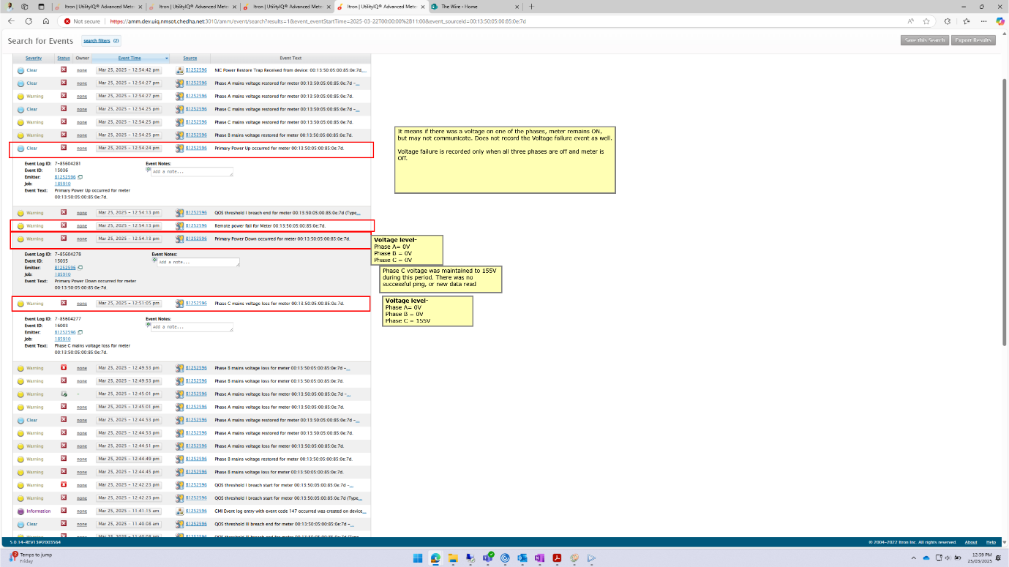

Secure Meters:

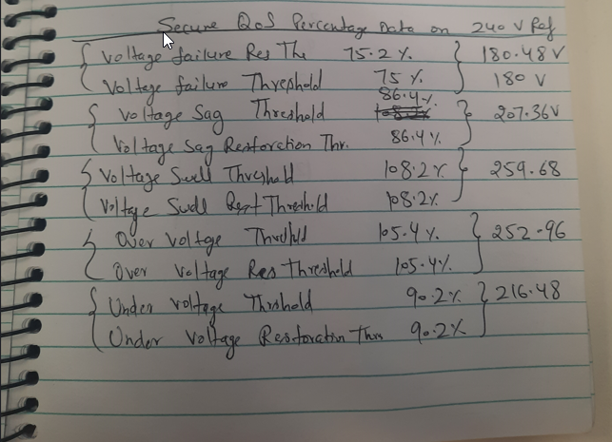

Troubleshooting:
- If meter not performing New Data Read or Ping: Check the DNS server info from Diagnostics, It may happen that when moving the meter from one environment to another environment it may loose this information. In this case, get the same info for the AP associated with the meter, and set the dns server info (DNS server and DNS zone_ to the meter using Network Centre or FSU.
- New Data Read Fail: It may also be caused if the meter is moved from one environment to other environment, and UIQ tries to read the old data, which is huge. In this case either leave the meter for some time, or reprogram the meter with different program, it will reset the data and will not need to read the data.

Network Center Command:

 | timesync between meter and NIC
Set_time | Sets time forward or backward in seconds for NIC, in reference to AP.
AA | AA

Important List for New Joiner:

List of Access Requests:
- Work From Home
  - Citrix Access and RSAs
- Citrix Published Apps
  - All UIQ and MST
- HP ALM / Quality Centre
- Role: QATester
  - Domain: TESTING_SERVICES
  - Project: NC_Quality
  - Domain: DEFAULT
  - Project: AMI_Trial
  - Domain: UNITED_ENERGY
  - Project: AMI_UIQ_Project
- UIQ CP/PAL
  - VPN UIQ LAB - same privileges as knjuguna
  - VPN UIQ DEV - same privileges as knjuguna
  - VPN UIQ SIT - same privileges as knjuguna
  - VPN UIQ UAT - same privileges as knjuguna
  - VPN UIQ PROD - general user
- UIQ UE
  - UE UIQ TEST - same privileges as knjuguna
  - UE UIQ DEV - same privileges as knjuguna
  - UE UIQ SIT - same privileges as knjuguna
  - UE UIQ QA - same privileges as knjuguna
  - UE UIQ PROD - general user
- NetManager CP/PAL
  - VPN UIQ LAB
  - VPN UIQ DEV
  - VPN UIQ SIT
  - VPN UIQ UAT
  - VPN UIQ PROD
- NetManager UE
  - UE UIQ TEST
  - UE UIQ DEV
  - UE UIQ SIT
  - UE UIQ QA
  - UE UIQ PROD

Automation Setup:

Hardware Config:
- COM9/PS1: ASSOCIATED\sPOWER\sTECHNOLOGIES\sINC.,320XAC,4100196,Version\
- COM15/PS2: ASSOCIATED\sPOWER\sTECHNOLOGIES\sINC.,320XAC,4100198,Version
- COM16/PS3: ASSOCIATED\sPOWER\sTECHNOLOGIES\sINC.,320XAC,4100197,Version s1.17\n
- USB0::0x2EC7::0x8615::802362063747850004::INSTR
ITECH\sLtd.,\sIT8615,\s802362063747850004,\s1.21-1.18-1.11\n

How to run memory in loops:
There is a VI called “ConfigureMemoryStepAndExecuteLoop” in the project APT300XAC. Configure memory cycle tin configure memory subVI, to run the same memory for multiple cycles.

NIC Mismatch Schedule Job:

Runs every Sunday:
Investigate - ST1 & ST5 - Meter Serial Number and Utility ID

M-Cubed Terminal Commands:

i1 -Reactive i1=-01.247
I1 Active current I1=+01.215
l1 Actual current supply-from e-load- rms l1=+02.080
L1 Line current L1=+01.739

M-Cubed Product Key:

L:\Software\Secure\M-Cubed\LAB Versions\Product Keys

M-Cubed KDF Flies Path:
L:\Software\Secure\KDF File

Lab Version Product Key:
L:\Software\Secure\M-Cubed\LAB Versions\Product Keys

Production Product Key:
L:\Software\Secure\M-Cubed\Production\Product Keys

Production KDF Files:
L:\Software\Secure\M-Cubed\LAB Versions\CHED PRI Keys

Test Meters KDF Files:
L:\Software\Secure\M-Cubed\LAB Versions\PRI test meters CHED

FSU SAM Credit Update for FSU 4.0:
- The current version of FSU device being used in prod in FSU 5. To have the credit update on FSU 4.0 we need install CATT 7.0.20 to the machine.
- First uninstall the HVCI software from the Software center- It will reboot the machine
- Second- Install the HVCI again from the software center, it will prompt to press F3, for 3 times. And in the end it will reboot the machine.
- Now if you have CATT 7.0.20 and FSU-SAM tool it will be possible to connect the FSU 4.0 to the machine and update the credits.
- Most probably the FSU Service Tray 3.0 is located at: L:\Software\SSN\CATT\7.x\FsuServiceSetup_v3.0_x64.exe
Below is the copy from existing document Related to HVCI: VPN Metering Master Training Knowledge Catalogue.docm
FSU - SAM: Need FSU Privillage administror role in Prod UIQ. FSU-SAM standalone exe can only reach Prod UIQ server via VPN Corp Ethernet.

Privillage Guard

FSU-SAM
- V5.2.5 has been packaged.
- To install latest version, download the setup.exe from Prod UIQ, FSU-SAM tab. Install it then import certificate following "ReadMe.txt"
EN/SD Hub - Security Certs 2021 - All Documents (sharepoint.com)
- Pre-requisite:
- FSU Service Tray, part of CATT suite. Only FSU Service Tray v3.0 works with FSU 4.
- Disable HVCI.
- Make sure that CATT can recognise FSU Credit. Otherwise FSU-SAM will not detect FSU hardware
- Make sure certificates has been imported into FSU-SAM. Othwerwise error occures after user login.
- Make sure that user's PC can directly access UIQ, prod and/or non prod, via user's local browser (not via Citrix apps). This ensures that FSU-SAM, a local application, can connect to prod and non-prod UIQ server.

CATT 7.xx with FSU Service Tray 3.0, and Disable HVCI
- Each CATT v7.xx installation software has it's own build in FSU Service Tray installer. Latest CATT is v7.6, with FSU Service Tray version 3.6 (to be confirmed).
- All recent FSU Service Tray versions from v3.0 and above supports FSU Gen 5
- However, the highest version FSU Service Tray version that works with FSU Gen 4 is v3.0.
- Existing CATT 7.0 software package in IT frontdoor contains FSU Service Tray v3.0. It is sufficient enough for MOG.
- If you need to test higher version of CATT in futuer without losing support for FSU Gen 4, you can do following:
- Install stand alone FSU Service Tray v3.0. Reboot PC if required
- Install new version of Communication Tester. It will first install CATT, then try to install newer version of FSU Service Tray next. Proceed with CATT installation. Pay attention to promt up window when it asks to install new FSU Service Tray. Click "Cancel" when this promt shows up. You will have new CATT installed and existing FSU Service Tray v3.0 untouched.

- Installed "Disable HVCI" from IT Front Door for FSU Gen 4 support. This allows FSU Gen 4 secure connection credit to be recognised, with correct amount and correct expiry date, instead of showing "-1/-1".
Read the instruction of this App in software Centre !!!!!!!!!! This Powercor in-home script disabled "Memory Integrity" setting of "Core Isolation" in Windows 10.
Your PC will reboot automatically. Then you will see black cmd window prior to booting into Windows 10. Press "F3" twice to apply changes.

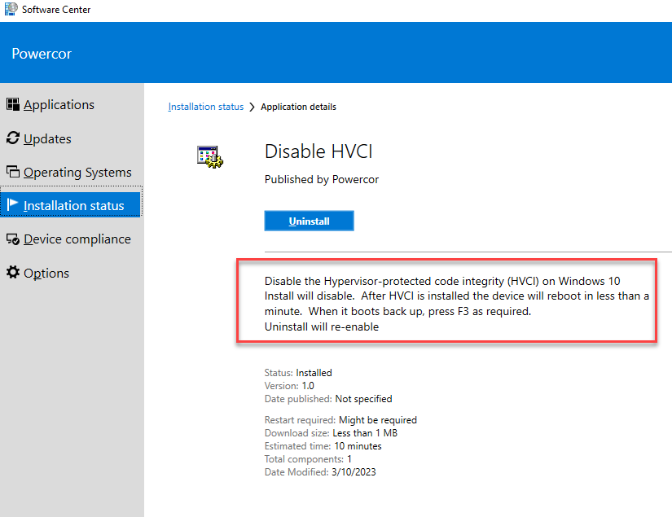

Remember that every time when there is an Windows update, it will likely reset "Memory Integrity" back to "Enabled". User will need to uninstalled "Disable HVCI" then reinstall it again.

- FSU Gen 5 do not have credit recognision issue (so far), and does not need Disable HVCI.

GMI Event Codes:

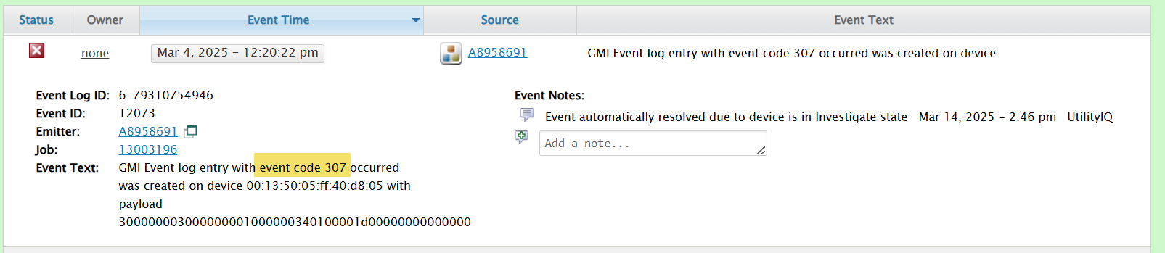

This is the distribution of these in UE and VPN for 2025:

UE | event_count
147 | 2580239
171 | 996564
169 | 209657
295 | 2832
148 | 1243
307 | 76
91 | 70
Grand Total | 3790681

VPN | EVENT_COUNT
171 | 15713941
147 | 1867027
169 | 896834
295 | 890
148 | 474
170 | 245
307 | 208
91 | 200
84 | 7
Grand Total | 18479826

Events 91,307 would apply to APs/MicroAPs.

Event 147 is for SIQ events. Fabian was able to correlate this to meters that are having several low voltage data in NAP.

Event | Event Name | Event Description
84 | EL_EVENT_METER_PSEMX | This event is generated when PSEMX is enabled/disabled, when the rolling key is changed/validated, or when a key test is passed.
91 | EL_EVENT_AP_FAILOVER | One AP has failed, and another has taken over in its place.  This indicates that one AP has taken the place of another on the mesh.
147 | EL_EVENT_POWER_MON_EVT | This event is recorded when a power mon alarm changes state.  The event includes a description of the alarm, the state of the alarm and the seq number of the data that triggered the alarm.
148 | EL_EVENT_DEVICE_SCRIPT_EXEC | Device script execution information for potential diagnostic audit.
169 | EL_EVENT_SYSVAR_ERROR | The event is generated each time a non-recoverable sysvar or app_sysvar error is detected. It may happen during the sysvar/app_sysvar initialization, read, or write.  Error codes are logged in the event, some errors may just be for info, while others may indicate issues.
170 | EL_EVENT_MEM_CHECK_FAIL | This event was introduced in firmware 3.12.0 and 4.2.0. It is generated if a memory error is repeatedly detected in flash or volatile memory. Although there are no known operational concerns of NICs with displaying these memory errors, they are being logged for diagnostic purposes.
171 | EL_EVENT_AUTH_KEY_MISSING_TRAP | This event is generated in cases where the NIC firmware is attempting to perform a certificate based validation for which a corresponding certificate is not available, and it is unable to obtain the rest of the certificate chain.
295 | EL_EVENT_SNTP_POLL_FAILURE | This AP sent an SNTP request for the time but did not receive any response.
307 | EL_EVENT_WAN_DIALER_STAT | One or more wan dialer failure statistics has crossed its threshold, causing a failover.

Email Subjects:

UIQ Read Flags Table:
UIQ read flags to IEE mapping

CityEdge/SSLS:

Minimum functionality requirements
A SCD (Smart Control Device) shall be capable of interfacing with: NEMA 7-pin compatible socket;

LabVIEW Installation:

- Find LabVIEW 2016 installaer and Driver at C:\Users\mkalra\OneDrive - NetworkPortal\Desktop\UE\SW
- Complete these above installations.
- Install vipm-25.3.3135-windows-setup fromsame location
- Install VIPM.
- Install all packages as in existing setup: 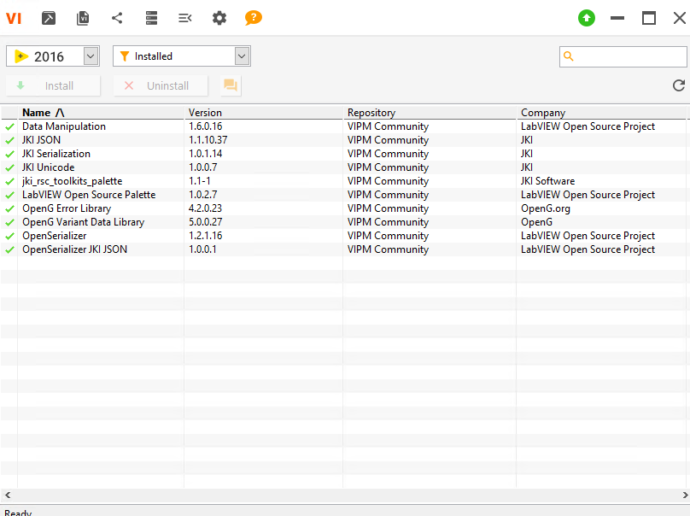
- Copy following drivers at below location in NI Installations:
  - C:\Program Files (x86)\National Instruments\LabVIEW 2016\instr.lib\APT 300XAC Series
  - C:\Program Files (x86)\National Instruments\LabVIEW 2016\instr.lib\ IT8600
  - C:\Program Files (x86)\National Instruments\LabVIEW 2016\instr.lib\ RIGOL DP800 Series
  - C:\Program Files (x86)\National Instruments\LabVIEW 2016\instr.lib\ RIGOL DS2000 DS4000 DS6000 Series

DLMS Metering:
DLMS (Device Language Message Specification) is an international communication protocol standard used for smart metering across electricity, water, gas, and heat meters. It is standardized under IEC 62056 and enables interoperable, secure, structured data exchange between smart meters and utility head-end systems.

DLMS in the DLMS/COSEM Architecture
DLMS is the application layer within the broader DLMS/COSEM model, which consists of:
- COSEM (Companion Specification for Energy Metering) – Defines the object model and semantics.
- OBIS (Object Identification System) – Names and classifies all meter data.
- DLMS – Converts COSEM objects into messages using standardized services.
- Communication Profiles – Enable transport over media like PLC, RF, cellular, Ethernet, optical ports.

Standardized Through IEC 62056 Series
Key standards include:
- IEC 62056-5-3 (DLMS/COSEM application layer)
- IEC 62056-6-1 (OBIS)
- IEC 62056-6-2 (COSEM classes)
- IEC 62056-4-7 (DLMS over IP networks)

Typical Uses of DLMS Protocol
- Automatic Meter Reading (AMR)
- Advanced Metering Infrastructure (AMI)
- Remote disconnect/reconnect
- Tariff updates
- Meter event and tamper detection
- Load profile and billing data retrieval
- Water/Gas/Heat metering integration

HES and MDMS difference:

Feature | HES (Head End System) | MDMS (Meter Data Management System)
Primary Role | Collects raw meter data; communicates with devices | Processes, stores, validates, and analyzes data  VEE: Validate, Estimate, Edit
Layer | Field/communications layer | Enterprise IT / data layer
Data Type | Raw, real-time | Validated, billing-grade
Storage | Short-term buffer | Long-term repository
Meter Control | Yes (remote connect, firmware mgmt) | No
Analytics | Basic operational | Advanced billing & grid analytics
Billing Support | Limited | Full billing integration
Integration | With meters, DCUs, HES–MDMS interface | CIS (Customer Information System), OMS, analytics platforms

GIT
- Github- Repository
- Git installation- Local Machine
- Tools to interact with Repo: Tortoise Git, Eclipse, Intellij

Useful Git Commands:

git init
- this creates a repo for the current folder you are in

git config --global user.name "Stuart McVicar"
* this sets the user that will be used when doing a check-in
* note this is not related to credentials

git config user.name
* this returns the value in that config setting

git config --global user.email "semcvicar@gmail.com"
* this sets the email for the user that is doing the checkin
* note this is not related to credentials

git config --global core.editor emacs
* this sets the editor that git will use when it wants you to type something.

git config --list --show-origin
* view all your git settings
* --show-origin - this shows where the setting comes from, which file, as the same setting can be in multiple files.

git config --global alias.co checkout
* sets up an alias for a command
* to checkout can now use git co rather than git checkout

git config --global alias.unstage 'reset HEAD --'
* can effectively create new commands
* can be used as git unstage myfile.txt rather than git reset HEAD -- myfile.txt

git config --global alias.visual '!gitk'
* can access an external command
* this will run gitk
* the '!' indicates it is an external command

git config --global credential.helper osxkeychain
git config --global credential.helper wincred
* this will stop git asking for your password each time

git add file.txt
* adds the file for the next commit
* nothing is committed at this point
* can use wild cards
* used for adding new files and telling the system that you want to commit a file that has been modified
* git takes the version of the file when you staged it. If you modify after adding(staging) the file, you will need to add it again.

git reset HEAD file.txt
* this removes a file from the staging area that you may have unintentionally added.
* it doesn't change the file in the working folder, so changes since the add won't be lost.

git checkout -- file.txt
* this will revert the file in the working folder.
* THIS WILL REMOVE YOUR CHANGES SINCE THE LAST COMMIT!

git commit -m "my first commit"
* records the state of the file at a specific time
* -m = add a message at the command line. Without this the default editor will be started to get a commit message from the user

git commit --amend
* takes the staged files and redoes the commit with the new changes
* if there are no staged files, then just the commit message will be updated

git rm PROJECTS.md
* moves the already deleted file into the staging area to be removed from tracking
* can also do with folders

git clone https://github.com/libgit2/libgit2 myFolder
* clone a remote repository to your local machine
* myfolder is optional, if given that is the folder that the repo will be cloned into

git remote -v
* will show the remote repos you have configured
* -v shows the URL

git fetch
* gets all the data from the remote repo that you don't have yet
* includes new branches, commits etc
* note that it doesn't merge the new changes with your work, you need to do that yourself
* this can be useful when you have merge problem, and pull won't work, but you need an update of data from the repo.

git pull
* this command fetches the latest data from the remote repo and merges that remote branch into your local branch.

git push
* pushes all your commited changes to the remote repo
* if someone else has pushed since your pull, your push will be rejected and their changes will need to be fetched and merged(pulled) before you can push up.

git tag
* shows the existing tags

git tag -a v1.4 -m "my version 1.4" 9fceb02
* adds an annotated tag to git with a specific message
* v1.4 is the tag identifier
* 9fceb02 is applying this tag to an earlier commit, it is optional. If no present it uses the last commit

git tag -d v1.4
* tags can be deleted

git push --tags
* by default tags aren't pushed to the server
* when pushing, specific tags can be referenced
* --tags pushes all tags at once.

git checkout v1.4
* this will checkout the files to a specific tag

git status -s
* this shows you the state of your local files in the local repo
* -s gives a short version of the status
* will show you the changed, untracked, added etc
* will give you the current branch

git log -p --stat
* shows the history of commits made in the repo
* -p adds the diffs of each commit
* --stat adds some stats about each commit
* --no-merges don't include merges in the output

git log --pretty=oneline
* shows a oneliner for each commit
* --pretty=format:"%H %s" allows customing the output
* see https://git-scm.com/book/en/v2/Git-Basics-Viewing-the-Commit-History#pretty_format for logging output information

git log -S function_name
* shows commits that changed the number of occurrences of that string
* handy way to check when a call to a function(function_name) is removed

git log --since="2008-10-01" --before="2008-11-01"
* only returns entries between the dates set for --before and --since
* each could be used alone
* --grep can be used to search commit message
* --author search the author entry for a string

git log --graph
* shows history in ascii graph - including branching

git diff --staged
* will tell you exactly what has changed
* compares what is in your staged area against your working directory
* this means, without --staged it won't show the staged changes
* --staged is optional - it will show what you've staged and what will go in the next commit.
* --cached is the same as --staged

git checkout -b feature21
* will create a new branch and switch to it
* same as:
git branch feature21
git checkout feature21

git checkout master
* will switch you to the master branch

git branch -d hotfix
* will delete a local branch

Actions

Reset local repo to be the same as a remote repository
git fetch origin
git reset --hard origin/master

Remove untracked files and directories
git clean -fdx
* Note that files will be deleted

View files to be removed
git clean -nfdx

Merge branch
git checkout targetBranch
git merge featureBranch

Process to follow when already working on a change and need to work in another branch

- "commit" changes in currentBranch
- checkout targetBranch your work will be merged into
  - git checkout targetBranch
- create a new workingBranch
  - git checkout -b workingBranch
- make changes
- commit changes
- checkout target brach your work will be merged into
  - git checkout targetBranch
- use git merge command to merge workingBranch into targetBranch
  - git merge workingBranch
- push if necessary
- delete workingBranch
  - git branch -d workingBranch
- checkout currentBranch and continue working
  - git checkout currentBranch
- back to work...

Handling merge conflicts

<<<<<<< HEAD:index.html
<div id="footer">contact : me@me.com</div>
=======
<div id="footer">
please contact us at notme@me.com
</div>
>>>>>>> feature21:index.html

* conflicts are shown with standard headers indicating where each version that is in conflict came from.
* <<<<<<< HEAD - this shows the part of the conflict from the current branch that you checkout out. Going from the HEAD to the '=======' marker.
* ======= - this is boundary between the conflict.
* >>>>>>> feature21 - this indicates the end of the conflict. From this point back to the '=======', they are the changes from the branch being merged in. feature21 indicates the branch being merged in.

* Once the conflicts have been merges the file should be added. This staging marks the conflict as resolved.

Ignore File
.gitignore - file
*.[oa]
*~

* this file lists the files that you don't want git to track
* # is a comment in the file
* ! to negate a pattern
* can "accumulate" rules ie
# ignore all .a files
*.a

# but do track lib.a, even though you're ignoring the other .a files
!lib.a

* the example above ignores all files that end in ".o" or ".a"
* the example above ignores all files that end with "~"
The lifecycle of the status of your files
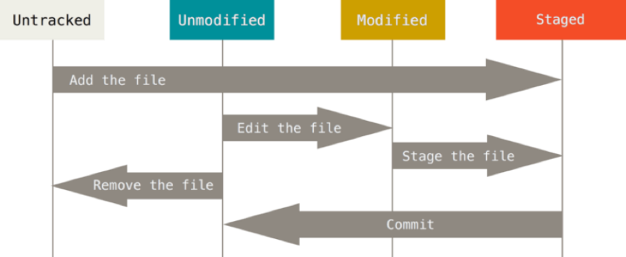

Basic Git Commands:

Git task | Notes | Git commands
Tell Git who you are | Configure the author name and email address to be used with your commits.  Note that Git strips some characters (for example trailing periods) from user.name. | git config --global user.name "Sam Smith"  git config --global user.email sam@example.com
Create a new local repository |  | git init
Check out a repository | Create a working copy of a local repository: | git clone /path/to/repository
 | For a remote server, use: | git clone username@host:/path/to/repository
Add files | Add one or more files to staging (index): | git add <filename>  git add *
Commit | Commit changes to head (but not yet to the remote repository): | git commit -m "Commit message"
 | Commit any files you've added with git add, and also commit any files you've changed since then: | git commit -a
Push | Send changes to the master branch of your remote repository: | git push origin master
Status | List the files you've changed and those you still need to add or commit: | git status
Connect to a remote repository | If you haven't connected your local repository to a remote server, add the server to be able to push to it: | git remote add origin <server>
 | List all currently configured remote repositories: | git remote -v
Branches | Create a new branch and switch to it: | git checkout -b <branchname>
 | Switch from one branch to another: | git checkout <branchname>
 | List all the branches in your repo, and also tell you what branch you're currently in: | git branch
 | Delete the feature branch: | git branch -d <branchname>
 | Push the branch to your remote repository, so others can use it: | git push origin <branchname>
 | Push all branches to your remote repository: | git push --all origin
 | Delete a branch on your remote repository: | git push origin :<branchname>
Update from the remote repository | Fetch and merge changes on the remote server to your working directory: | git pull
 | To merge a different branch into your active branch: | git merge <branchname>
 | View all the merge conflicts:  View the conflicts against the base file:  Preview changes, before merging: | git diff  git diff --base <filename>  git diff <sourcebranch> <targetbranch>
 | After you have manually resolved any conflicts, you mark the changed file: | git add <filename>
Tags | You can use tagging to mark a significant changeset, such as a release: | git tag 1.0.0 <commitID>
 | CommitId is the leading characters of the changeset ID, up to 10, but must be unique. Get the ID using: | git log
 | Push all tags to remote repository: | git push --tags origin
Undo local changes | If you mess up, you can replace the changes in your working tree with the last content in head:  Changes already added to the index, as well as new files, will be kept. | git checkout -- <filename>
 | Instead, to drop all your local changes and commits, fetch the latest history from the server and point your local master branch at it, do this: | git fetch origin  git reset --hard origin/master
Search | Search the working directory for foo(): | git grep "foo()"
Table 1: Basic Git Commands

Steps to Start with Git Fresh:

- Install Git Git-2.50.0.2-64-bit for Windows.
- Create account on Github and create a repository in your github profile.
- Create Git configuration with username and emailID:
a. git config --global user.name "manojkalra1208"
b. git config --global user.email manoj.kalra1208@gmail.com
- Create a Folder in your local machine, where Github code will be synced.
- Go to command prompt-> CD to the path of that folder, run:
  - Git init – It will create the “.git” file
- There are 2 steps to commit in GITHUB:
  - Stage
  - Commit
- Pointers:
  - GITHUB only commits (commit command) the code which is Staged.
  - GITHUB takes the code/files, which is in commit state or committed.
  - So the process will be- New->Stage->Commit->Push
- Add files to Stage and commit:
  - Git add * - Add all files to STAGE
  - Git add “file”- only specific file to STAGE
- Make connection in local repo and GITHUB
  - Git remote add origin “http path for remote repo”
- PUSH to GITHUB
  - Git push origin master – as of now pushing to master branch.

Cloning Existing Repo:
Only for first time to create a local repo of already GITHUB repo, later pull request will be used to update this local repo.
- Go to the Folder in your Local machine where you want to clone.
- Git clone “url of repo” - clone the repo locally( https://github.com/manojkalra1208/UE.git)

Push:
- Git push origin master - the update should already be staged and committed.

Pull:
- Git pull origin master

Postgre Installation Issue:

- Problem running post-install step. Installation may not complete correctly the database cluster initialisation failed.
Solution:
- cd "C:\Program Files\PostgreSQL\18\bin"
- initdb -E UTF8 --locale=en_US.utf8 -U postgres -D "C:\PostgresData"
- mkdir C:\PostgresData
- pg_ctl start -D "C:\PostgresData"

Add PostgreSQL 18 Manually:
Add PostgreSQL 18 Manually in pgAdmin
If it's installed and running but not showing in pgAdmin:
- Open pgAdmin.
- In the left panel, right-click on Servers → Create → Server.
- In the General tab:
  - Name: Give it a name like PostgreSQL 18.
- In the Connection tab:
  - Host name/address: localhost
  - Port: 5432 (or whatever port PostgreSQL 18 is using)
  - Maintenance database: postgres
  - Username: postgres (or your DB user)
  - Password: Enter your password (check "Save Password" if desired)
- Click Save.

Python Selenium Learning

Screenshot with address bar:
Supported PyScreeze and Pillow version supported for Python 3.12.5:
-----pip show pyscreeze
Name: PyScreeze
Version: 0.1.30
Summary: A simple, cross-platform screenshot module for Python 2 and 3.
Home-page: https://github.com/asweigart/pyscreeze
Author: Al Sweigart
Author-email: al@inventwithpython.com
License: MIT
Location: C:\Users\mkalra\AppData\Local\Programs\Python\Python312\Lib\site-packages
Requires:
Required-by: PyAutoGUI

-----pip show pillow
Name: pillow
Version: 11.3.0
Summary: Python Imaging Library (Fork)
Home-page: https://python-pillow.github.io
Author:
Author-email: "Jeffrey A. Clark" <aclark@aclark.net>
License:
Location: C:\Users\mkalra\AppData\Local\Programs\Python\Python312\Lib\site-packages
Requires:
Required-by:

Python code:
#browser with address bar

Import pyautogui
pyautogui.screenshot().save("On_DemandPing.png")

Python Installation:

- Download 3.12.5 exe for 64 bit windows
- Install standard, and copy the installation pathin the last screen during installation.
- Check the python version: python --version
- Check the pip version : pip --version
- Install selenium: pip install selenium
- All new packages are sitting in C:\Users\mkalra\AppData\Local\Programs\Python\Python312\Lib\site-packages
- Check Selenium: pip show selenium
- pip install pytest
- pip install pytest-html
- pip3 install pyautogui
- pip install Pillow
- pip install pytest-order
- pip Install pandas
- pip install pywin32

Python CMD Command
Pytest filename.py --html="C:\Automation\ExecutionLogs\ManualExecution\ test_ProgramMeter.html”
pytest -m sanity --html=report1.html
Pytest test_OnDemandPing.py --html=OnDemandPing.html
pytest test_OnDemandPing.py --html="C:\Automation\ExecutionLogs\ManualExecution\OnDemandPing.html"
pytest test_ProgramMeter.py --html="C:\Automation\ExecutionLogs\ManualExecution\ test_ProgramMeter.html"
pytest test_OnDemandLCClose.py --html="C:\Automation\ExecutionLogs\ManualExecution\test_OnDemandLCClose.html"

test_OnDemandLCOpen.py

Python Tricks:

#User function Template for python3
a = input()
b = input()
c = input()
# Write your code below that prints a a times and b b times, seperated by C
print((a*int(a))+c+(b*int(b)),end="")

Output: 666666&4444

- Problem:
Input: s = "Hello", n = 20, f = 5.5
Output:
Hello
30
55.0
Solution:
s = input()
n = int(input())
f = float(input())
print(s)
print(10+n)
print(f * 10)

- Problem

RDP User account add:

Remote Desktop Users:
Computer Management-> Local Users and Groups-> Remote Desktop Users->Double Click and add the user.

