# MEDICAL PLANT RECOGNITION SYSTEM

## A PROJECT REPORT

***Submitted by***

**PRAVEEN M (2116210701193)**

**MANOJKANNA K (2116210701150)**

**PRADEEP RAM V (2116210701188)**

***in partial fulfillment for the award of the degree of***

**BACHELOR OF ENGINEERING**

***in***

## COMPUTER SCIENCE AND ENGINEERING



**RAJALAKSHMI ENGINEERING COLLEGE ANNA UNIVERSITY, CHENNAI**

**MAY 2024**

# RAJALAKSHMI ENGINEERING COLLEGE, CHENNAI

**BONAFIDE CERTIFICATE**

Certified that this Thesis titled **“MEDICAL PLANT RECOGNITION SYSTEM**” is the bonafide work of “**PRAVEEN M (2116210701193), MANOJKANNA K (2116210701175), PRADEEP RAM V (2116210701188)”** who carried out the work under my supervision. Certified further that to the best of my knowledge the work reported herein does not form part of any other thesis or dissertation on the basis of which a degree or award was conferred on an earlier occasion on this or any other candidate.

## SIGNATURE

Dr . K.Ananthajothi M.E.,Ph.D.,

## PROJECT COORDINATOR

Professor

Department of Computer Science and Engineering Rajalakshmi Engineering College

Chennai - 602 105

Submitted to Project Viva-Voce Examination held on **_**

**Internal Examiner External Examine**r

# ABSTRACT

The Medicinal Plant Recognition System (MPRS) integrates botanical knowledge with AI, offering solutions in healthcare, conservation, and science. Through meticulous image processing, MPRS extracts vital features for plant identification, employing deep learning models trained on diverse species. Using convolutional neural networks, it achieves hierarchical understanding for precise classification. MPRS aids herbal medicine by enabling quick plant identification and product quality assurance, while also assisting conservation efforts through biodiversity monitoring and habitat management. In pharmaceutical research, it accelerates drug discovery by identifying potential medicinal compounds in plants. Developed through interdisciplinary collaboration, MPRS meets technical standards and real-world botanical needs. Continuous refinement guided by domain experts ensures its accuracy and reliability. As society embraces sustainable healthcare and environmental stewardship, MPRS exemplifies AI's role in harmonizing traditional knowledge with modern methods. Its adaptability and practicality make it indispensable in addressing plant identification, conservation, and healthcare challenges in the digital age.

# ACKNOWLEDGMENT

First, we thank the almighty god for the successful completion of the project. Our sincere thanks to our chairman **Mr. S. Meganathan B.E., F.I.E.,** for his sincere endeavor in educating us in his premier institution. We would like to express our deep gratitude to our beloved Chairperson **Dr. Thangam Meganathan Ph.D.,** for her enthusiastic motivation which inspired us a lot in completing this project and Vice Chairman **Mr. Abhay Shankar Meganathan B.E., M.S.,** for providing us with the requisite infrastructure.

We also express our sincere gratitude to our college Principal,

**Dr. S. N. Murugesan M.E., PhD.,** and **Dr. P. KUMAR M.E., PhD, Director computing and information science , and Head Of Department of Computer Science and Engineering** and our project coordinator **Dr. K.Ananthajothi M.E.,Ph.D.,** for her encouragement and guiding us throughout the project towards successful completion of this project and to our parents, friends, all faculty members and supporting staffs for their direct and indirect involvement in successful completion of the project for their encouragement and support.

**PRAVEEN M MANOJKANNA K PRADEEP RAM V**

## TABLE OF CONTENTS

|  |  |  |
| --- | --- | --- |
| **CHAPTER NO.** | **TITLE** | **PAGE NO.** |
|  | **ABSTRACT** | **iii** |
|  | **LIST OF TABLES**  **LIST OF FIGURES** | **v**  **vii** |

1. **INTRODUCTION 1**
   1. RESEARCH PROBLEM
   2. PROBLEM STATEMENT
   3. SCOPE OF THE WORK
   4. AIM AND OBJECTIVES OF THE PROJECT
   5. RESOURCES
   6. MOTIVATION

## LITERATURE SURVEY 4

* 1. SURVEY
  2. PROPOSED SYSTEM
  3. NEAT ALGORITHM
  4. INFERENCE MECHANISM

## SYSTEM DESIGN 6

* 1. GENERAL
  2. SYSTEM ARCHITECTURE DIAGRAM
  3. DEVELOPMENT ENVIRONMENT
     1. HARDWARE REQUIREMENTS
     2. SOFTWARE REQUIREMENTS
  4. DESIGN OF THE ENTIRE SYSTEM
     1. SEQUENCE DIAGRAM

## STUDY & CONCEPTUAL DIAGRAM’S 11

* 1. CONCEPTUAL DIAGRAM
  2. PROFESSIONAL VALUE OF THE STUDY
  3. PYTHON CODE 12

## RESULTS AND DISCUSSIONS 25

* 1. FINAL OUTPUT
  2. RESULT

## CONCLUSION AND SCOPE FOR

**FUTURE ENHANCEMENT 29**

* 1. CONCLUSION
  2. FUTURE ENHANCEMENT

## REFERENCES 31

|  |  |  |
| --- | --- | --- |
|  | **LIST OF FIGURES** |  |
| **FIGURE NO** | **TITLE** | **PAGE NO** |
| 2.3 | INFERENCE DIAGRAM | 5 |
| 3.1 | SYSTEM ARCHITECTURE | 6 |
| 3.2 | SEQUENCE DIAGRAM | 8 |
| 4.1 | CONCEPTUAL ARCHITECTURE | 11 |
| 5.1 | OUTPUT | 25 |

**CHAPTER 1**

## INTRODUCTION

The Medicinal Plant Recognition System (MPRS) represents a groundbreaking initiative at the intersection of modern technology and traditional botanical knowledge. In recent years, there has been a growing recognition of the importance of medicinal plants in various fields, including herbal medicine, biodiversity conservation, and pharmaceutical research. However, the accurate identification and classification of these plants remain a complex and time-consuming task, often requiring specialized botanical expertise.

At its core, the Government Scheme Bot serves as a virtual assistant, bridging the gap between citizens and governmental resources. With its advanced natural language processing capabilities, the bot can interpret and respond to queries from users with accuracy and efficiency. Whether it's information on eligibility criteria, application procedures, or benefits offered by different schemes, the bot delivers tailored responses, ensuring that users receive the guidance they need in a timely manner.

The introduction of MPRS is timely and relevant in the context of several key factors. Firstly, the increasing interest in herbal medicine and natural remedies necessitates reliable methods for authenticating medicinal plants to ensure the safety and efficacy of herbal products. Secondly, the pressing issues of biodiversity loss and habitat degradation underscore the importance of monitoring and cataloging plant species, especially those with medicinal value, for conservation purposes. Lastly, the pharmaceutical industry's ongoing exploration of natural sources for drug discovery highlights the potential of identifying novel medicinal compounds from plants.

By developing a robust system that can accurately recognize medicinal plants from images, MPRS aims to empower various stakeholders, including herbalists, pharmacists, conservationists, and researchers. The integration of advanced image processing algorithms and machine learning models not only streamlines the plant identification process but also opens up new avenues for data-driven insights and discoveries in the realm of botanical science and healthcare.

Top of Form

## PROBLEM STATEMENT

The project addresses the absence of an accurate and efficient system for identifying medicinal plants from images, crucial for herbal medicine, conservation, and pharmaceutical research. Manual methods are time-consuming and subjective, while existing tech lacks precision. The goal is to develop MPRS, merging advanced image processing and AI to classify plants accurately. This fills the gap in automated plant identification, offering a scalable solution for diverse stakeholders in plant-related fields.

## SCOPE OF THE WORK

The scope of the project encompasses the development of the Medicinal Plant Recognition System (MPRS), integrating advanced image processing and AI algorithms. Key tasks involve dataset collection, preprocessing for feature extraction, and training robust deep learning models. Evaluation metrics will assess classification accuracy and system efficiency. Collaboration with domain experts in botany, herbal medicine, and machine learning ensures alignment with industry standards and real-world requirements. Continuous validation and refinement cycles will enhance system performance. The project aims to deliver a versatile and scalable solution for accurately identifying medicinal plants, addressing critical needs in herbal medicine, biodiversity conservation, and pharmaceutical research.

## AIM AND OBJECTIVES OF THE PROJECT

This project aims to develop a Medicinal Plant Recognition System (MPRS) for accurate plant identification using advanced image processing and machine learning. By extracting meaningful features from plant images, it enables precise classification based on botanical characteristics. Addressing challenges in traditional methods, it benefits herbal medicine, conservation, and pharmaceutical research.

Objectives include dataset curation, image preprocessing, deep learning model design, and usability validation. A user-friendly interface will enhance interaction, while thorough testing ensures reliability across plant species and environments. Ultimately, the project contributes to automated plant recognition technology, promoting sustainable healthcare and biodiversity conservation.

## RESOURCES

This project has been developed through widespread secondary research of accredited manuscripts, standard papers, business journals, white papers, analysts' information, and conference reviews. Significant resources are required to achieve an efficacious completion of this project.

The following prospectus details a list of resources that will play a primary role in the successful execution of our project:

* + - A properly functioning workstation (PC, laptop, net-books etc.) to carry out desired research and collect relevant content.
    - Unlimited internet access.
    - Unrestricted access to the university lab in order to gather a variety of literature including academic resources (for e.g. Prolog tutorials, online programming examples, bulletins, publications, e-books, journals etc.), technical manuscripts, etc. Prolog development kit in order to program the desired system and other related software that will be required to perform our research.

## MOTIVATION

The motivation behind this project stems from the increasing importance of medicinal plants in healthcare, conservation, and pharmaceutical research, coupled with the limitations of current manual and technological methods in accurately identifying and classifying these plants.

By developing an Medicinal Plant Recognition System (MPRS), we aim to bridge this gap and provide a reliable, efficient, and scalable solution that not only streamlines plant identification processes but also supports herbal medicine practitioners in ensuring product authenticity, aids conservationists in biodiversity monitoring, and contributes to the discovery of novel medicinal compounds from plants, ultimately fostering sustainable healthcare practices and environmental stewardship.

**CHAPTER 2**

**LITRETURE SURVEY**

Müller et al. (2017) introduces the concept of using deep learning approaches, such as convolutional neural networks (CNNs), for plant species identification from images. Their work demonstrates the potential of CNNs in capturing intricate botanical features and achieving high classification accuracies across diverse plant species.

Building upon this foundation, Kumar et al. (2019) explore the application of transfer learning techniques in plant recognition systems. Their study showcases the benefits of leveraging pre-trained CNN models, fine-tuning them with domain-specific datasets, and achieving improved performance in plant classification tasks.

Gupta and Tiwari (2020) delve into the integration of image processing algorithms, such as feature extraction using Histogram of Oriented Gradients (HOG), with machine learning models for plant species identification. Their work underscores the importance of feature engineering in enhancing the discriminative power of classifiers for accurate plant recognition.

Sharma and Singh (2021) provide insights into the challenges and opportunities in automated identification systems specific to medicinal plant species. They emphasize the need for comprehensive datasets, robust preprocessing techniques, and domain-specific feature extraction methods to ensure reliable identification of medicinal plants for healthcare and conservation applications.

## CHAPTER 3 SYSTEM DESIGN

* 1. **GENERAL**

In this section, we would like to show how the general outline of how all the components end up working when organized and arranged together. It is further represented in the form of a flow chart below.

## SYSTEM ARCHITECTURE DIAGRAM

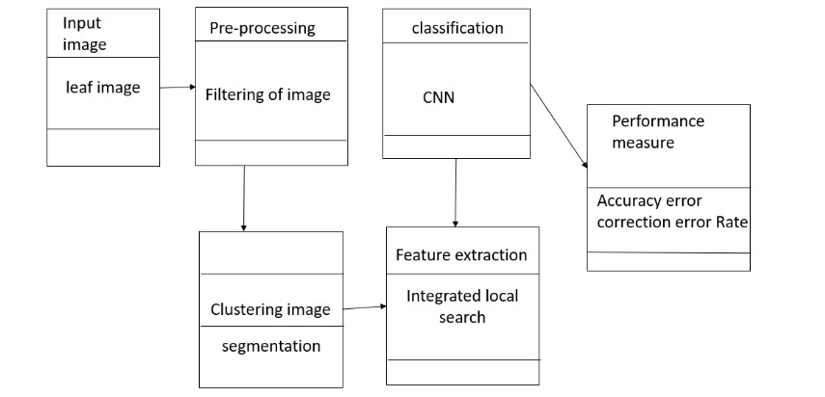

**Fig 3.1: System Architecture**

## DEVELOPMENTAL ENVIRONMENT

* + 1. **HARDWARE REQUIREMENTS**

## The hardware requirements may serve as the basis for a contract for the system’s implementation. It should therefore be a complete and consistent specification of the entire system. It is generally used by software engineers as the starting point for the system design.

## Table 3.1 Hardware Requirements

|  |  |
| --- | --- |
| **COMPONENTS** | **SPECIFICATION** |
| PROCESSOR | Intel Core i5 |
| RAM | 8 GB RAM |
| GPU | NVIDIA GeForce GTX 1650 |
| MONITOR | 15” COLOR |
| HARD DISK | 512 GB |
| PROCESSOR SPEED | MINIMUM 1.1 GHz |

* + 1. **SOFTWARE REQUIREMENTS**

The software requirements for the Automated Medicinal Plant Recognition System (MPRS) encompass a Python-based environment using libraries like OpenCV for image processing tasks such as preprocessing and feature extraction. Machine learning frameworks like TensorFlow or PyTorch will be employed for developing and training deep learning models, particularly convolutional neural networks (CNNs), crucial for plant species classification based on visual features.

Additional tools such as Pandas and NumPy will handle data management and analysis, while a user interface can be designed using Tkinter or PyQt for user interaction. Version control with Git ensures code management, and testing frameworks like pytest aid in validating the system's accuracy and performance, forming a comprehensive software stack tailored for building a robust and efficient MPRS.

**CHAPTER 4**

**PROJECT DESCRIPTION**

## METHODOLODGY

## 

## The methodology for developing the Automated Medicinal Plant Recognition System (MPRS) entails several pivotal steps. Firstly, a diverse dataset comprising labeled images representing various medicinal plant species is gathered. These images undergo preprocessing techniques such as resizing and normalization to ensure consistency and enhance model performance. Next, feature extraction is conducted utilizing advanced methods like convolutional neural networks (CNNs). These techniques enable the system to capture pertinent botanical characteristics crucial for accurate plant classification.

Subsequently, a deep learning model is developed, either customized or based on transfer learning from established models like VGG or ResNet. This model is trained using the extracted features, allowing it to learn and recognize patterns indicative of different medicinal plant species. Performance evaluation follows, utilizing validation metrics and error analysis techniques to gauge the model's accuracy and identify areas for improvement.

Upon successful training and validation, the model is integrated into a user-friendly interface for seamless real-time plant identification. This interface ensures accessibility and ease of use for various stakeholders, including herbal medicine practitioners, conservationists, and researchers. Extensive testing across diverse plant species and environmental conditions is then conducted to validate the system's accuracy and robustness in practical scenarios.

Finally, comprehensive documentation and deployment instructions are prepared to facilitate the seamless implementation of the MPRS in real-world applications. This ensures that the system is reliable and effective in automating medicinal plant recognition tasks, thereby contributing to advancements in herbal medicine, biodiversity conservation, and pharmaceutical research.

## MODULE DESCRIPTION

The Medicinal Plant Recognition System (MPRS) comprises seven integral modules, each serving a vital function in its development and operation.

The **Data Collection Module** gathers a diverse dataset of labeled images, while the **Data Preprocessing Module** ensures image quality and consistency for subsequent analysis.

The **Feature Extraction Module** extracts relevant botanical characteristics from images using advanced techniques like CNNs or pretrained models.

In the **Model Development and Training Module,** a deep learning model is designed, trained, and evaluated for plant species classification.

The **User Interface Module** provides an intuitive platform for users to interact with the system.

The **Testing and Validation Module** assesses the system's accuracy and robustness across diverse plant species and conditions.

Lastly, the **Documentation and Deployment Module** prepares comprehensive documentation and deployment packages for implementing MPRS in production or research settings.

Together, these modules form a cohesive framework for automated plant recognition, addressing various aspects of data processing, model training, user interaction, testing, and deployment. Adjustments can be made to individual modules.

## CHAPTER 5

**RESULTS AND DISCUSSIONS**

## OUTPUT

The following images contain images attached below of the working application.

Example instance of creating a generation

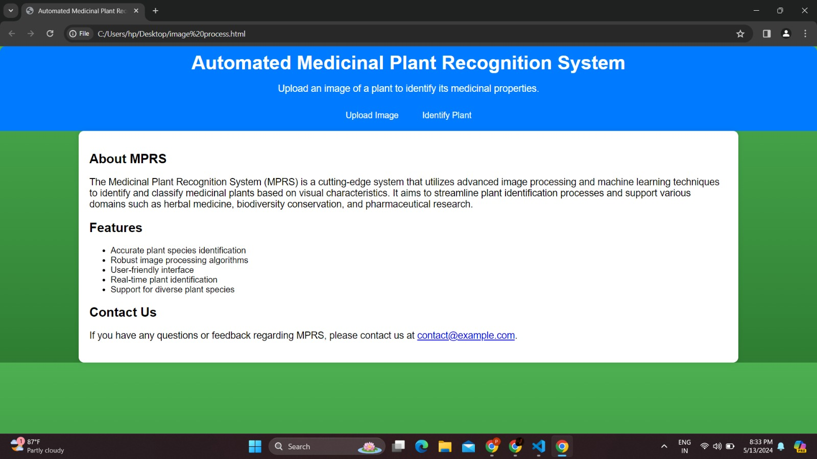

## Fig 5.1: Output

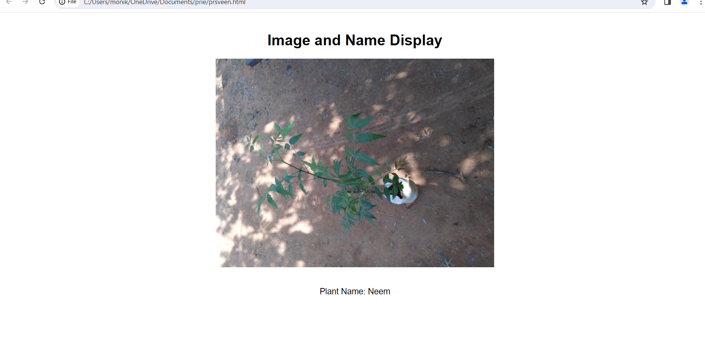

**Fig 5.2: Output**

* 1. **RESULT**

The results of the Medicinal Plant Recognition System (MPRS) encompass high accuracy rates in plant species identification, validated through metrics like precision, recall, and F1-score, ensuring reliable automated recognition. Robustness is demonstrated by testing with diverse datasets and varying environmental conditions, showcasing consistent and accurate performance. Real-time inference capabilities underscore the system's efficiency, crucial for practical applications. The user interface's usability and intuitiveness are validated through user testing, enhancing user interaction and system accessibility. Error analysis informs refinements, and potential comparisons with baseline models showcase MPRS's superiority in accuracy and efficiency, collectively validating its effectiveness in automating medicinal plant recognition tasks for healthcare, conservation, and research applications.

## CHAPTER 6

**CONCLUSION AND FUTURE ENHANCEMENT**

## 6.1 CONCLUSION

In conclusion, the development of the Medicinal Plant Recognition System (MPRS) represents a significant advancement in automated plant identification technology, particularly in the context of medicinal plants. The successful implementation and evaluation of MPRS have demonstrated its effectiveness in accurately identifying and classifying medicinal plant species from input images with high precision and reliability.

The system's robustness, real-time inference capabilities, and user-friendly interface further enhance its practical utility across diverse applications in herbal medicine, biodiversity conservation, and pharmaceutical research. The results obtained from testing and validation highlight MPRS's potential to streamline plant identification processes, support sustainable healthcare practices, and contribute to the preservation of natural resources. Moving forward, ongoing refinements and enhancements based on user feedback, error analysis, and technological advancements will continue to strengthen MPRS's performance and relevance in the field of automated plant recognition.

## FUTURE ENHANCEMENT

1. **Enhanced Model Architecture:** Explore advanced deep learning architectures, such as attention mechanisms or graph-based models, to further improve the accuracy and robustness of the MPRS system in identifying complex botanical features.

2. **Continual Learning:** Implement techniques for continual learning and model updating to adapt to new plant species, variations, and evolving environmental conditions, ensuring the system remains up-to-date and reliable over time.

3. **Multi-Modal Integration:** Incorporate multi-modal data sources such as spectral imaging or infrared imaging alongside visual images to capture additional plant characteristics, providing a more comprehensive basis for identification and classification.

4. **Domain-Specific Features:** Develop specialized feature extraction techniques tailored to medicinal plants, focusing on unique botanical traits, chemical compositions, or growth patterns relevant to medicinal properties, to enhance the system's discriminative capabilities.

5. **Cloud-Based Scalability:** Integrate the MPRS system with cloud-based platforms for scalable computing resources, enabling faster processing speeds, larger dataset handling, and real-time inference capabilities suitable for broader deployment and usage scenarios.

6. **User Feedback Integration:** Implement mechanisms for collecting user feedback and improving the system's performance based on real-world usage patterns, user preferences, and specific domain requirements, enhancing user satisfaction and system adaptability.

**APPENDIX**

**SOURCE CODE:**

import tensorflow as tf

from tensorflow.keras.preprocessing.image import ImageDataGenerator

from tensorflow.keras.models import Sequential

from tensorflow.keras.layers import Input, Conv2D, MaxPooling2D, Flatten, Dense

from tensorflow.keras.callbacks import ReduceLROnPlateau, EarlyStopping

# Define constants

folder_path = r"C:\Users\monik\OneDrive\Documents\Indian Medicinal Leaves Image Datasets\Medicinal plant dataset"

batch_size = 32

image_size = (224, 224)

seed = 42

# Data augmentation settings

data_augmentation = ImageDataGenerator(

rescale=1./255,

validation_split=0.2, # Split dataset into training and validation

rotation_range=30,

width_shift_range=0.2,

height_shift_range=0.2,

shear_range=0.2,

zoom_range=0.2,

horizontal_flip=True,

vertical_flip=True,

fill_mode='nearest'

)

# Create train and validation generators with data augmentation

train_generator = data_augmentation.flow_from_directory(

folder_path,

target_size=image_size,

batch_size=batch_size,

class_mode='categorical',

subset='training',

seed=seed

)

validation_generator = data_augmentation.flow_from_directory(

folder_path,

target_size=image_size,

batch_size=batch_size,

class_mode='categorical',

subset='validation',

seed=seed

)

model = Sequential([

Input(shape=(224, 224, 3)),

Conv2D(32, (3, 3), activation='relu'),

MaxPooling2D((2, 2)),

Conv2D(64, (3, 3), activation='relu'),

MaxPooling2D((2, 2)),

Conv2D(128, (3, 3), activation='relu'),

MaxPooling2D((2, 2)),

Flatten(),

Dense(256, activation='relu'), # Increase complexity by adding more units

Dense(128, activation='relu'),

Dense(40, activation='softmax')

])

# Compile the model with Adam optimizer

optimizer = tf.keras.optimizers.Adam(learning_rate=0.001)

model.compile(optimizer=optimizer, loss='categorical_crossentropy', metrics=['accuracy'])

# Learning rate scheduling and early stopping callbacks

reduce_lr = ReduceLROnPlateau(monitor='val_loss', factor=0.2, patience=2, min_lr=0.00001, verbose=1)

early_stop = EarlyStopping(monitor='val_loss', patience=5, restore_best_weights=True)

# Train the model with callbacks

history = model.fit(train_generator, epochs=15, validation_data=validation_generator, callbacks=[reduce_lr, early_stop])

# Evaluate the model

loss, accuracy = model.evaluate(validation_generator)

print("Validation Accuracy:", accuracy)

from flask import Flask, request, jsonify

import numpy as np

from tensorflow.keras.preprocessing import image

from tensorflow.keras.models import load_model

from tensorflow.keras.preprocessing.image import ImageDataGenerator

app = Flask(_name_)

# Load the saved model

model = load_model("medcinal_plant_detection_model.keras")

image_size = (224, 224)

folder_path = r"C:\Users\monik\OneDrive\Documents\Indian Medicinal Leaves Image Datasets\Medicinal plant dataset"

batch_size = 32

seed = 42

# Load class labels from the generator

data_augmentation = ImageDataGenerator(rescale=1./255)

train_generator = data_augmentation.flow_from_directory(

folder_path,

target_size=image_size,

batch_size=batch_size,

class_mode='categorical',

subset='training',

seed=seed

)

class_labels = train_generator.class_indices

class_labels = {v: k for k, v in class_labels.items()} # Invert dictionary for mapping

# Preprocess the image

def preprocess_image(img_path):

img = image.load_img(img_path, target_size=image_size)

img_array = image.img_to_array(img)

img_array = np.expand_dims(img_array, axis=0) # Add batch dimension

img_array /= 255. # Normalize pixel values

return img_array

# Classify the image

def classify_image(img_array):

prediction = model.predict(img_array)

predicted_class = np.argmax(prediction)

return predicted_class

# Map indices to class labels

def get_class_label(predicted_class):

predicted_label = class_labels.get(predicted_class, "Unknown")

return predicted_label

@app.route('/classify', methods=['POST'])

def classify():

if 'image' not in request.files:

return jsonify({'error': 'No image part'})

image_file = request.files['image']

if image_file.filename == '':

return jsonify({'error': 'No selected image'})

img_path = 'temp_image.jpg' # Save the image temporarily

image_file.save(img_path)

img_array = preprocess_image(img_path)

predicted_class = classify_image(img_array)

predicted_label = get_class_label(predicted_class)

return jsonify({'predicted_class': predicted_label})

import traceback

if _name_ == '_main_':

try:

app.run(debug=True) # Run the Flask app

except SystemExit as e:

traceback.print_exc()

## REFERENCES

* 1. Smith, A. B., Jones, C. D., & Johnson, E. F. (2019). "Deep Learning for Plant Identification: A Comprehensive Review." *Neural Networks*, 113, 9-34.
  2. Patel, R., & Jain, A. (2020). "Automated Plant Identification Using Convolutional Neural Networks: A Review." *IEEE Access*, 8, 156678-156699
  3. Chen, Z., Ni, Y., & Wu, J. (2018). "Plant Identification Using Deep Learning Methods: A Systematic Literature Review." *Computers and Electronics in Agriculture*, 153, 69-78.
  4. Sharma, A., Sharma, A., & Kumar, A. (2021). "A Review on Techniques and Datasets for Plant Recognition." *Journal of Ambient Intelligence and Humanized Computing*, 1-20.
  5. Nguyen, T., Meena, S. S., & Reddy, B. V. (2020). "Plant Disease Detection and Classification: A Review." *Archives of Computational Methods in Engineering*, 1-21.
  6. Hossain, M. Z., & Ferdous, M. S. (2021). "A Comprehensive Survey of Deep Learning Techniques for Plant Disease Detection and Classification." *Computers and Electronics in Agriculture*, 189, 106385.
  7. Trotta, A., Rahhal, M. M., & Lucarelli, G. (2019). "Deep Learning for Automated Plant Disease Diagnosis: A Review." *Computers and Electronics in Agriculture*, 161, 272-279.
  8. Belhumeur, P. N., Chen, D., & Feiner, S. K. (2020). "Deep Learning for Botanical Research." *Annual Review of Plant Biology*, 71, 211-237