To Run the application BeOBank app please follow below steps

**Solution file is inside the folder = > BeOBank.Api**

1. **Go to property and select multiple startup project as below.**

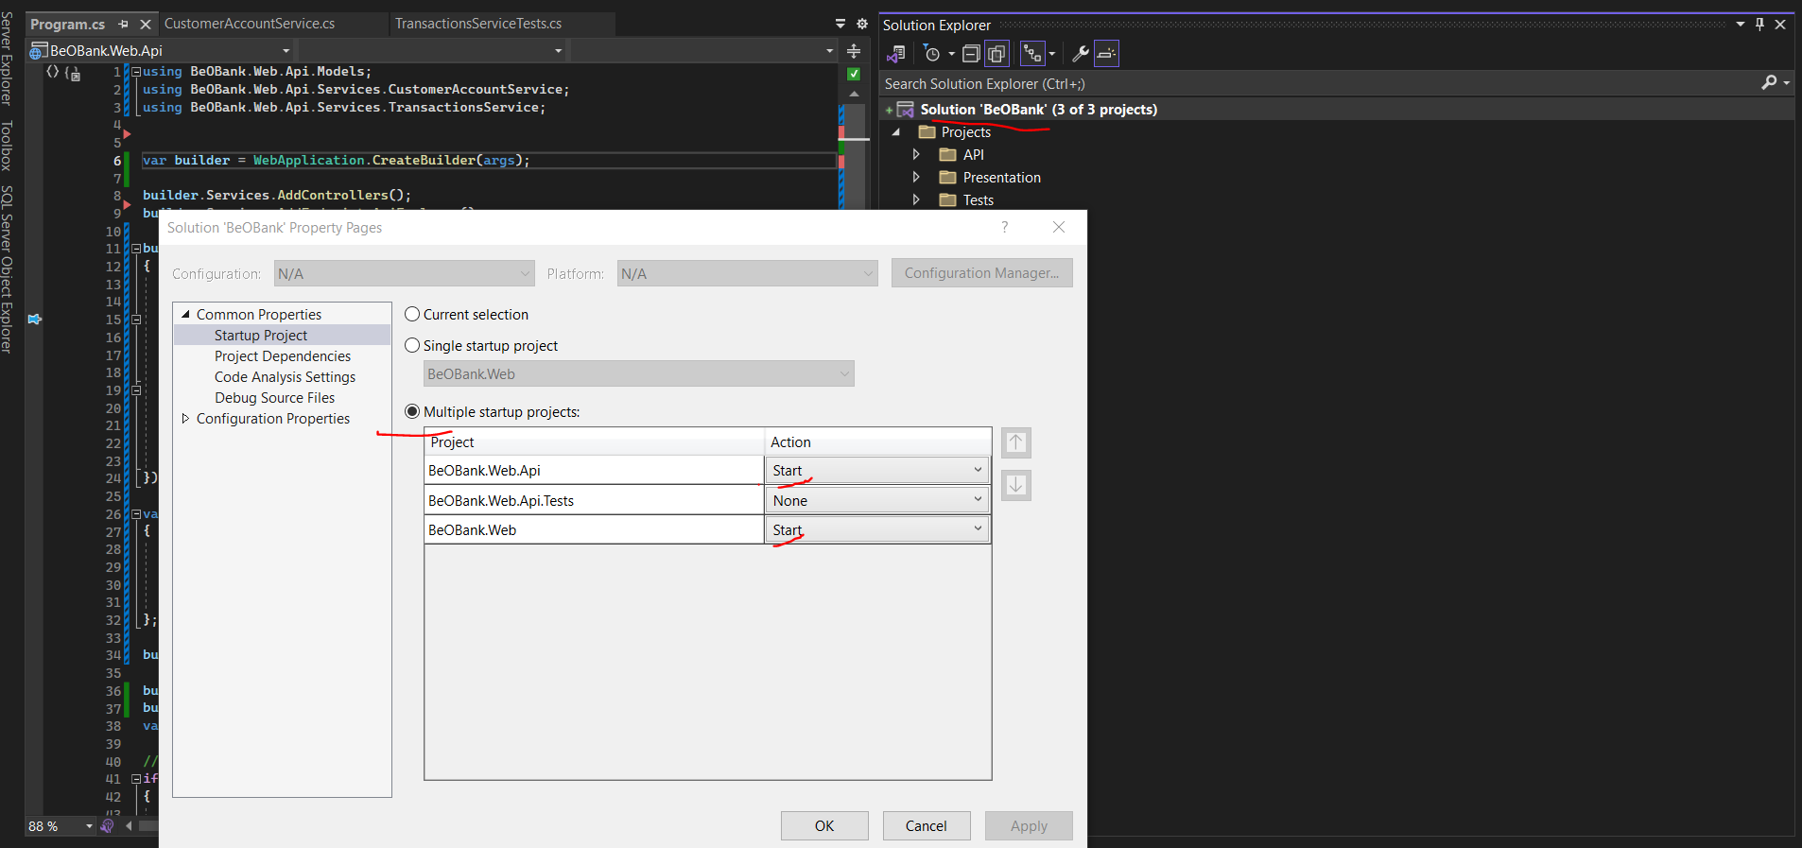

1. Click Start and accept any certificate prompt if asked

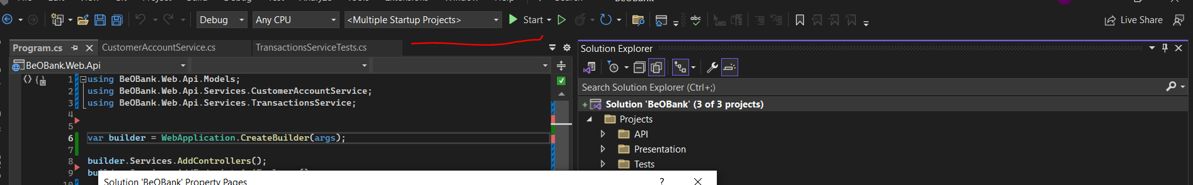

1. Two tab will open below is UI

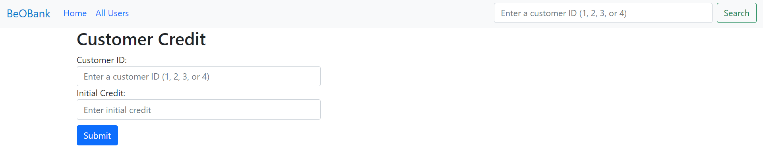

1. Other is swagger

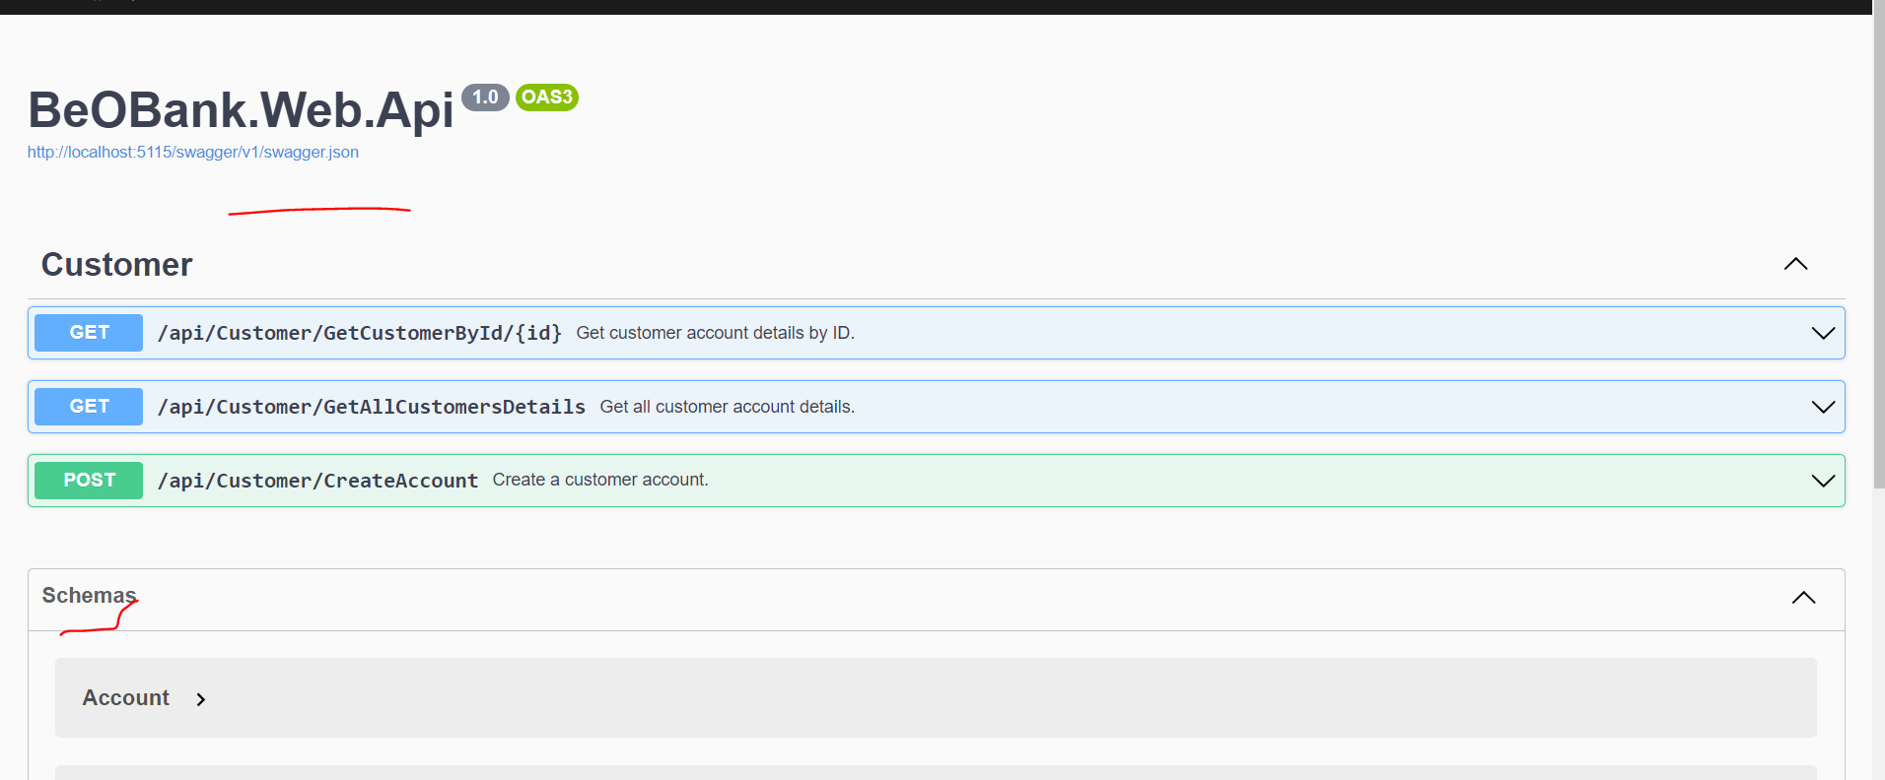

1. There are 13 Test cases you can view in Test-Explorer

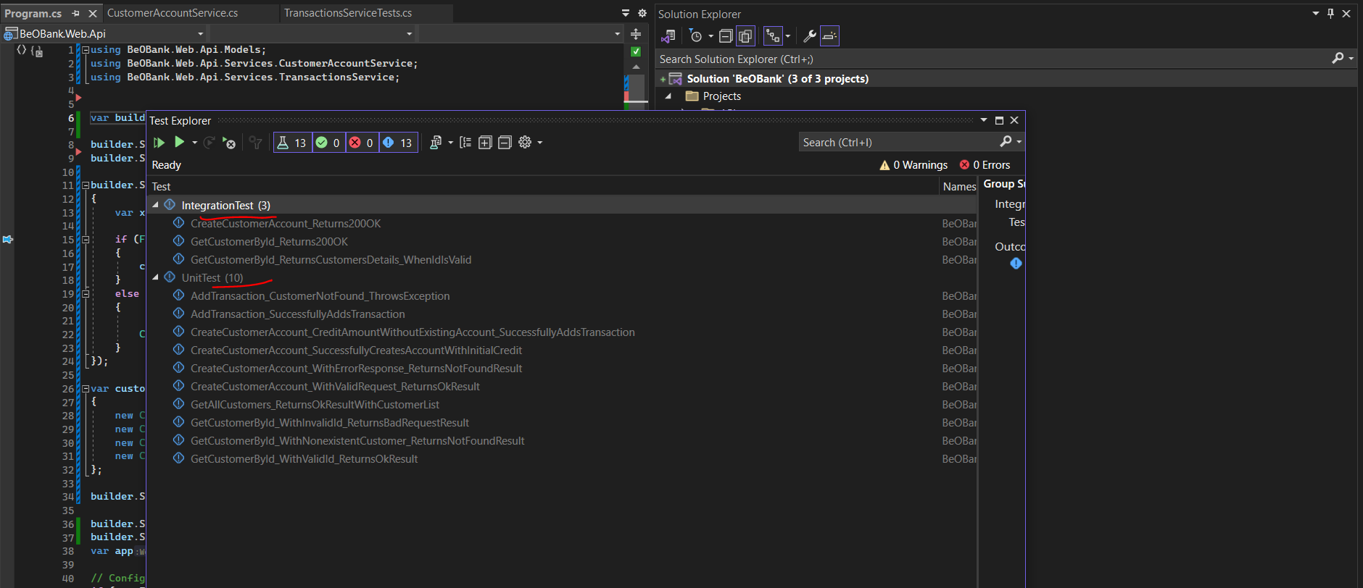

Thanks,  
Manoj Kargeti