|  |
| --- |
| Name: P D S S Pitiyage |
| Student Reference Number:10638393 |



|  |  |  |
| --- | --- | --- |
| Module Code: SOFT255SL | Module Name: Software Engineering for the internet using Java | |
| Coursework Title: | | |
| Deadline Date: | | Member of staff responsible for coursework: |
| Programme:  BSc(hons) Software Engineering | | |
| Please note that University Academic Regulations are available under Rules and Regulations on the University website [www.plymouth.ac.uk/studenthandbook](http://www.plymouth.ac.uk/studenthandbook). | | |
| Group work: please list all names of all participants formally associated with this work and state whether the work was undertaken alone or as part of a team. Please note you may be required to identify individual responsibility for component parts.  ***We confirm that we have read and understood the Plymouth University regulations relating to Assessment Offences and that we are aware of the possible penalties for any breach of these regulations. We confirm that this is the independent work of the group.***  Signed on behalf of the group: | | |
| Individual assignment: ***I confirm that I have read and understood the Plymouth University regulations relating to Assessment Offences and that I am aware of the possible penalties for any breach of these regulations. I confirm that this is my own independent work.***  Signed : | | |
| Use of translation software: failure to declare that translation software or a similar writing aid has been used will be treated as an assessment offence.  I *have used/not used translation software.  If used, please state name of software………………………………………………………………… | | |
| **Overall mark _____% Assessors Initials ______ Date_________** | | |

*Please delete as appropriateSci/ps/d:/students/cwkfrontcover/2013/14

Contents

Acknowledgement 3

Introduction 4

Drawbacks of the Existing System 5

Benefits of the new system 5

Entity Relationship Diagram (ER) 6

Use case Diagram 7

7

Site Map 8

Technologies Used 9

Interfaces 10

Workload Matrix 19

# Acknowledgement

**We would like to express our special thanks of gratitude to Mr. Chaminda Wijesinghe who gave us the guidance and consultations to succeed this project.**

# Introduction

* This site was developed to fill the gap between universities, students and the Industry.
* This will be also helpful to provide collaboration between industries and universities.
* Industry and student will be able to post their own problems and researches via this site and other parties will be able see them.
* Industry can pick students by seeing their performance since their results and projects will be uploaded to this website.
* There will be 4 main roles in this site

1. University :

* Post university calendar
* Request for lectures/support
* Register students
* Post results

1. Industry :

* Create events
* View student results
* View calendars
* Create problems for students
* Answer student problems
* Post vacancy

1. Student :

* Post problems/researches
* Solve industrial problems
* Participate in events

1. Public :

* View public posts

# Drawbacks of the Existing System

* After the graduation students may have to search for the jobs by looking for industrial companies one by one.
* Companies do not have a way to track the activities of student.
* Companies do not have proper way to post vacancies targeting a special batch.

# Benefits of the new system

* Students will be able to actively participate in the industrial level questions and events.
* Companies will be able to hire students by viewing the results since universities will be able to upload the results.
* Students will be able to view the events hosted by companies in a one place.
* Universities will be able to ask for events
* Students will have a place to post their problems and communicate with the industry

# Entity Relationship Diagram (ER)

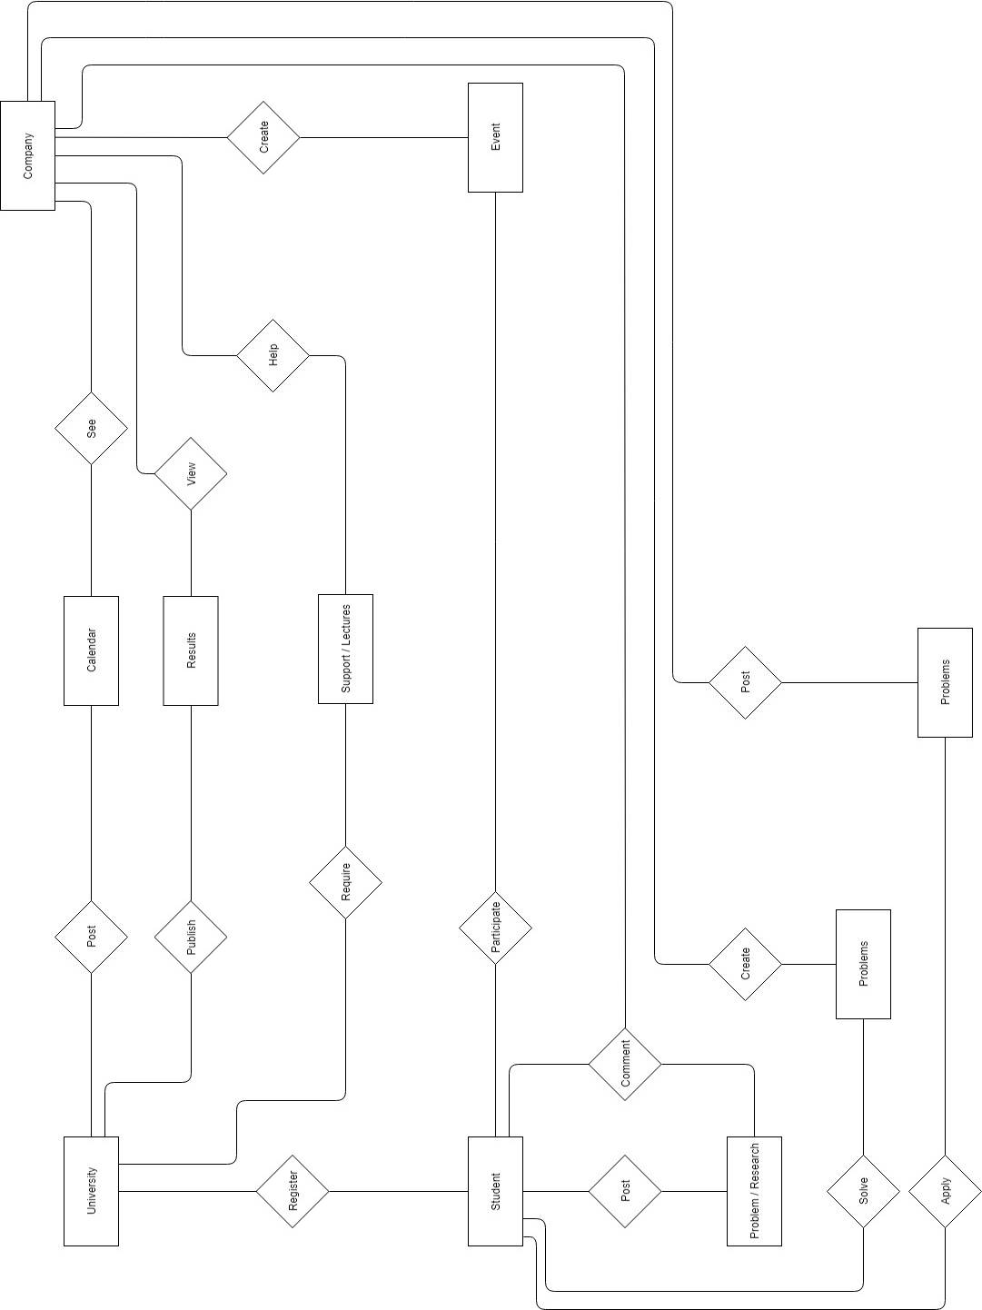

# Use case Diagram

# C:\Users\Suthura\AppData\Local\Microsoft\Windows\INetCache\Content.Word\Untitled Diagram (4).jpg

# Site Map

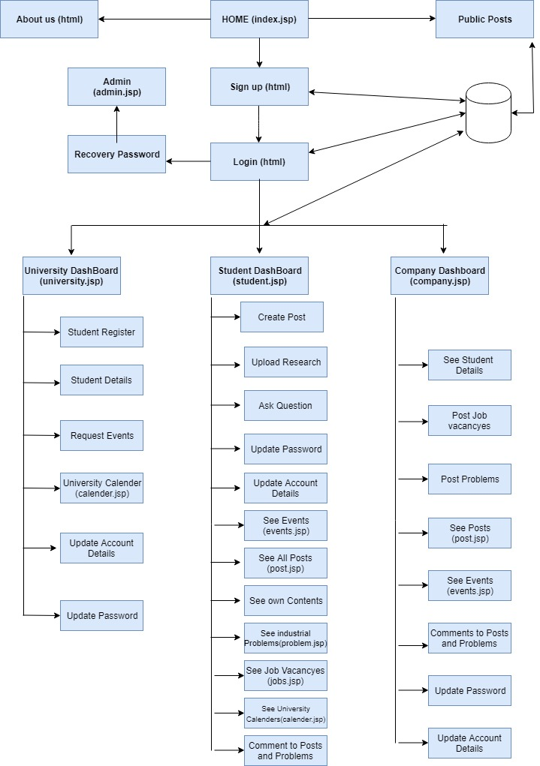

# Technologies Used

* HTML
* CSS
* JAVA
* JSP
* JAVA BEANS
* JQUERY
* JAVASCRIPT
* BOOTSTRAP
* MVC ARCHITECTURE

# Interfaces

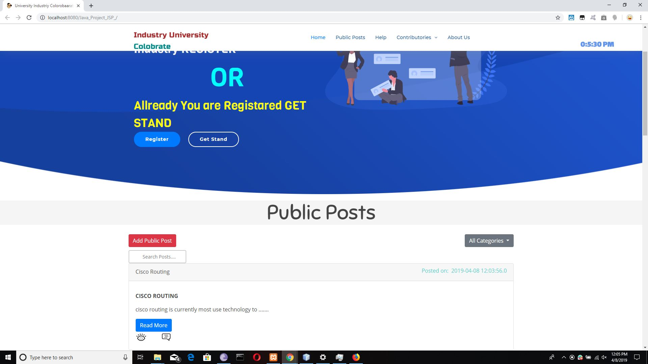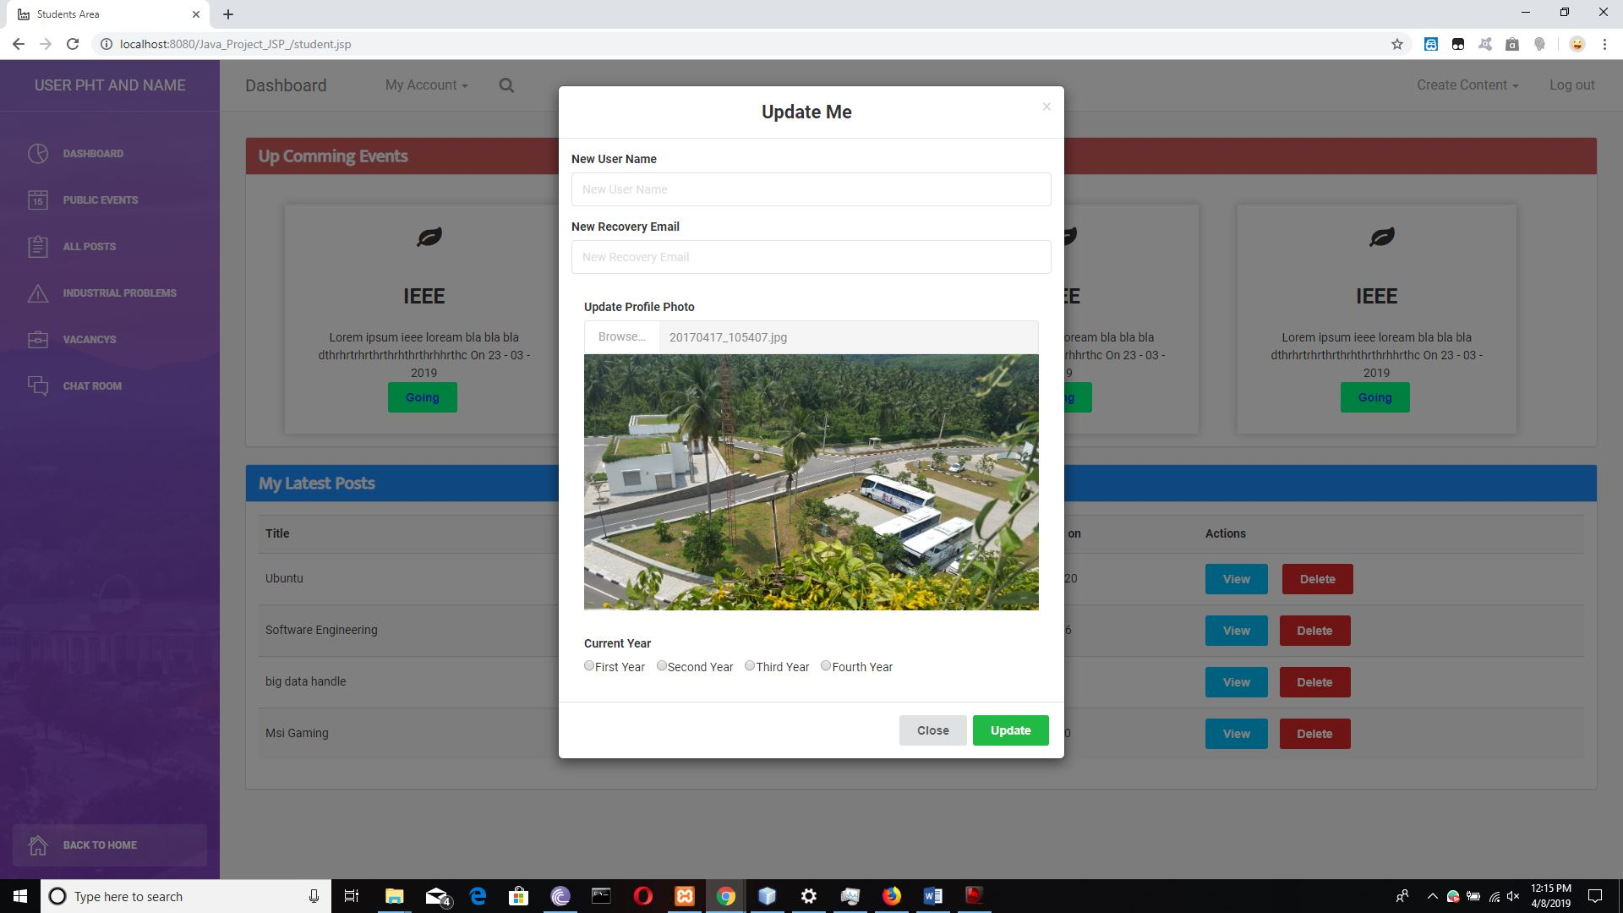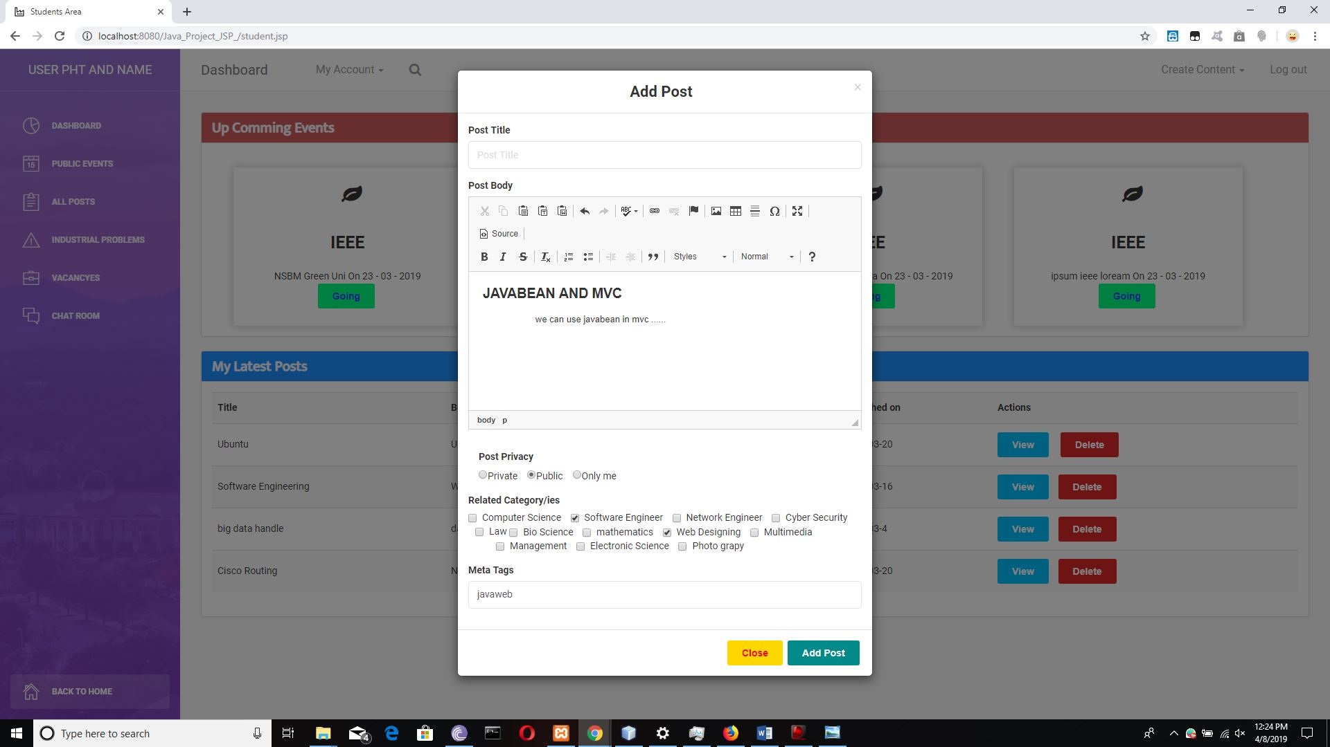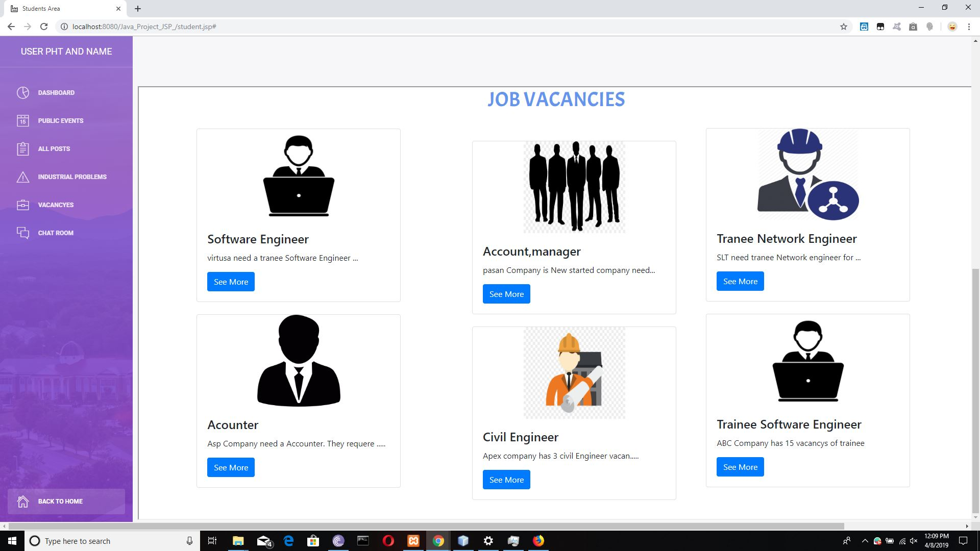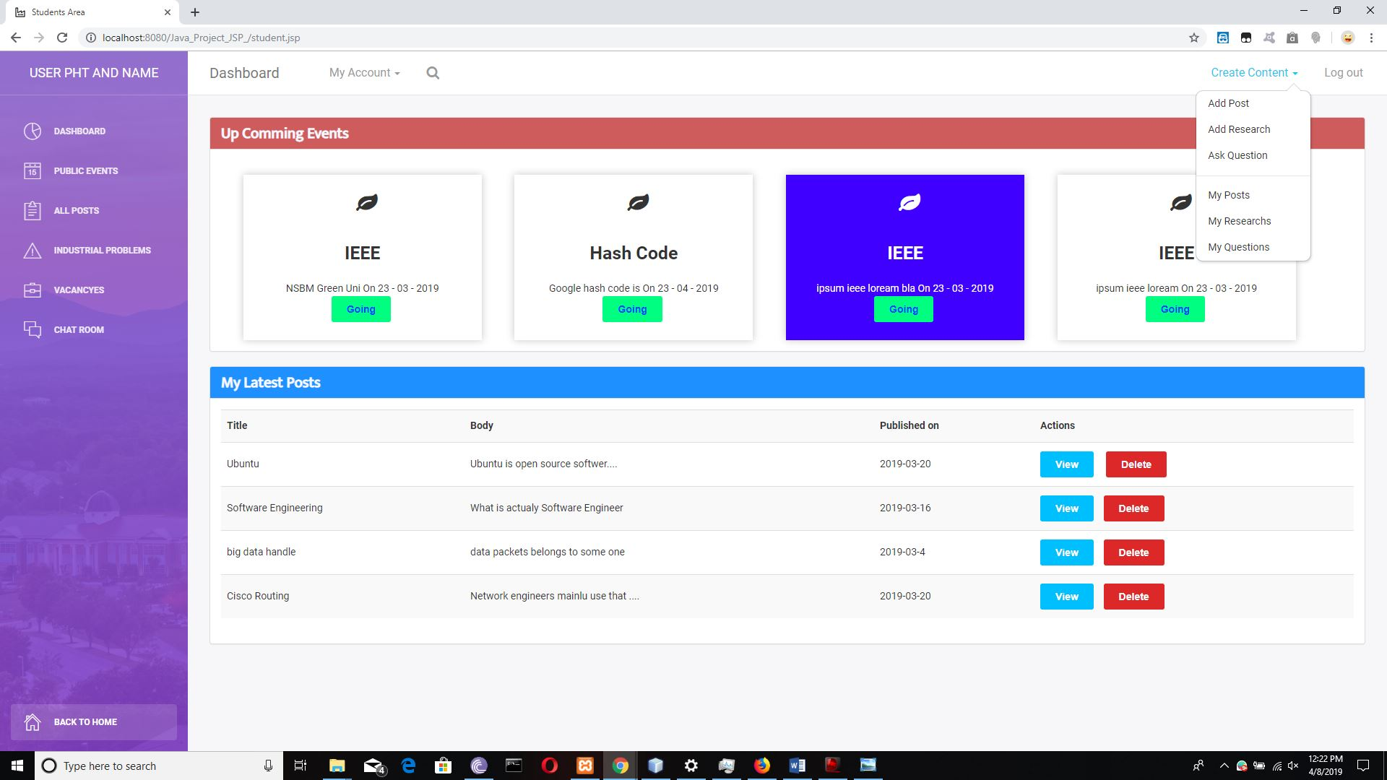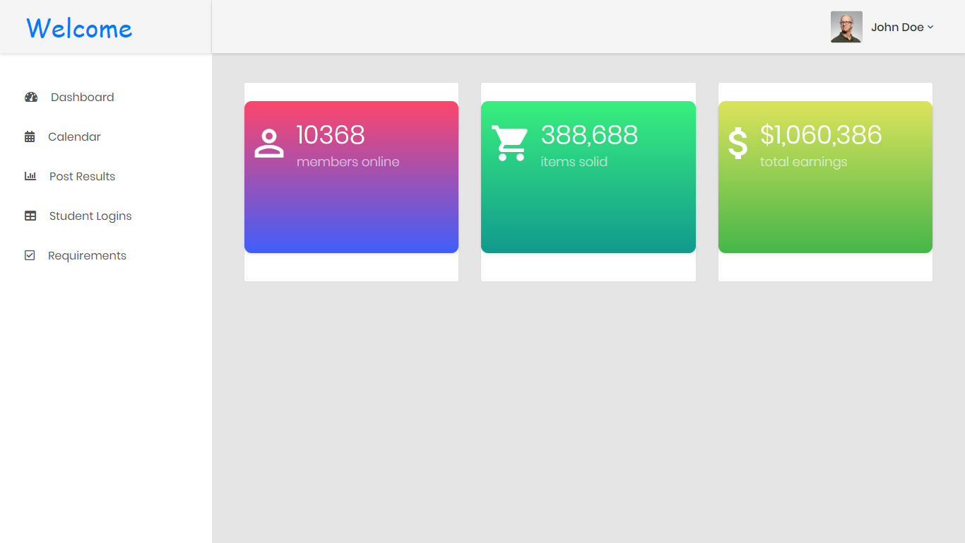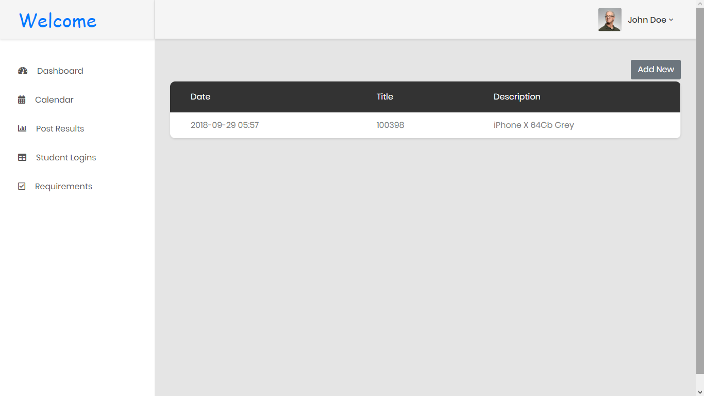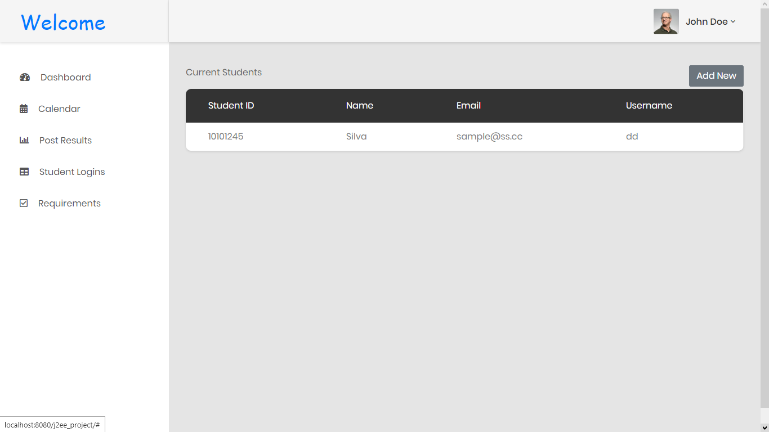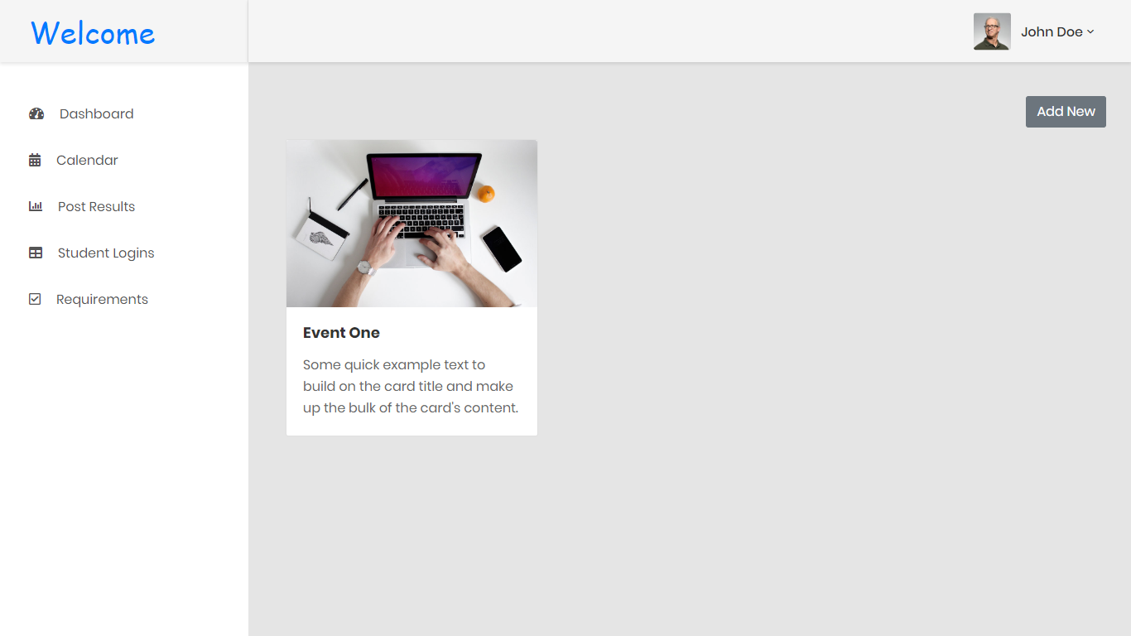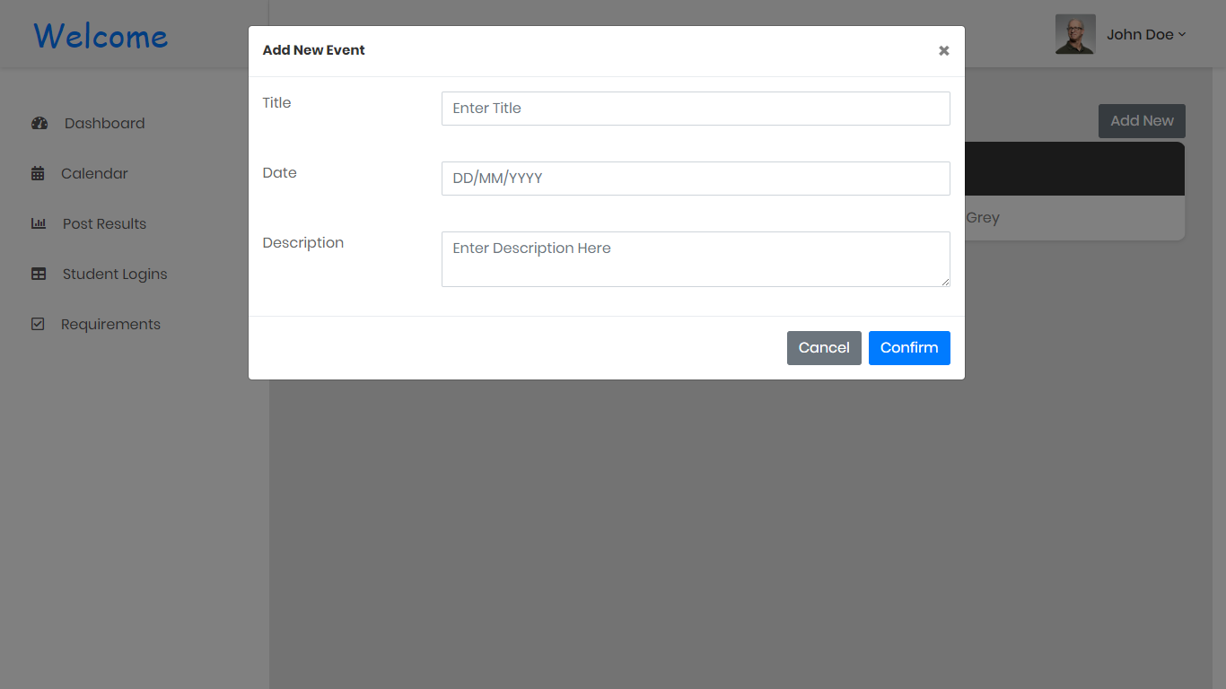

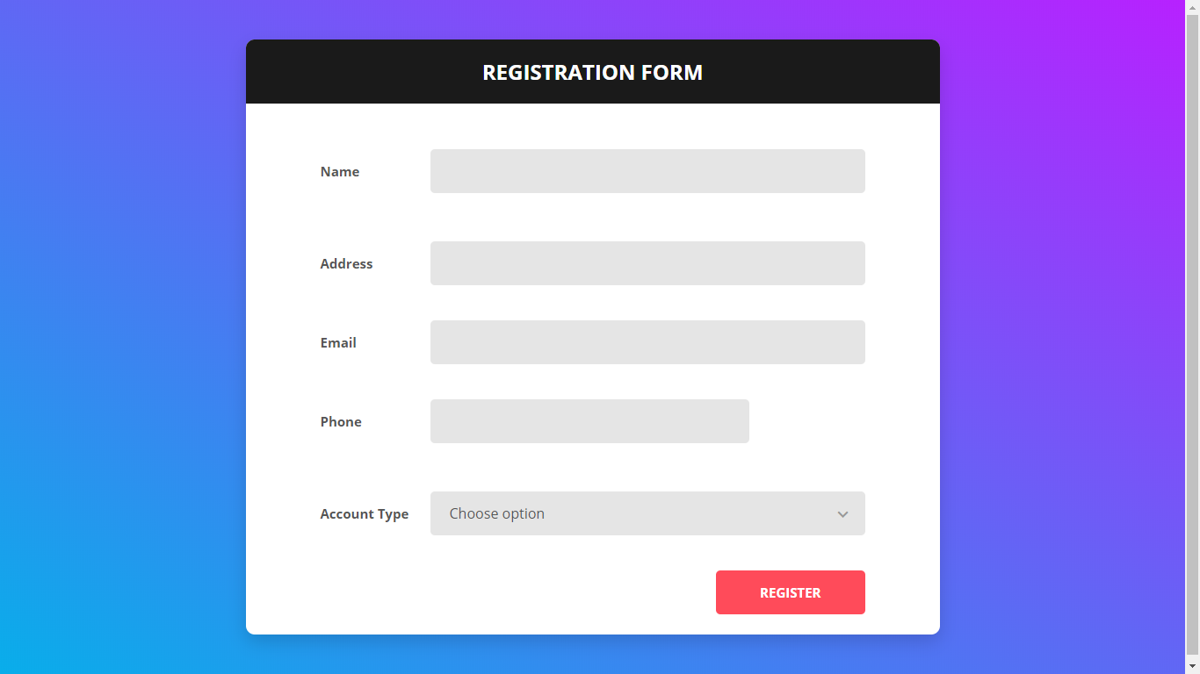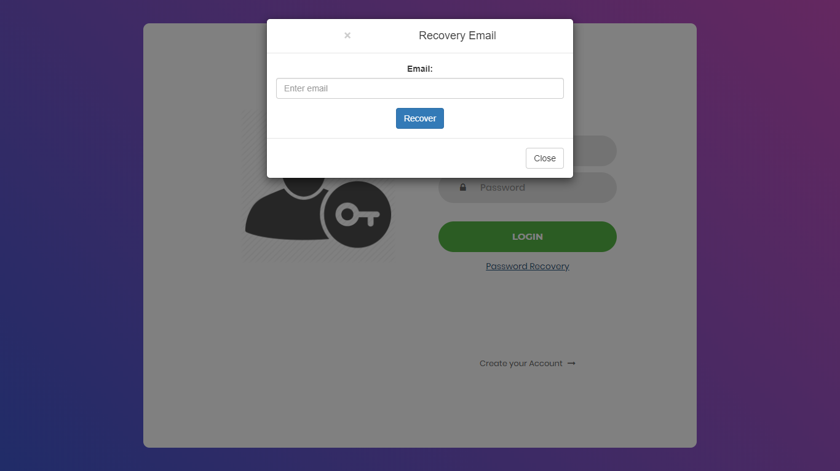

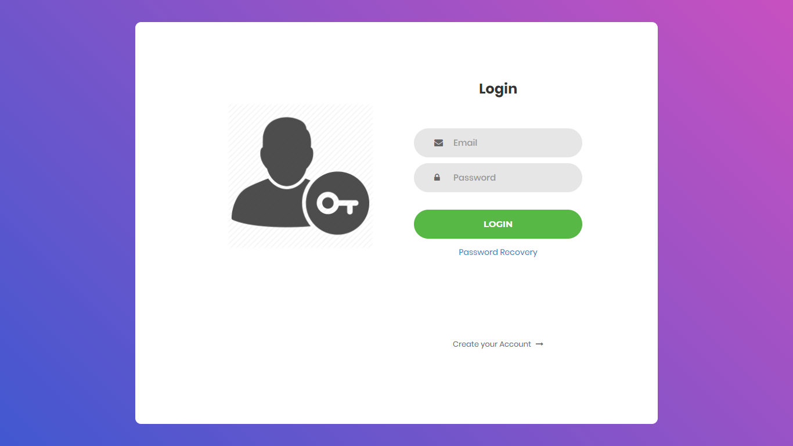

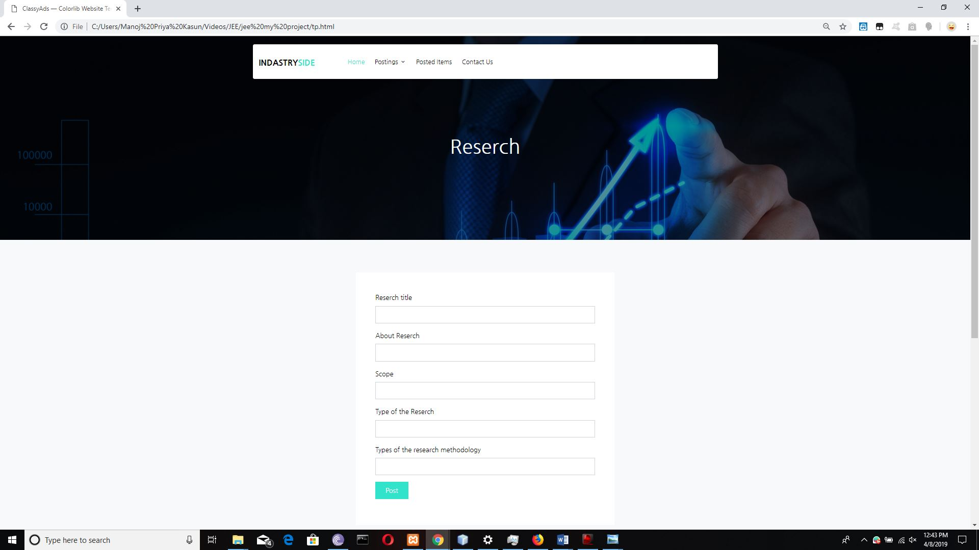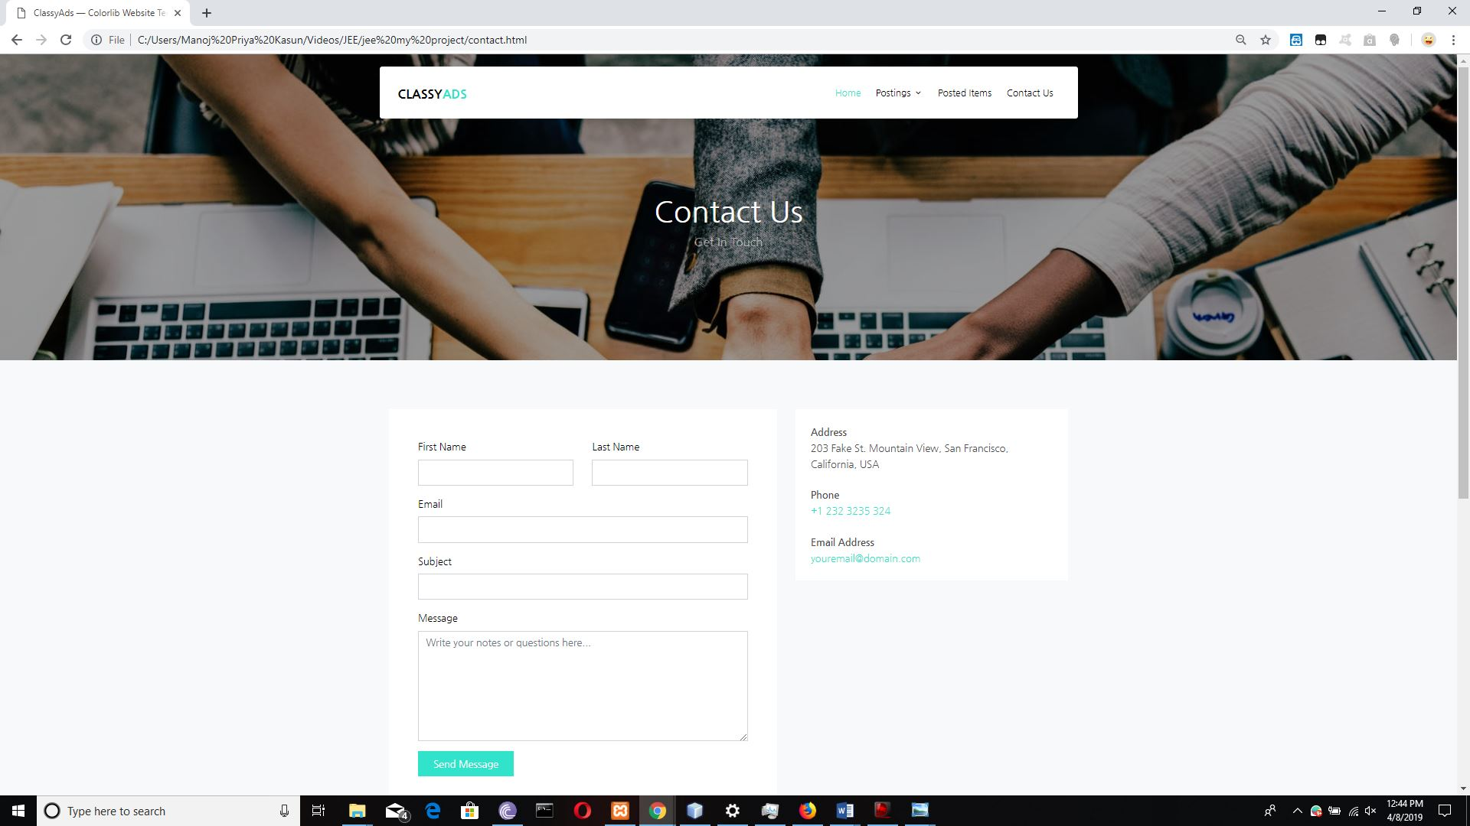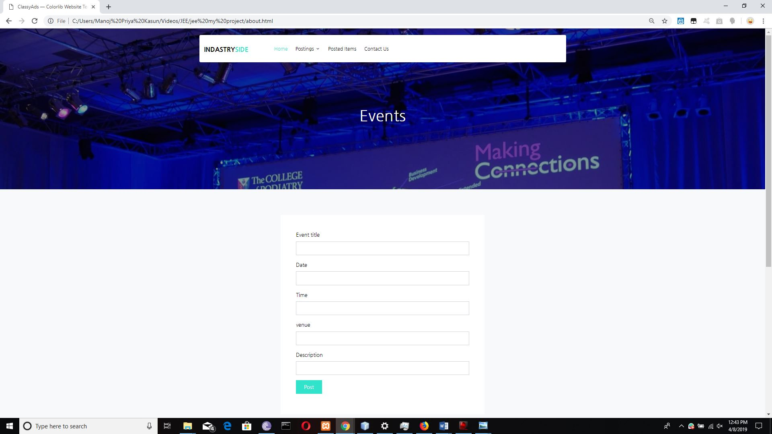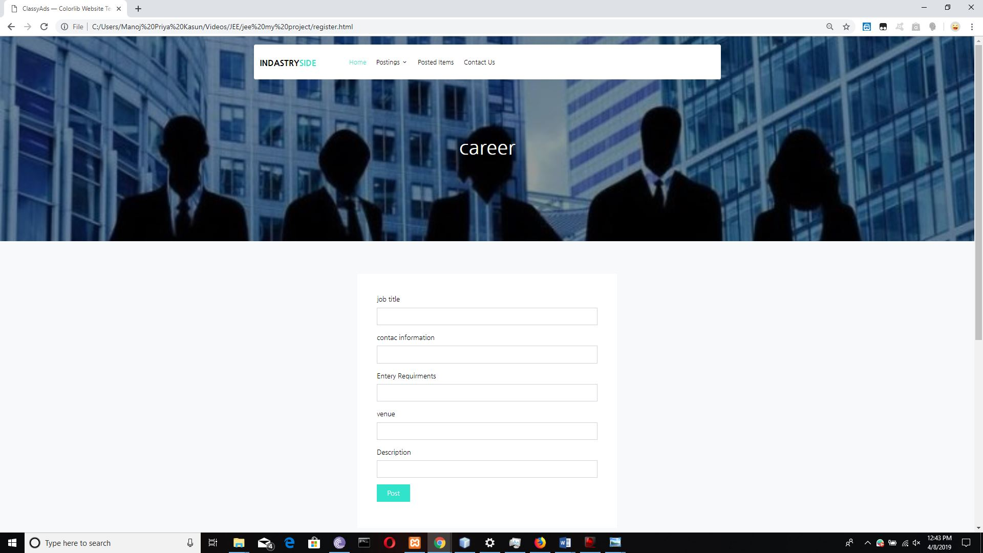

# Workload Matrix

|  |  |  |  |  |  |  |  |  |
| --- | --- | --- | --- | --- | --- | --- | --- | --- |
| Index | Login & Signup | Home & public Post | Student Dashboard | University Dashboard | Company  Dashboard | Admin Panel | Public  Chat | Internal  Chat |
| 10638393 |  |  |  | x |  | x |  |  |
| 10638401 |  |  |  |  | x |  | x |  |
| 10638380 | x |  |  |  |  |  |  | x |
| 10638365 |  | x | x |  |  |  |  |  |