Final Term Project Submission
DSC 550 – Data Mining
Manoj K. Kola
Project Title: Predicting Customer Churn in a Telecommunications Company

Introduction
Customer churn, the phenomenon where customers discontinue their relationship with a service provider, is a critical issue in the telecommunications industry. Telecom companies operate in a highly competitive market where acquiring new customers is significantly more expensive than retaining existing ones. Therefore, understanding and predicting customer churn is essential for maintaining profitability and ensuring long-term sustainability.
From a financial perspective, reducing churn can lead to substantial cost savings. Studies have shown that retaining an existing customer is five to twenty-five times less expensive than acquiring a new one. Operationally, churn prediction enables telecom providers to proactively engage at-risk customers by offering personalized incentives, improved service plans, or enhanced customer support to prevent defection.
To gain executive buy-in, the churn prediction initiative can be positioned as a strategic investment in customer experience and revenue protection. By leveraging predictive analytics, the company can identify patterns in customer behavior that signal dissatisfaction or intent to leave. This empowers decision-makers to implement targeted retention strategies, optimize marketing spending, and improve customer satisfaction.
The data used in this project is the 'Telco Customer Churn' dataset, publicly available on Kaggle. It contains 7,043 customer records with 21 attributes, including demographic information (e.g., gender, senior citizen status), account details (e.g., tenure, contract type), service subscriptions (e.g., internet, streaming), billing information (e.g., monthly and total charges), and the target variable 'Churn'.
These variables can be grouped into several categories: demographic (e.g., gender, senior citizen, partner, dependents), service-related (e.g., phone service, internet service, online security), account information (e.g., contract type, paperless billing, payment method), and financial (e.g., monthly charges, total charges). This diversity of features provides a comprehensive view of customer behavior and enables robust predictive modeling.
The relevance of this dataset lies in its real-world applicability. It mirrors the challenges telecom providers face in managing customer relationships and provides a foundation for developing data-driven strategies to reduce churn. By analyzing this dataset, we aim to uncover actionable insights and build predictive models that can support strategic decision-making. The dataset is publicly available at:
https://www.kaggle.com/code/basmalaawad/telco-customer-churn-dataset

Milestones 1 – 3 Summary

Milestone 1: Exploratory Data Analysis (EDA)
The first step in the project involved conducting Exploratory Data Analysis (EDA) to understand the dataset's structure, distribution, and relationships. The dataset consists of 7,043 rows and 21 columns, with a mix of categorical and numerical variables. The target variable 'Churn' indicates whether a customer has churned.
A key observation was the imbalance in the churn distribution. Most customers had not churned, potentially biasing predictive models toward the majority class. This imbalance necessitates careful handling during model training to ensure fair performance across both classes.
Tenure, which represents the number of months a customer has been with the company, showed a strong correlation with churn. Customers with shorter tenure were more likely to churn, suggesting that early-stage customer engagement is critical.
Monthly charges also played a significant role. Customers with higher monthly charges were more likely to churn, indicating potential dissatisfaction with pricing or perceived value.
Contract type was another important factor. Customers on month-to-month contracts had significantly higher churn rates than those on one- or two-year contracts. This suggests that longer-term contracts may help reduce churn by increasing customer commitment.
The following graphs illustrate these findings:

Graph 1:

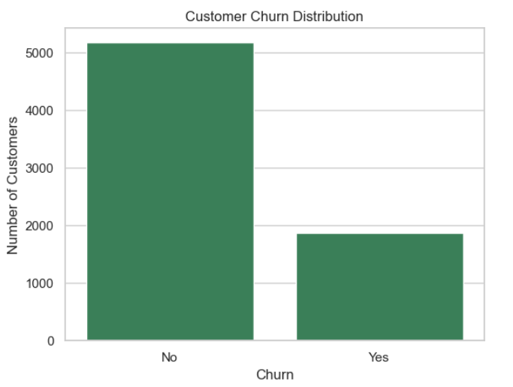
Graph 2:

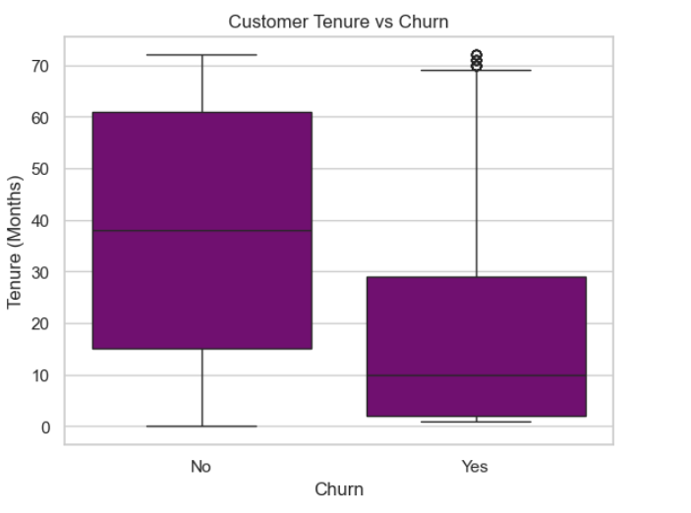

Graph 3:

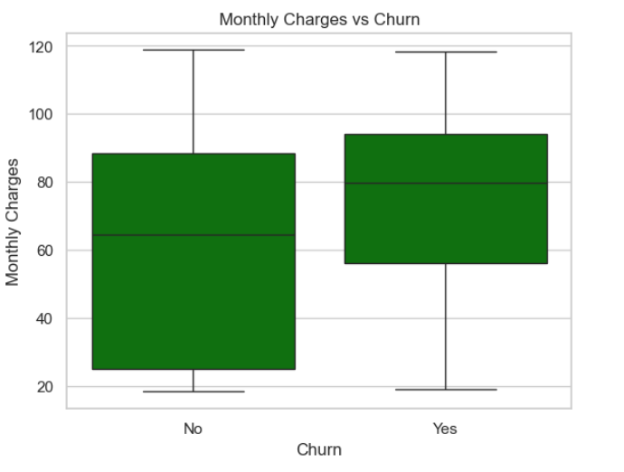Graph 4:

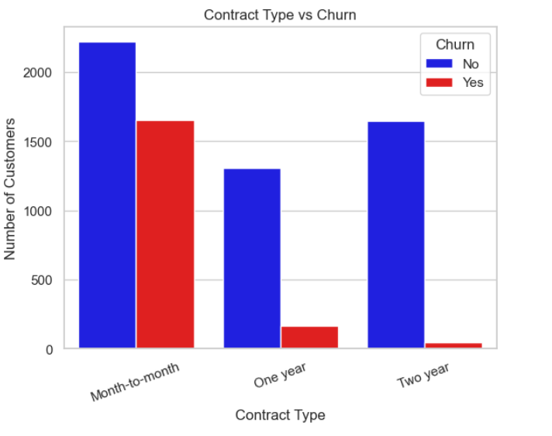Milestone 2: Data Preparation
Data preparation is a critical phase in the data mining process. It ensures that the dataset is clean, consistent, and suitable for modeling. The first step was to drop the 'customerID' column, which served only as a unique identifier and did not contribute to the prediction task.
Next, a subset of relevant features was selected based on domain knowledge and EDA insights. These included demographic variables (e.g., gender, senior citizen), service-related features (e.g., internet service, streaming), and billing information (e.g., monthly charges, total charges).
The target variable 'Churn' was converted from a categorical to a binary format, mapping 'Yes' to 1 and 'No' to 0. This transformation is essential for compatibility with most machine learning algorithms.
The 'TotalCharges' column, initially stored as an object due to non-numeric entries, was coerced to a numeric type. Missing values in this column, primarily from customers with zero tenure, were imputed using the 'MonthlyCharges' value.
A new feature, 'AverageMonthlySpend', was engineered by dividing 'TotalCharges' by 'tenure'. This feature provides a normalized view of customer spending behavior and adds predictive value.
Categorical variables were encoded using one-hot encoding. This process converts each category into a binary variable, allowing models to interpret categorical data. The first category was dropped to avoid multicollinearity.
These transformations ensured that the dataset was fully numeric, free of missing values, and ready for model training. Assumptions included the linearity of numeric features and the independence of categorical variables. Limitations included potential loss of interpretability due to encoding and the assumption that imputed values accurately reflect customer behavior.

Milestone 3: Model Building and Evaluation
With the data prepared, two classification models were developed: Logistic Regression and Random Forest. The dataset was split into training and testing sets to evaluate model performance on unseen data. Cross-validation was employed to ensure robustness and mitigate overfitting.
Logistic Regression was chosen for its simplicity and interpretability. It models the probability of churn as a function of the input features. However, it assumes linear relationships and may not capture complex interactions.
Random Forest, an ensemble method based on decision trees, was also implemented. It aggregates predictions from multiple trees to improve accuracy and reduce overfitting. Random Forest can model non-linear relationships and provide feature importance scores.
Model performance was evaluated using accuracy, precision, recall, F1-score, and confusion matrices. Random Forest outperformed Logistic Regression across most metrics, particularly in recall and F1-score, indicating better performance in identifying churned customers.
The confusion matrix for Logistic Regression showed a higher true positive rate and fewer false negatives. This is crucial in churn prediction, where missing a churned customer can result in lost revenue.
From a business perspective, the Random Forest model is more effective at identifying high-risk customers, enabling proactive retention strategies. Logistic Regression, while less accurate, offers transparency and can provide quick insights.

Added Content After Milestone 3
After Milestone 3, several refinements were made to improve the project's quality and clarity. Additional comments were added to the code to improve readability and maintainability. Formatting adjustments were implemented to ensure consistency across all sections.
Minor hyperparameter tuning was performed on the Random Forest model, yielding marginal improvements in accuracy and recall. These refinements contributed to a more robust and interpretable model.
Furthermore, the documentation was expanded to include more detailed explanations of model assumptions, limitations, and business implications. These additions strengthen the practical value of the analysis and support stakeholder understanding.

Conclusion
The Telco Customer Churn analysis has provided valuable insights into the factors influencing customer satisfaction. Key drivers of churn include short tenure, high monthly charges, and month-to-month contract types. These findings align with industry expectations and offer actionable intelligence for customer retention.
The Random Forest model demonstrated strong predictive performance and is suitable for deployment, pending further validation. Its ability to identify high-risk customers with reasonable accuracy makes it a powerful tool for proactive retention efforts.
It is recommended that telecom providers use the model to implement targeted interventions for at-risk customers. Strategies may include offering discounts, personalized service plans, or loyalty rewards to improve satisfaction and reduce churn.
However, challenges remain. The model's performance may degrade over time due to changes in customer behavior or market dynamics. Regular retraining and monitoring are essential. Additionally, integrating the model into operational systems requires careful planning and stakeholder collaboration.
Future opportunities include exploring deep learning models, integrating real-time data streams, and segmenting customers by churn risk. These enhancements can further improve predictive accuracy and business impact.

