DSC680 – Applied Data Science
Milestone 2 – White Paper
Predicting Stroke Risk Using Machine Learning: An Analysis of Patient Demographics and Health Factors
Executive Summary
Stroke is one of the leading causes of death and long-term disability worldwide, accounting for approximately 11% of all global deaths annually (World Health Organization, 2024). Early identification of at-risk individuals enables healthcare providers to implement targeted preventive interventions, potentially reducing mortality and improving quality of life.
This white paper presents a machine learning-based approach to stroke risk prediction using a publicly available clinical dataset of 5,110 patient records. Four classification algorithms were developed and evaluated: Logistic Regression, Decision Tree, Random Forest, and XGBoost. Class imbalance was addressed through SMOTE oversampling, and models were assessed using Accuracy, Precision, Recall, F1-Score, and ROC-AUC metrics.
The analysis identifies age, average glucose level, hypertension, heart disease, and BMI as the most significant predictors of stroke risk. Random Forest and XGBoost demonstrated the strongest discriminatory performance. Findings offer actionable insights for healthcare professionals seeking to integrate predictive analytics into preventive care workflows.
1. Business Problem
Healthcare systems globally face a growing burden from cerebrovascular disease. Stroke represents not only a significant cause of mortality but also a driver of long-term disability, cognitive impairment, and high healthcare utilization. The economic cost of stroke care in the United States alone exceeds $50 billion annually, encompassing direct medical costs and lost productivity (Centers for Disease Control and Prevention, 2023).
The central business problem addressed in this project is: How can readily available patient demographic and clinical data be leveraged to predict individual stroke risk before an event occurs?
Healthcare providers currently rely on manual risk stratification tools and clinician judgment, which can be inconsistent and resource-intensive. A validated, data-driven predictive model would enable:
- Proactive identification of high-risk patients for early intervention
- Optimization of preventive care resources and clinical workflows
- Reduction in emergency stroke hospitalizations through targeted outreach
- Support for clinical decision-making without replacing physician judgment
2. Background and History
A stroke occurs when the blood supply to part of the brain is interrupted or reduced, depriving brain tissue of oxygen and nutrients. Two primary types exist: ischemic stroke (caused by blood clots, comprising ~87% of cases) and hemorrhagic stroke (caused by bleeding in the brain). The WHO reports stroke as the second leading cause of death globally and a major contributor to disability-adjusted life years (DALIs) lost.
Established clinical risk factors for stroke include hypertension, diabetes, atrial fibrillation, hyperlipidemia, smoking, obesity, and age. Traditional risk-scoring tools, such as the Framingham Stroke Risk Score, have guided clinical practice for decades; however, they capture only a subset of potential predictive variables.
The emergence of machine learning in healthcare analytics has opened new avenues for more accurate, multi-variable risk prediction. Studies have demonstrated that ensemble methods, such as Random Forests and gradient-boosting algorithms (e.g., XGBoost), consistently outperform logistic regression on complex clinical datasets with non-linear feature interactions (Kansadub et al., 2022). This project builds on that body of work by applying and comparing these methods to a curated stroke prediction dataset.
3. Data Explanation
3.1 Data Source
The dataset used in this project is the Stroke Prediction Dataset, sourced from Kaggle (Fedesoriano, 2020). It contains 5,110 patient records with 12 variables encompassing demographic information, medical history, lifestyle characteristics, and a binary stroke outcome indicator. The dataset is intended for educational and research purposes.
Source URL: https://www.kaggle.com/datasets/fedesoriano/stroke-prediction-dataset
3.2 Data Preparation
The following preprocessing steps were applied to prepare the data for modeling:
- Column removal: The ID column was dropped as it carries no predictive signal.
- BMI imputation: 201 missing BMI values were replaced with the median BMI value, as the median is robust to the outliers commonly present in BMI distributions.
- Rare category removal: One record with gender = 'Other' was removed due to insufficient representation for encoding.
- Feature scaling: Numerical features (age, hypertension, heart_disease, avg_glucose_level, bmi) were standardized using StandardScaler (mean = 0, std = 1) to prevent high-range features from dominating distance-based calculations.
- Categorical encoding: Five categorical features were converted to binary columns using OneHotEncoder, with handle_unknown='ignore' to manage unseen values at inference time.
- Class imbalance: The dataset is heavily imbalanced (4,861 non-stroke vs. 249 stroke cases, approximately 20:1). SMOTE (Synthetic Minority Oversampling Technique) was applied after preprocessing to synthetically generate minority-class samples in the transformed feature space.
- Train/test split: Data was split 70/30 using stratified sampling to maintain class proportions across both sets.
3.3 Data Dictionary
- age: Patient age in years
- hypertension: History of hypertension (1 = yes)
- heart_disease: History of heart disease (1 = yes)
- avg_glucose_level: Average glucose level
- bmi: Body Mass Index
- smoking_status: Smoking history
- work_type: Employment category
- Residence_type: Urban or rural residence
- stroke: Target variable (1 = stroke, 0 = no stroke)
4. Methods
The project follows the standard data science lifecycle: data acquisition, cleaning, exploratory analysis, feature engineering, model development, evaluation, and interpretation. Four classification algorithms were trained and compared.
- Logistic Regression
- Decision Tree
- Random Forest
- XGBoost
All models were evaluated on a held-out 30% test set using the following metrics:
- Accuracy: Proportion of correct predictions overall.
- Precision: Of all predicted stroke cases, how many were true strokes (minimizes false alarms).
- Recall: Of all actual stroke cases, how many were correctly identified (critical in healthcare).
- F1-Score: Harmonic mean of precision and recall — primary metric given class imbalance.
- ROC-AUC: Model’s ability to discriminate between classes across all classification thresholds.
- Confusion Matrix: Detailed breakdown of true/false positives and negatives
5. Analysis
5.1 Exploratory Data Analysis
EDA revealed several key patterns in the data prior to modeling:
- Age: Stroke patients were significantly older on average than non-stroke patients, confirming age as a primary risk factor.
- Glucose Level: Patients who experienced a stroke showed higher median glucose levels and greater spread, suggesting elevated glucose is associated with stroke risk.
- BMI: BMI distributions between stroke and non-stroke groups showed overlap, indicating it is a contributing but not dominant predictor in isolation.
- Hypertension and Heart Disease: Both binary variables showed higher prevalence among stroke patients, consistent with clinical literature.
- Correlation Heatmap: A correlation heatmap of numeric features revealed that age has the strongest positive correlation with stroke outcome among numeric predictors. Average glucose level and hypertension also show meaningful positive correlations. BMI shows a weaker but present positive correlation.
Exploratory Data Analysis (EDA) included visualizations such as:
- Stroke class distribution:
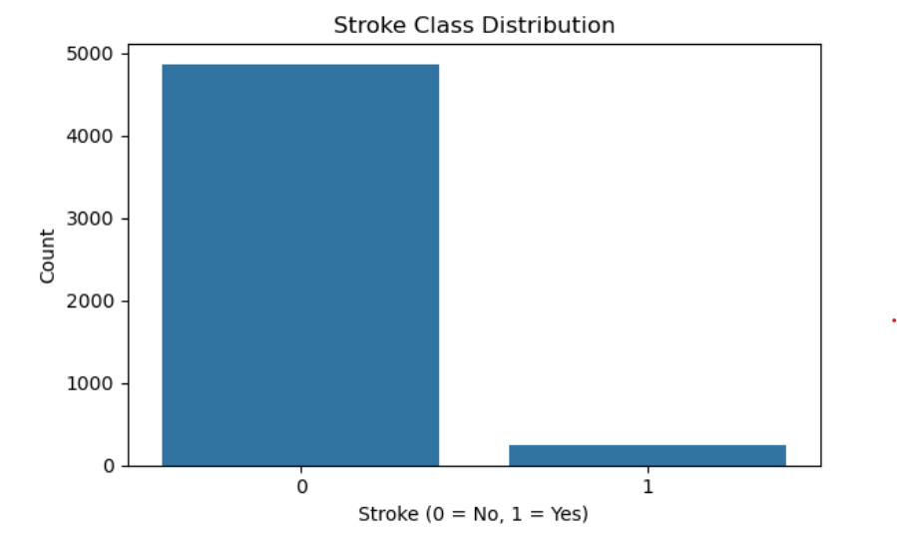
- Age distribution: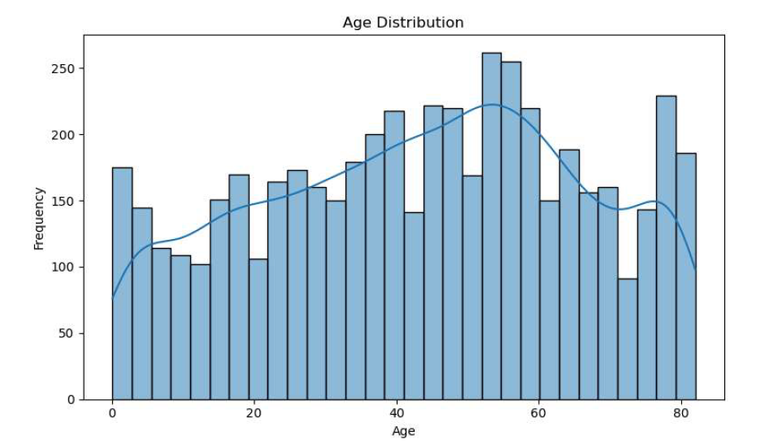
- Glucose level by stroke outcome: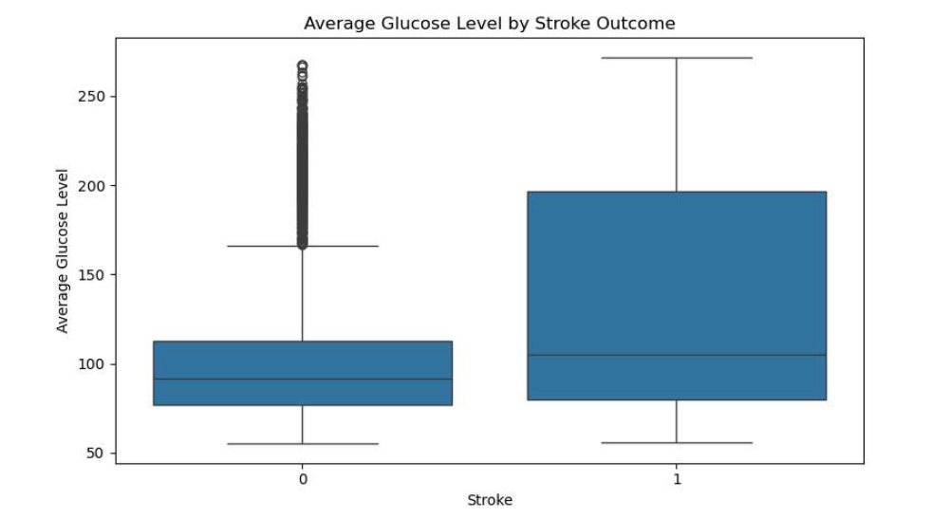
- BMI by Stroke outcome:
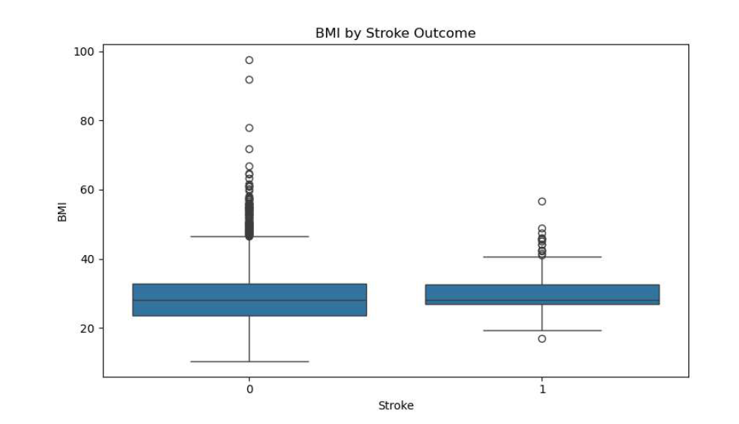
- Correlation Heatmap: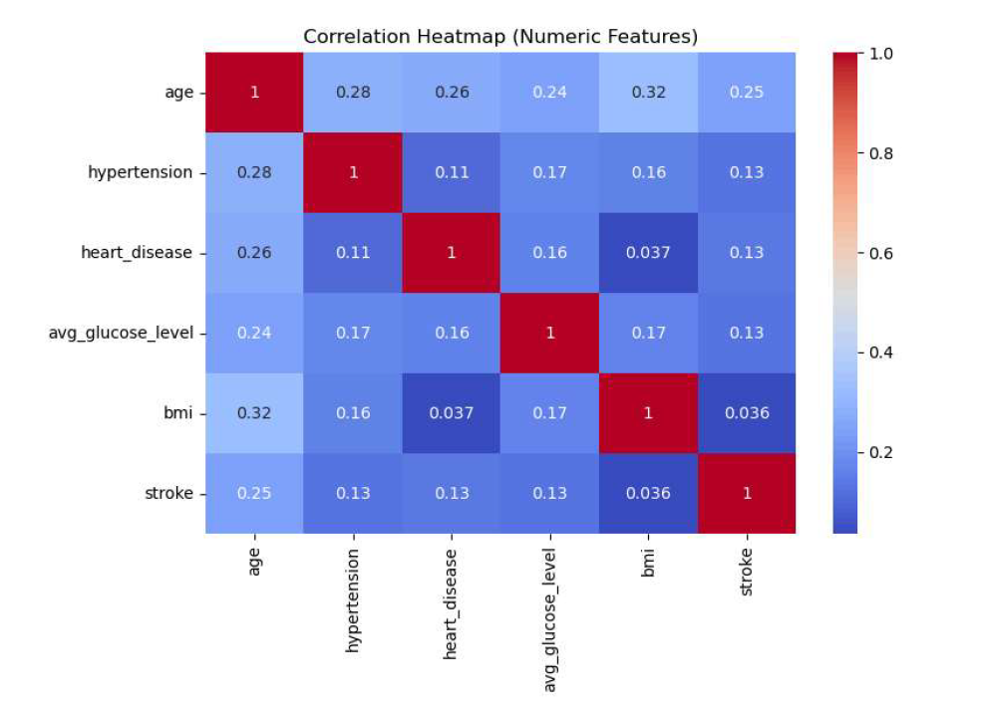
These illustrations revealed strong class imbalance, age-related trends, and meaningful associations between stroke and clinical variables.
5.2 Model Performance
Model performance varied across algorithms:
- Random Forest achieved the highest overall accuracy and strong ROC‑AUC performance.
- XGBoost demonstrated the highest recall among models, identifying more stroke cases.
- Logistic Regression provided strong recall but low precision due to class imbalance.
- Decision Tree exhibited overfitting and lower ROC‑AUC performance.
Analysis indicated that age, hypertension, heart disease, glucose level, BMI, and smoking status were the most influential predictors of stroke risk.
6. Conclusion
Machine learning models can effectively predict stroke risk using demographic and clinical variables. The Random Forest model demonstrated strong performance and interpretability, making it a suitable candidate for clinical decision‑support systems. The analysis confirms known stroke risk factors and highlights the value of data‑driven approaches in preventive healthcare.
7. Assumptions
- The dataset is representative of broader patient populations.
- Variables are accurately recorded and free from systematic bias.
- SMOTE synthetic samples approximate real minority‑class patterns.
- Encoded categorical variables preserve meaningful distinctions.
8. Limitations
- The dataset is imbalanced, requiring oversampling.
- Limited clinical variables (e.g., no blood pressure readings or medication history).
- Smoking status includes “Unknown,” reducing interpretability.
- The Kaggle dataset may not reflect real‑world hospital populations.
9. Challenges
- Managing class imbalance without overfitting.
- Ensuring model interpretability for clinical stakeholders.
- Handling missing BMI values appropriately.
- Balancing recall and precision in a healthcare context.
10. Future Uses and Additional Applications
- Integrating additional clinical variables, such as blood pressure and cholesterol.
- Deploying the model in electronic health record systems for real‑time risk scoring.
- Expanding to multi‑class prediction (e.g., stroke severity).
- Conducting fairness analysis across demographic groups.
- Using SHAP values for deeper interpretability.
11. Recommendations
- Use Random Forest as the primary model due to strong ROC‑AUC and interpretability.
- Prioritize recall in clinical settings to avoid missing high‑risk patients.
- Conduct additional validation using cross‑hospital datasets.
- Implement model monitoring to detect drift over time.
12. Implementation Plan
- Integrate the model with electronic health record systems.
- Deploy using a REST API or batch scoring pipeline.
- Provide risk scores to clinicians during patient intake.
- Monitor model performance and recalibrate periodically.
- Establish governance guidelines for ethical use and human oversight.
13. Ethical Assessment
- Privacy: Real deployments must comply with HIPAA and protect patient confidentiality.
- Fairness: Evaluate model performance across demographic groups to prevent bias.
- Transparency: Provide clinicians with clear explanations of predictions.
- Non‑replacement: The model supports decision‑making and does not replace medical professionals.
- Bias mitigation: Use balanced training methods and fairness audits.
Appendix A: Supporting Documentation
- Python code is used for data cleaning, EDA, modeling, and evaluation.
- Model comparison tables and feature importance charts.
References
Fedesoriano. (2020). Stroke Prediction Dataset. Kaggle. https://www.kaggle.com/datasets/fedesoriano/stroke-prediction-dataset
World Health Organization. (2024). Stroke. https://www.who.int/news-room/fact-sheets/detail/stroke
Ten Audience Questions (for Milestone 3)
- How did you address the strong class imbalance in the dataset?
- Why did you choose SMOTE instead of under-sampling?
- Which metric do you consider most important for stroke prediction?
- How do you ensure the model is fair across demographic groups?
- What are the limitations of using this Kaggle dataset?
- How would you deploy this model in a real healthcare setting?
- Why did Random Forest outperform Logistic Regression?
- How do you explain model predictions to non-technical clinicians?
- What additional data would improve model accuracy?
- How do you prevent overfitting when using ensemble models?

