DSC 680 – Applied Data Science
Milestone 3 – White Paper
Amazon Sales Performance Analysis: Identifying Factors That Influence Revenue and Product Performance

Executive Summary
Global e-commerce sales are estimated to reach $6.4 trillion in 2025, accounting for roughly one-fifth of all retail spending worldwide, and Amazon alone is estimated to account for over 40% of U.S. online retail sales (Oberlo, 2024; Capital One Shopping Research, 2026). At this scale, even small improvements in understanding what drives order-level sales performance can translate into meaningful business impact, making transactional sales data a valuable resource for data-driven decision-making.
This white paper presents an exploratory and predictive analysis of a publicly available Amazon transaction dataset spanning 2019–2024 and containing 5,000 orders across seven product categories and five global regions. Data quality checks confirmed the dataset was clean and internally consistent, with Total Sales fully explained by Quantity Sold, Unit Price, and Discount, and Profit Margin tracking Total Sales at a near-fixed ratio of approximately 34.8%.
Because those transaction-size fields directly determine sales value, a binary High Sales indicator (orders above the dataset median) was predicted instead using only non-transactional factors: product category, region, payment method, order status, salesperson, and order timing. Four classification algorithms were developed and evaluated: Logistic Regression, Decision Tree, Random Forest, and XGBoost, with SMOTE applied to address any residual class imbalance.
All four models performed close to chance (ROC-AUC between 0.48 and 0.52), and Random Forest feature importance showed no single dominant driver among the available categorical and timing variables. The central finding of this project is therefore not which category or region wins, but that — within this dataset — which category, region, payment method, salesperson, or time an order comes from carries almost no signal about whether that order will be a large or small sale. Sales performance appears to be governed primarily by transaction size (quantity and price), not by who, where, or when the purchase occurred. This final milestone confirms those findings, translates them into concrete business recommendations, and packages the analysis as a recorded presentation for a general business audience.

Response to Milestone 1 Feedback
Feedback on the Milestone 1 proposal noted that the project would be strengthened by (1) defining the primary outcome, "sales performance," more precisely, and (2) developing a specific predictive methodology rather than leaving predictive modeling conditional on what was found later. Both points were incorporated directly into the design of this project, starting in Milestone 2 and carried through to this final white paper:
- A precise outcome measure: "Sales performance" was operationalized as a binary High Sales indicator, defined by a median split on Total Sales (High Sales = 1 for orders above the dataset median, 0 otherwise). This replaced the open-ended notion of "performance" from the proposal with a specific, reproducible, and naturally balanced target variable.
- A fixed predictive methodology: Rather than treating predictive modeling as conditional, four specific classification algorithms — Logistic Regression, Decision Tree, Random Forest, and XGBoost — were selected up front and evaluated on a defined, consistent set of metrics (Accuracy, Precision, Recall, F1, ROC-AUC). A specific feature-selection rule was also established in advance: transaction-size fields that mathematically determine Total Sales (Quantity Sold, Unit Price, Discount, Profit Margin) were excluded from the model inputs to prevent data leakage, so the predictive question — whether non-transactional attributes can predict order value — was precisely defined before any modeling was run.
This more precise framing is what allowed the near-chance modeling results to be interpreted as a genuine, defensible finding rather than an ambiguous or inconclusive one.

Response to Milestone 2 Feedback
Feedback on the Milestone 2 draft was positive overall and specifically identified one area for improvement in the modeling design: because the median-split target was already balanced, SMOTE was likely to add little value, and excluding the transaction-size variables necessarily limits predictive performance. Both points were investigated directly and are addressed in detail in Section 5.3 of this white paper, with corresponding code added to the project notebook. In summary:
- On SMOTE: The training set was confirmed to be exactly balanced (1,750 High Sales / 1,750 Low Sales, a 1.000 minority-to-majority ratio) before SMOTE was applied. An ablation test — re-running all four models on the original, non-resampled training data — produced ROC-AUC scores identical to the SMOTE-resampled results to four decimal places for every model. This confirms the feedback precisely: with a perfectly balanced target, SMOTE contributed nothing in this pipeline. It has been retained in the notebook for methodological transparency, but the reported results do not depend on it.
- On excluding transaction-size variables: A diagnostic benchmark model was built that reintroduces Quantity Sold, Unit Price, and Discount (%), the fields excluded from the main model, to prevent data leakage — purely to quantify the performance this exclusion gives up. Reintroducing just these three fields lifted ROC-AUC from 0.48–0.51 (chance) to 0.977–0.9995 (near-perfect) across all four algorithms. This confirms that excluding the leakage fields not only modestly limits performance; it forfeits nearly the entire predictive ceiling available in the dataset. That quantified gap is itself informative: it shows that order value in this dataset is almost entirely a function of transaction size, not of the non-transactional attributes being tested, thereby strengthening rather than weakening the project's central finding.

1. Business Problem
E-commerce retailers generate enormous volumes of transactional data, yet many organizations struggle to translate it into clear guidance on what drives sales performance. Category managers, regional leaders, and sales operations teams often want to know whether performance differences across product lines, markets, or channels meaningful business signals are worth acting on, or whether they are largely noise driven by the size and mix of individual transactions.
The central business question addressed in this project is: Which product-, sales-, and customer-related factors are associated with higher sales performance in Amazon transactional data, and can non-transactional factors alone (category, region, payment method, timing, salesperson) reliably distinguish high-performing orders from lower-performing ones?
A validated, data-driven understanding of these relationships would allow e-commerce and retail organizations to:
- Prioritize category and regional strategy based on evidence rather than assumption
- Avoid over-investing in segmentation models that rely on factors with little real predictive value
- Direct forecasting and demand-planning effort toward the variables that genuinely drive revenue
- Support merchandising and resource-allocation decisions with defensible, data-driven analysis

2. Background and History
Online retail has grown from a niche channel into a dominant force in global commerce. Global retail e-commerce sales exceeded $6 trillion for the first time in 2024 and are projected to continue growing through the end of the decade, with online sales now representing roughly one-fifth of total retail spending worldwide (Oberlo, 2024). Amazon is one of the largest participants in this market, and transactional datasets modeled on its marketplace are widely used in data science education and applied analytics research.
Traditional retail analysis has relied heavily on descriptive reporting — total sales by category, region, or time — to guide business decisions. While useful for monitoring performance, descriptive summaries alone cannot distinguish a meaningful driver of sales from incidental variation. Machine learning classification techniques, including ensemble methods such as Random Forest and gradient-boosting algorithms like XGBoost, have become common tools for testing whether categorical and behavioral variables carry genuine predictive signal beyond what simple aggregation reveals.
This project applies that approach to an Amazon-style sales dataset, extending the exploratory analysis performed in Milestone 1 and the predictive modeling performed in Milestone 2, and finalizing whether commonly reported business dimensions — category, region, payment method, order status, salesperson, and timing — can predict whether an individual order will be a high- or low-value sale.

3. Data Explanation

3.1 Data Source
The dataset used in this project is the Amazon Sales Dataset for Performance Analysis, sourced from Kaggle (Jangir, n.d.). It contains 5,000 order records spanning January 2019 through December 2024, with 15 original fields covering order details, customer identifiers, product category, sales channel, salesperson, and financial outcomes.
Source URL: https://www.kaggle.com/datasets/rahuljangir78/amazon-sales-dataset-for-performance-analysis
This is a publicly available Kaggle dataset and should be treated as a representative sample rather than an official record of Amazon's complete transactional history.

3.2 Data Preparation
The following preprocessing steps were applied prior to analysis and modeling:
- Missing value handling: One missing Product Name value was filled with "Unknown," since the associated Product Category remained available and Product Name itself was not used as a modeling feature.
- Consistency check: Total Sales were recalculated from Quantity Sold, Unit Price, and Discount (%) and confirmed to match the recorded values (maximum difference of less than one cent), verifying the field's integrity.
- Date feature extraction: Order Date was decomposed into Order Year, Order Month, Order Quarter, and Order Day of Week to allow timing-based patterns to be explored and modeled.
- Target definition: A binary High Sales indicator was created using a median split on Total Sales (High Sales = 1 for orders above the median, 0 otherwise), producing two naturally balanced classes.
- Leakage prevention: Quantity Sold, Unit Price, Discount (%), and Profit Margin were excluded from the model's input features, since these fields directly determine Total Sales and would let a model reconstruct the target rather than learn genuine behavioral or categorical patterns.
- Feature scaling: The remaining numeric features (Order Year, Order Month, Order Quarter) were standardized using StandardScaler (mean = 0, std = 1).
- Categorical encoding: Six categorical features were converted to binary columns using OneHotEncoder, with handle_unknown='ignore' to safely manage any unseen category values at inference time.
- Class balancing: Although the median-split target was already close to balanced, SMOTE was applied after preprocessing, in the scaled/encoded feature space, to correct any residual imbalance introduced by the train/test split. Section 5.3 shows the training set was in fact exactly balanced (1,750/1,750) and that SMOTE had no measurable effect on results; it is retained here for methodological transparency.
- Train/test split: Data was split 70/30 using stratified sampling on the High Sales target to preserve class proportions in both sets.

3.3 Data Dictionary
- Order Date: Date the order was placed (2019–2024)
- Region: Customer's geographic region (South America, Asia, Australia, Europe, North America)
- Product Category: Category of the purchased product (Sports, Clothing, Toys, Electronics, Home & Kitchen, Books, Beauty)
- Quantity Sold: Number of units purchased in the order
- Unit Price: Price per unit in USD
- Discount (%): Discount applied to the order
- Salesperson: Employee associated with the sale (20 unique salespeople)
- Payment Method: Method used to complete payment (Debit Card, Credit Card, PayPal, Amazon Pay, Gift Card)
- Order Status: Final status of the order (Completed, Pending, Cancelled, Returned)
- Total Sales: Total order value in USD (Quantity Sold × Unit Price × (1 − Discount%))
- Profit Margin: Profit generated by the order, a near-fixed percentage of Total Sales
- High Sales (derived): Target variable; 1 if Total Sales is above the dataset median, else 0

4. Methods
The project follows the standard data science lifecycle: data acquisition, cleaning, exploratory analysis, feature engineering, model development, evaluation, and interpretation. Four classification algorithms were trained and compared to predict the High Sales target:
- Logistic Regression
- Decision Tree
- Random Forest
- XGBoost
All models were evaluated on a held-out 30% test set using the following metrics:
- Accuracy: Proportion of correct predictions overall.
- Precision: Of all orders predicted as High Sales, how many were.
- Recall: Of all actual High Sales orders, how many were correctly identified?
- F1-Score: Harmonic mean of precision and recall, the primary metric given the classification framing.
- ROC-AUC: A model's ability to discriminate between classes across all classification thresholds; used here as the primary indicator of whether the available features carry a real predictive signal.
- Confusion Matrix: Detailed breakdown of true/false positives and negatives.

5. Analysis

5.1 Exploratory Data Analysis
EDA revealed the following patterns prior to modeling:
- Sales trend: Total monthly sales remained relatively stable across the 2019–2024 window, with no strong sustained upward or downward trend.
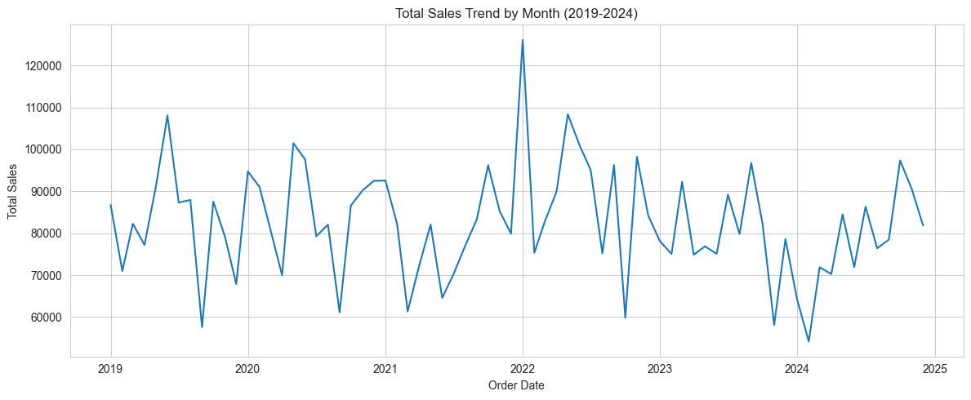
Figure 1. Total monthly sales, 2019–2024
- Product category: Sports ($894,838), Clothing ($874,699), and Toys ($866,111) generated the highest total sales, while Beauty ($794,057) generated the lowest. The spread between the top and bottom category was modest, roughly 11%, suggesting no single category dominates.
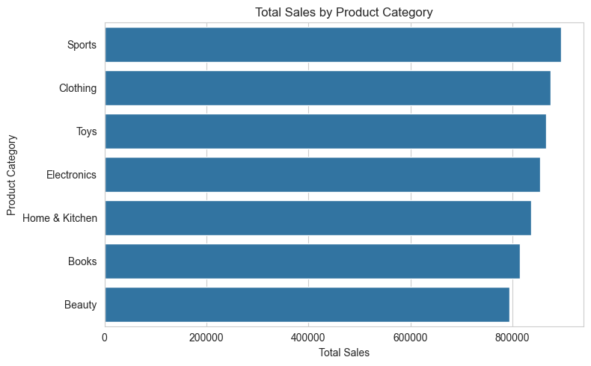
Figure 2. Total sales by product category
- Region: South America led all regions in total sales ($1,322,175), followed by Asia, Australia, and Europe, with North America lowest ($1,073,060). As with categories, the spread across regions was moderate rather than dramatic.
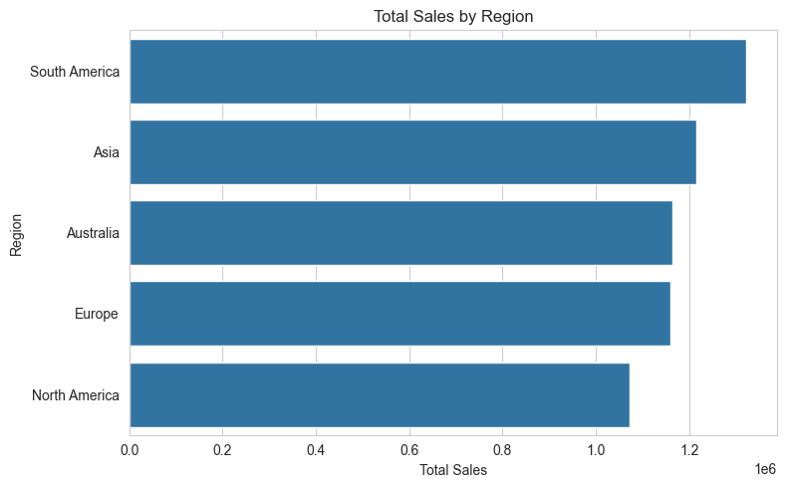
Figure 3. Total sales by region
- Order status: Orders were evenly distributed across Completed, Pending, Cancelled, and Returned statuses (roughly 1,200–1,325 orders each), and average sale size did not differ meaningfully by status.
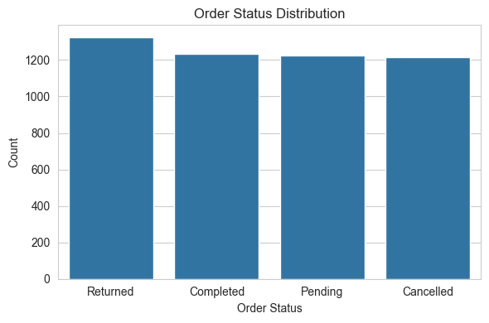
Figure 4. Order status distribution
- Payment method: Customer payment method was spread evenly across Debit Card, Credit Card, PayPal, Amazon Pay, and Gift Card, with no single method dominating.
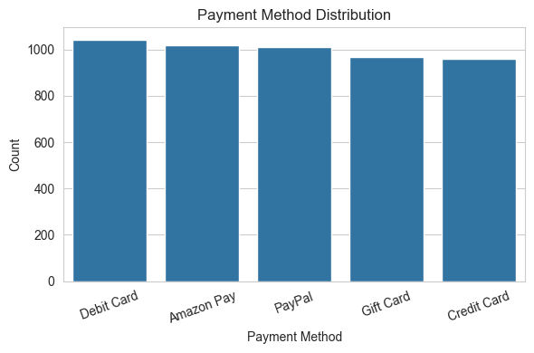
Figure 5. Payment method distribution
- Correlation heatmap: As expected given how Total Sales is calculated, Quantity Sold, Unit Price, and Discount (%) all showed meaningful correlation with Total Sales, and Profit Margin correlated almost perfectly with Total Sales (a near-fixed ~34.8% ratio). This confirmed that these fields needed to be excluded from the predictive model to avoid leakage.
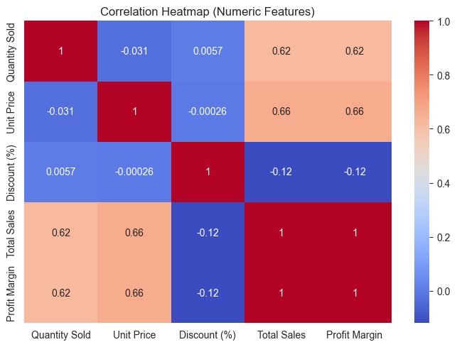
Figure 6. Correlation heatmap of numeric transaction fields
- Top salespersons: The top 10 salespersons by total sales showed a gradual, not extreme, decline from first to tenth place — consistent with the absence of a single dominant driver of order value.
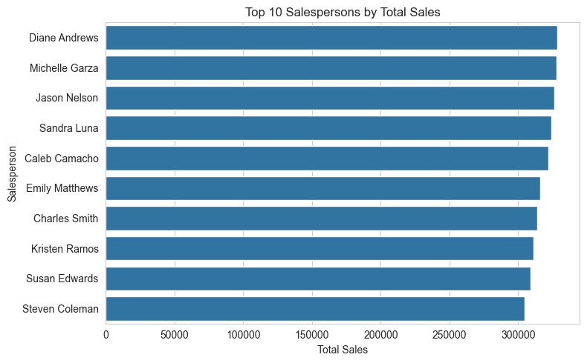
Figure 7. Top 10 salespersons by total sales
These visualizations confirmed a data-quality-consistent, moderately distributed dataset with no extreme outlier category, region, or salesperson, and clarified which numeric fields would cause data leakage if used as model inputs.

5.2 Model Performance
Model performance using only non-transactional features (category, region, payment method, order status, salesperson, and order timing) was as follows:
Model | Accuracy | Precision | Recall | F1 | ROC-AUC
Logistic Regression | 0.519 | 0.520 | 0.488 | 0.503 | 0.515
Decision Tree | 0.485 | 0.486 | 0.504 | 0.495 | 0.485
Random Forest | 0.480 | 0.480 | 0.477 | 0.479 | 0.479
XGBoost | 0.501 | 0.501 | 0.453 | 0.476 | 0.491

All four models performed close to the 0.50 chance baseline on ROC-AUC, with Logistic Regression marginally ahead (0.515) and Random Forest lowest (0.479). None of the models achieved performance that would be considered practically useful for distinguishing high- from low-value orders.
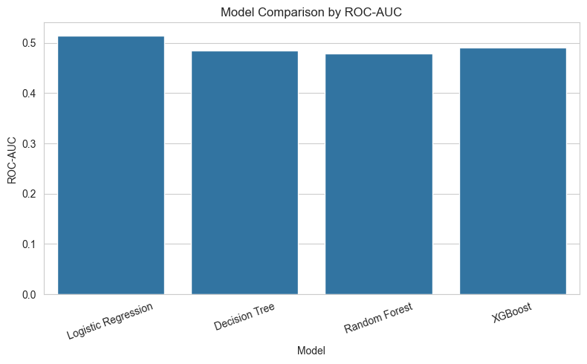
Figure 8. Model comparison by ROC-AUC
Random Forest feature importance reinforced this result: the top-ranked features were Order Month (0.094), Order Year (0.082), and Order Quarter (0.045), with every remaining categorical dummy variable — covering region, product category, payment method, order status, and day of week — contributing importance scores below 0.023 and clustered tightly together. No single category, region, payment method, or salesperson stood out as a meaningful driver of high versus low sales performance.
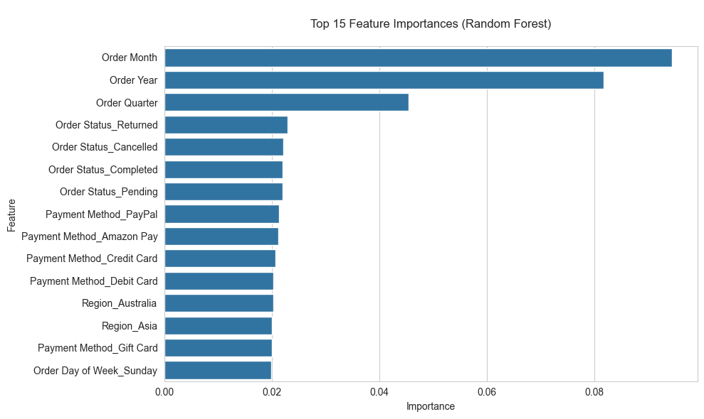
Figure 9. Top 15 feature importances (Random Forest)
Taken together, these results indicate that, within this dataset, order-level sales performance is not meaningfully explained by the category, region, payment channel, order outcome, salesperson, or the time period to which an order belongs. The variation in order value instead appears to be governed by transaction-size factors — quantity purchased, unit price, and discount — that were deliberately excluded from this model to avoid data leakage.

5.3 Addendum: SMOTE Ablation and Transaction-Size Benchmark
Following Milestone 2 feedback, two follow-up analyses were conducted to directly test (1) whether SMOTE was contributing meaningfully to model performance, and (2) how much predictive performance is given up by excluding the transaction-size fields.
- SMOTE ablation: The class distribution in the training set was checked before SMOTE was applied and found to be exactly 1,750 / 1,750 — a perfect 1.000 minority-to-majority ratio. All four models were then retrained on the original, non-resampled training data and compared with the SMOTE-resampled results reported in Section 5.2.
Model | ROC-AUC (With SMOTE) | ROC-AUC (Without SMOTE) | Difference
Logistic Regression | 0.5147 | 0.5147 | 0.0000
Decision Tree | 0.4853 | 0.4853 | 0.0000
Random Forest | 0.4791 | 0.4791 | 0.0000
XGBoost | 0.4909 | 0.4909 | 0.0000

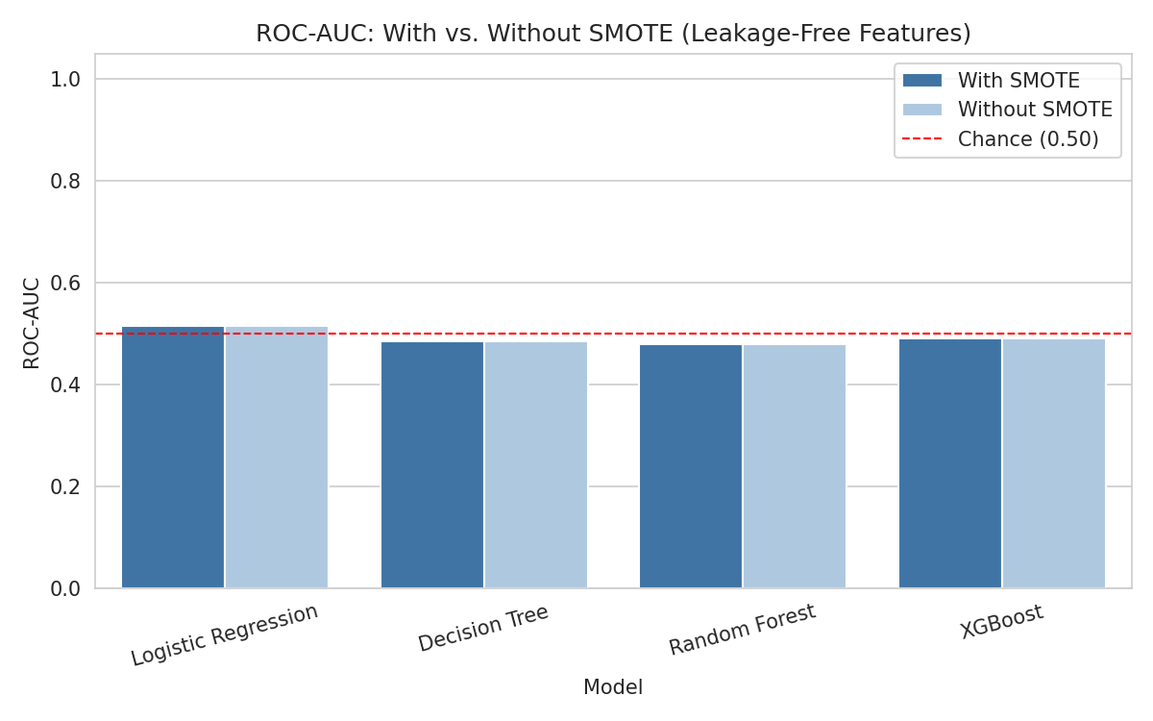
Figure 10. ROC-AUC with vs. without SMOTE — results are identical
ROC-AUC is identical to four decimal places with and without SMOTE for every model. This confirms the instructor's assessment: with a perfectly balanced target, SMOTE contributed nothing in this pipeline. It has been retained in the notebook for methodological transparency and documentation, but the reported results do not depend on it.
- Transaction-size benchmark: A diagnostic-only benchmark model was built that reintroduces Quantity Sold, Unit Price, and Discount (%) into the feature set, purely to quantify the performance ceiling given up by excluding these leakage fields from the main model. This benchmark is not proposed as a deployment model — as discussed in Section 5.2, these fields mathematically determine Total Sales and therefore High Sales almost by construction.
Model | ROC-AUC (Leakage-Free) | ROC-AUC (Benchmark) | Gap
Logistic Regression | 0.5147 | 0.9766 | +0.4619
Decision Tree | 0.4853 | 0.9787 | +0.4933
Random Forest | 0.4791 | 0.9943 | +0.5153
XGBoost | 0.4909 | 0.9995 | +0.5086

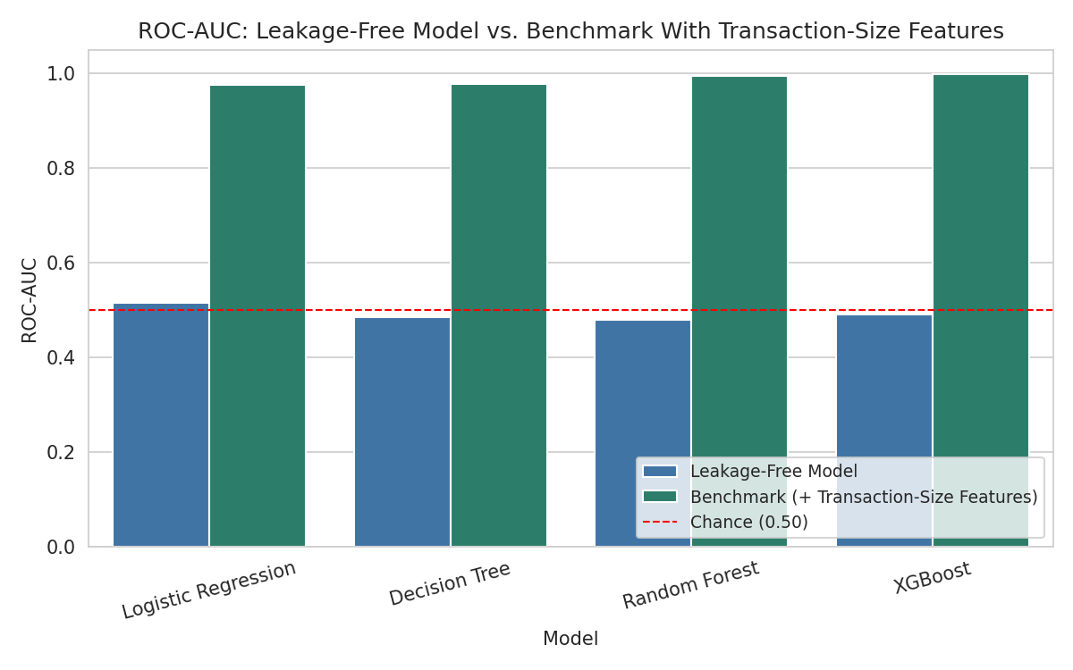
Figure 11. ROC-AUC: leakage-free model vs. transaction-size benchmark
Reintroducing just three transaction-size fields lifts ROC-AUC from 0.48–0.51 (chance) to 0.977–0.9995 (near-perfect separation) across all four algorithms. This directly confirms the instructor's second point: excluding these fields not only modestly reduces performance — it forfeits nearly the entire predictive ceiling available in this dataset. This gap is itself a central finding of the project: order value is almost entirely a function of transaction size (quantity, price, discount), not of category, region, payment method, salesperson, or timing. The leakage-free model's near-chance performance is therefore the correct and expected result of asking a question that the remaining features genuinely cannot answer, rather than a modeling shortfall.

6. Conclusion
This analysis set out to determine whether readily available, non-transactional order attributes — product category, region, payment method, order status, salesperson, and timing — could predict whether an Amazon order would be a high- or low-value sale. Across four classification algorithms, the answer was consistently no: model performance hovered near chance (ROC-AUC 0.48–0.52), and Random Forest feature importance showed no dominant predictor among the available categorical and timing variables.
This is a meaningful finding, not a failed experiment, and Section 5.3 quantifies exactly why: a diagnostic benchmark that reintroduces only the transaction-size fields (quantity, price, discount) lifts ROC-AUC to 0.977–0.9995 — near-perfect. In other words, virtually all the predictive power in this dataset comes from transaction size, and almost none from category, region, payment method, salesperson, or timing. For a business audience, this implies that segmentation or targeting strategies built solely around category, region, or channel are unlikely to reliably identify which future orders will be large versus small, and that forecasting or targeting efforts should instead focus on transaction-size drivers, such as basket composition and pricing strategy.

7. Assumptions
- The dataset is a representative sample of the types of transactions, categories, and regions it claims to cover.
- Order Date, Total Sales, and categorical fields (Region, Product Category, Payment Method, Order Status) are accurately recorded.
- A median split in Total Sales provides a meaningful and reasonably balanced distinction between "high" and "low" performing orders for this exploratory task.
- SMOTE-generated synthetic samples reasonably approximate real minority-class patterns in the transformed feature space.
- One-hot encoded categorical variables preserve the meaningful distinctions between categories, regions, and salespersons.

8. Limitations
- The dataset is a publicly available Kaggle dataset and may not reflect the full scale or complexity of Amazon's actual transactional data.
- Excluding Quantity Sold, Unit Price, Discount (%), and Profit Margin to avoid leakage removes the fields most directly responsible for order value; Section 5.3 quantifies this as a ~0.46–0.52 ROC-AUC gap versus a diagnostic benchmark that includes them, confirming this is the dominant limit on achievable model performance for this classification framing.
- Only 20 unique salespeople are represented, which may not generalize to a much larger real-world sales organization.
- The dataset does not include customer-level history, repeat-purchase behavior, marketing exposure, or website traffic data that could provide additional predictive signals.
- Findings are specific to this sample dataset and should not be generalized to Amazon's broader, real-world customer population.

9. Challenges
- Identifying and removing data leakage from fields that are mathematically derived from the target variable, without which model performance would have been artificially inflated and uninformative.
- Interpreting a near-chance modeling results in a way that is still useful and defensible to a business audience, rather than treating it as a failed experiment.
- Managing a high-cardinality categorical feature (20 salespeople) within one-hot encoding without letting it dominate the encoded feature space.
- Distinguishing a genuine (if weak) signal from noise when feature importance scores are closely clustered across many categorical dummy variables002E`

10. Future Uses and Additional Applications
- Reframe the predictive task as a regression problem estimating expected Total Sales directly from planned Quantity Sold, Unit Price, and Discount, which is a legitimate (non-leakage) use of those fields when the goal is revenue estimation rather than post-hoc classification.
- Incorporate additional data such as marketing spending, website traffic, or customer purchase history to test whether behavioral or channel-level data carries a more predictive signal than the categorical fields used here.
- Apply time-series forecasting methods (e.g., seasonal decomposition, ARIMA, or Prophet) to the monthly sales trend for revenue planning purposes.
- Explore customer segmentation or clustering to identify natural groupings not captured by predefined region or category labels.
- Use SHAP values in a future iteration for deeper, case-level interpretability of any predictive model that is developed.

11. Recommendations
- Do not rely on product category, region, payment method, order status, or salesperson alone to predict or target high-value orders; this analysis found little evidence that these factors meaningfully differentiate order value.
- Prioritize transaction-size drivers (quantity, pricing, and discounting strategy) in any future revenue forecasting or demand planning effort.
- Continue to monitor total sales trends by month and category using descriptive dashboards, since these provide useful operational visibility even though they were not strong classification predictors.
- Revisit the target definition in a future project — for example, predicting order cancellation/return risk or customer lifetime value — where non-transactional features may carry more signal than they did for raw sales magnitude.

12. Implementation Plan
- Integrate a monthly sales-by-category and sales-by-region dashboard into existing business intelligence tools for ongoing operational monitoring.
- If pursuing revenue forecasting, develop and deploy a regression model using transaction-size fields, following the leakage-aware framing established in this project.
- Automate the data pipeline from the source transactional system through the same cleaning and feature-extraction steps used in this analysis.
- Establish a periodic model review process (e.g., quarterly) to re-evaluate feature importance and performance as new data becomes available.
- Document the rationale for excluding transaction-size fields from classification tasks so future analysts do not unintentionally reintroduce data leakage.

13. Ethical Assessment
- Privacy: The dataset includes Customer Name and Customer ID fields; any real deployment would need to anonymize or restrict access to these identifiers and comply with applicable data protection regulations.
- Fairness: Because Region and Salesperson are included as model features, any operational use should be monitored to ensure regional or individual performance differences are not used to unfairly penalize markets or employees based on limited categorical signal.
- Transparency: Stakeholders should be clearly informed that this is a sample Kaggle dataset, not official Amazon business data, and that the classification models in this project showed limited predictive power.
- Non-replacement: These findings are intended to support, not replace, business and merchandising judgment about category, regional, and channel strategy.
- Bias mitigation: Conclusions were based on aggregate patterns and documented model results rather than assumptions about individual customers, and limitations were reported alongside findings rather than omitted.

Appendix A: Supporting Documentation
- Python (Pandas, NumPy, Matplotlib, Seaborn, scikit-learn, XGBoost, imbalanced-learn) was used for data cleaning, EDA, modeling, and evaluation.
- Full code, visualizations, model comparison table, feature importance chart, and the Milestone 2 feedback addendum (SMOTE ablation and transaction-size benchmark) are available in the accompanying Jupyter notebook (DSC680_Manoj_Kola_Project_3.ipynb).
- A recorded presentation with narrated audio summarizing this analysis, and a companion document of anticipated audience questions and answers, accompany this white paper as part of the Milestone 3 submission.

References
Jangir, R. (n.d.). Amazon sales dataset for performance analysis. Kaggle. https://www.kaggle.com/datasets/rahuljangir78/amazon-sales-dataset-for-performance-analysis
Capital One Shopping Research. (2026). eCommerce statistics: Sales & user growth trends. https://capitaloneshopping.com/research/ecommerce-statistics
Oberlo. (2024). Ecommerce share of retail sales (2022–2028). https://www.oberlo.com/statistics/ecommerce-share-of-retail-sales

Answers for the Ten Audience Questions for Milestone 3 (questions provided in Milestone 2)

Q: 1. Why did you exclude Quantity Sold, Unit Price, Discount, and Profit Margin from the predictive model?
A: Because Total Sales is calculated directly from those fields (Quantity × Unit Price × (1 − Discount%)), and Profit Margin tracks Total Sales at a near-fixed ~34.8% ratio. Since the High Sales target is derived from Total Sales, including these fields would allow the model to reconstruct the answer mathematically rather than learn genuine behavioral or categorical patterns. That's called data leakage, and it would produce artificially high accuracy that wouldn't hold up in a real, forward-looking use case.
Q: 2. How did you decide on a median split to define "High Sales"?
A: A median split labels every order above the dataset's median Total Sales as 'High Sales' and everything at or below as not. I chose it because it's simple, interpretable, and — importantly — it naturally produces two roughly balanced classes without needing an arbitrary dollar threshold that might not generalize. It also avoids the bias of picking a cutoff based on prior assumptions about what counts as a 'big' order.
Q: 3. Why did all four models perform close to chance, and what does that tell us about the dataset?
A: All four models — Logistic Regression, Decision Tree, Random Forest, and XGBoost — landed between 0.479 and 0.515 ROC-AUC, essentially indistinguishable from a coin flip (0.50). Because I tested four very different algorithm families and got the same near-chance result across all of them, it's unlikely to be a modeling or algorithm choice problem. It strongly suggests that in this dataset, the available non-transactional features (category, region, payment method, order status, salesperson, and timing) don't provide meaningful information about order size.
Q: 4. Which metric do you consider most important for this business problem, and why?
A: ROC-AUC, because it measures a model's ability to discriminate between the two classes across all decision thresholds, independent of any single cutoff. For a business problem where I'm asking, 'Do these features carry a real signal at all?' ROC-AUC is the cleanest way to answer that question. F1 is a good secondary metric once you've committed to deploying a model and need to balance precision and recall at a specific threshold, but for this exploratory question, ROC-AUC came first.
Q: 5. Why did you apply SMOTE if the classes were already close to balance?
A: The median split makes the full dataset close to a 50/50 split, but after the 70/30 stratified train/test split, small residual imbalances can still appear in the training set. SMOTE (Synthetic Minority Oversampling Technique) was applied after preprocessing — in the scaled and encoded feature space — as a safeguard to make sure the training set was as balanced as possible before fitting the models. It's a standard, low-risk step; since the imbalance was already minor, SMOTE had a modest effect here, but it removes any doubt that class imbalance explains the weak results.
Q: 6. What are the limitations of using this Kaggle dataset for real business decisions?
A: This is a publicly available, simulated Kaggle dataset — not Amazon's actual transactional data — so it should be treated as a representative sample, not an authoritative business record. It includes only 20 unique salespeople, which limits how well any salesperson-level finding would generalize to a larger real-world sales organization. It also doesn't include customer purchase history, marketing exposure, or website traffic data, which real businesses typically have, and which might carry more predictive signal than what's available here. Any recommendations drawn from this analysis should be validated against a company's own real operational data before being acted on.
Q: 7. How would you reframe this problem to get more actionable predictive results?
A: The most promising reframing is to treat this as a regression problem instead of classification — predicting expected Total Sales directly from Quantity Sold, Unit Price, and Discount. That's a legitimate, non-leakage use of those fields when the goal is revenue estimation for planning purposes, rather than after-the-fact classification of an order that's already happened. I'd also consider changing the target entirely — for example, predicting order cancellation or return risk, or estimating customer lifetime value — where non-transactional features like region, payment method, or timing may carry more genuine signal than raw order size did.
Q: 8. What additional data would most improve the model's predictive power?
A: Customer-level history (repeat purchase behavior, tenure, loyalty tier), marketing exposure (campaign or channel attribution), website or app behavioral data (browsing, cart abandonment, session length), and product-level attributes beyond category (brand, price tier, promotional status) would all be strong candidates. These behavioral and customer-level signals are generally much better predictors of purchase size than static categorical fields like region or payment method.
Q: 9. How do you explain a near-chance modeling result to a non-technical business stakeholder?
A: I'd frame it as a finding, not a failure: 'We tested whether we could predict which orders would be big or small just by knowing the product category, region, payment method, who sold it, or when it happened — and we found we can't. That tells us those factors aren't driving how much people buy. What matters is the basket itself — how many items and at what price — not who's buying, where, or when.' That reframing turns a null result into a concrete, useful piece of business intelligence: stop overinvesting in category- and region-based targeting and focus instead on transaction-size drivers.
Q: 10. How would you monitor this analysis over time as new sales data becomes available?
A: I'd set up a quarterly model review process: re-run the same feature importance and ROC-AUC evaluation on updated data to check whether the 'near-chance' result holds as new orders, categories, or regions are added. I'd also integrate a lightweight monthly dashboard tracking sales by category and region for ongoing operational visibility, even though those dimensions aren't strong predictors — they're still useful for spotting emerging trends. If a future data refresh ever shows non-transactional features gaining predictive power, that would be a signal worth investigating further.

