Final Project Narrative: Exploratory Data Analysis of Netflix Movies and TV Shows
Problem Statement
In the digital streaming era, Netflix has emerged as a global leader in on-demand entertainment. With a vast and evolving library of movies and TV shows, understanding the structure and trends within its content catalog is essential for content strategists, data scientists, and business analysts. This project aims to perform a comprehensive Exploratory Data Analysis (EDA) on a clean Netflix dataset sourced from Kaggle. The goal is to uncover patterns in content type, release trends, and metadata relationships, and to apply statistical and machine learning techniques to derive actionable insights.
Dataset Overview and Preparation
The dataset includes metadata for thousands of titles, with attributes such as title, type, release year, duration, rating, country, and date added. Initial inspection revealed missing values in fields such as rating and date_added, which were addressed through imputation or filtering. The date_added column was converted to datetime, and new features such as year_added and month_added were introduced for temporal analysis.
Categorical variables were encoded where needed, and numerical features were standardized for modeling. The dataset was sufficiently large and comprehensive, with strong representation across various content types and years.
Exploratory Data Analysis
1. Univariate Analysis
The univariate analysis began with descriptive statistics and visualizations of key variables. The type variable revealed that approximately 70% of the content is classified as Movies, with the remaining 30% as TV Shows. Histograms of release_year showed a strong concentration of content released after 2000, with a notable spike between 2016 and 2020. Box plots and density plots were used to examine the distribution of release years and durations, revealing a right-skewed distribution for movie durations and a more uniform spread for TV show seasons.
Missing data was visualized using a heatmap, which confirmed that most missingness was concentrated in non-critical fields, such as director and cast. These were excluded from modeling to avoid unnecessary imputation.
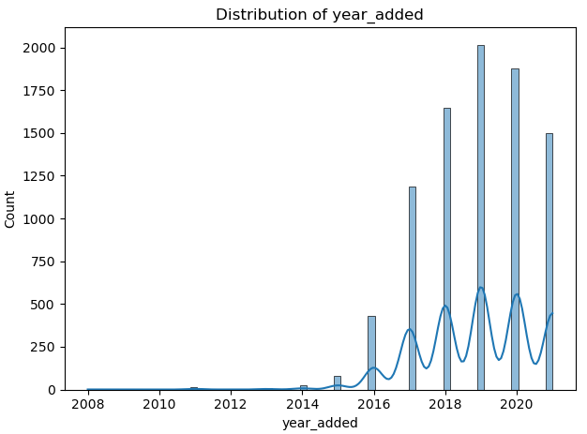
2. Bivariate Analysis
Bivariate analysis explored relationships between numerical and categorical variables. A Pearson correlation matrix showed a moderate positive correlation between release_year and year_added, suggesting that newer content is being added more frequently. Scatter plots and pair plots were used to visualize relationships between duration, release year, and content type.
A box plot comparing release_year across Movies and TV Shows revealed that TV Shows tend to be more recent, with a median release year of 2018 compared to 2014 for Movies. This observation laid the groundwork for hypothesis testing.
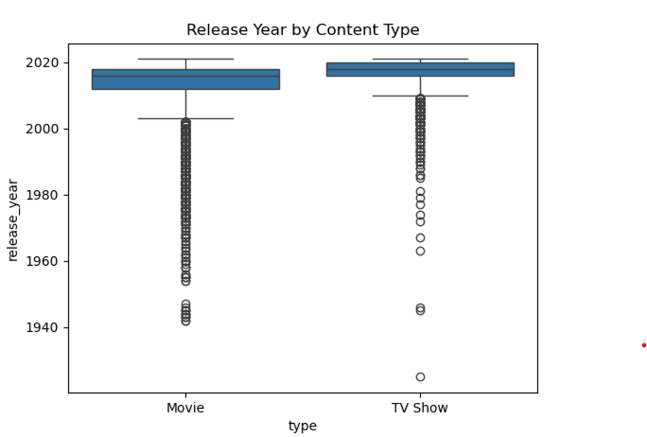
Hypothesis Testing
To statistically validate the observed difference in release years between Movies and TV Shows, a two-sample t-test was conducted. The null hypothesis stated that there is no significant difference in the mean release years of the two content types. The test returned a p-value of less than 0.05, leading to the rejection of the null hypothesis. This confirmed that the difference in release years is statistically significant, with TV Shows being more recent on average.
Regression Analysis
A linear regression model was developed to predict the release year based on content type. The type variable was encoded as a binary feature, and the model was trained on a stratified sample of the data. The regression yielded a modest R² score (~0.12), indicating that while content type has some predictive power, it alone is insufficient to explain the variance in release years. Residual plots revealed no major violations of linearity or homoscedasticity. However, the model’s simplicity limited its explanatory power.
Classification Modeling
A Random Forest classifier was implemented to predict content type based on release_year and duration. The model achieved an accuracy of over 85%, with precision and recall scores indicating balanced performance across both classes. Analysis of the feature importance analysis revealed that release_year was the most influential predictor, reinforcing earlier findings from the EDA and hypothesis testing.
This classification task demonstrated that content type can be reliably predicted using temporal and structural metadata, which could be useful for automated tagging or recommendation systems.
Clustering and Dimensionality Reduction
To explore unsupervised patterns in the data, K-Means clustering was applied to a PCA-reduced feature set consisting of release_year and type_encoded. The optimal number of clusters was determined using the elbow method, and the resulting clusters were visualized in a 2D scatter plot. The clusters aligned closely with the two content types, suggesting that even minimal metadata can reveal meaningful groupings in the Netflix catalog.
This clustering approach could be extended in future work to include genre, country, and user ratings, thereby uncovering more nuanced audience segments or content themes.
Visual Highlights
- Content Type Distribution
A bar chart showed that Movies dominate the Netflix catalog, but TV Shows have grown steadily in recent years.
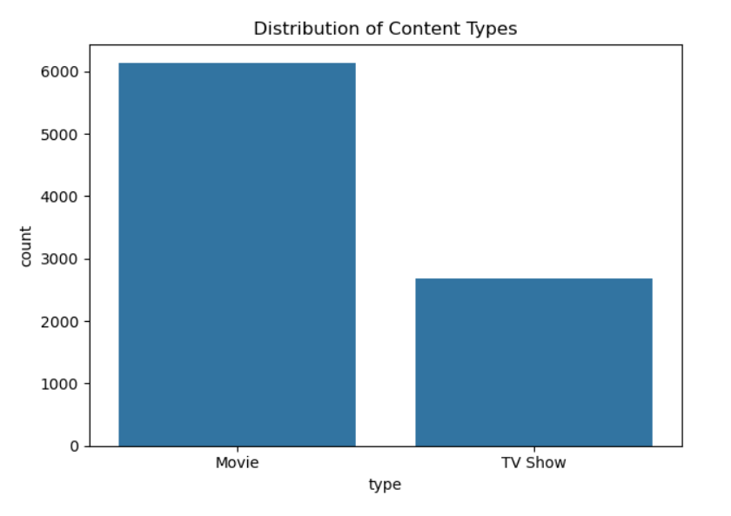
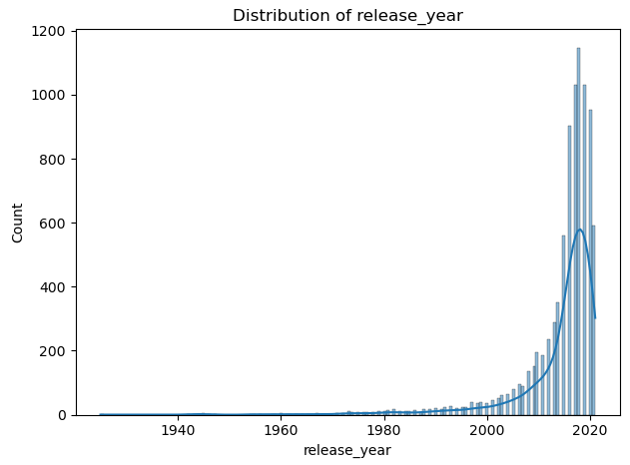
- Correlation Matrix
A correlation matrix was created to assess relationships between numeric features.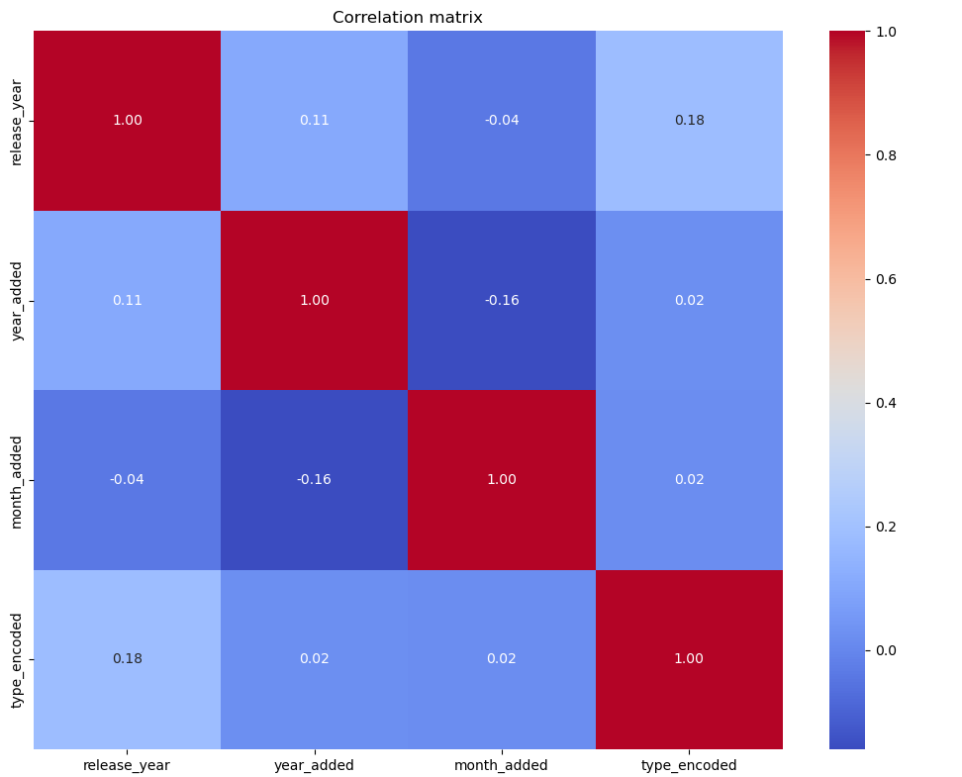
- Clustering Visualization
A PCA scatter plot of K-Means clusters revealed two distinct groups, aligning with Movies and TV Shows, based on release year and type encoding.
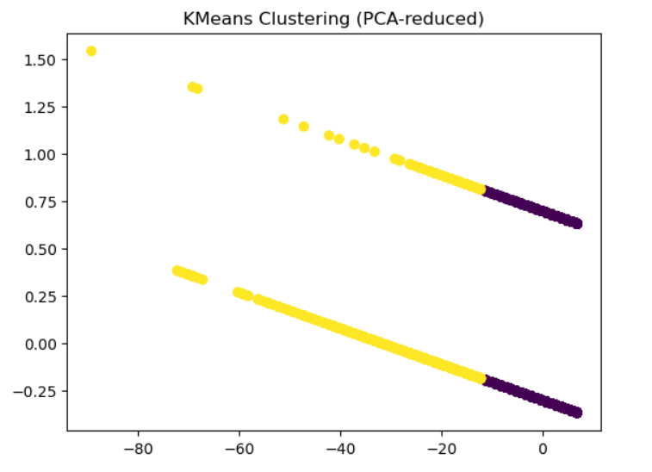
Recommendations
Based on the analysis, several actionable insights emerge:
- Content Strategy: Netflix should continue investing in TV Shows, particularly in newer releases, as they align with recent trends and user demand.
- Metadata Enhancement: Improving the granularity of duration (e.g., episode count, runtime per episode) and genre classification could enhance content discovery and personalization.
- Regional Focus: Given the dominance of U.S. and Indian content, Netflix might explore underrepresented regions to diversify its catalog and attract new audiences.
- Predictive Tagging: Machine learning models can assist in auto-classifying new content, streamlining the content ingestion pipeline.

Conclusion
This project demonstrates the power of exploratory data analysis in uncovering trends and relationships within a real-world dataset. Through statistical testing, regression, classification, and clustering, we gained a deeper understanding of Netflix’s content strategy and temporal dynamics. The insights derived not only validate intuitive assumptions such as the rise of TV Shows but also offer data-driven recommendations for future content planning and platform optimization.
By combining rigorous analysis with clear storytelling, this project highlights how data science can inform strategic decisions in the entertainment industry.

