Overview:

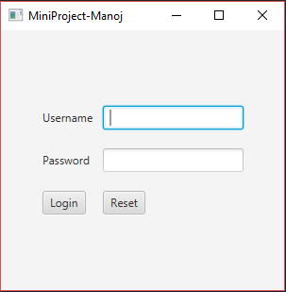

**Main Class** contains the code of this UI and this is executed in the main thread and goes to sleep till user authentication is done. After, the authentication an object of Subjects class is instantiated.

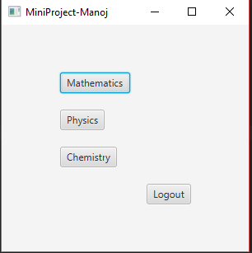

Then an event handler is used to find the button clicked and corresponding Pool Class object is created. The object then displays the questions available in the bank of that particular subject in a list view. The user is given access to the methods which can insert, delete or modify questions in the database. Other than the functions that can manipulate the question bank, user also has the feature to generate a quiz of required number of questions.

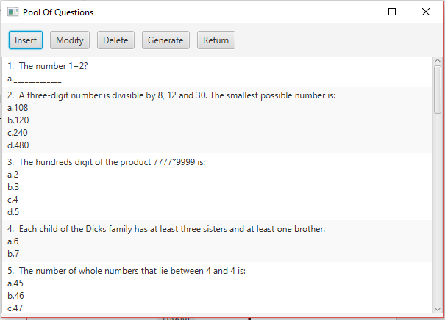

List of Classes:

* Main
* Subjects
* Pool
* popup
* generatepop
* PopUp2
* Methods

Main Class

Methods:

Start Method: Sets up the primary stage for the application

Main Method: Starting point of the application

Subjects Class

Methods:

Starter Method: Generated the scene for selecting subjects

Pool Class

Methods:

Show Method: Generates the UI displaying the list of questions in a particular subjects(Handled using Event Handlers) and an interface to manipulate question bank and generate a test.

Popup Class

This class is designed to throw an Appilcation MODAL when the user authentication fails.

Methods Class :

delete method: This method is used to delete the selected question from file

add method: It is used to add a question to pool of questions in a

particular subject

modify method: to modify the selected question from the list view

generate method: to generate the test of required number of questions

to a default location