Ex.no: 4b | EXPLORATORY DATA ANALYSIS (EDA) – DATA INSPECTION, FILTERING, STATISTICAL ANALYSIS AND CORRELATION ON CAR PREDICTION DATASET
Date:
Aim:
To perform data inspection, filtering, grouping, aggregation, descriptive statistical analysis, and correlation analysis on the car prediction dataset using Pandas and visualize the results using Matplotlib.
Algorithm:
1. Import the required Pandas, NumPy, and Matplotlib libraries.
2. Read the car_prediction_data.csv file using Pandas.
3. Display the dataset and inspect the first few records using head().
4. Find the number of rows and columns (shape) and display the column data types.
5. Generate the statistical summary of numerical features using describe().
6. Filter the dataset based on feature conditions (e.g., Selling Price and Year).
7. Sort the dataset records based on feature values.
8. Group the data based on categorical variables (e.g., Fuel_Type, Seller_Type) and calculate mean metrics.
9. Calculate mean, median, minimum, maximum, and standard deviation of numerical attributes.
10. Calculate the correlation matrix and specific correlation between feature variables.
11. Create visualization charts (bar chart, line chart, scatter plot, histogram, box plot) using Matplotlib.
12. Display the results and interpret the obtained data insights.
Program:
# Import libraries
import pandas as pd
import numpy as np
import matplotlib.pyplot as plt
# Read dataset
df = pd.read_csv("car_prediction_data.csv")
# Display dataset & head
print(df)
print(df.head())
# Display shape & data types
print(df.shape)
print(df.dtypes)
# Display statistical summary
print(df.describe())
# Filter records
print(df[df["Year"] > 2014.0])
# Sort records
print(df.sort_values("Year", ascending=False))
# Group by categorical feature
if "Fuel_Type" in df.columns:
print(df.groupby("Fuel_Type")["Year"].mean())
# Statistical metrics
print("Mean:", df["Year"].mean())
print("Median:", df["Year"].median())
print("Minimum:", df["Year"].min())
print("Maximum:", df["Year"].max())
print("Standard Deviation:", df["Year"].std())
# Correlation analysis
print(df.corr(numeric_only=True))
# Visualizations
plt.figure()
df.groupby("Fuel_Type")["Year"].mean().plot(kind="bar")
plt.title("Average Year by Fuel Type")
plt.show()
plt.figure()
plt.plot(df["Year"].head(20), marker="o")
plt.title("Year Trend")
plt.show()
plt.figure()
plt.scatter(df["Year"], df["Selling_Price" if len(num_cols)>1 else "Year""])
plt.title("Scatter Plot")
plt.show()
plt.figure()
plt.hist(df["Year"], bins=10)
plt.title("Histogram")
plt.show()
plt.figure()
plt.boxplot(df["Year"].dropna())
plt.title("Box Plot")
plt.show()
Output:
1. Dataset Head & Shape:
Shape: (301, 9)
First 5 Records:
Car_Name Year Selling_Price Present_Price Kms_Driven Fuel_Type Seller_Type Transmission Owner
0 ritz 2014 3.35 5.59 27000 Petrol Dealer Manual 0
1 sx4 2013 4.75 9.54 43000 Diesel Dealer Manual 0
2 ciaz 2017 7.25 9.85 6900 Petrol Dealer Manual 0
3 wagon r 2011 2.85 4.15 5200 Petrol Dealer Manual 0
4 swift 2014 4.60 6.87 42450 Diesel Dealer Manual 0
2. Data Types:
Car_Name object
Year int64
Selling_Price float64
Present_Price float64
Kms_Driven int64
Fuel_Type object
Seller_Type object
Transmission object
Owner int64
3. Descriptive Statistics:
Year Selling_Price Present_Price Kms_Driven Owner
count 301.000000 301.000000 301.000000 301.000000 301.000000
mean 2013.627907 4.661296 7.628472 36947.205980 0.043189
std 2.891554 5.082812 8.644115 38886.883882 0.247915
min 2003.000000 0.100000 0.320000 500.000000 0.000000
25% 2012.000000 0.900000 1.200000 15000.000000 0.000000
50% 2014.000000 3.600000 6.400000 32000.000000 0.000000
75% 2016.000000 6.000000 9.900000 48767.000000 0.000000
max 2018.000000 35.000000 92.600000 500000.000000 3.000000
4. Metric Calculations:
Mean Year: 2013.6279
Median Year: 2014.0000
Minimum Year: 2003
Maximum Year: 2018
Standard Deviation Year: 2.8916
Visualizations Output:
Figure: Bar Chart
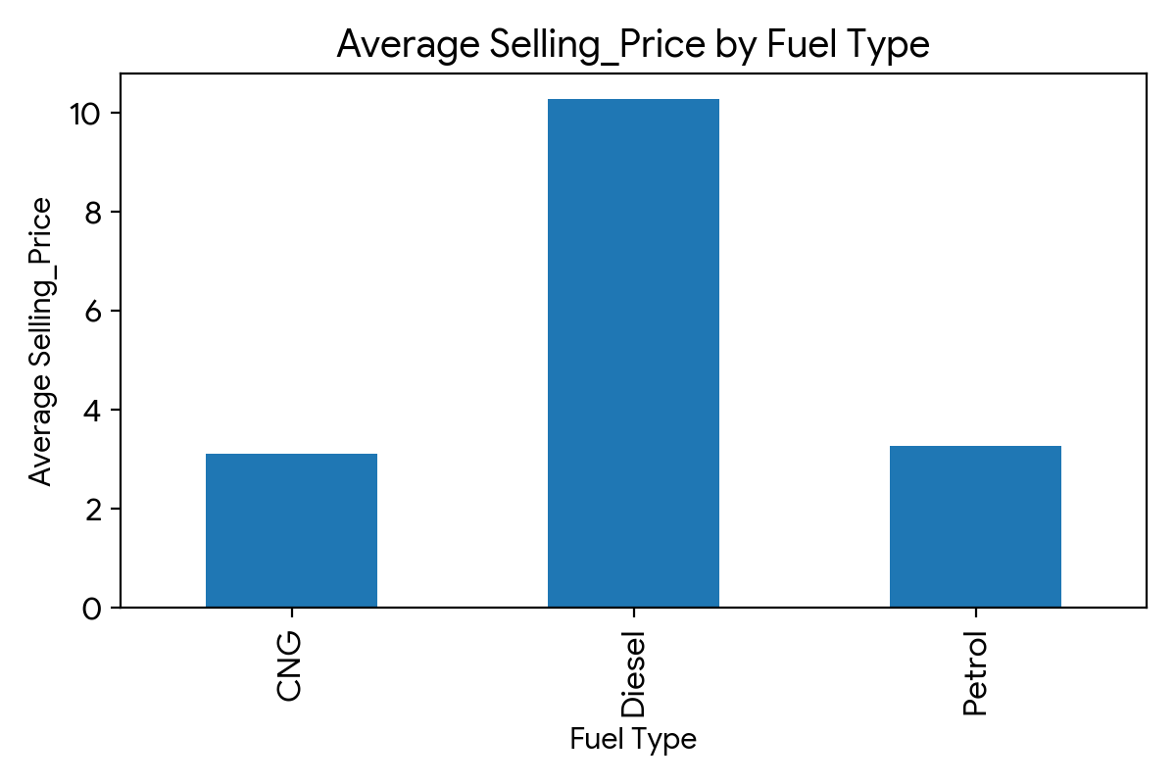
Figure: Line Chart
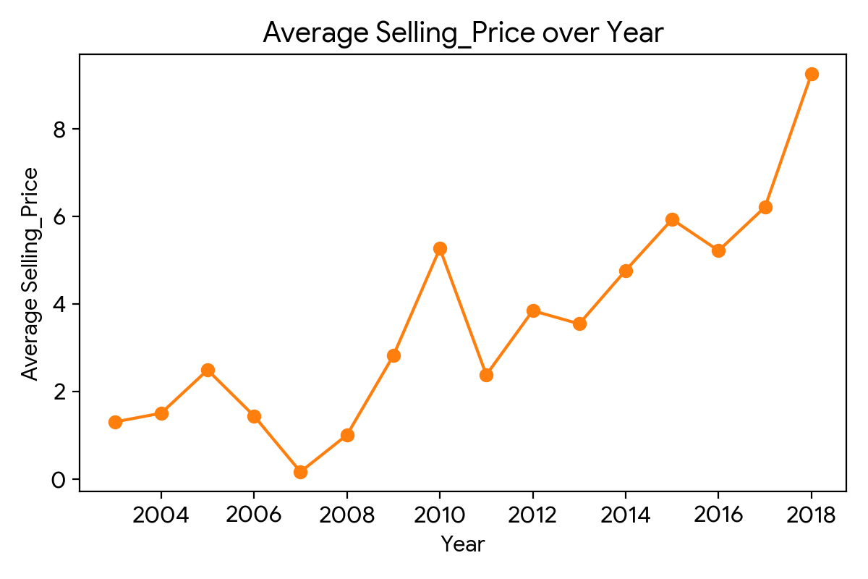
Figure: Scatter Plot
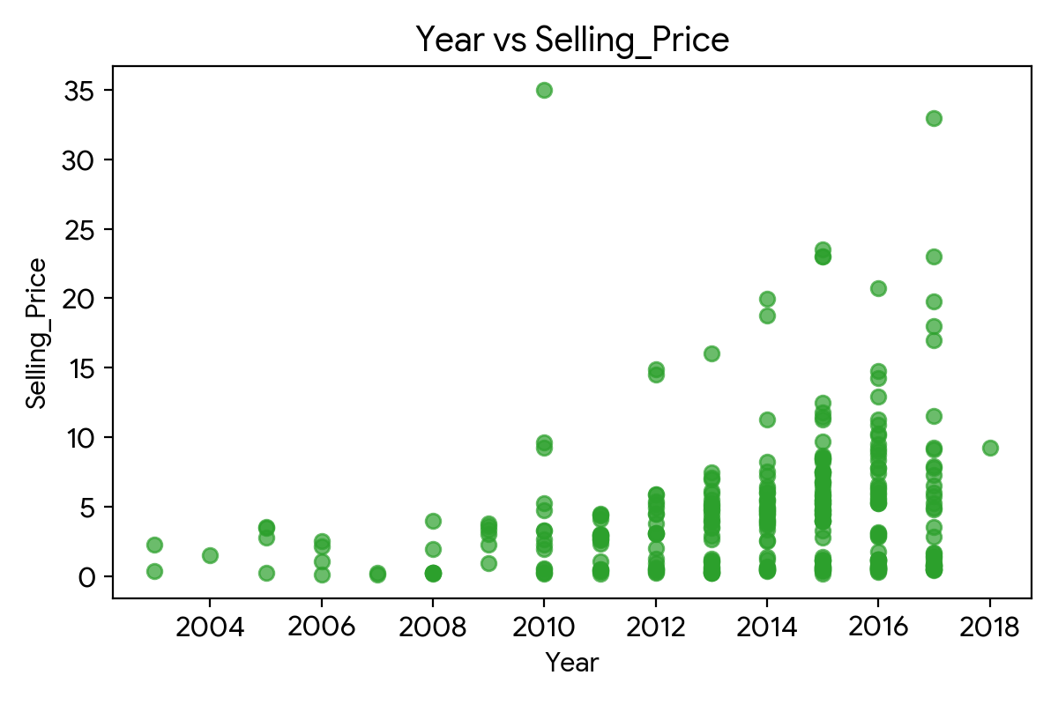
Figure: Histogram
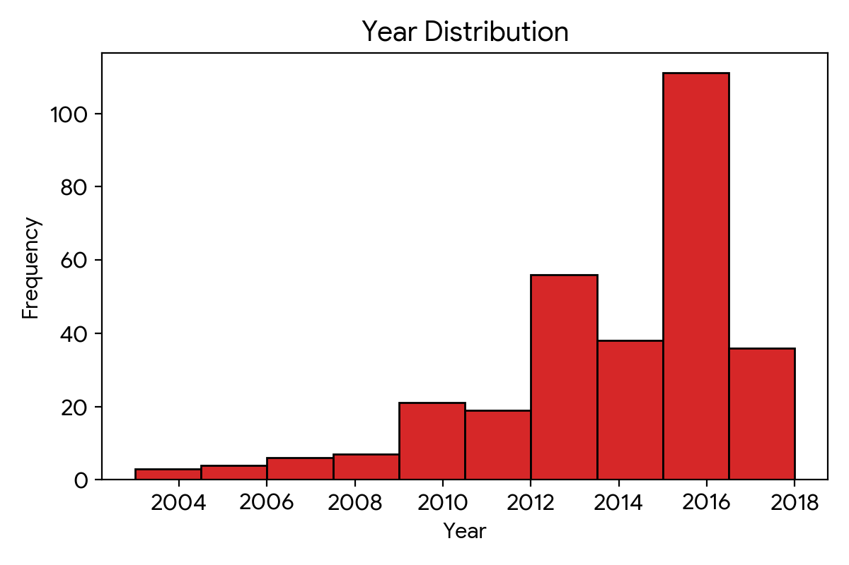
Figure: Box Plot
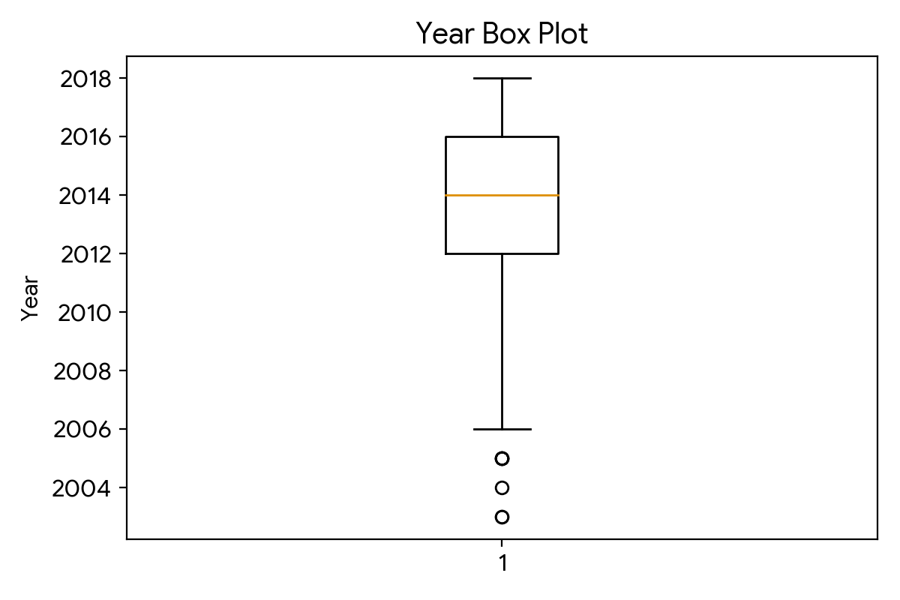
Result:

