EX:2 SCHEDULING OF PROJECT WITH PERT AND CPM TECHNIQUES TO ESTIMATE THE COMPLETION TIME

AIM
To perform project scheduling, identify the critical path, and estimate total project completion time for "resume builder1" using Critical Path Method (CPM) and Program Evaluation and Review Technique (PERT) principles within open-source project management software.

PROCEDURE

Step 1: Work Breakdown Structure (WBS) Creation
Initialize project 'resume builder1' in the open-source software and configure working days/hours. Itemize all activity modules: Requirement Analysis, Market Analysis, System Design, Database Design, Coding, Testing, Bug Fixing, and Deployment.

Step 2: Dependency Mapping & Predecessor Definition (CPM Network)
Define network logic by assigning predecessors to establish task sequence:
• Task 1: Requirement Analysis (5 days, Start: 13/07/26)
• Task 2: Market Analysis (2 days, Start: 13/07/26)
• Task 3: System Design (4 days, Predecessors: 1, 2)
• Task 4: Database Design (3 days, Predecessor: 3)
• Task 5: Coding (5 days, Predecessor: 4)
• Task 6: Testing (2 days, Predecessor: 5)
• Task 7: Bug Fixing (2 days, Predecessor: 6)
• Task 8: Deployment (1 day, Predecessor: 7)

Step 3: Critical Path Analysis (CPM Evaluation)
Calculate Early Start (ES), Early Finish (EF), Late Start (LS), Late Finish (LF), and Float/Slack for each activity. Identify the sequence of dependent activities with zero float that determine the total duration (Critical Path: 1 -> 3 -> 4 -> 5 -> 6 -> 7 -> 8).

Step 4: Resource Allocation & Histogram Verification (PERT Analysis)
Assign resources (Ram, Vijaya, Pooja, Raja, Arun) to respective tasks. Monitor individual resource charts to ensure 100% capacity utilization without resource bottlenecking or over-allocation.

Step 5: Completion Time Estimation & Cost Verification
Verify total calculated working days (22 working days), planned work duration (160 hours), and final estimated cost (₹8,373.00).

OUTPUT
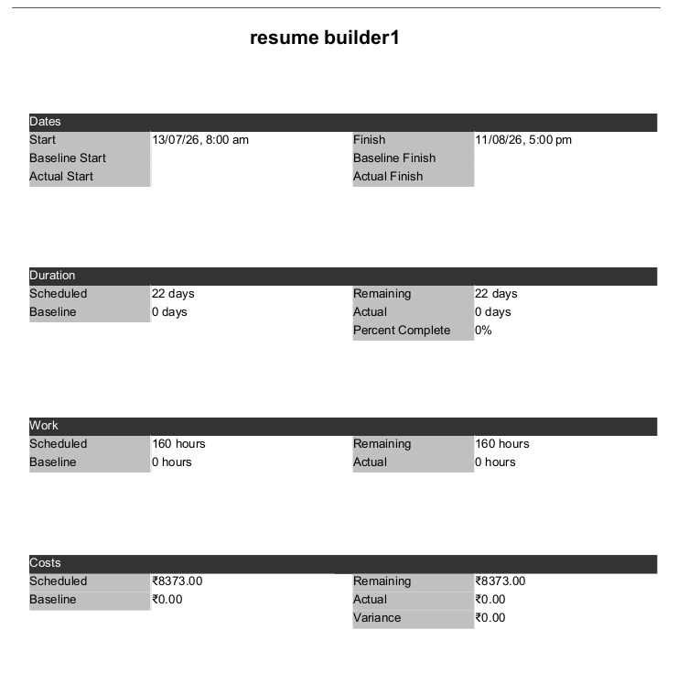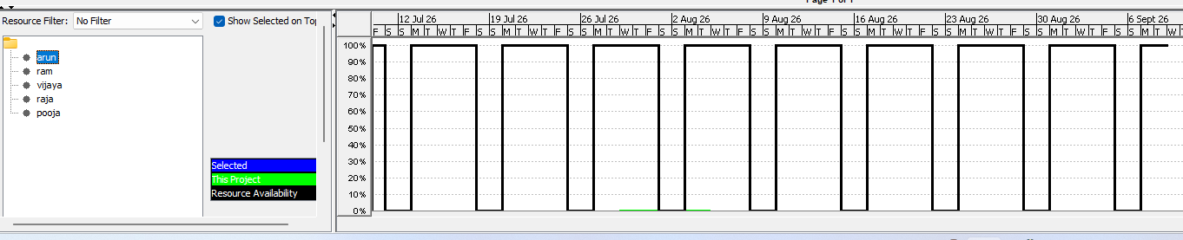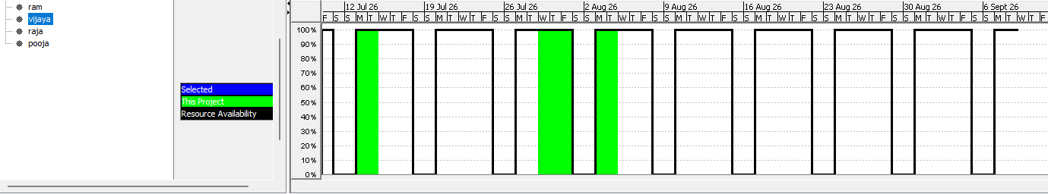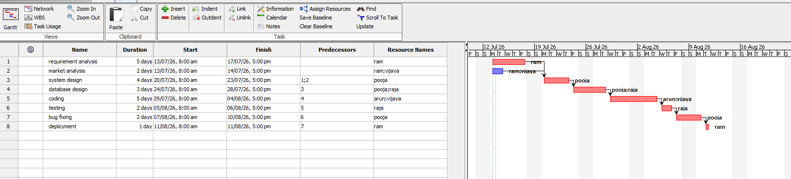

RESULT
Project scheduling using PERT/CPM techniques was performed successfully for 'resume builder1'. The critical path and estimated completion parameters are summarized below:
PERT/CPM Scheduling Parameter | Estimated Output / Status
Project Critical Path | 1 -> 3 -> 4 -> 5 -> 6 -> 7 -> 8
Project Start Date | 13/07/26, 8:00 AM
Project Estimated Completion Date | 11/08/26, 5:00 PM
Total Estimated Completion Time | 22 Working Days
Total Project Effort | 160 Hours
Total Budgeted Cost | ₹ 8,373.00
Conclusion: By applying CPM/PERT principles, the critical path was identified and the minimum project completion time was determined as 22 working days (160 hours) starting on 13/07/26 and finishing on 11/08/26 with an estimated cost of ₹8,373.00.

