Simplilearn FullStack Java Developer Phase 2
Project 1

GitHub: https://github.com/mha77/Phase2_Project1

IDE: Eclipse JEE 2022-09

Core Libraries:
MySql
Hibernate
JSP/Servlet/HTML

Description:
Learner’s Academy is a school that has an online management system. The system keeps track of its classes, subjects, students, and teachers. It has a back-office application with a single administrator login.

Sprint 1:
Setup Database and provide master List in Java EE for all entities
- Classes
- Subjects
- Teacher
- Student

Sprint 2:
Implement the Assignments:
- Student to class
- Subject to Teacher
- Subject to Class

Sprint 3:
Class Report
Improvements in Navigation
Clean Up

Screenshots:
Welcome Page: Navigation to all the options

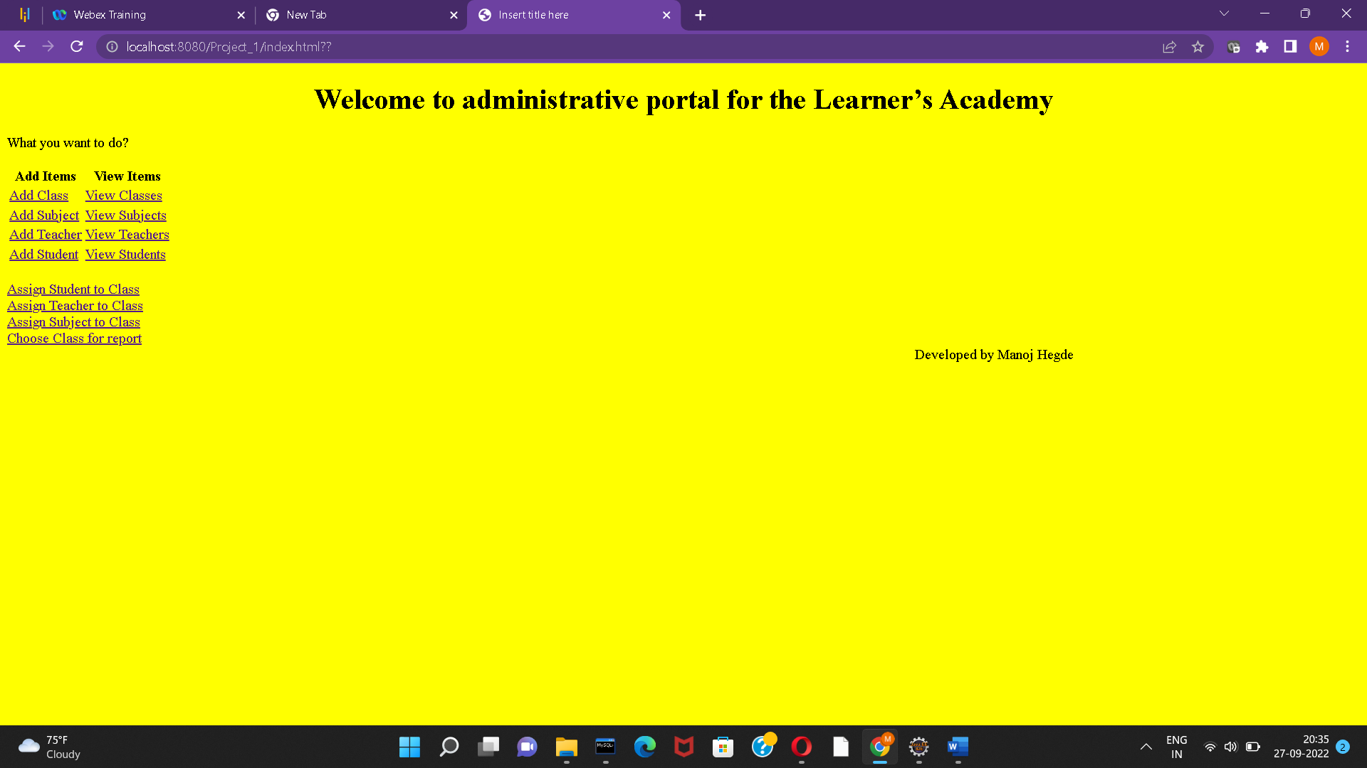
Create the Masterlists:

