EEG-Based Neuromarketing: Tracking Brain Responses to Video Advertisements with a Dry-Electrode Cap
PROJECT REPORT
Submitted by
Group Number: ____
SIDDHANT SAWHNEY (1BM23CS327)
MANOJ KULKARNI (1BM23CS184)
PRANAV EASWAR (1BM23CS365)
PADMA DEEPAK (1BM23CS222)
in partial fulfillment for the award of the degree of
BACHELOR OF ENGINEERING
in
COMPUTER SCIENCE AND ENGINEERING
Under the Guidance of
Prof. Amit Pradhan
Professor, Department of CSE, BMSCE

B.M.S. COLLEGE OF ENGINEERING
(Autonomous Institution under VTU)
BENGALURU - 560019
Academic Year - 2026–2027

Certificate
This is to certify that the project report entitled “EEG-Based Neuromarketing: Tracking Brain Responses to Video Advertisements with a Dry-Electrode Cap” is a bonafide work carried out by SIDDHANT SAWHNEY (USN: 1BM23CS327), MANOJ KULKARNI (USN: 1BM23CS184), PRANAV EASWAR (USN: 1BM23CS365), PADMA DEEPAK (USN: 1BM23CS222) in partial fulfillment of the requirements for the award of the degree of Bachelor of Engineering in Computer Science and Engineering, under my supervision during the academic year 2026–2027.

Guide Signature | HoD Signature | Principal Signature
Amit Pradhan | Dr. Kavitha Sooda | Dr. Bheemsha Arya

Name and signature of Examiners along with date
Examiner 1
Examiner 2

Abstract
Advertisers usually judge an ad by asking viewers questions after it ends. Such answers are a single number, are open to social-desirability bias, and cannot tell which moment of the ad held attention. This project builds a low-cost electroencephalography (EEG) system that records viewers while they watch real television ads and converts their brain activity into a second-by-second engagement timeline. The work continues an earlier phase in which we reanalysed a public EEG decision-making dataset (OpenNeuro ds002739, 24 subjects): pre-response EEG predicted the upcoming choice with a mean AUC of 0.563 using a shrinkage linear discriminant decoder, while a compact convolutional network (EEGNet) performed worse (0.544, p = 0.019), showing that simple, well-understood models are preferable with small EEG datasets. For the neuromarketing system, a Mitsar amplifier with a 19-channel dry-electrode cap streams EEG through the Lab Streaming Layer (LSL); our PsychoPy task presents a resting baseline and five real ads, stamps event markers on the same clock, and collects liking and purchase-intent ratings after each ad. An MNE-based pipeline automatically rejects electrodes without contact, removes eye blinks with ICA, and computes four measures in 3-second sliding windows: frontal alpha asymmetry, a beta/alpha engagement index, frontal theta and posterior alpha suppression, each relative to the participant’s own baseline. An offline replay viewer plays the ad in sync with the four graphs, shows the baseline readings they are compared against, and summarises each ad in plain language. On synthetic data with known effects the pipeline recovered 92–99% of each planted change and reduced a 127 µV blink to 21 µV. In a full test recording, markers were accurate to about 0.1 s, 10 of 19 electrodes were usable, and the ad produced 45% posterior alpha suppression and a 14.5% rise in engagement relative to rest. The system is ready for group data collection, which is needed to test whether the measures track viewers’ ratings.

DECLARATION
We hereby declare that the Major Project Phase-2 work entitled “EEG-Based Neuromarketing: Tracking Brain Responses to Video Advertisements with a Dry-Electrode Cap” is a bonafide work carried out by us under the guidance of Prof. Amit Pradhan, Professor, Department of Computer Science and Engineering, B.M.S. College of Engineering, Bengaluru, in partial fulfillment of the requirements of the degree of Bachelor of Engineering in Computer Science and Engineering of Visvesvaraya Technological University, Belagavi. We further declare that, to the best of our knowledge and belief, this project has not been submitted either in part or in full to any other university for the award of any degree.
Candidate details:
SL. NO. | Student Name | USN | Student’s Signature
1 | SIDDHANT SAWHNEY | 1BM23CS327
2 | MANOJ KULKARNI | 1BM23CS184
3 | PRANAV EASWAR | 1BM23CS365
4 | PADMA DEEPAK | 1BM23CS222

Place: Bengaluru
Date:
Certified that these candidates are students of the Computer Science and Engineering Department of B.M.S. College of Engineering. They have carried out the project work titled “EEG-Based Neuromarketing: Tracking Brain Responses to Video Advertisements with a Dry-Electrode Cap” as Major Project Phase-2 work. It is in partial fulfillment for completing the requirement for the award of the B.E. degree by VTU. The work is original and duly certified the same.
Guide Name: Prof. Amit Pradhan
Date:
Signature

Acknowledgment
We express our sincere gratitude to Prof. Amit Pradhan, Professor, Department of Computer Science and Engineering, for the guidance, encouragement and valuable insights throughout this project. We are grateful to ITIE Knowledge Solutions for providing the Mitsar EEG amplifier and SmartDRY dry-electrode cap through an industry collaboration, without which the recordings in this project would not have been possible. We thank the faculty members of the Department of CSE, BMSCE, for providing the infrastructure and academic support, and the volunteers who took part in the test sessions. Finally, we thank our friends and family for their constant motivation and support.

Contents
List of Figures viii
List of Tables ix
Chapter 1 Introduction 1
1.1 Overview 1
1.2 Motivation 1
1.3 Objective 2
1.4 Scope 2
1.5 SDG Justification 3
1.6 Existing System 3
1.7 Proposed System 4
1.8 Work Plan 4
Chapter 2 Literature Survey 5
2.1 Overview 5
2.2 Detailed Survey 5
2.2.1 EEG Decoding of Perceptual Decisions 5
2.2.2 EEG in Neuromarketing 5
2.2.3 EEG Measures of Approach, Engagement and Attention 6
2.2.4 Low-Cost and Synchronised EEG Acquisition 6
2.3 Research Gap Identification 6
2.4 Mapping of Objectives with Research Gap 7
Chapter 3 Software and Hardware Requirement Specification 8
3.1 Functional Requirements 8
3.2 Non-Functional Requirements 8
3.3 Hardware Requirements 9
3.4 Software Requirements 9
3.5 Cost Estimation 9
Chapter 4 Design 10
4.1 High Level Design 10
4.2 System Architecture 10
4.3 Use-case Diagram 12
4.4 Detailed Design: Signal Processing Pipeline 12
4.5 Detailed Design: EEG Measures 13
4.6 Component Mapping 14
Chapter 5 Implementation 15
5.1 Overview of Technologies Used 15
5.2 Implementation Details of Modules 15
5.2.1 Phase One: Decoding Pipeline 15
5.2.2 LSL Recording 15
5.2.3 Channel Calibration 16
5.2.4 Session Task 16
5.2.5 Preprocessing and Feature Extraction 16
5.2.6 Replay Viewer 17
5.3 Challenges Encountered and Strategies Used 18
Chapter 6 Testing and Experimental Analysis and Results 19
6.1 Unit Testing 19
6.2 Integration Testing 20
6.3 Experimental Dataset 20
6.4 Worked Example: From Raw Signal to Final Numbers 21
6.5 Performance Analysis 22
6.6 Neuromarketing Results 23
6.7 Interpretation of the Test Advertisement 26
Chapter 7 Conclusion and Future Work 28
7.1 Conclusion 28
7.2 Future Work 28
REFERENCES 29
Appendix A: Project Snapshots 31
Appendix B: Details of List of Publications Related to this Project 34
Appendix C: Details of Patent 35
Appendix D: Details of Funding 36
Appendix E: POs and PSOs Mapped 37
Appendix F: Similarity Report and AI-Generated Report 38

List of Figures
Figure 4.1: Layered architecture of the EEG neuromarketing system. 11
Figure 4.2: Session protocol with event markers. 11
Figure 4.3: Use-case diagram of the system. 12
Figure 4.4: Signal processing pipeline. 13
Figure 6.1: Percentage of each planted effect recovered by the pipeline. 20
Figure 6.2: One 3-second window from raw signal to timeline: raw Fz, after filtering and ICA, its Welch spectrum, and the sliding-window timeline with baseline and ad medians. 22
Figure 6.3: Per-subject choice AUC, shrinkage-LDA against EEGNet. 23
Figure 6.4: Electrode quality in the test recording. 24
Figure 6.5: Engagement timeline of the test recording (gray: baselines, green: ad). 25
Figure 6.6: Replay viewer: session map with the baseline highlighted, ad video, and the four measures relative to rest. 25
Figure 6.7: Conclusion card for ad04: whole-ad values against rest, ratings and plain-language summary. 27
Figure A.1: Replay viewer showing the eyes-open baseline block: the readings whose medians define the rest level. 31
Figure A.2: Replay viewer summary for the eyes-closed block, reporting the cap check (1.35× on P3). 31
Figure A.3: Welch spectrum computed by hand: five overlapping 1 s pieces, Hamming taper, averaged FFT power. 32
Figure A.4: Analysis output for the test recording (quality check, ICA, cap check, per-ad values). 32
Figure A.5: Timeline of the pilot recording, in which asymmetry was unavailable because of poor contact. 33

List of Tables
Table 1.1: Project work plan 4
Table 2.1: Mapping of research gaps to objectives 7
Table 4.1: Mapping of system components to technologies 14
Table 5.1: Challenges and strategies 18
Table 6.1: Synthetic validation of the pipeline 19
Table 6.2: Datasets used 20
Table 6.3: Worked example on the test recording 21
Table 6.4: Phase-one decoding results with shrinkage-LDA 22
Table 6.5: Per-ad results for the test recording 24
Table 6.6: Ad values compared with normal variation at rest 26
Table E.1: Programme Outcomes mapping with project 37
Table E.2: Programme Specific Outcomes mapping with project 37

Chapter 1 Introduction

1.1 Overview
Every purchase starts with a decision, and much of that decision is shaped by advertising. Companies spend heavily on ads yet still judge them mainly through questionnaires and focus groups, which capture what viewers are willing and able to say after the ad has ended. Neuromarketing complements these methods by measuring physiological responses while the ad is being watched. Electroencephalography (EEG) is particularly suitable: it is non-invasive, portable and has millisecond time resolution, so it can show how engagement rises and falls from one second of an ad to the next.
This project is the second phase of our major project on EEG-based decision decoding. In the first phase we rebuilt, in Python, the analysis of a public perceptual decision-making dataset and showed that EEG recorded just before a response carries information about the upcoming choice. In this phase we apply the same theme to an everyday decision, the response to an advertisement, using our own recordings from a 19-channel dry-electrode cap. The result is a complete, validated system that records viewers, cleans the signal, computes four established EEG measures, and lets the team replay each ad alongside the brain responses it produced.

1.2 Motivation
1. Questionnaires give one number after the ad. Self-report ratings are retrospective, are affected by social desirability, and cannot locate the moment of an ad that worked or failed.
2. Commercial neuromarketing is expensive and closed. Industry ad-testing labs use proprietary hardware and unpublished analyses; independent replication is limited.
3. Low-cost dry EEG is attractive but fragile. Dry caps need no gel and set up quickly, but suffer from poor electrode contact, unlabelled data streams and timing drift. A usable system must detect and handle these problems automatically rather than produce misleading graphs.
4. Continuity with phase one. Phase one showed that EEG carries decision information but that complex models overfit small datasets. This motivates interpretable, literature-backed measures rather than black-box classifiers for a new, small neuromarketing dataset.

1.3 Objective
The objectives of this project are:
- To reproduce a published EEG decision-decoding analysis locally and compare a linear decoder with EEGNet under within-subject cross-validation.
- To build a recording system in which EEG from a Mitsar dry-electrode cap and the events of an ad-viewing task share a single clock, with marker accuracy of the order of 0.1 s.
- To design a session protocol with resting baselines, buffers around each ad and two ratings (liking and purchase intent) after every ad.
- To implement automatic electrode-quality checking and eye-blink removal suited to a dry cap with broken electrodes.
- To compute four EEG measures (frontal alpha asymmetry, engagement index, frontal theta, posterior alpha suppression) as second-by-second timelines and per-ad values relative to each participant’s baseline.
- To validate every analysis step on synthetic data with known effects and to provide a replay viewer that links brain responses to moments in the ad.

1.4 Scope
The project covers the full chain from data acquisition to visualisation: the stimulus-presentation task, synchronised EEG recording, preprocessing, feature extraction, plots and an interactive replay page. The stimuli are five existing real television advertisements of 32–90 s. The outcomes collected are two 1–9 ratings per ad; no purchase behaviour, memory tests or AI-generated ads are part of the scope. Statistical testing across a group of participants and predictive modelling are planned once group data has been collected and are described as future work.
The project is carried out in industry collaboration with ITIE Knowledge Solutions, which provided the Mitsar EEG amplifier and SmartDRY 19-channel dry-electrode cap used for all recordings. It is also a multidisciplinary project, combining neuroscience, signal processing, consumer psychology and software engineering, with field work in the form of EEG recording sessions with volunteer participants.

1.5 SDG Justification
- SDG 9 (Industry, Innovation and Infrastructure): the project turns a low-cost 19-channel dry EEG cap and free, open-source Python tools into a working ad-testing system, lowering the barrier to neuromarketing research that is otherwise limited to expensive commercial services.
- SDG 12 (Responsible Consumption and Production): measuring how advertisements actually affect attention, liking and purchase intent supports more transparent study of advertising influence on consumers.
- SDG 3 (Good Health and Well-Being): the signal-quality checks and EEG measures developed here are reusable in cognitive and clinical EEG applications, continuing the health relevance of phase one.

1.6 Existing System
- Self-report testing: surveys and focus groups give a single retrospective score per ad and are prone to bias.
- Commercial EEG ad testing: systems from industry vendors use proprietary hardware and analysis, with accuracy claims that are mostly unpublished.
- Research pipelines: published studies typically use gel-based, high-density EEG in specialised labs; their code is rarely available as a complete system that includes stimulus presentation, recording and visualisation.
- Manual synchronisation: many low-cost setups align stimulus events with EEG by hand-pressed markers, which drift over a session and introduce timing errors.

1.7 Proposed System
The proposed system records EEG from a Mitsar amplifier and SmartDRY 19-channel dry cap through EEGStudio’s LSL Outlet. A PsychoPy task runs the session (eyes-open and eyes-closed baselines, then five ads, each between a fixation cross and a gray screen, followed by two ratings) and writes event markers on the same LSL clock as the EEG. An MNE-based pipeline checks electrode contact, filters the signal, removes blinks with ICA and computes four measures in 3-second sliding windows relative to the eyes-open baseline. Outputs are per-ad numbers, a timeline plot and an offline HTML replay viewer. All software is written in Python and runs in an isolated virtual environment on a standard Windows laptop.

1.8 Work Plan
Table 1.1: Project work plan
Phase | Period (2026) | Work
1 | Aug – Sep | Literature survey; local reconstruction of the ds002739 decoding pipeline (Review 1, 04-09-2026)
2 | Sep | EEGNet implementation and comparison with shrinkage-LDA
3 | Late Sep | Pivot to neuromarketing; isolated Python environment; LSL setup and channel calibration in the lab; first pilot recording
4 | Oct | Session protocol, quality checks, four measures, synthetic validation, test recording, replay viewer (Review 2)
5 | Nov onwards | Consent forms, recruitment of about 20 participants, group statistics, paper writing

Chapter 2 Literature Survey

2.1 Overview
This project draws on four bodies of work: single-trial EEG decoding of decisions (phase one), EEG-based neuromarketing, the physiology behind individual EEG measures of affect and attention, and practical methods for low-cost, synchronised EEG acquisition.

2.2 Detailed Survey

2.2.1 EEG Decoding of Perceptual Decisions
Gherman and Philiastides [1] recorded simultaneous EEG and fMRI during a random-dot motion task with confidence ratings and released the data as OpenNeuro ds002739. Earlier work showed that EEG components track the accumulation of sensory evidence towards a decision, most notably the centro-parietal positivity described by O’Connell et al. [2], and that single-trial discriminant analysis can extract decision-related signals [3], [5]. Shrinkage estimators of the covariance matrix [6] make linear discriminant analysis stable when features outnumber trials. Lawhern et al. [4] proposed EEGNet, a compact convolutional network for EEG, which is often presented as an alternative to hand-crafted features.

2.2.2 EEG in Neuromarketing
Vecchiato et al. [11] reviewed the use of EEG and MEG in neuromarketing and showed that frontal activity differs between remembered and forgotten ads. Dmochowski et al. [12] found that the inter-subject correlation of EEG in a small lab audience predicted large-scale audience preferences for television content. Boksem and Smidts [13] showed that frontal EEG during movie trailers predicted both individual preference and box-office success better than stated willingness to pay. Hakim et al. [15] combined frontal-pole band power, asymmetry and inter-subject correlation with machine learning and improved preference prediction over questionnaires alone. In contrast, Venkatraman et al. [14] found that occipital alpha and frontal asymmetry added little beyond traditional measures when predicting advertising sales, which shows that EEG measures must be evaluated carefully rather than assumed to work.

2.2.3 EEG Measures of Approach, Engagement and Attention
Davidson [7] linked relatively greater left-frontal activity to approach motivation; because alpha power is inversely related to cortical activity, frontal alpha asymmetry is computed as the log alpha power on the right minus the left, and positive values indicate approach [8]. Pope et al. [9] introduced an engagement index based on the ratio of beta to lower-frequency power. Klimesch [10] reviewed evidence that alpha power decreases with attention and that frontal-midline theta increases with working-memory load, which underlies our posterior alpha suppression and frontal theta measures.

2.2.4 Low-Cost and Synchronised EEG Acquisition
Dry electrodes remove the need for conductive gel but have higher and less stable contact impedance [21]. The Lab Streaming Layer [18] provides time-synchronised streaming between acquisition and stimulus programs, PsychoPy [17] provides precise stimulus presentation, and MNE-Python [16] provides standard filtering, independent component analysis [20] and spectral estimation by Welch’s method [19].

2.3 Research Gap Identification
1. Complete open system gap: published neuromarketing studies report results but rarely provide an end-to-end, reproducible system covering presentation, synchronised recording, analysis and visualisation.
2. Dry-cap robustness gap: most studies use gel caps; automatic handling of dead or poorly connected dry electrodes is seldom described.
3. Moment-level interpretability gap: many studies reduce an ad to one number, losing where in the ad engagement changed.
4. Validation gap: analysis pipelines are rarely tested on synthetic data with known effects before being applied to real recordings.

2.4 Mapping of Objectives with Research Gap
Table 2.1: Mapping of research gaps to objectives
Research gap | Objective that addresses it
Complete open system | Session task, LSL recorder, analysis pipeline and replay viewer in one Python code base
Dry-cap robustness | Automatic electrode-quality check, electrode-pair fallback, blink removal restricted to the slow band
Moment-level interpretability | 3-second sliding-window timelines and a replay viewer that plays the ad with the graphs
Validation | Synthetic EEG with planted effects for every measure; a noise-floor test for asymmetry

Chapter 3 Software and Hardware Requirement Specification

3.1 Functional Requirements
- Stream acquisition: receive the EEGStudio LSL stream (27 channels) and record it with per-sample timestamps.
- Session control: present eyes-open and eyes-closed baselines, five ads in a participant-specific random order, a fixation cross before and a gray screen after each ad, and two 1–9 ratings after each ad.
- Event marking: write markers for every baseline, buffer and ad onset/offset on the same clock as the EEG.
- Data safety: save the recording and ratings even if the session is aborted, and refuse to overwrite an existing participant ID.
- Quality control: automatically flag electrodes without real contact and report the cap check.
- Feature extraction: compute four EEG measures as timelines and per-ad values relative to baseline.
- Visualisation: produce a timeline plot and an offline replay page synchronised with the ad video.

3.2 Non-Functional Requirements
- Timing accuracy: markers aligned to EEG within about 0.1 s; use of the measured sampling rate rather than the nominal rate.
- Robustness: the analysis must not produce a measure from a dead electrode; it reports the measure as unavailable instead.
- Reproducibility: all processing parameters are fixed in code; the environment is isolated in a virtual environment with a requirements file.
- Privacy: participant recordings and ad videos are excluded from the public code repository.
- Usability: the replay viewer works offline in a web browser without any server or internet connection.

3.3 Hardware Requirements
- Mitsar EEG amplifier with SmartDRY 19-channel dry-electrode cap (10–20 layout), provided by ITIE Knowledge Solutions.
- Windows laptop running EEGStudio Acquisition and the Python task (8 GB RAM or more).
- Display and speakers or headphones for ad presentation.

3.4 Software Requirements
- Acquisition: EEGStudio Acquisition with the LSL Outlet plug-in (data type “Raw data (in uV)”).
- Language and environment: Python 3.11 in an isolated virtual environment.
- Libraries: PsychoPy (stimulus presentation), pylsl and pyxdf (streaming), MNE-Python (filtering, ICA, spectra), NumPy, SciPy, pandas, scikit-learn, Matplotlib; PyTorch for EEGNet in phase one.
- Visualisation: a standard web browser for the HTML replay viewer.

3.5 Cost Estimation
The EEG amplifier, dry cap and EEGStudio software were provided by ITIE Knowledge Solutions through an industry collaboration, so no hardware purchase was needed. All other software is free and open source, and the public dataset used in phase one is freely available. Participants are volunteers and the ads are existing public advertisements. The only recurring cost is consumables such as saline for electrode contact, which is negligible.

Chapter 4 Design

4.1 High Level Design
The system is organised in three layers. The acquisition layer runs live during a session: the amplifier streams EEG through EEGStudio’s LSL Outlet, and our recorder receives it together with the event markers produced by the PsychoPy task, so both share one clock. The result is a single session file. The processing layer runs offline on that file, and the output layer produces per-ad numbers, a timeline plot and a replay viewer. Because the session file is the only hand-off point, the analysis can be rerun at any time without the cap.

4.2 System Architecture
The layered architecture is shown in Figure 4.1.
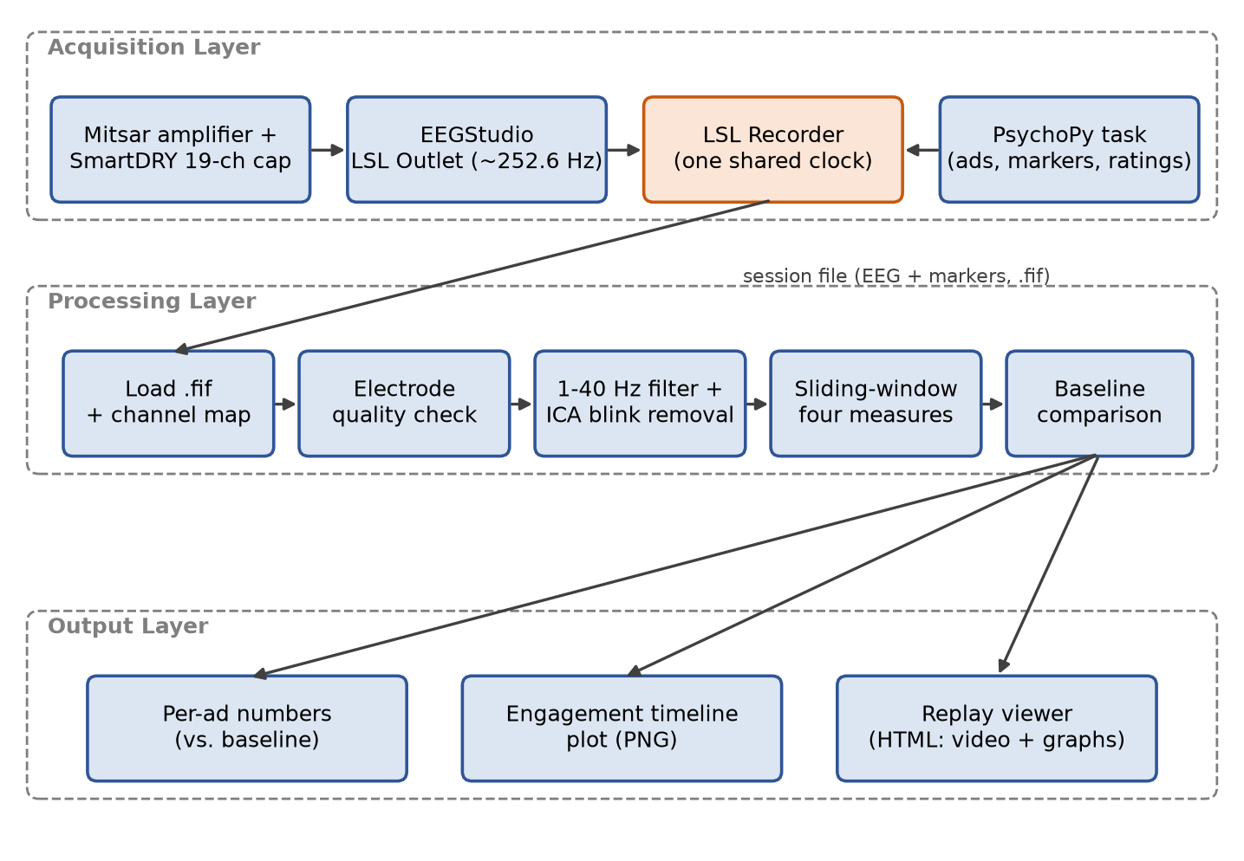
Figure 4.1: Layered architecture of the EEG neuromarketing system.
Each session follows a fixed protocol, shown in Figure 4.2. The eyes-open baseline is the reference for every measure. The eyes-closed block checks cap contact, because closing the eyes should raise posterior alpha. The 4 s fixation cross lets the head settle after the previous key press, and the 3 s gray screen captures the delayed response to the ending and logo. Only the interval between the AD_START and AD_END markers is used for per-ad values.
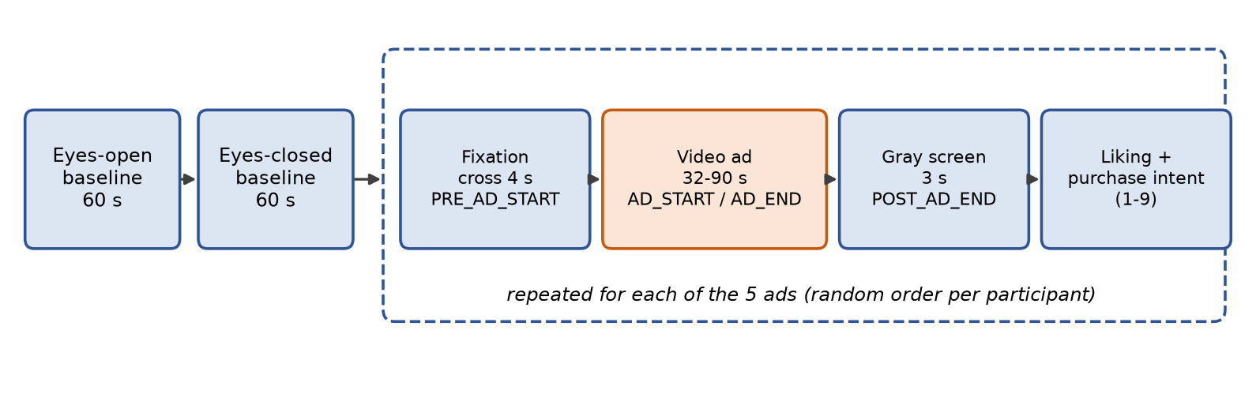
Figure 4.2: Session protocol with event markers.

4.3 Use-case Diagram
Figure 4.3 shows the three actors. The participant completes the baselines, watches the ads and gives the ratings; the experimenter fits the cap, checks contact and runs the session; the analyst processes the recording and inspects the timeline plot and replay viewer.
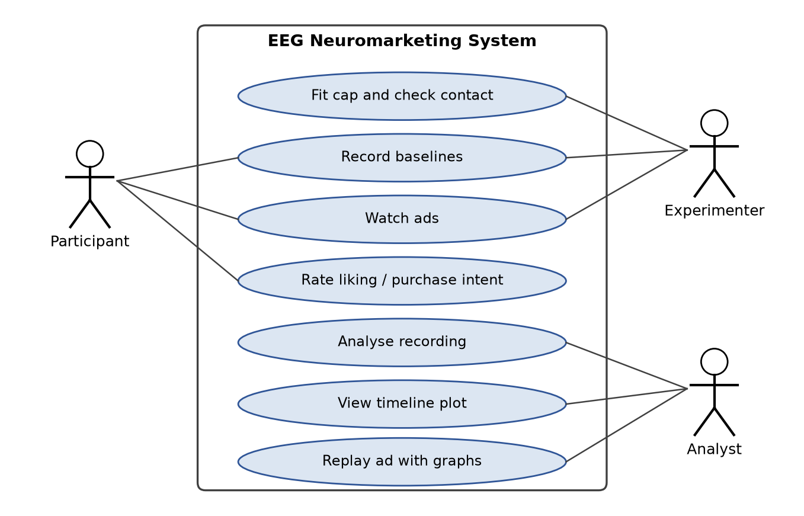
Figure 4.3: Use-case diagram of the system.

4.4 Detailed Design: Signal Processing Pipeline
Figure 4.4 shows the processing stages. The flat spare channel is dropped first, because a constant channel makes ICA rank-deficient. An electrode is marked bad if its correlation with any unconnected auxiliary input exceeds 0.8 in absolute value (it picks up room noise rather than brain activity) or if its standard deviation after 1–40 Hz filtering exceeds 150 µV. ICA is then fitted on the good channels, and a component is removed if its correlation with the mean of Fp1 and Fp2 exceeds 0.5 after both are low-pass filtered below 4 Hz. Restricting the comparison to the slow band removes blinks without removing the 8–13 Hz alpha activity that is later measured at the same electrodes.
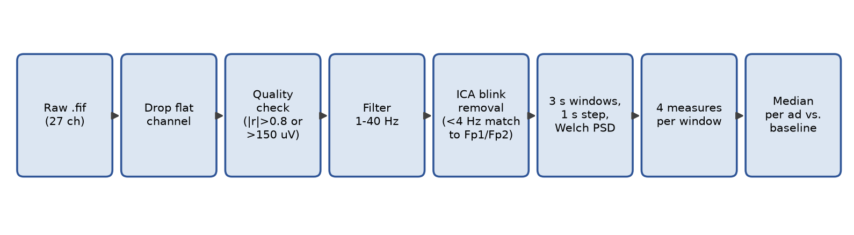
Figure 4.4: Signal processing pipeline.
The cleaned signal is divided into 3 s windows advanced in 1 s steps. In each window, power spectral density is estimated with Welch’s method using 1 s segments with 50% overlap. A 3 s window is a compromise: shorter windows were found to be considerably noisier (about ±0.8 dB for 1 s against ±0.35 dB for 3 s), while published studies use windows of 2–4 s.

4.5 Detailed Design: EEG Measures
In the equations below, P denotes band power estimated within one window, with the band as a subscript and the electrode in brackets. The four measures are defined as follows.
Frontal alpha asymmetry uses the alpha band (8–13 Hz) at the frontal-pole pair, because F3 and F8 are permanently dead on our cap (the pair order tried is F3/F4, then F7/F8, then Fp1/Fp2):
FAA = ln Pα(Fp2) − ln Pα(Fp1) (4.1)
Positive values indicate relatively more left-frontal activity, i.e. approach. The per-ad change is the difference between the ad value and the baseline value.
Engagement index uses beta (13–25 Hz, capped below 30 Hz to limit muscle contamination on a dry cap) and alpha averaged over Cz and Fz:
E = log10( Pβ / Pα ), ΔE% = (10^(E_ad − E_base) − 1) × 100 (4.2)
Frontal theta is the 4–8 Hz power at Fz, reported as a change in decibels relative to baseline:
Δθ = 10 · log10( Pθ,ad / Pθ,base ) dB (4.3)
Posterior alpha suppression is the drop in alpha power at O1, O2 and Pz (falling back to P3/P4 when these are rejected):
S = (1 − Pα,ad / Pα,base) × 100 % (4.4)
For each ad, the value of each measure is the median over all windows that lie entirely inside the ad, which makes the result insensitive to short artefacts. The cap check is the ratio of posterior alpha with eyes closed to eyes open; a ratio of at least 1.3 indicates that the posterior electrodes record genuine brain activity.
To make the results understandable to non-specialists, the replay viewer labels each measure with a plain name next to its scientific name: Visual attention (posterior alpha suppression, alpha event-related desynchronisation), Alertness (beta/alpha engagement index), Mental effort (frontal midline theta, FMθ) and Wanting (frontal alpha asymmetry, FAA).

4.6 Component Mapping
The mapping of system components to technologies is summarised in Table 4.1.
Table 4.1: Mapping of system components to technologies
Component | Technology | Function
Acquisition | Mitsar amplifier, SmartDRY cap, EEGStudio | EEG signal, LSL Outlet stream
Recorder | pylsl, MNE (lsl_recorder.py) | Timestamped EEG + markers to .fif
Channel mapping | calibrate_channels.py, channel_map.json | Labels for an unlabelled stream
Session task | PsychoPy (ad_viewing_task.py) | Baselines, ads, buffers, ratings
Preprocessing | MNE (preprocess_mne.py) | Quality check, filtering, ICA
Features | MNE, NumPy (extract_neuromarketing_features.py) | Four measures, baseline comparison, plot
Replay viewer | build_replay.py, HTML canvas | Ad video synchronised with graphs
Phase-one decoding | scikit-learn, PyTorch | Shrinkage-LDA and EEGNet

Chapter 5 Implementation

5.1 Overview of Technologies Used
The system is written entirely in Python 3.11 and runs in an isolated virtual environment, which was necessary because installing MNE into the global Python installation had previously removed an unrelated package. Stimulus presentation uses PsychoPy, streaming uses pylsl, signal processing uses MNE-Python with NumPy and SciPy, and plots use Matplotlib. The replay viewer is a self-contained HTML page drawn with the browser canvas, so it needs no server.

5.2 Implementation Details of Modules

5.2.1 Phase One: Decoding Pipeline
The ds002739 raw data totals about 38 GB, more than the available disk space, so the download script fetches one subject at a time from the public repository, extracts epochs and deletes the raw files. MATLAB files are read directly with SciPy, which removed the dependence on Octave that earlier notebooks had. Each epoch is 300 ms of EEG ending 150 ms before the response, downsampled from 1000 Hz to 250 Hz; this window retains 99.5% of trials overall and at least 94.3% for every subject, giving 7,341 epochs. The decoder averages each epoch into three time bins per channel and applies shrinkage linear discriminant analysis with 5-fold, 5-repeat stratified cross-validation and 200-permutation null distributions per subject. EEGNet was implemented in PyTorch with about 1,900 parameters and kernels scaled to the 75-sample window.

5.2.2 LSL Recording
EEGStudio’s LSL Inlet, which would have allowed EEGStudio to receive our markers, never connected despite testing several marker formats and network configurations. The direction was therefore reversed: EEGStudio’s Outlet broadcasts the EEG, and our recorder receives it and adds the task markers itself. The recorder probes candidate streams and selects the one that is actually sending data, stores per-sample LSL timestamps, and computes the sampling rate from the data (about 252.6 Hz) instead of assuming the nominal 250 Hz, which would drift markers by about 6% over a session. On stopping, it drains the buffer up to the stop time and saves an MNE .fif file with markers as annotations.

5.2.3 Channel Calibration
The LSL stream carries no channel labels. An initial mapping taken from EEGStudio’s numbered electrode list was wrong (tapping O1 appeared as Cz). The correct order, which follows EEGStudio’s on-screen montage, was recovered by recording our stream and EEGStudio’s labelled EDF export at the same time and matching channels by correlation, then confirmed with a tap test. The map is stored in channel_map.json and loaded automatically; slots 20–26 are unconnected auxiliary inputs and slot 27 is constant.

5.2.4 Session Task
The PsychoPy task requires a participant ID, shuffles the ad order using that ID, and refuses to overwrite an existing session. Videos are displayed at a uniform size. The AD_START marker is sent only after the first video frame has actually been drawn, and the start is retried if the video player fails, which occurred intermittently. Keys pressed during an ad are cleared before each rating question. The recording and ratings file are written inside a finally block, so pressing Escape mid-session never loses data.

5.2.5 Preprocessing and Feature Extraction
The preprocessing module loads .fif, .xdf or .edf files, drops flat channels, runs the electrode quality check and applies filtering and ICA as described in Section 4.4. The feature module marks known-bad electrodes (F3, F8) together with automatically detected ones, chooses the first usable electrode pair or set for each measure, computes the sliding-window timelines, extracts baseline and ad segments from the markers, and prints per-ad values relative to the eyes-open baseline. It saves a four-panel timeline plot in which baselines, ads and post-ad gray screens are shaded and the baseline level is drawn as a dashed line.

5.2.6 Replay Viewer
The replay builder writes a self-contained, offline HTML page for each recording. It was redesigned so that the results can be explained to people without an EEG background. The page has three parts.
- Session map. A strip across the top shows the whole session: the eyes-open baseline (highlighted), the eyes-closed cap check, each ad and its post-ad gray screen. Text beside it states that every graph and number is measured against the baseline, so 0 means “same as rest”. Clicking any block opens it.
- Synchronised graphs. The ad video plays beside four graphs, ordered from the most to the least reliable measure and labelled with both plain and scientific names, band and electrodes. In every graph the baseline is a dashed line labelled “rest”; the curve is shaded in colour above rest and in gray below it. A red cursor follows playback, a shaded band marks the 3-second window behind the current point, and clicking or dragging on a graph seeks the video. A gray band on the asymmetry graph marks the ±0.18 range produced by noise alone. Each graph is scaled to its typical range, so a single movement spike cannot flatten the curve; points beyond that range are pinned to the edge and labelled as likely movement. Beside the video, the current values are restated as sentences, for example “14% more alert than at rest”.
- Conclusion card. For the selected ad, the four whole-ad values (the same numbers as the analysis script) are shown as bars running from the rest line, each with a one-line verdict, together with the participant’s liking and purchase-intent ratings and an automatically written plain-language summary. A collapsible section explains how the numbers are calculated.
The baseline blocks can be opened like ads. For the eyes-open block the viewer shows the four lines wobbling around rest, explains that their median is the rest level, and reports the normal resting spread of each measure, which shows how large a change must be to mean anything. For the eyes-closed block it reports the official cap-check ratio. All percentages use the same formulas as the analysis script, so the viewer and the pipeline never disagree.

5.3 Challenges Encountered and Strategies Used
Table 5.1: Challenges and strategies
Challenge | Strategy
LSL Inlet in EEGStudio never connected | Record EEGStudio’s Outlet ourselves and add markers on the same clock
Unstable rate in “processed” mode (236–271 Hz) | Use “Raw data (in uV)” mode and always the measured rate and timestamps
Stream has no channel labels | Correlation-based calibration against a labelled EDF export, confirmed by tap test
F3 and F8 permanently dead; poor posterior contact | Automatic quality check; electrode-pair fallback; report measures as unavailable instead of plotting noise
Quality limits too lenient (Pz 466 µV passed) | Limits tightened to 150 µV and |r| > 0.8 after the test recording
Blink removal could erase frontal alpha | Match ICA components to Fp1/Fp2 in the <4 Hz band only
Key-press movement at ad onset | 4 s fixation cross before every ad
Brain response to the logo after the video ends | 3 s gray screen after every ad, included in the timeline
Asymmetry sign convention reversed in early code | Corrected so that positive asymmetry means approach
Video player failures on some filenames | Rename ads to simple names; retry the first frame

Chapter 6 Testing and Experimental Analysis and Results

6.1 Unit Testing
Each analysis step was tested on synthetic EEG in which a known effect was planted, so that the correct answer was known in advance. Results are given in Table 6.1 and Figure 6.1.
Table 6.1: Synthetic validation of the pipeline
Test | Planted (expected) | Measured by pipeline
Eye-blink removal (ICA) | Blink of 127 µV on Fp1 | Reduced to 21 µV; blink component found with r = 0.999
Asymmetry preserved by blink removal | Alternating Fp1/Fp2 alpha asymmetry −2.7 / +2.7 | −3.5 / +3.2 after cleaning
Posterior alpha suppression | 50% drop | 49.4%
Frontal theta change | +3.0 dB | +2.87 dB
Engagement index | Beta doubled (+100%) | +92%
Robustness of per-ad median | 2 s, 150 µV artefact burst | Per-ad result changed by less than 1%
Timeline localisation | Effect present only in first half of segment | Shift appears at the correct time in the timeline
Welch spectrum, recomputed by hand | Alpha power of one real Fz window, library value 2.725 µV²/Hz | Independent step-by-step calculation: 2.725 µV²/Hz (identical)

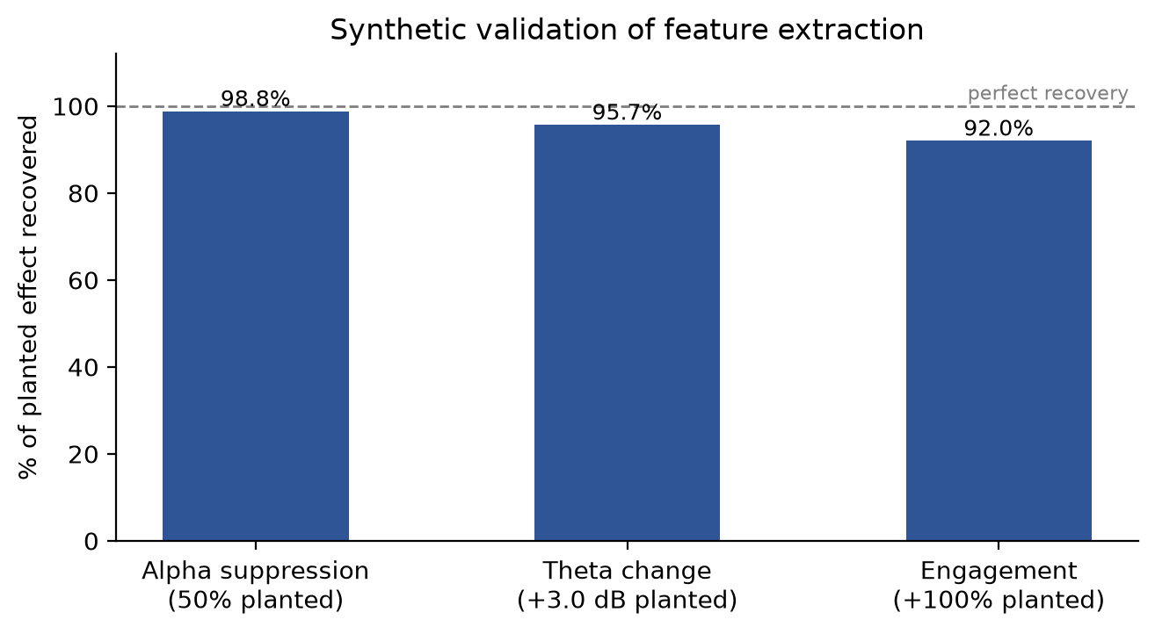
Figure 6.1: Percentage of each planted effect recovered by the pipeline.
The same tests revealed a limitation. With about 30 s of data, noise alone produced asymmetry changes with a standard deviation of about 0.18 (maximum about 0.4), while effects reported in the literature are about 0.1–0.3. Averaging more Welch segments did not reduce this spread, so it is a data-length limit: frontal asymmetry for a single person and a single ad cannot be interpreted, and asymmetry conclusions require group-level statistics.

6.2 Integration Testing
The complete chain was tested on the real cap. In the pilot recording (29-09-2026, ad02, 61.6 s) the marked ad duration matched the video exactly, but 8 of 19 electrodes had no contact, so only frontal theta was valid; this led to the automatic quality check. In the test recording test1 (19-10-2026, ad04, 60.1 s) the ad was marked as 59.8 s long, confirming marker accuracy of about 0.1 s, and the recording, cleaning, feature extraction, plot and replay viewer all ran end to end. Aborting a session with Escape was verified to save the data recorded so far, and starting a session with an existing ID was verified to be refused.

6.3 Experimental Dataset
Table 6.2: Datasets used
Dataset | Description | Size
OpenNeuro ds002739 [1] | EEG recorded during fMRI; random-dot motion decisions with 1–9 confidence | 24 subjects × 2 runs; 7,341 epochs; 58–64 channels
pilot01_ads (own) | Mitsar SmartDRY cap, ad02, one participant | 1 ad; 11 of 19 electrodes in contact
test1 (own) | Mitsar SmartDRY cap, baselines + ad04, one participant | 255 s; 10 of 19 electrodes usable
Stimuli | Five existing real television advertisements | 32–90 s each

6.4 Worked Example: From Raw Signal to Final Numbers
To make the processing transparent, one real recording (test1) was traced through every step, printing the intermediate values. Table 6.3 summarises the steps and Figure 6.2 shows them for one 3-second window taken 20 s into the ad.
Table 6.3: Worked example on the test recording
Step | What happens | Values in test1
1. Raw signal | 26 channels at 250.1 samples/s for 257.5 s (about 1.67 million numbers) | Raw Fz ≈ 22,000 µV: a steady electrode offset plus about 800 µV of mains hum
2. Quality check | Electrodes copying an unconnected input or above 150 µV are rejected | 9 rejected, 10 kept
3. Filter + ICA | 1–40 Hz band-pass removes offset and hum; ICA removes the blink component | Brain signal of about ±30 µV remains; 1 component removed
4. One window | Welch spectrum of 3 s; band power per electrode | Alpha: Fp1 7.63, Fp2 6.13 µV²/Hz → FAA = ln 6.13 − ln 7.63 = −0.22
5. Slide | Repeat every 1 s across the recording | 255 windows per measure
6. Medians | Median over windows inside the baseline and inside the ad | 58 baseline windows, 57 ad windows
7. Convert | Differences of medians turned into %, dB or an asymmetry change | +14.5% alertness, −1.07 dB theta, 45.4% alpha suppression, +0.06 asymmetry

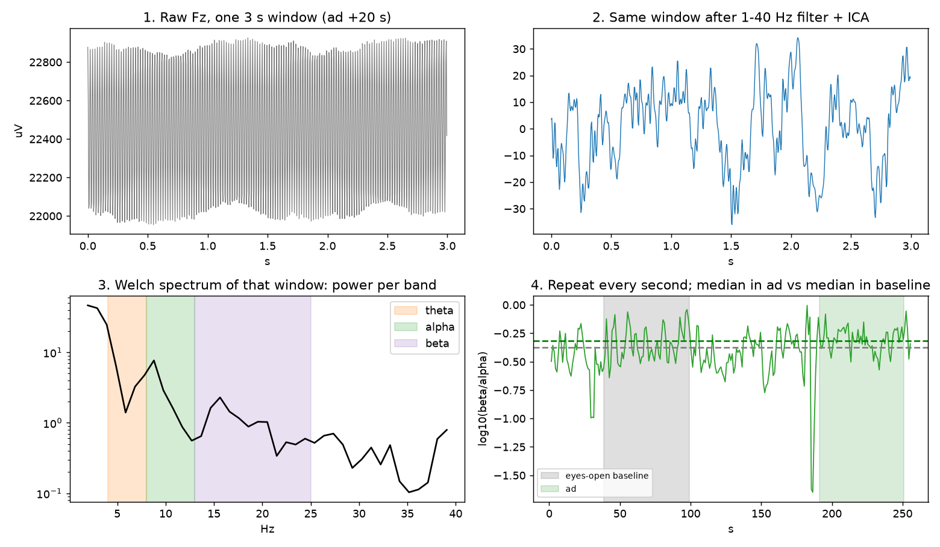
Figure 6.2: One 3-second window from raw signal to timeline: raw Fz, after filtering and ICA, its Welch spectrum, and the sliding-window timeline with baseline and ad medians.
The final numbers produced step by step were identical to those reported by the pipeline, and the spectrum of the window was also recomputed by hand from its definition (Table 6.1).

6.5 Performance Analysis
Phase one decoding. Table 6.4 compares our reconstruction with the numbers in the phase-one paper draft. Pre-response EEG predicted the upcoming choice reliably (12 of 24 subjects individually significant against their permutation nulls), whereas the physical stimulus direction was not decodable, indicating that the signal reflects the decision rather than the stimulus. Removing the slow trend from each epoch reduced choice AUC to chance (0.499), showing that the information lies in a slow voltage build-up.
Table 6.4: Phase-one decoding results with shrinkage-LDA
Target | Paper draft AUC | Our reconstruction AUC | Group p (Wilcoxon)
Choice | 0.558 | 0.563 | 0.00005
Accuracy | 0.537 | 0.542 | 0.009
Stimulus direction (control) | 0.510 | 0.513 | 0.33 (n.s.)

Figure 6.3 compares LDA and EEGNet subject by subject. EEGNet reached a mean choice AUC of 0.544 against 0.563 for LDA (paired p = 0.019), with LDA higher for 16 of 24 subjects; for accuracy the difference was not significant (0.534 against 0.542, p = 0.49). With about 150 trials per subject the additional capacity of the network leads to overfitting.
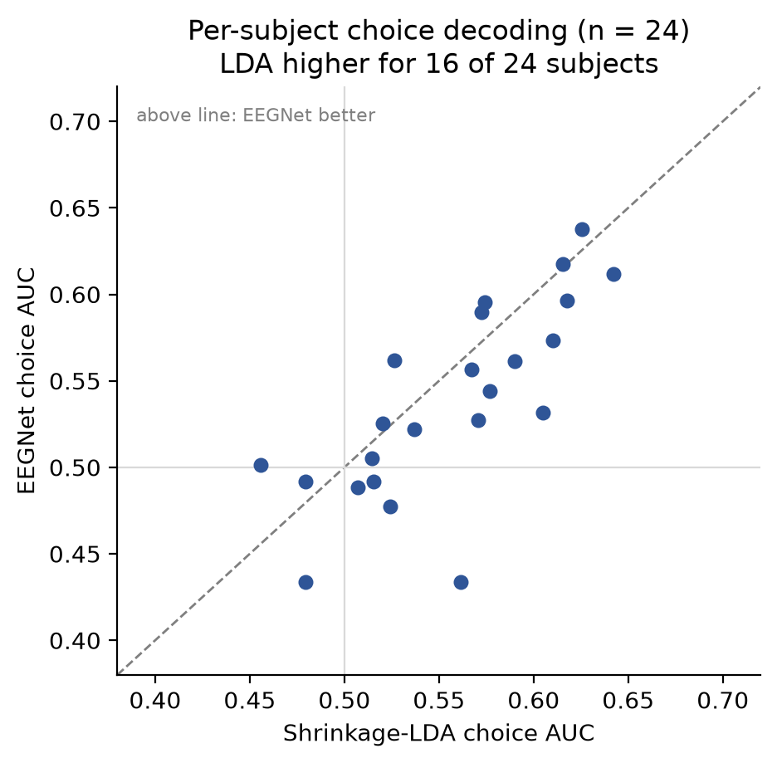
Figure 6.3: Per-subject choice AUC, shrinkage-LDA against EEGNet.
Timing. The recorder measures the delivered sampling rate for every recording (250.1 Hz in test1 and about 252.6 Hz in other sessions) instead of assuming the nominal 250 Hz; using this rate and per-sample timestamps kept markers within about 0.1 s of true event times.

6.6 Neuromarketing Results
Figure 6.4 shows the electrode quality check for test1. Ten electrodes were usable (Fp1, Fp2, F7, Fz, F4, C3, Cz, C4, T5, P3). F3 and F8 matched an unconnected input (r = 1.00 and 0.98), and T3, T4, T6, Pz, P4, O1 and O2 exceeded the amplitude limit or matched an unconnected input. ICA removed one blink component (r = 0.78). The cap check gave an eyes-closed to eyes-open posterior alpha ratio of 1.35 on P3, above the 1.3 threshold.
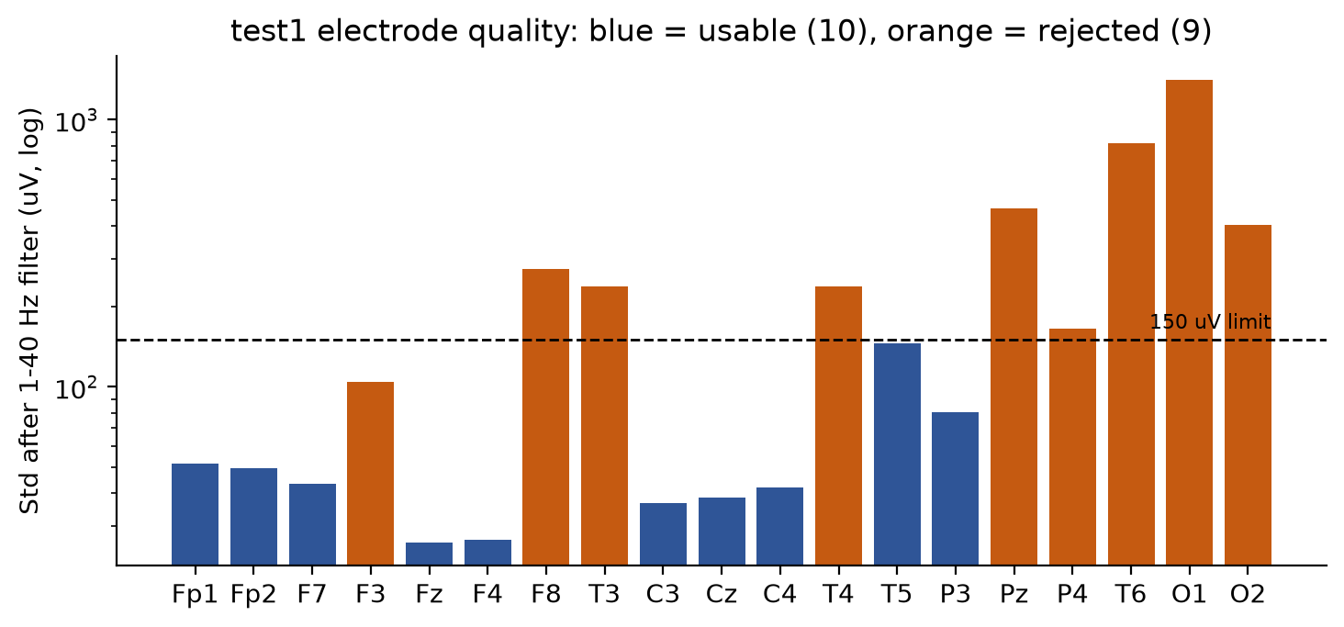
Figure 6.4: Electrode quality in the test recording.
Table 6.5: Per-ad results for the test recording
Measure (ad04 against eyes-open baseline) | Value | Interpretation
Visual attention: posterior alpha suppression | 45.4% | Strong visual attention (includes a general video-watching effect)
Alertness: engagement index | +14.5% | More alert than at rest
Mental effort: frontal midline theta | −1.1 dB | Slightly below rest
Wanting: frontal alpha asymmetry change | +0.06 | Within the noise floor; not interpretable for one person
Ratings: liking / purchase intent | 8 / 4 (of 9) | Ad liked, product unlikely to be bought

Figure 6.5 shows the full timeline. Large swings before the ad were caused by the participant settling and pressing keys, which motivated the fixation buffer. Figure 6.6 shows the replay viewer with the session map, the labelled rest line and the four graphs.
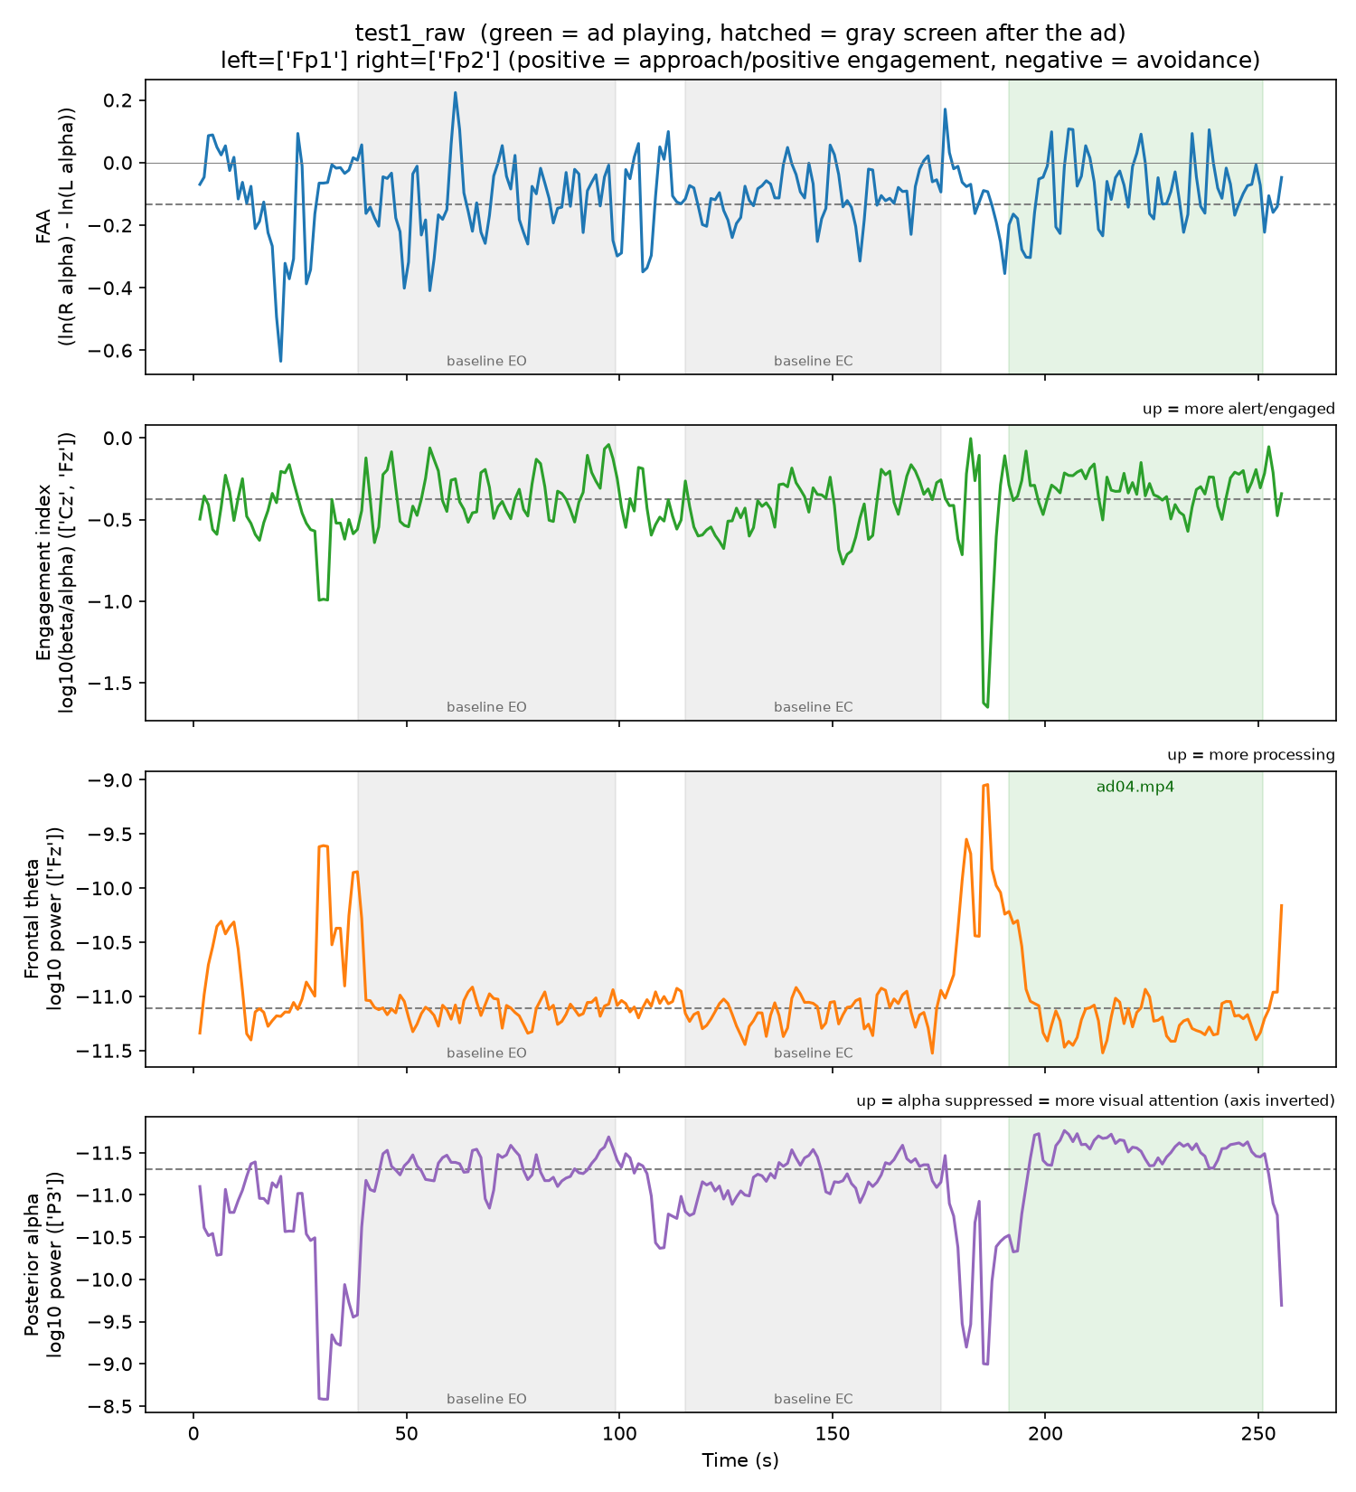
Figure 6.5: Engagement timeline of the test recording (gray: baselines, green: ad).
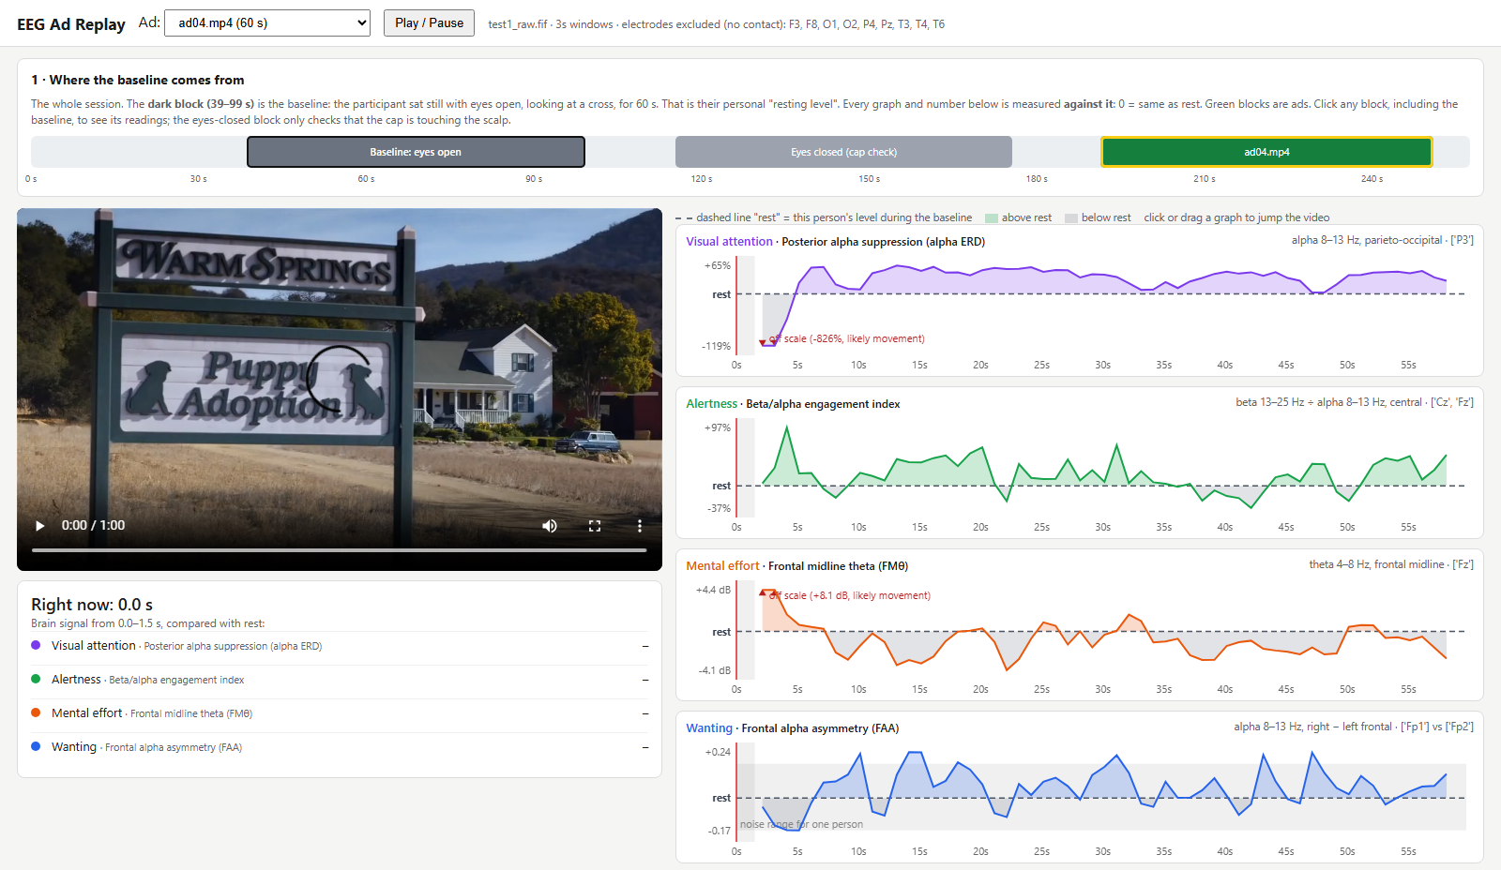
Figure 6.6: Replay viewer: session map with the baseline highlighted, ad video, and the four measures relative to rest.
Comparison with normal resting variation. Brain rhythms fluctuate even at rest. Table 6.6 compares each whole-ad value with the range covering the middle half of the single 3-second windows during the eyes-open baseline. Because the ad value is a median over 57 windows, a value beyond this range is a strong change, while a value inside it should not be read as an effect for one person.
Table 6.6: Ad values compared with normal variation at rest
Measure | ad04 vs rest | Middle half of resting values | Reading
Visual attention | +45% | −27% to +31% | Above the typical resting range
Alertness | +14.5% | −17% to +41% | Inside the resting range
Mental effort | −1.1 dB | −0.6 to +0.6 dB | Slightly below the resting range
Wanting | +0.06 | −0.05 to +0.09 | Inside the resting range and the noise floor

6.7 Interpretation of the Test Advertisement
Taken together, the measures and the ratings tell a consistent story for ad04. The ad held the viewer’s eyes (strong posterior alpha suppression) and was enjoyed (liking 8 of 9). It required little mental effort, which fits an easy-to-follow emotional story. The brain showed no measurable approach response, and the participant reported being unlikely to buy the product (purchase intent 4 of 9). In short, the ad was watched and liked but did not create desire for the product. Figure 6.7 shows how the viewer presents this conclusion.
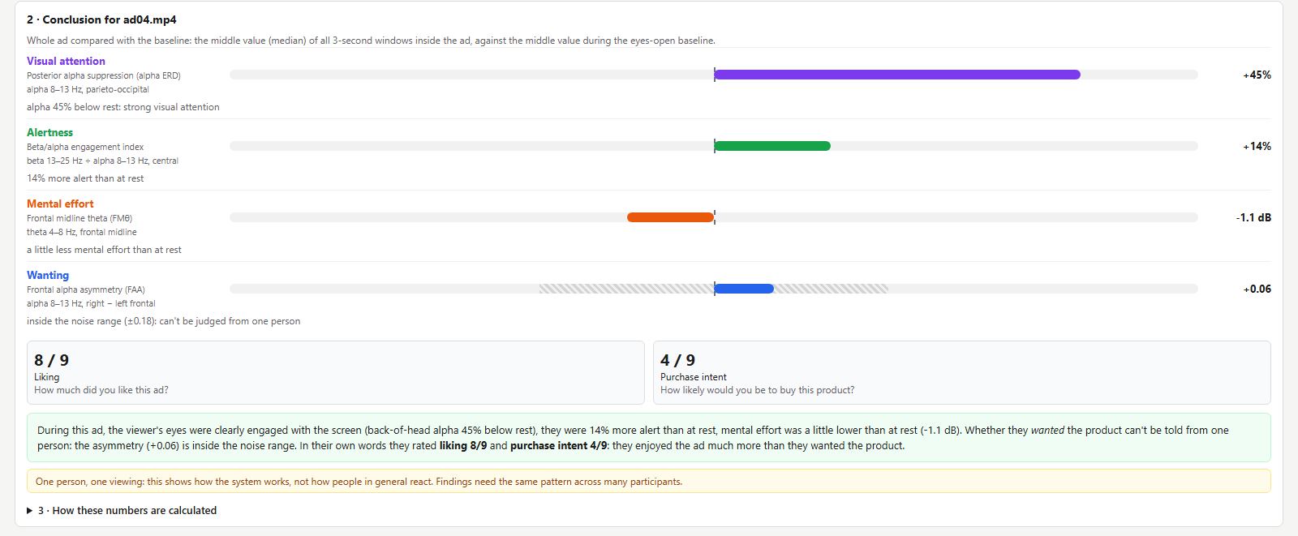
Figure 6.7: Conclusion card for ad04: whole-ad values against rest, ratings and plain-language summary.
These statements describe one participant and one viewing. Part of the alpha suppression reflects watching a video rather than a static cross; this offset is the same for every ad, so it cancels when ads are compared, but it inflates the value of a single ad. The result demonstrates that the system produces coherent, interpretable output that agrees with the participant’s own ratings; whether the pattern holds for viewers in general is the question for the group study.

Chapter 7 Conclusion and Future Work

7.1 Conclusion
This project designed and implemented a complete, low-cost EEG neuromarketing system. EEG from a 19-channel dry-electrode cap and the events of an ad-viewing task are recorded on one clock with an accuracy of about 0.1 s; dead and poorly connected electrodes are detected automatically; blinks are removed without removing frontal alpha; and four established EEG measures are computed as second-by-second timelines and per-ad values relative to each participant’s baseline. Every analysis step recovered 92–99% of planted effects on synthetic data, and the full chain ran on a real recording, which showed a strong drop in posterior alpha and a rise in engagement during the ad. For the test ad, the brain measures and the participant’s ratings agreed: the ad was watched closely and liked, but produced no approach response and low purchase intent. A redesigned replay viewer presents the baseline, the four measures and a plain-language conclusion so that results can be explained to non-specialists. The work continues phase one, where we reproduced a published decision-decoding result and showed that a compact deep network did not outperform a linear decoder on small EEG datasets; that finding guided the choice of interpretable measures in this phase.

7.2 Future Work
- Record full sessions with all five ads and improve contact at the posterior electrodes.
- Obtain informed consent and record about 20 participants.
- Test, within each participant, whether the four measures vary with liking and purchase intent across ads, using repeated-measures statistics.
- Add an opening-seconds “hook” score and inter-subject correlation between viewers.
- Build a prediction model for the ratings, evaluated on participants not used for training.
- Consider a question on prior familiarity with each ad and trimming ads to equal length.

REFERENCES
[1] S. Gherman and M. G. Philiastides, “Human VMPFC encodes early signatures of confidence in perceptual decisions,” eLife, vol. 7, e38293, 2018.
[2] R. G. O’Connell, P. M. Dockree, and S. P. Kelly, “A supramodal accumulation-to-bound signal that determines perceptual decisions in humans,” Nature Neuroscience, vol. 15, no. 12, pp. 1729–1735, 2012.
[3] M. G. Philiastides, R. Ratcliff, and P. Sajda, “Neural representation of task difficulty and decision making during perceptual categorization,” Journal of Neuroscience, vol. 26, no. 35, pp. 8965–8975, 2006.
[4] V. J. Lawhern et al., “EEGNet: a compact convolutional neural network for EEG-based brain–computer interfaces,” Journal of Neural Engineering, vol. 15, no. 5, 056013, 2018.
[5] B. Blankertz, S. Lemm, M. Treder, S. Haufe, and K.-R. Müller, “Single-trial analysis and classification of ERP components,” NeuroImage, vol. 56, no. 2, pp. 814–825, 2011.
[6] O. Ledoit and M. Wolf, “A well-conditioned estimator for large-dimensional covariance matrices,” Journal of Multivariate Analysis, vol. 88, no. 2, pp. 365–411, 2004.
[7] R. J. Davidson, “Anterior cerebral asymmetry and the nature of emotion,” Brain and Cognition, vol. 20, no. 1, pp. 125–151, 1992.
[8] J. J. B. Allen, J. A. Coan, and M. Nazarian, “Issues and assumptions on the road from raw signals to metrics of frontal EEG asymmetry in emotion,” Biological Psychology, vol. 67, no. 1–2, pp. 183–218, 2004.
[9] A. T. Pope, E. H. Bogart, and D. S. Bartolome, “Biocybernetic system evaluates indices of operator engagement in automated task,” Biological Psychology, vol. 40, no. 1–2, pp. 187–195, 1995.
[10] W. Klimesch, “EEG alpha and theta oscillations reflect cognitive and memory performance: a review and analysis,” Brain Research Reviews, vol. 29, no. 2–3, pp. 169–195, 1999.
[11] G. Vecchiato et al., “On the use of EEG or MEG brain imaging tools in neuromarketing research,” Computational Intelligence and Neuroscience, vol. 2011, 643489, 2011.
[12] J. P. Dmochowski et al., “Audience preferences are predicted by temporal reliability of neural processing,” Nature Communications, vol. 5, 4567, 2014.
[13] M. A. S. Boksem and A. Smidts, “Brain responses to movie trailers predict individual preferences for movies and their population-wide commercial success,” Journal of Marketing Research, vol. 52, no. 4, pp. 482–492, 2015.
[14] V. Venkatraman et al., “Predicting advertising success beyond traditional measures: new insights from neurophysiological methods and market response modeling,” Journal of Marketing Research, vol. 52, no. 4, pp. 436–452, 2015.
[15] A. Hakim et al., “Machines learn neuromarketing: improving preference prediction from self-reports using multiple EEG measures and machine learning,” International Journal of Research in Marketing, vol. 38, no. 3, pp. 770–791, 2021.
[16] A. Gramfort et al., “MEG and EEG data analysis with MNE-Python,” Frontiers in Neuroscience, vol. 7, 267, 2013.
[17] J. Peirce et al., “PsychoPy2: experiments in behavior made easy,” Behavior Research Methods, vol. 51, no. 1, pp. 195–203, 2019.
[18] C. Kothe et al., “Lab Streaming Layer (LSL),” software, https://github.com/sccn/labstreaminglayer.
[19] P. D. Welch, “The use of fast Fourier transform for the estimation of power spectra,” IEEE Transactions on Audio and Electroacoustics, vol. 15, no. 2, pp. 70–73, 1967.
[20] A. Hyvärinen and E. Oja, “Independent component analysis: algorithms and applications,” Neural Networks, vol. 13, no. 4–5, pp. 411–430, 2000.
[21] M. A. Lopez-Gordo, D. Sanchez-Morillo, and F. Pelayo Valle, “Dry EEG electrodes,” Sensors, vol. 14, no. 7, pp. 12847–12870, 2014.

Appendix A: Project Snapshots
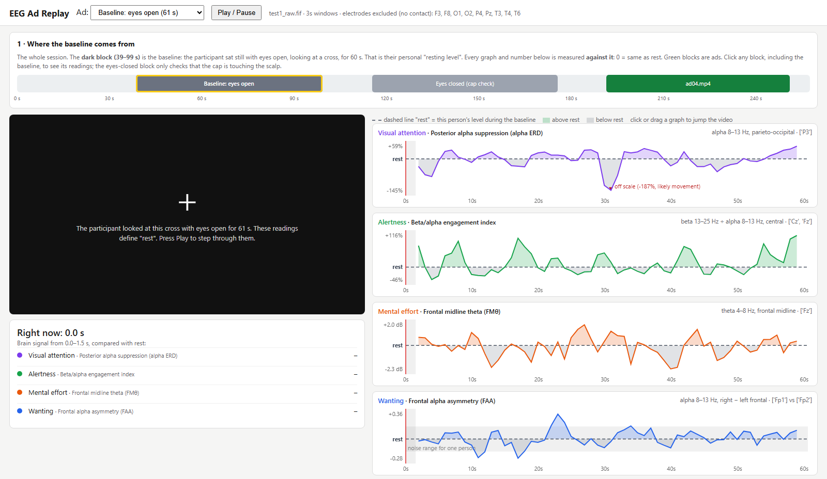
Figure A.1: Replay viewer showing the eyes-open baseline block: the readings whose medians define the rest level.
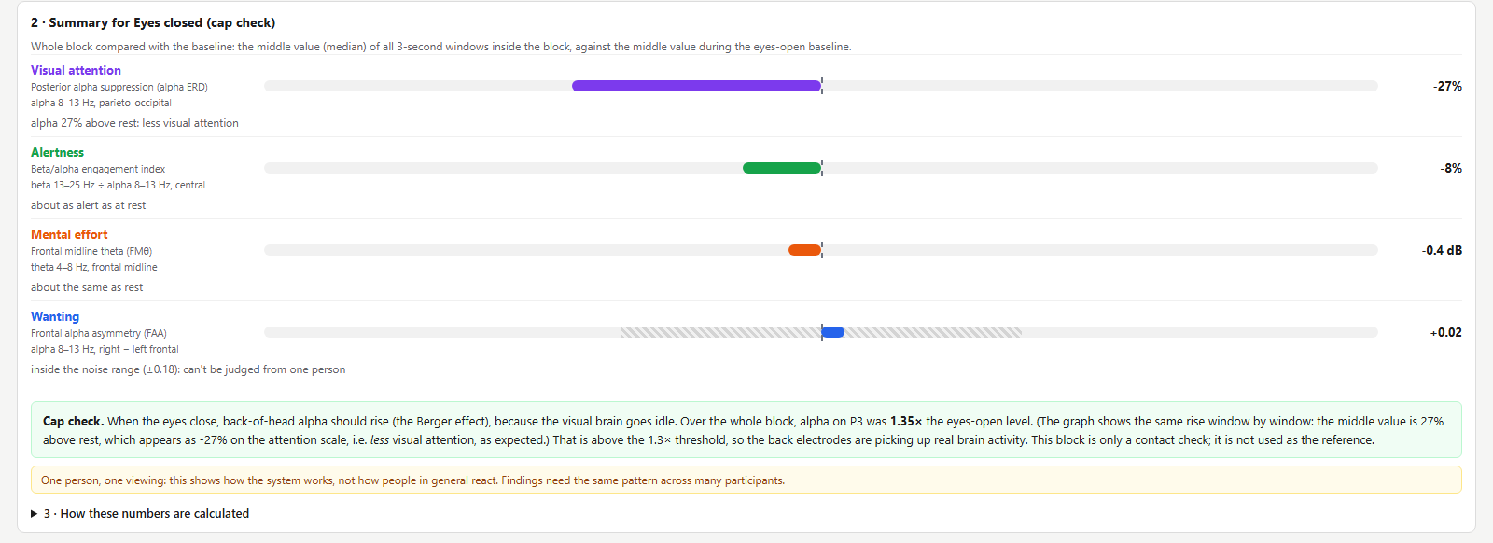
Figure A.2: Replay viewer summary for the eyes-closed block, reporting the cap check (1.35× on P3).
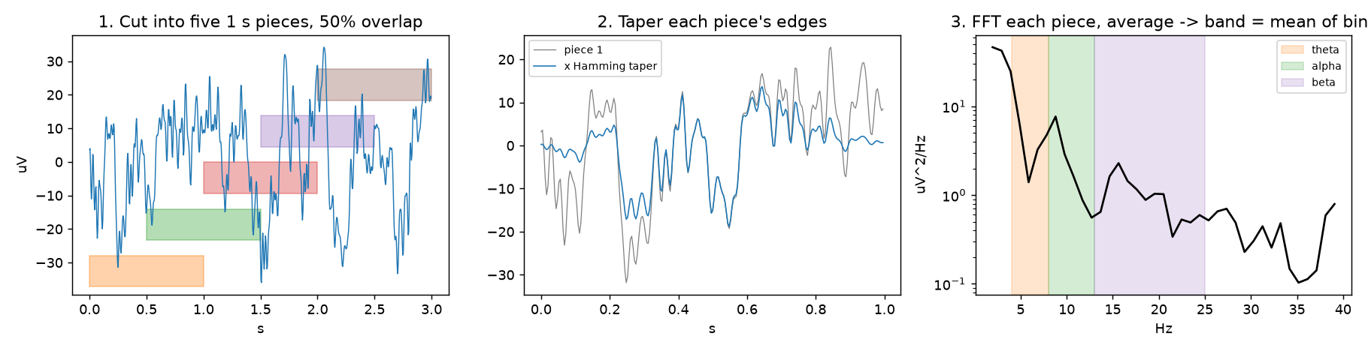
Figure A.3: Welch spectrum computed by hand: five overlapping 1 s pieces, Hamming taper, averaged FFT power.
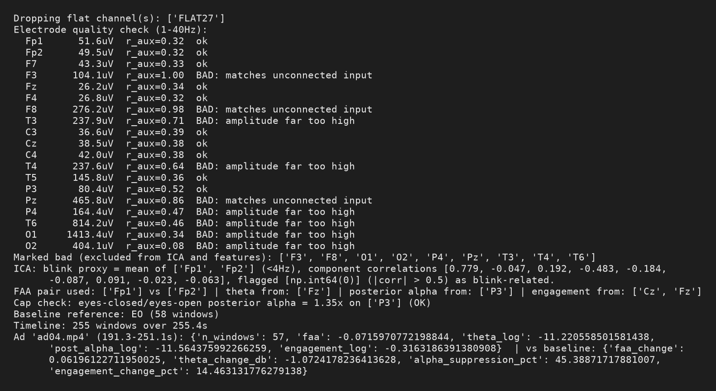
Figure A.4: Analysis output for the test recording (quality check, ICA, cap check, per-ad values).
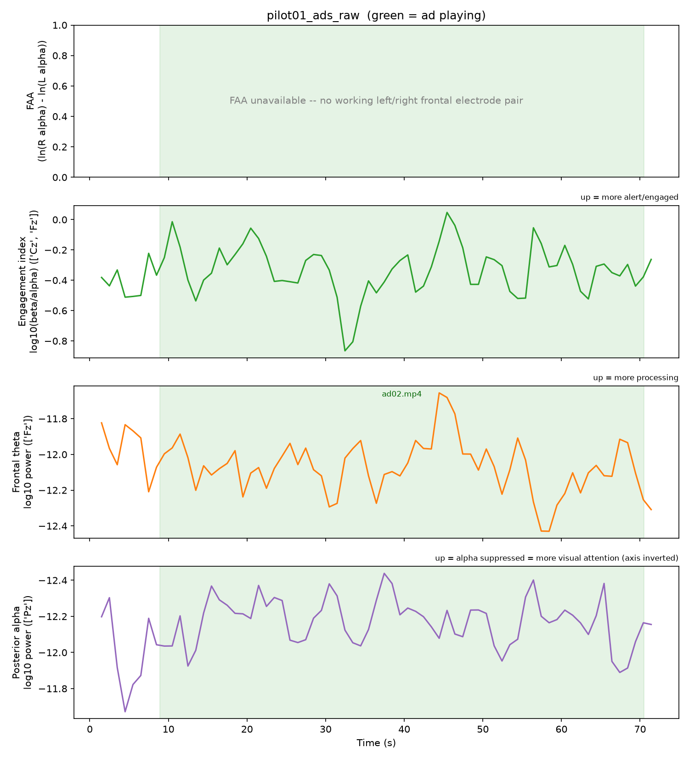
Figure A.5: Timeline of the pilot recording, in which asymmetry was unavailable because of poor contact.

Appendix B: Details of List of Publications Related to this Project
Status: No paper has been submitted yet. A journal manuscript on the neuromarketing study is planned after group data collection (candidate venues: MDPI Sensors or Brain Sciences, IEEE Access, Frontiers). A manuscript on the phase-one decoding work (shrinkage-LDA against EEGNet) is in preparation.

Appendix C: Details of Patent
Status: Not Applicable (NA). No patent has been filed for this project work.

Appendix D: Details of Funding
Status: No monetary grant was received. The EEG recording equipment (Mitsar amplifier, SmartDRY 19-channel dry-electrode cap and EEGStudio software) was provided in kind by ITIE Knowledge Solutions under an industry collaboration.

Appendix E: POs and PSOs Mapped
Table E.1: Programme Outcomes mapping with project
PROGRAMME OUTCOMES | Level (1/2/3) | Justification if addressed
PO1 | 3 | Applies signal processing, statistics and software engineering to EEG acquisition and analysis.
PO2 | 3 | Analyses the limits of questionnaire-based ad testing and the failure modes of dry EEG.
PO3 | 3 | Designs a complete system: session protocol, synchronised recording, pipeline and viewer.
PO4 | 3 | Validates every step on synthetic data, compares LDA with EEGNet, and tests on real recordings.
PO5 | 3 | Uses modern tools: LSL, PsychoPy, MNE-Python, scikit-learn, PyTorch.
PO6 | 2 | Addresses the societal question of how advertising influences consumers.
PO7 | 2 | Uses industry-provided hardware and open-source software, avoiding new equipment purchases.
PO8 | 3 | Protects participant data (kept out of the public repository) and plans informed consent.
PO9 | 3 | Developed collaboratively by a four-member team with divided responsibilities.
PO10 | 2 | Documents the system in a team guide, README and presentations.
PO11 | 2 | Plans phased work from reanalysis to group data collection within the academic year.
PO12 | 2 | Leaves clear extensions: group statistics, inter-subject correlation, prediction models.

Table E.2: Programme Specific Outcomes mapping with project
PROGRAMME SPECIFIC OUTCOMES | Level (1/2/3) | Justification if addressed
PSO1 | 2 | Uses networked streaming (LSL) between acquisition and presentation programs.
PSO2 | 3 | Applies software engineering practice: modular code, isolated environment, version control.
PSO3 | 3 | Integrates machine learning and signal processing to solve an applied problem.

Appendix F: Similarity Report and AI-Generated Report
Similarity Report:

AI-Generated Content Report:

