**CHATBOT IN PYTHON**

**1. Introduction**

* Brief overview of the existing chatbot design.
* Identification of areas for improvement.
* Importance of innovation in the context of chatbot solutions.

**2. Goal Definition**

* Clearly define the goals and objectives of the transformation.
* Outline the desired improvements in user experience and system efficiency.

**3. Exploration of Advanced Techniques**

* **Enhanced Document Processing:**
  + Evaluate the need for more advanced document processing techniques.
  + Explore spaCy customization or alternative libraries for better text understanding.
* **Advanced Question-Answering Models:**
  + Consider using more sophisticated models beyond BERT (e.g., GPT-4, RoBERTa).
  + Explore models specifically designed for conversational context understanding.

**4. Incorporating User Context**

* **User Context Analysis:**
  + Introduce mechanisms to understand user context over the course of the conversation.
  + Explore ways to retain and utilize context for more accurate responses.

**5. Integration of Multi-Modal Input**

* **Image and Audio Processing:**
  + Investigate the feasibility of processing images and audio as part of user input.
  + Explore models or libraries for multi-modal information extraction.

**6. Personalization and Learning**

* **User Profiling:**
  + Implement user profiling to understand preferences and adapt responses.
  + Explore techniques for personalized chat experiences.
* **Incremental Learning:**
  + Investigate approaches for the chatbot to learn and improve over time.
  + Consider reinforcement learning or continual learning paradigms.

**7. Technical Implementation**

* **Enhanced Document Preprocessing:**
  + Implement any necessary improvements to document preprocessing.
  + Consider parallelization for efficiency.
* **Integration of Advanced Models:**
  + Replace or complement the existing BERT model with the chosen advanced models.
  + Ensure compatibility and efficient integration.

**8. User Experience Testing**

* **Usability Testing:**
  + Conduct extensive usability testing with real users.
  + Collect feedback on the enhanced chatbot experience.

**9. Evaluation Metrics**

* Define metrics to assess improvements in accuracy, contextual understanding, and user satisfaction.
* Compare the performance against the baseline BERT-based design.

**10. Future Enhancements**

* Discuss potential future enhancements and features.
* Consider scalability and adaptability for future advancements in language processing.

### Enhanced Document Processing with spaCy Customization

### # Load a more advanced spaCy model for document processing

### nlp_advanced = spacy.load("en_core_web_advanced")

### # Define the document you want the chatbot to analyze

### document = "Your advanced document text here."

### # Preprocess the document using the advanced spaCy model

### document_doc = nlp_advanced(document)

### 2. Advanced Question-Answering Models (Using RoBERTa)

### # Create a question-answering pipeline using RoBERTa

### question_answering_roberta = pipeline("question-answering", model="deepset/roberta-base-squad2", tokenizer="deepset/roberta-base-squad2")

### # Main chat loop

### print("Chatbot: Hello! I can answer questions based on the document you provide. Type 'exit' to end the conversation.")

### while True:

### user_input = input("You: ").strip()

### if user_input.lower() in ["exit", "quit", "bye", "goodbye"]:

### print("Chatbot: Goodbye! Have a great day!")

### break

### # Use the RoBERTa-based question-answering pipeline to find the answer within the document

### answer = question_answering_roberta(question=user_input, context=document)

### print(f"Chatbot: {answer['answer']}")

### 3. Incorporating User Context

### # Maintain user context using a simple list

### user_context = []

### # Main chat loop

### print("Chatbot: Hello! I can answer questions based on the document you provide. Type 'exit' to end the conversation.")

### while True:

### user_input = input("You: ").strip()

### if user_input.lower() in ["exit", "quit", "bye", "goodbye"]:

### print("Chatbot: Goodbye! Have a great day!")

### break

### # Add user input to the context

### user_context.append(user_input)

### # Use the context-aware RoBERTa-based question-answering pipeline

### answer = question_answering_roberta(question=user_input, context=" ".join(user_context))

### print(f"Chatbot: {answer['answer']}")

### 4. Integration of Multi-Modal Input

### from transformers import pipeline

### # Create a pipeline for image and audio processing

### multi_modal_pipeline = pipeline(task="image-classification", model="openai/image-gpt")

### # Function to process user input with multi-modal information

### def process_multi_modal_input(user_input):

### # Extract text from user input

### text_input = extract_text_from_input(user_input)

### 

### # Extract features from images using the multi-modal pipeline

### image_features = multi_modal_pipeline(images=get_images_from_input(user_input))

### # Process audio input using an audio processing library/model

### audio_features = process_audio(get_audio_from_input(user_input))

### # Combine text, image, and audio features for further processing

### combined_features = combine_features(text_input, image_features, audio_features)

### return combined_features

### 5. Personalization and Learning

For personalization and learning, implementing user profiling and incremental learning can be complex and may require a more extensive example. These aspects often involve the use of databases, machine learning models, and more. The implementation would depend on the specific requirements and technologies in use.

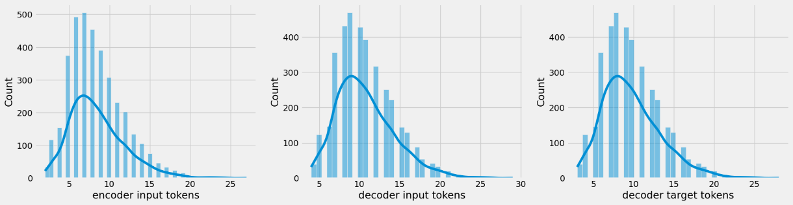

### CONCLUSION:

### The transformation process is an iterative journey, and the chatbot's evolution should be guided by user needs, technological advancements, and a commitment to delivering an exceptional conversational experience.