GISMA

University of Applied Sciences

Advanced Databases
M605

Library Management System
Project Report

Student Information
Full Name | Manoj Kumar
Student ID | GH1037914
Module | Advanced Databases M605
Submission Date | 18.09.2026

Project URL’s
GitHub Repository | https://github.com/manojkumar-techdev/Modern-Library-Management-System
Video Demonstration

Index

- Introduction
- Executive summary
- System Design
- Implementation
- Results
- Challenges and Solutions
- Conclusion and Future Work

1. Introduction
The project demands a design and implementation of a detailed and automated database system that can apply either SQL and/or NoSQL technologies. The main purpose of the given project is to create a modern system including hybrid mode effectively which can handle structured, semi-structured and unstructured data to fulfill the real-world design aims.

A large number of domains can be freely opted and designed for a business or system of personal choice which can be beneficial for current world problems. The project has to follow the modern database management system including creating database, data insertion and implementation of queries and commands for performance-based optimal results.

Problem Definition
Project Requirements

- SQL/NoSQL Database
- Structured data
- Schema design
- Data insertion
- ACID compliance (e.g., user accounts, transactions)
- No full web app or user interface required

2. Executive Summary
The project Library Management System is based on using SQL (Structured Query Language) using Relational Database Management System (MySQL). This system stores information about books, members, book categories, authors, borrowing, fines and returning books in an organized way.

The core goal of this Library Management System is to automate the information using REDMS to minimize the manual actions taken in a library, improve the accuracy of library records by making it convenient for librarians to search books and members. The project offers an easy, trustworthy and optimal system for managing library operations.

Technology Used

- Database: MySQL
- Language: SQL
- Database Design: Relational Database Model
- Tools: MySQL Workbench / MySQL Server
Project Features

- Database Creation
- Tables
- Primary Keys
- Foreign Keys
- Constraints
- Sample Data
- Basic Queries
- Inner, Left & Right Joins
- Aggregation
- Subqueries
- Stored Procedures
- Stored Functions
- Triggers
- Transactions
- Indexes
- Views
- Management Reports
- Inventory Management
- Reservations
- Fines & Payments
- Reviews
- Library Events
- Suppliers & Acquisitions
- Audit Logging

Project Objectives

- 1. To create a computerized system for managing library resources.
- 2. To maintain information about books and authors.
- 3. To organize books according to categories.
- 4. To maintain publisher’s information.
- 5. To register and manage library members.
- 6. To manage librarians.
- 7. To record book issuing and return transactions.
- 8. To identify overdue books.
- 9. To calculate and manage library fines.
- 10. To manage book reservations.
- 11. To generate useful library reports.
- 12. To maintain data integrity using relational database constraints.

4. System Architecture
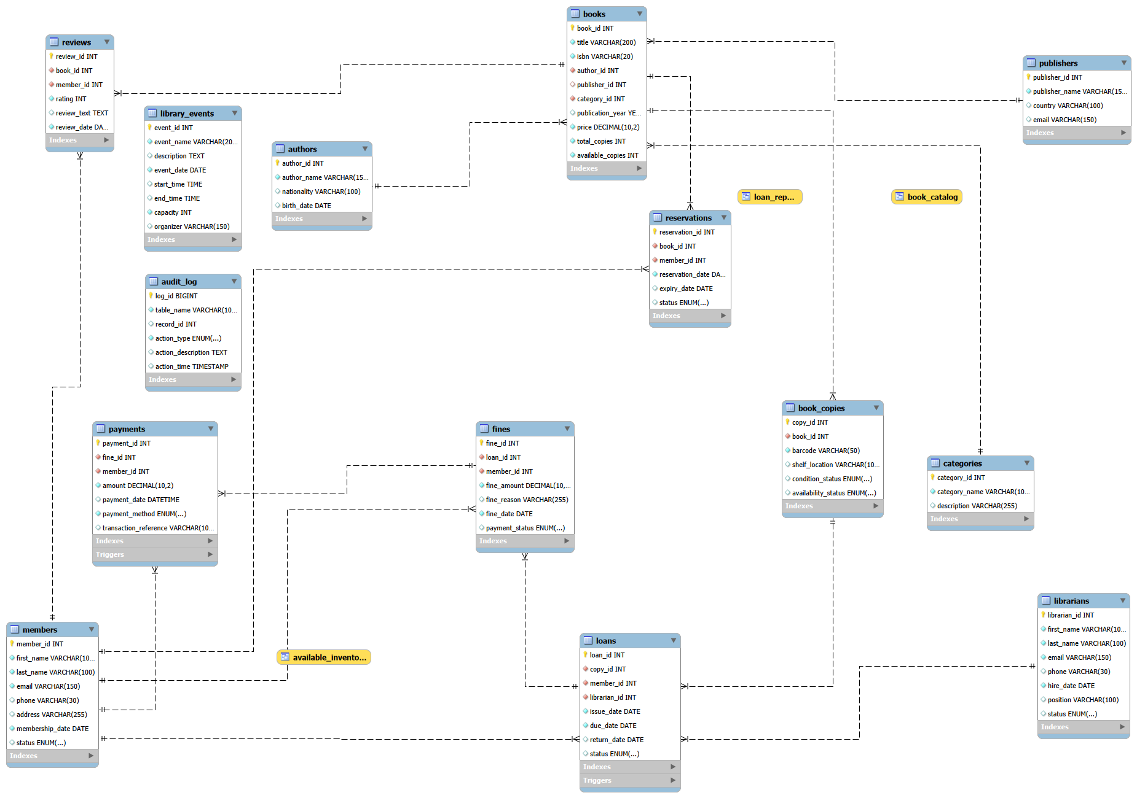

ER DIAGRAM - 1

Database Relationships

No. | Parent Table | Child Table | Primary Key | Foreign Key | Relationship
1 | authors | books | authors.author_id | books.author_id | 1 : N
2 | publishers | books | publishers.publisher_id | books.publisher_id | 1 : N
3 | categories | books | categories.category_id | books.category_id | 1 : N
4 | books | book_copies | books.book_id | book_copies.book_id | 1 : N
5 | members | loans | members.member_id | loans.member_id | 1 : N
6 | librarians | loans | librarians.librarian_id | loans.librarian_id | 1 : N
7 | book_copies | loans | book_copies.copy_id | loans.copy_id | 1 : N
8 | books | reservations | books.book_id | reservations.book_id | 1 : N
9 | members | reservations | members.member_id | reservations.member_id | 1 : N
10 | loans | fines | loans.loan_id | fines.loan_id | 1 : N
11 | members | fines | members.member_id | fines.member_id | 1 : N
12 | fines | payments | fines.fine_id | payments.fine_id | 1 : N
13 | members | payments | members.member_id | payments.member_id | 1 : N
14 | books | reviews | books.book_id | reviews.book_id | 1 : N
15 | members | reviews | members.member_id | reviews.member_id | 1 : N

Database Relationships — Table 1

4. Implementations

- Database Creation
- Table Creation
- Data Insertion
- Data Retrieval
- Data Updating
- Data Deletion
- Table Relationships
- Transactions
- Stored Procedure Implementation
- Stored Function Implementation
- Trigger Implementation
- View Implementation
- Index Implementation
- Aggregation Implementation
- Audit Logging Implementation

4. Results
- Database Creation

# 1 QUERY -- DROP DATABASE IF EXISTS library_management;

DROP DATABASE deletes the existing database if it already exists. This is useful when rerunning your project from the beginning.

Figure 1: Example of DROP DATABASE IF EXISTS

# 2 QUERY -- CREATE DATABASE library_management;

CREATE DATABASE command creates a new database named library_management.

Figure 2: Example of CREATE DATABASE database_name

# 3 QUERY -- USE library_management;
USE command selects the database so that all subsequent tables and SQL objects are created inside it.

Figure 3: Example of USE DATABASE database_name

- Table Creation

# 4 Query -- CREATE TABLE authors;
The CREATE TABLE command is used to create a new table in a database.
Tables store data in the form of Tabular Structure and Data is stored using table name, columns, rows, primary keys, foreign keys and constraints.

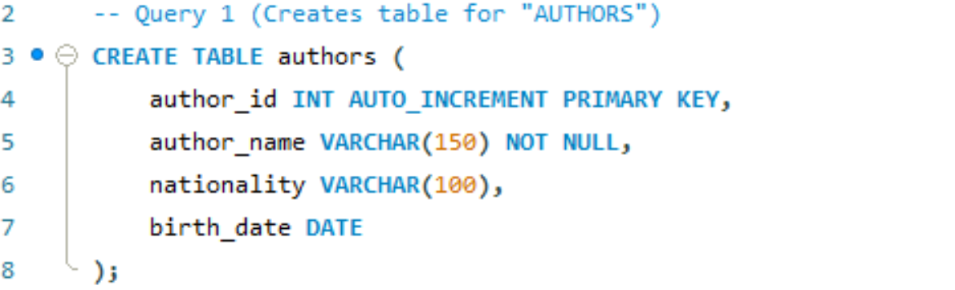
Figure 4: Example of INSERT INTO table_name
SYNTAX FOR CREATING ALL TABLES

All tables are created in Library Management System project using CREATE TABLE command, and tables which are created are “author, publisher, categories, books, members, librarians, book_copies, loans, reservations, fines, payments, reviews and library events tables”.

Syntax used for creating all tables:

- CREATE TABLE authors ();
- CREATE TABLE publisher ();
- CREATE TABLE categories ();
- CREATE TABLE books ();
- CREATE TABLE members ();
- CREATE TABLE librarians ();
- CREATE TABLE book_copies ();
- CREATE TABLE loans ();
- CREATE TABLE reservations ();
- CREATE TABLE fines ();
- CREATE TABLE payments ();
- CREATE TABLE reviews ();
- CREATE TABLE library_events ();

- Data Insertion

# 5 Query -- INSERT INTO authors

INSERT INTO command is used to insert new rows (new records) into the table. This command inserts news records for fields created during creation of a specific table.
Author table contains 100 rows of data. Similarly, all tables are inserted with 100 rows of data and data is inserted using INSERT INTO table_name. Data is inserted in “author, publisher, categories, books, members, librarians, book_copies, loans, reservations, fines, payments, reviews and library events tables”.

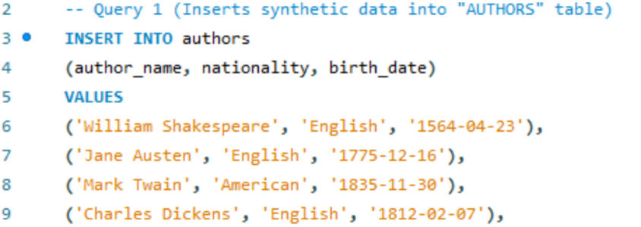

Figure 5: Example of INSERT INTO table_name

Syntax used for inserting data in all tables:

INSERT INTO authors () VALUES ();
INSERT INTO publishers () VALUES ();
INSERT INTO categories () VALUES ();
INSERT INTO books () VALUES ();
INSERT INTO members () VALUES ();
INSERT INTO book_copies () VALUES ();
INSERT INTO librarians () VALUES ();
INSERT INTO loans () VALUES ();
INSERT INTO reservations () VALUES ();
INSERT INTO fines () VALUES ();
INSERT INTO payments () VALUES ();
INSERT INTO reviews () VALUES ();
INSERT INTO library_events () VALUES ();

- Basic & CRUD Queries

# 6 Query -- Display all books (SELECT * FROM books);
To display all books from book table, SELECT * FROM books query is used. This query use “*” which means all. So when SELECT * is given, it selects all books from table “book” and shows a table containing all books along with columns used at the time of table creation.

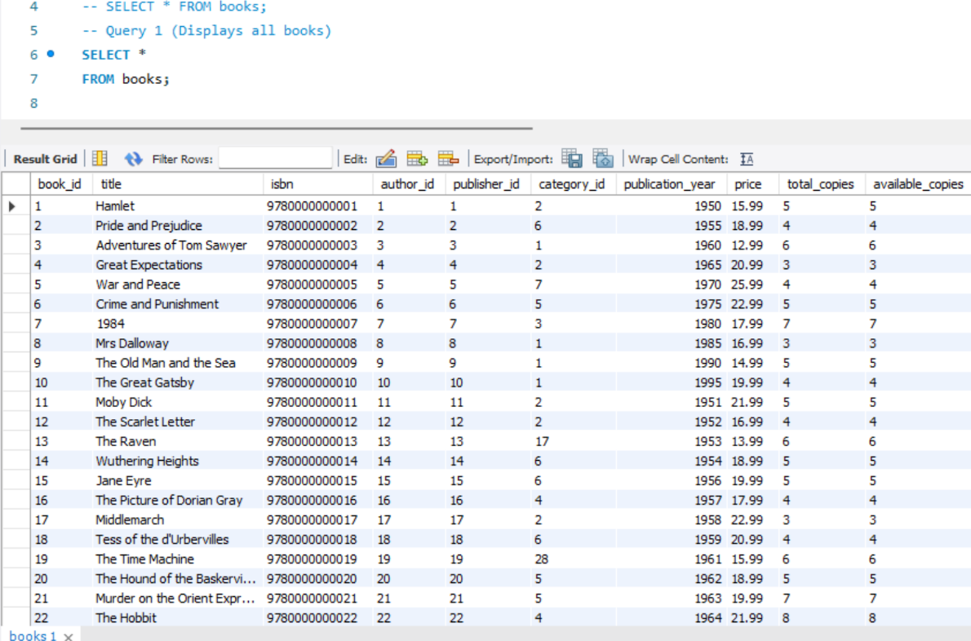

Figure 6: Example of SELECT * FROM books;

# 7 Query -- Display all books (SELECT * FROM books WHERE price > 20);

WHERE clauses are used to select the books from table using logic greater than filter books which have price more than 20. WHERE selects, updates, or deletes the rows with the help of operators =, <, >, <=, >=, <>, AND, OR.
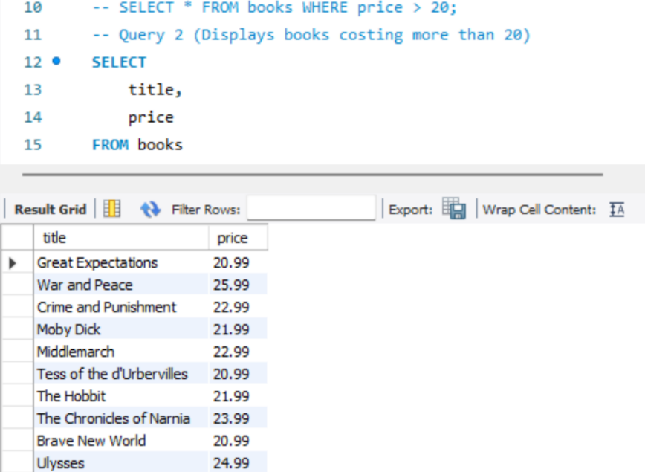

Figure 7: Example of SELECT * FROM books WHERE price > 20

# 8 Query -- Display all books (SELECT * FROM books WHERE title LIKE ‘%Great%’;)

Like clause is used to search for a specific pattern in text and it is commonly used with WHERE clause. In the example, LIKE clause searched for “Great” keyword and it displayed the books with title including “Great”. It searched for 2 books in the entire Database.

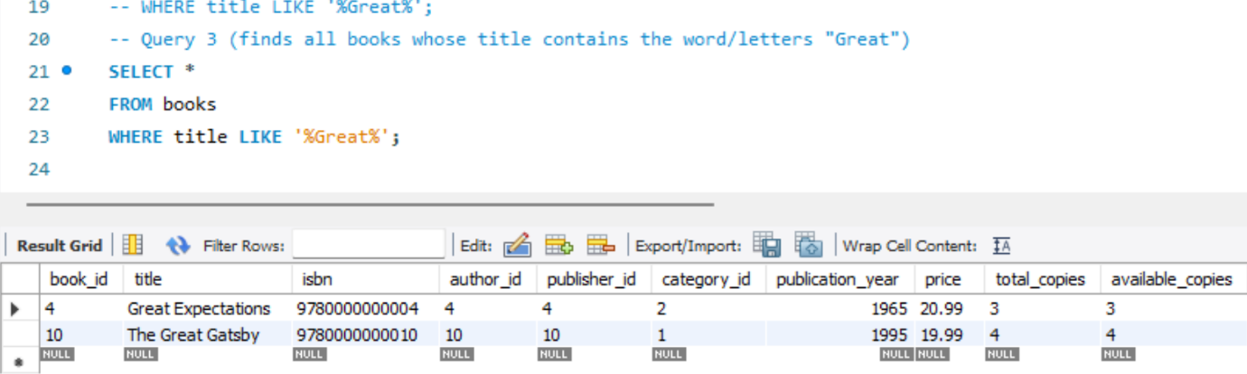

Figure 8: Example of SELECT * FROM books WHERE price > 20

# 9 Query -- Sort books (ORDERED BY price DESC;)

ORDERED BY and DESC works together to filter all books and order them in a descending order. But descending is applied on a filter value given to query. Price is used as a filter value which is compared in Descending order and all books are listed from top to bottom in a decreasing price order.
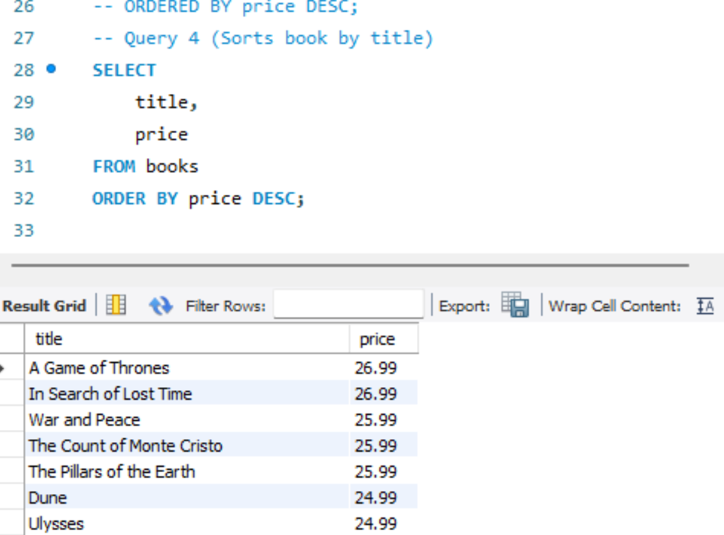

Figure 9: Example of ORDERED BY with DESC

# 10 Query -- Equality checks for status (WHERE status = 'Active';)

WHERE and = operator together displays the status of members where they are active. SELECT * selects all columns and FROM members use the members’ table to compare WHERE status is 'Active' in the records. This query shows only where the status is exactly active.

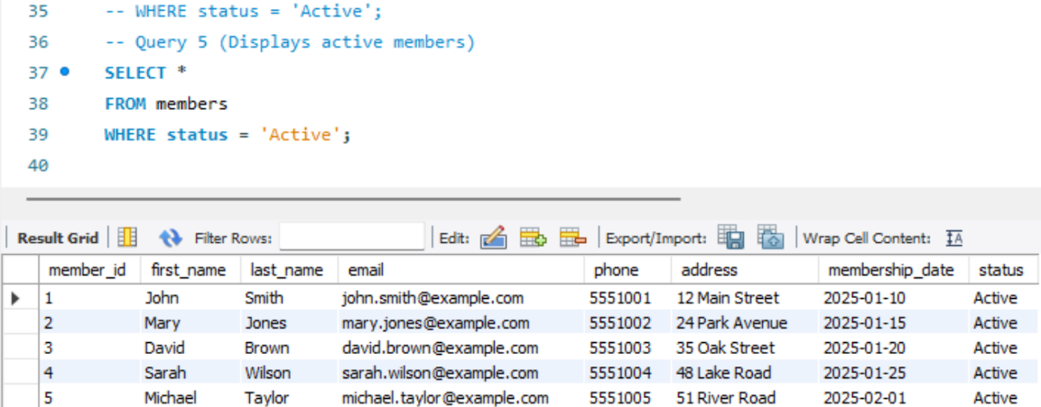

Figure 10: Example of WHERE with “=” Operator

# 11 Query – CREATE (Adds a new library member)

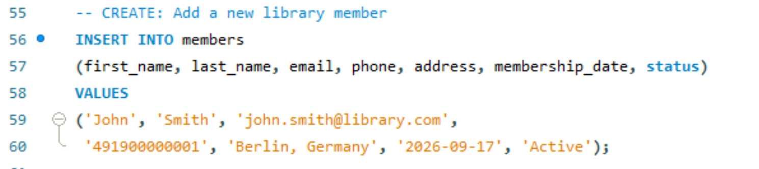
Figure 11: Example of CREATE

# 12 Query – READ (Displays a specific member)

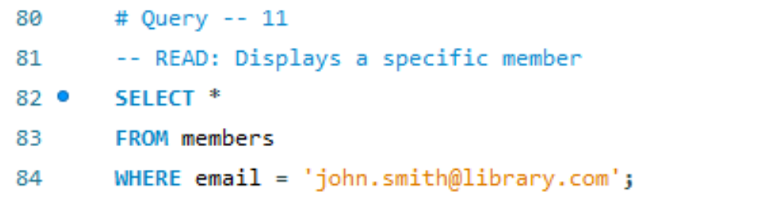
Figure 12: Example of READ

# 13 Query – UPDATE ( Changes the member’s phone number)

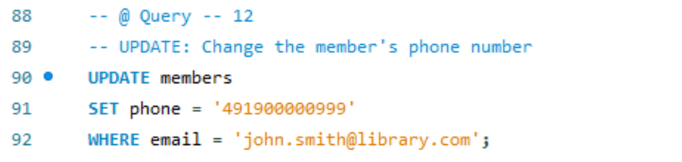
Figure 13: Example of UPDATE

# 14 Query – DELETE (Removes a member where email is mentioned)

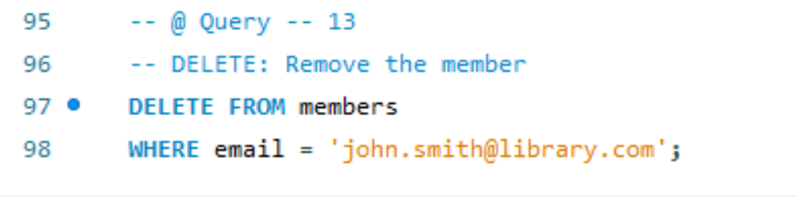
Figure 14: Example of DELETE

- Joins

JOIN SCOPE FOR PROJECT:

- INNER JOIN
- LEFT JOIN
- RIGHT JOIN
- MULTIPLE JOINS

# 15 Query -- INNER JOIN (multi-table INNER JOIN query)

INNER JOIN combines information from four tables: books, authors, publishers, and categories. INNER JOIN returns only records that have matching data in all joined tables. If a book has no matching author, that book will not appear in the result.

This query first selects columns, then connects books with authors, then connects each book to its publisher and connects each book to its category. So, multiple INNER JOINS work one after another to produce the result.
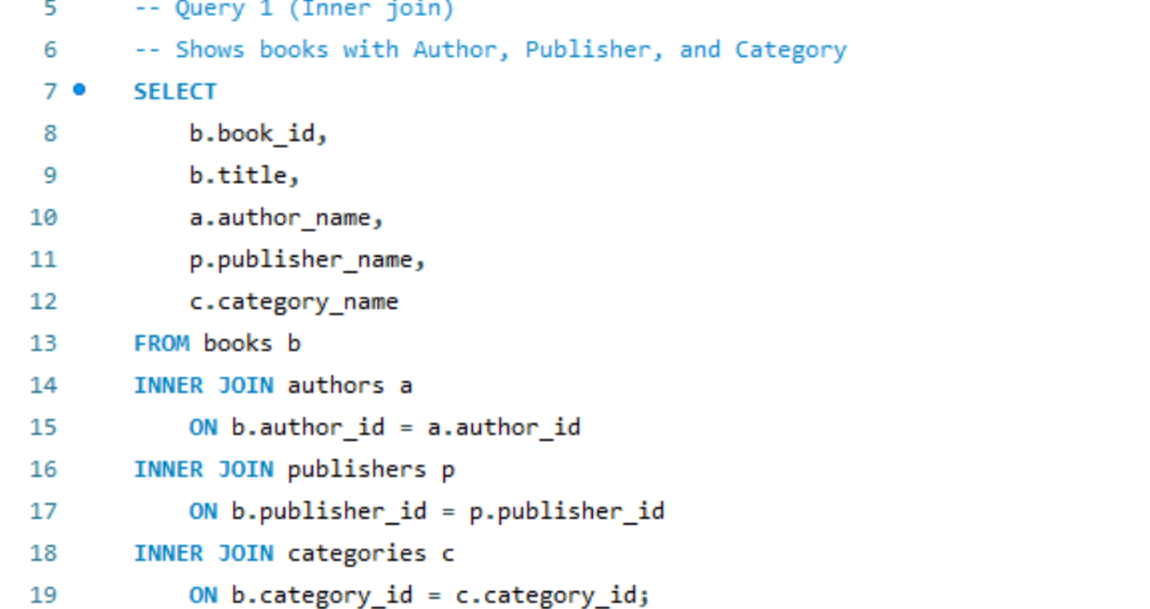

Figure 15: Example of INNER JOIN

- Aggregations

AGGREGATION SCOPE FOR PROJECT:

- COUNT ()
- SUM ()
- AVG ()
- MAX ()
- MIN ()

# 16 QUERY -- Aggregation (COUNT(*))

Aggregation command is used to run a query to count the total number of rows. The book table contains 100 rows. When the query is run, COUNT(*) counts all rows, and AS total_titles, gives tota_titals. FROM books counts rows from the books table.



Figure 16: Example of COUNT aggregation

- Stored Procedures
STORED PROCEDURE SCOPE FOR PROJECT:

- CREATE PROCEDURE SearchBooks
- CREATE PROCEDURE GetMemberLoans

# 17 QUERY – Stored Procedure (Searches books)

This stored procedure is correct and compatible with books and authors tables.

Procedure Flow:

What the procedure does
- SearchBooks receives a keyword

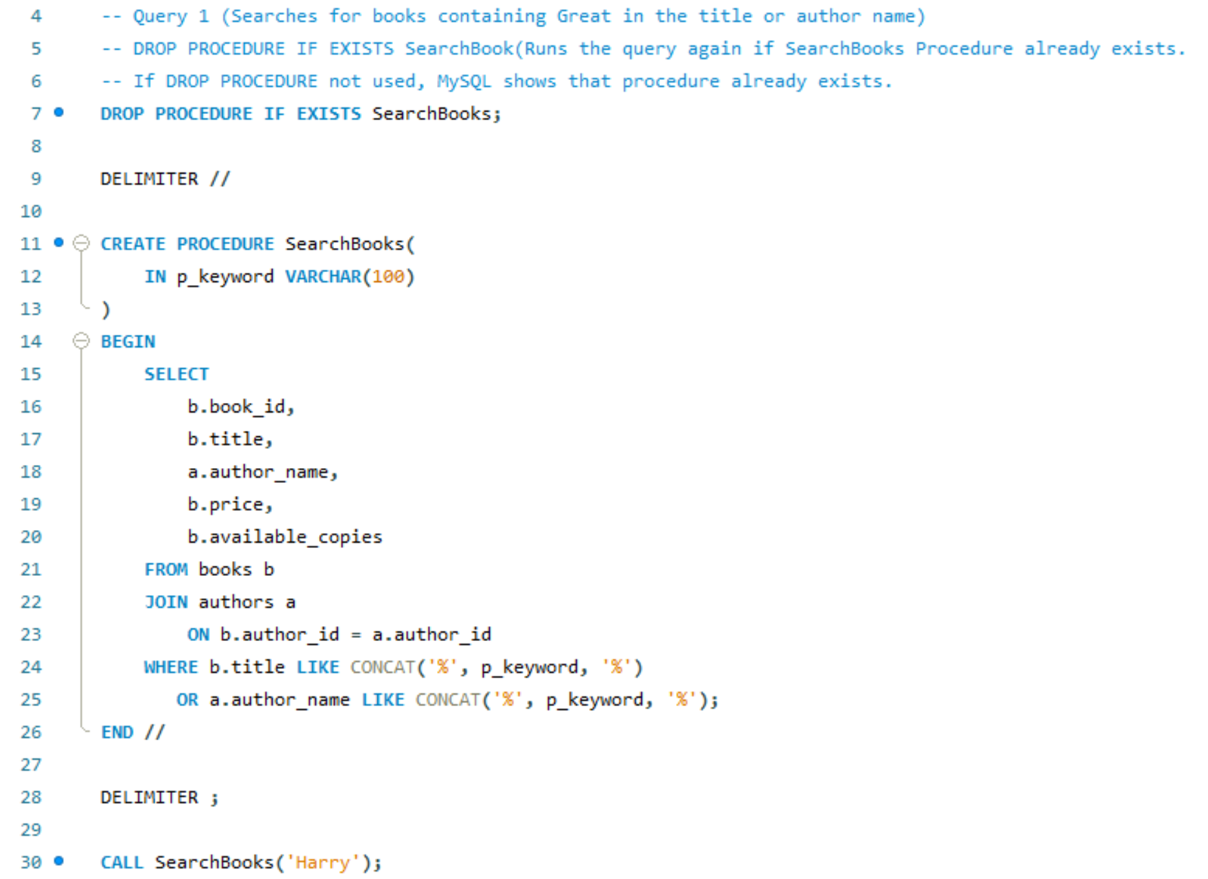

Figure 17: Example of STORED PROCEDURE

- Stored Function Implementation
This stored function is called CalculateFine, and it calculates a library fine at 1.00 per overdue day.

Working procedure:
If the book has been returned, it calculates:
return_date - due_date
If the book has not been returned, it calculates:
current date - due_date
If the result is zero or negative, the fine is 0.00.
Otherwise, the fine is 2.00 per late day.
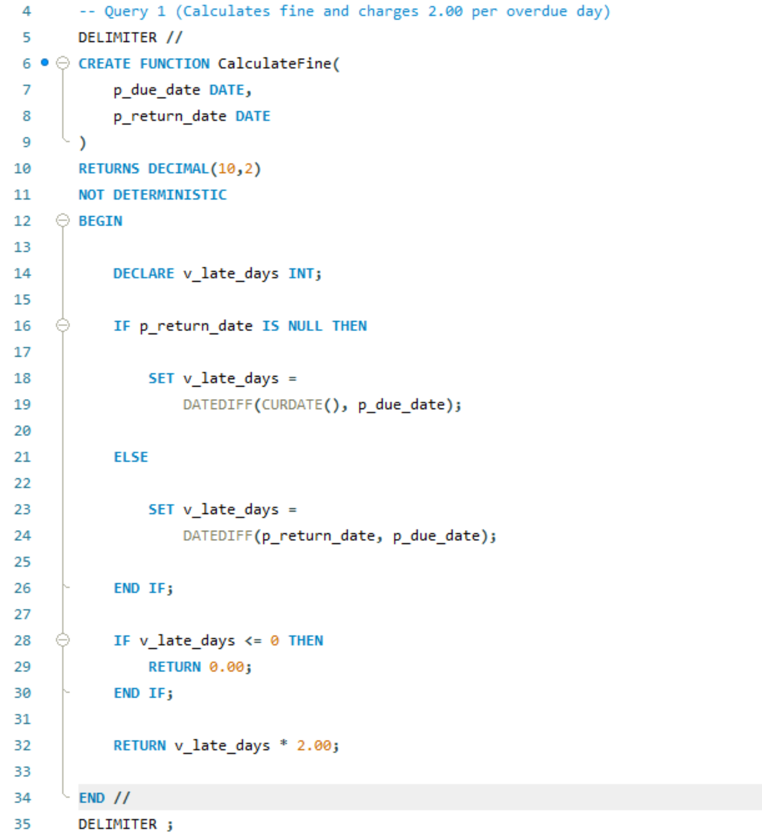

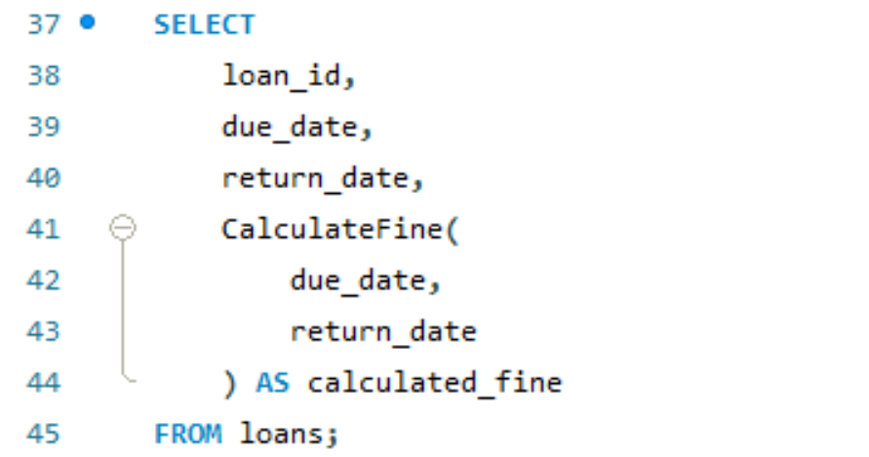

Figure 18: Example of STORED FUNCTIONS

- Trigger Implementation

Trigger runs before a new loan is inserted
Gets the availability status of the requested copy
Checks if the copy is available:
If copy not available, it stops the insert with an error:
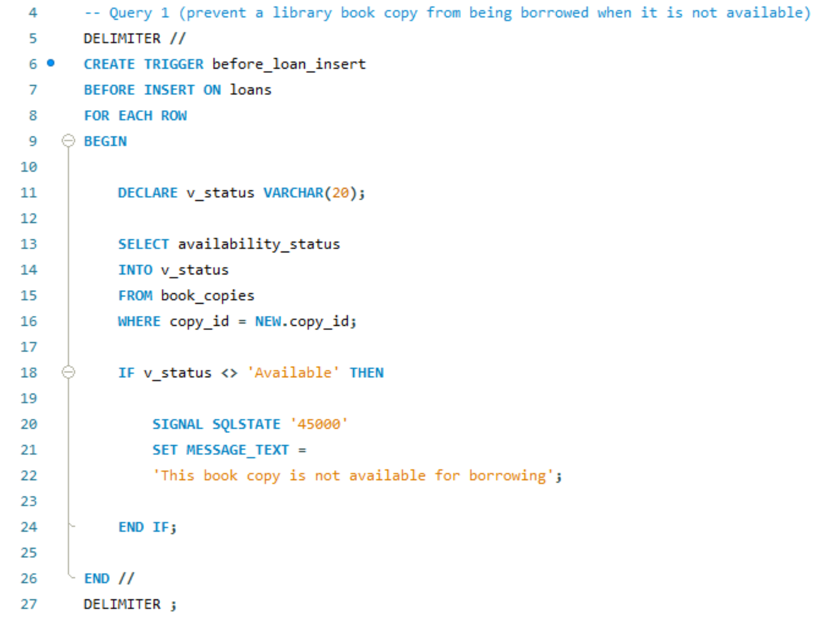

Figure 18: Example of STORED FUNCTIONS

- Transactions
# Query - Records a €5.00 card payment.

This transaction checks fine id 5, member id 5, amount 5, payment_method card and transaction_reference TXN-20260915 and finally commit permanent changes in payments. It results in 5.00 which is valid output for this transaction.
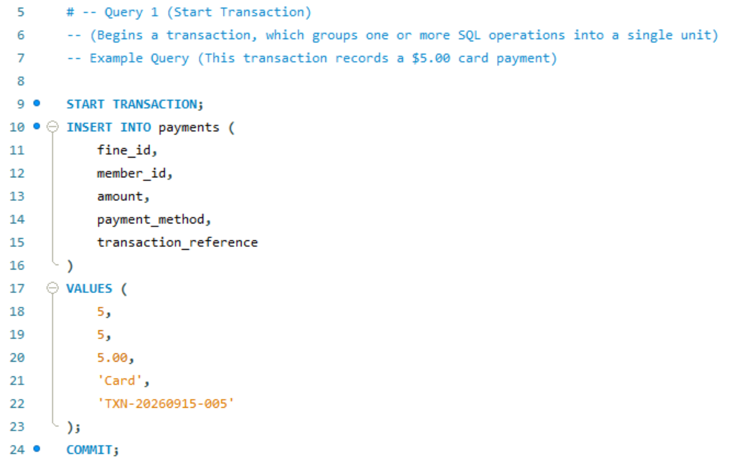
- Report
# Query -- Displays library dashboard summary query
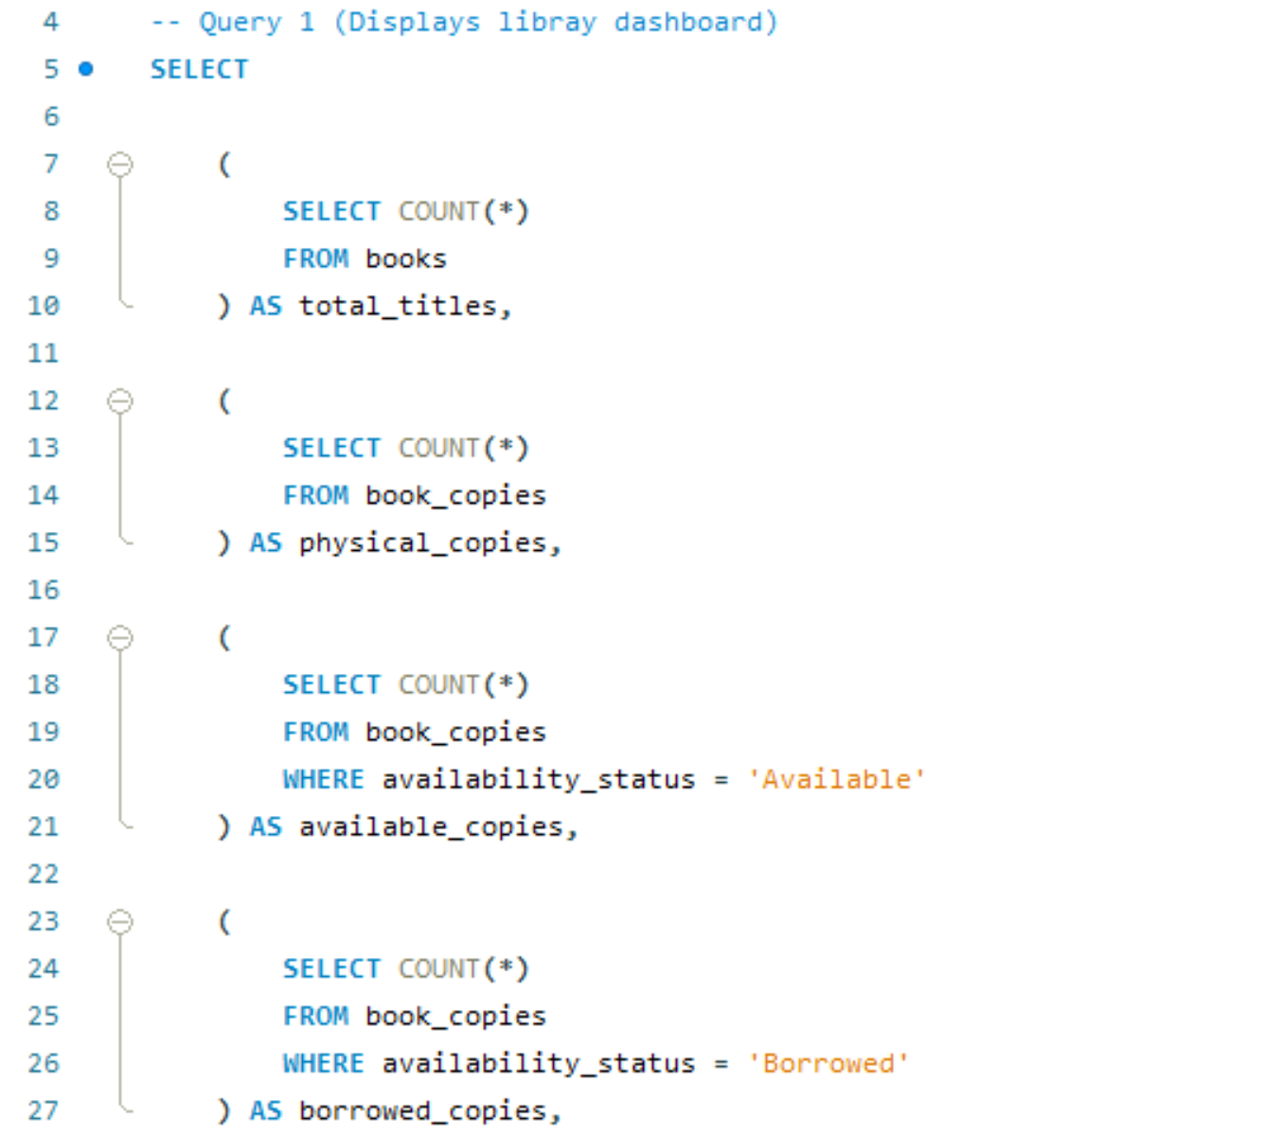
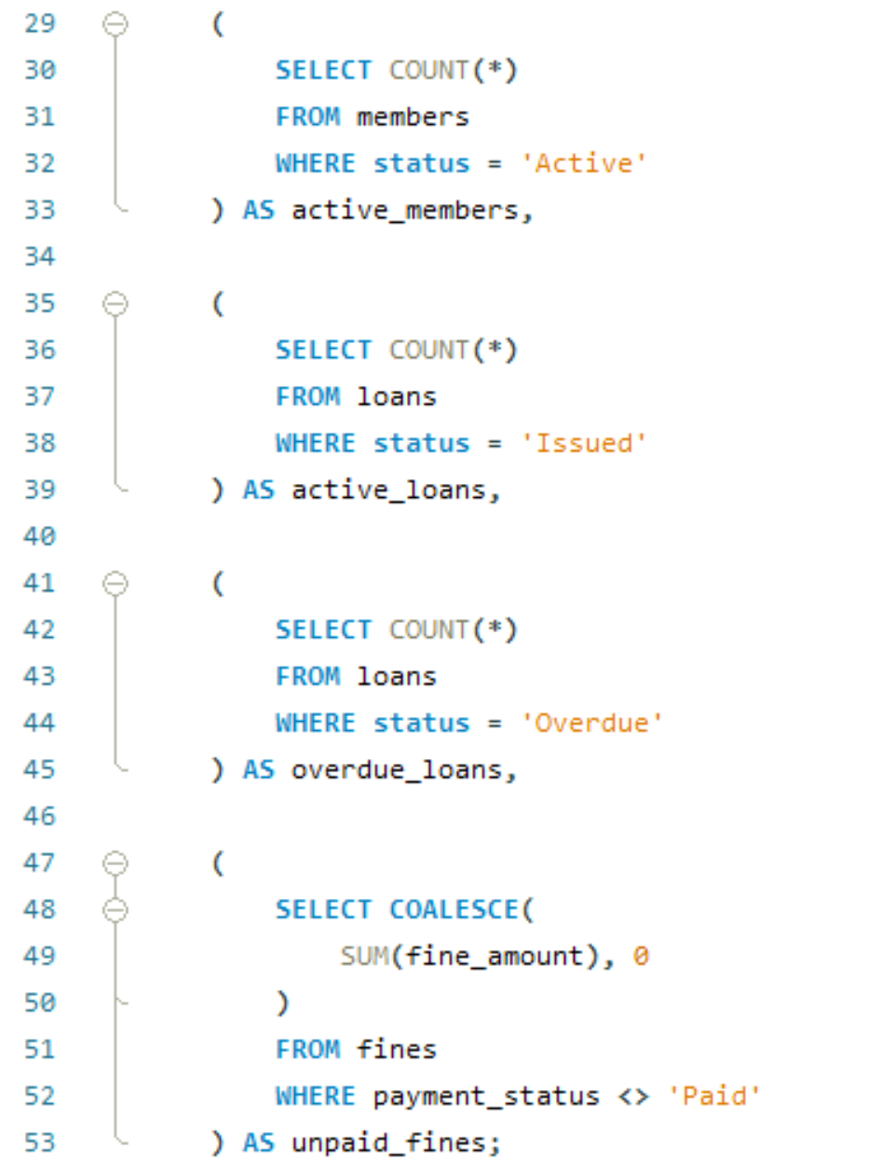

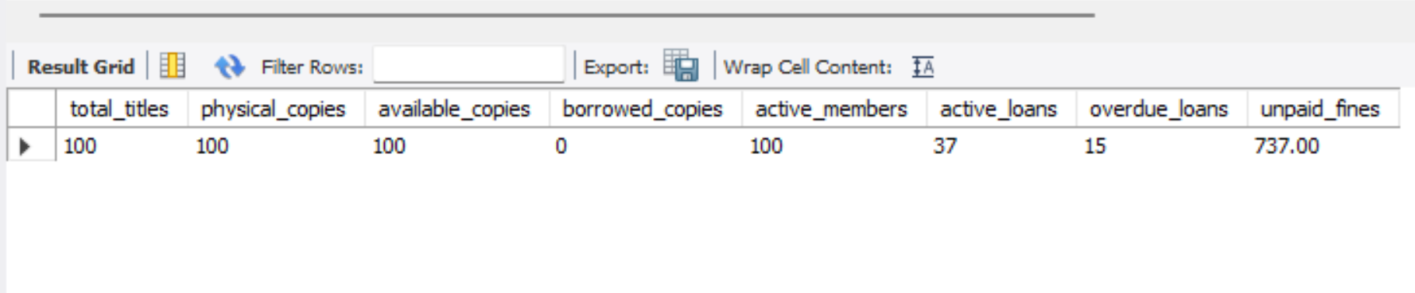

- Inventory Management
# Query – Displays all currently available physical book copies.
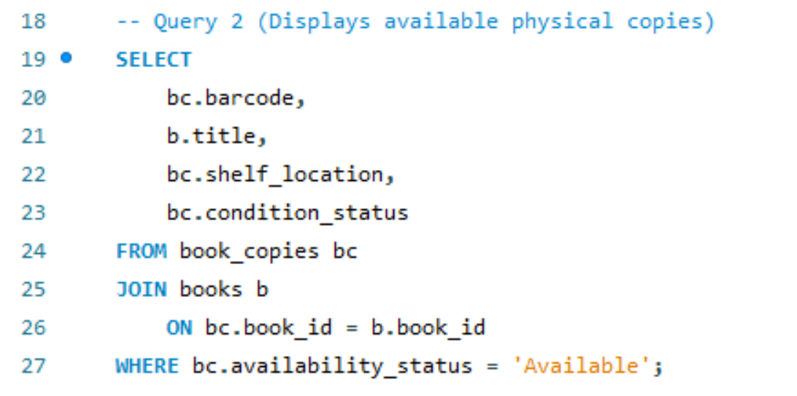
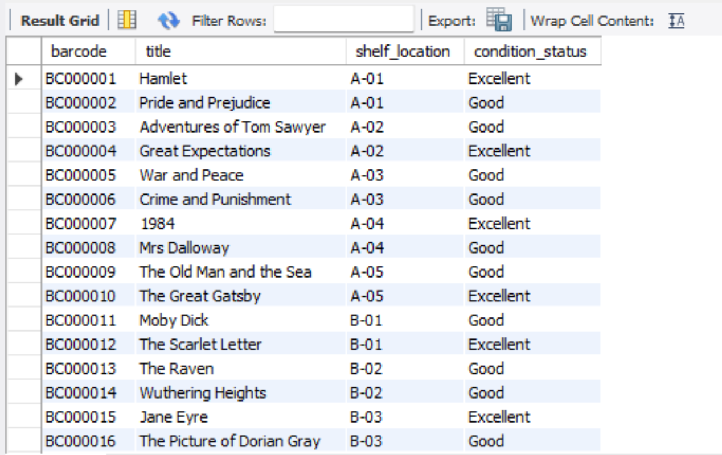

- Reservations
# Query – Creates new reservation with reservation_date → current date expiry_date → current date + 7 days status → Pending Status.
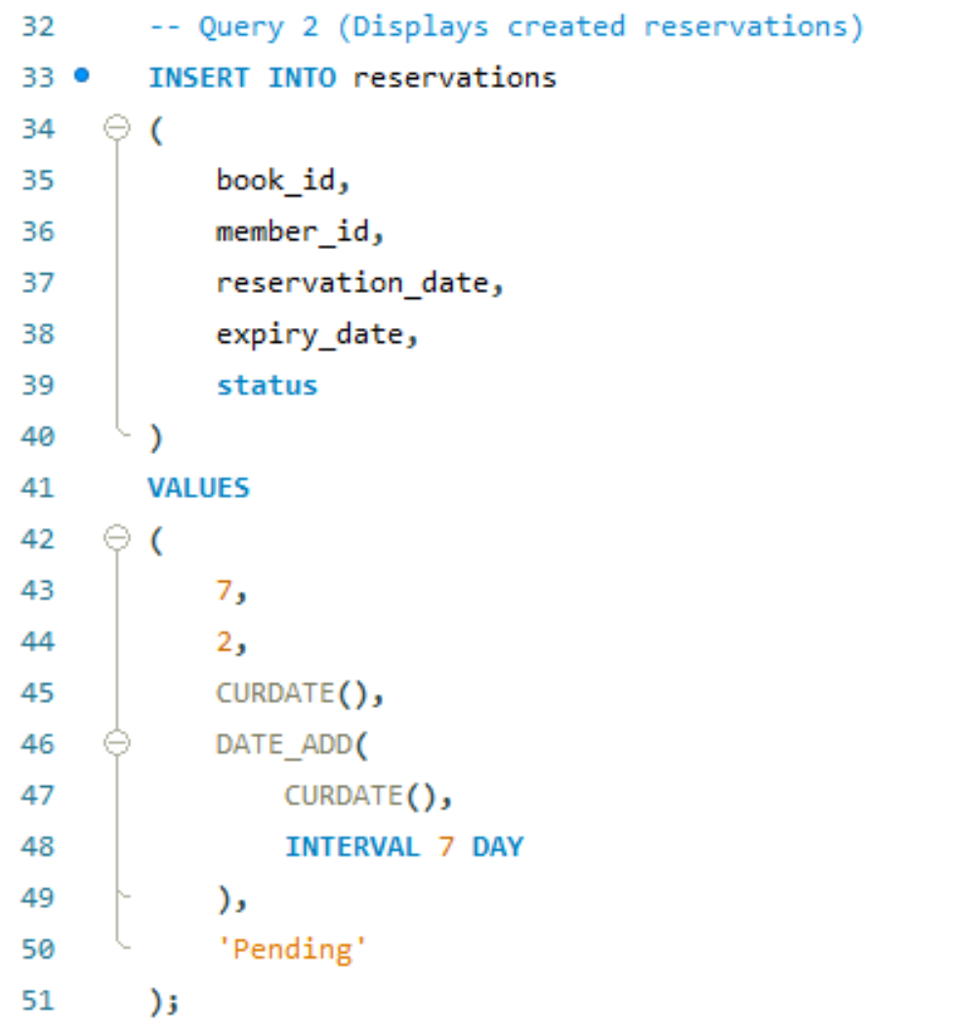

- Fines & Payments
# Query - Displays a useful unpaid/partially paid fines report.
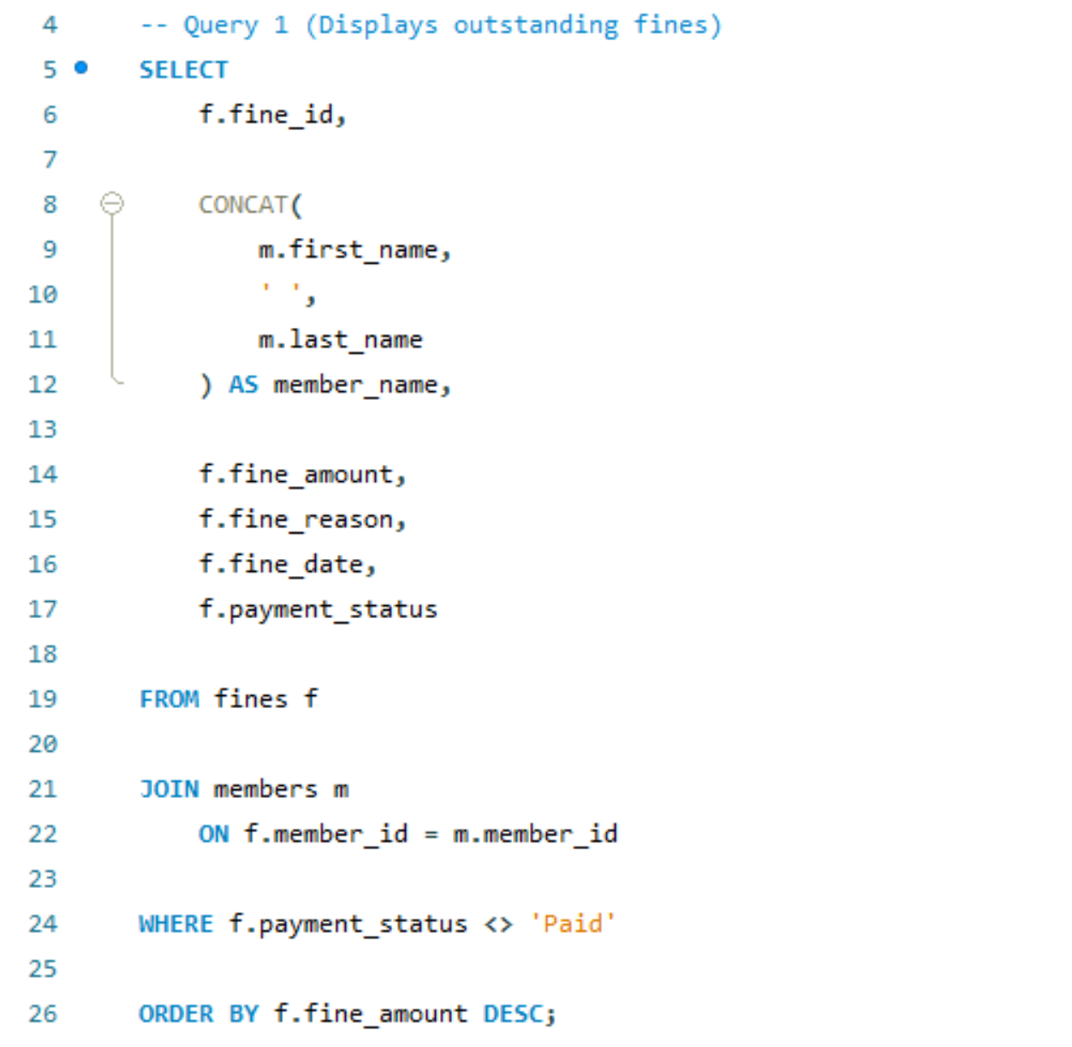
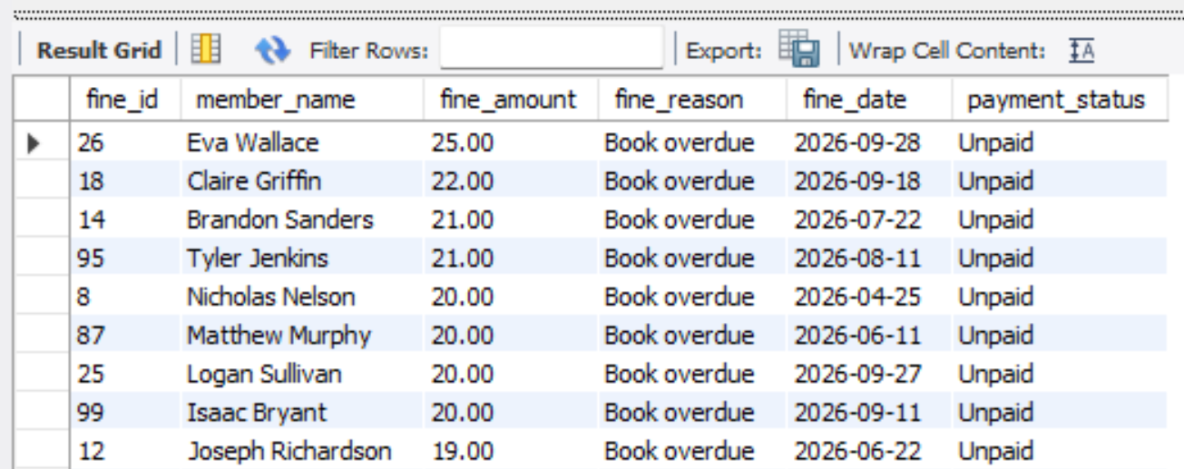

- Library Events
# Query – Displays upcoming library events, including events happening today.

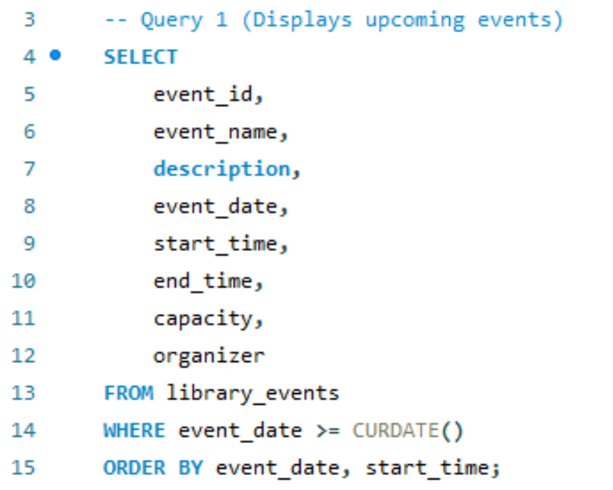
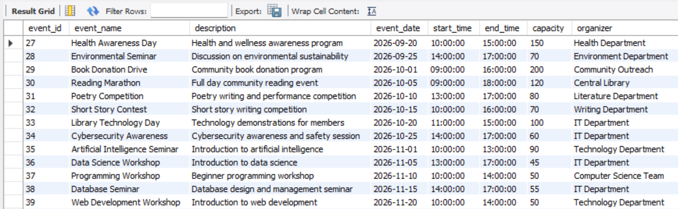

- Indexes
# Query -- Creates an index named idx_books_title on the title column of the books table. Index is used to improve queries that search or sort by book title.

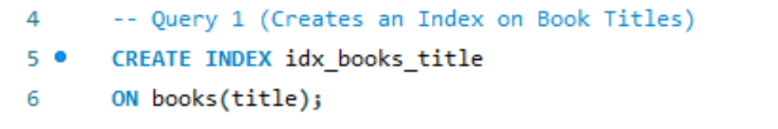

4. Challenges and Solutions

# Challenge 1 – There was a schema mismatch for member table.

Member table had columns:

Query used “membership_status”

When column does not exists, MySQL returns an error such as Unknown column
'membership_status'

Corrected Query Used Afterwards is:

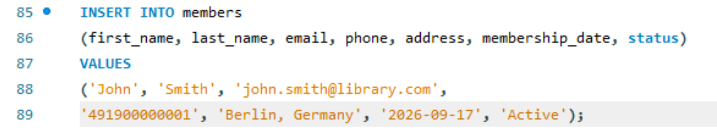

# Challenge 2 – Use of Determistic vs Not Determistic in stored functions.

Stored Function with Error:
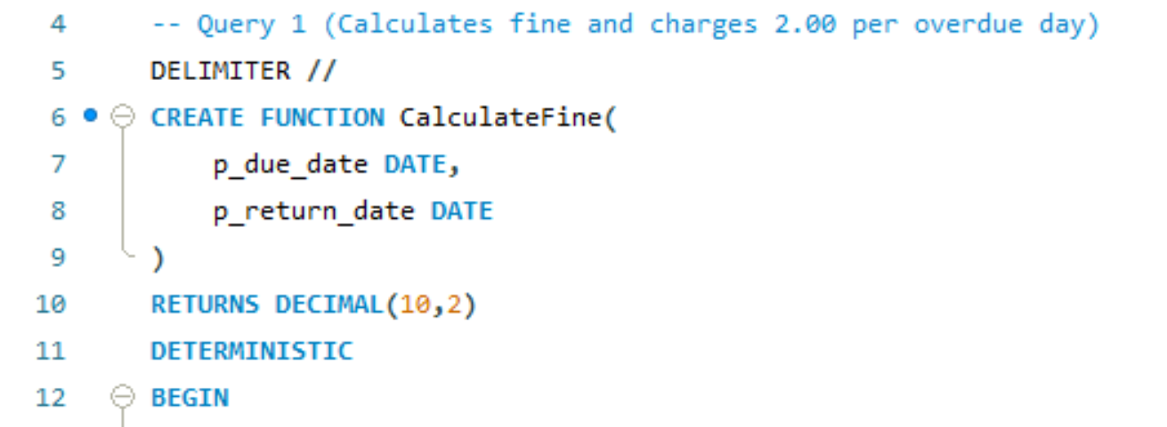

Solution: If a function relys on the current date/time, random values, or other changing data, function must not be declare it DETERMINISTIC. So, in such condition, Not Determistic has to be used.
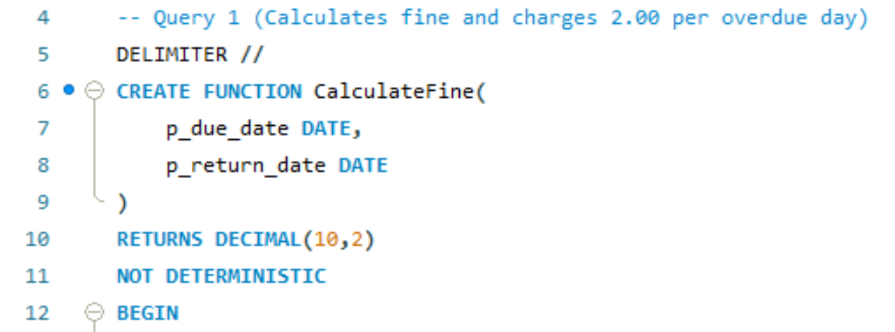

4. Conclusion and Future Work

Moden Library Management System implements all the necessary guidelines of module M604:

Backend Development: using SQL Language and MySQL Database Software.

Data Interaction: Database, tables, aggregation, views, transactions and queries are functional.

System Design: ER diagram is the visual representation of Relationships existing in Database.

Implementations:

Database is created to store the entire data of Modern Library Management System.

Tables are created using CREATE TABLE for different components of the Applications. Tables contain columns and rows to store data along with constraints, keys and indexes.

Data is inserted in relevant tables using INSERT commands, and structure od data is built as per the TABLES designed for Library Management System.

The applications works without any errors and produces the desired results as per the queries inserted and data can be seen in the tables in result section of MySQL GUI.

Some challenges have been faced during the application development and those errors have been eliminated by depth work and system changes with the help of structure of storing tables and query commands.

Some improvements can be done in the future. Front-end, APIs or Advanced Backend System can be developed using File Automation, Advance Searches, Online Reservation, Notification System, Web or Mobile Interface Integration.

Enhancements of this project is will be done in the future which are these: In future Docker containerization and Spring Security and also the Pagination, Unit tests with the JUnit, Swagger documentation and also the cloud deployment will be done in the future to improve or expand this project in the future.

References
1.MySQL Documentation: https://dev.mysql.com/doc/

2.MySQL 8.0 Reference Manual: https://dev.mysql.com/doc/refman/8.0/en/

3.W3Schools – SQL Tutorial: https://www.w3schools.com/sql/

4.W3Schools – MySQL Tutorial: https://www.w3schools.com/mysql/

5.GeeksforGeeks – DBMS and SQL: https://www.geeksforgeeks.org/

6.A Guide to MySQL: Pratt, P. J., & Last, M. Z. (2005).Publisher: Cengage Learning. Publication date: December 9, 2005.

7.MySQL Bible : Suehring, S. (2002). Publisher: Wiley. Publication date: July 2002.

8.Database System Concepts (7th ed.).Silberschatz, A., Korth, H. F., & Sudarshan, S. (2019).Publisher: McGraw-Hill Education.Publication year: 2019.

