Project title :Data warehousing with IBM cloud Db2 warehouse

1. Data Integration

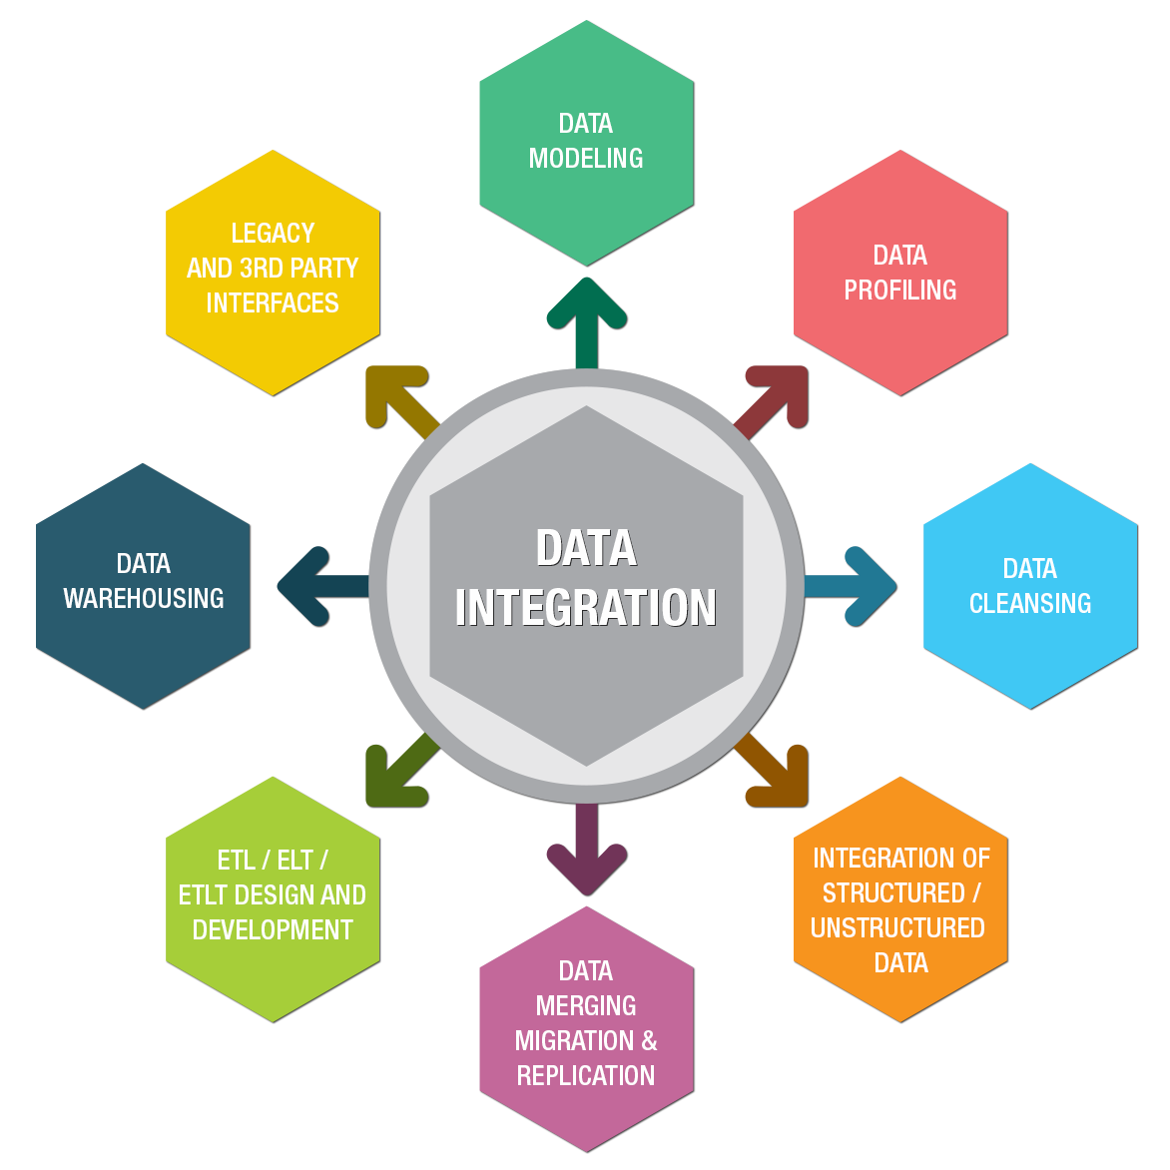

-Problem: Diverse data sources, formats, and structures.

-Innovation: Utilize automated data integration tools with machine learning capabilities. These tools can learn from previous data integration processes to automate mapping and transformation tasks more accurately over time.

2.Data Transformation



- Problem: Data needs to be cleaned, standardized, and transformed.

- Innovation: Implement data profiling and machine learning algorithms to automatically detect data quality issues and suggest transformation rules. Employ AI-based natural language processing (NLP) to understand and adapt to unstructured data.

3.ETL Processes

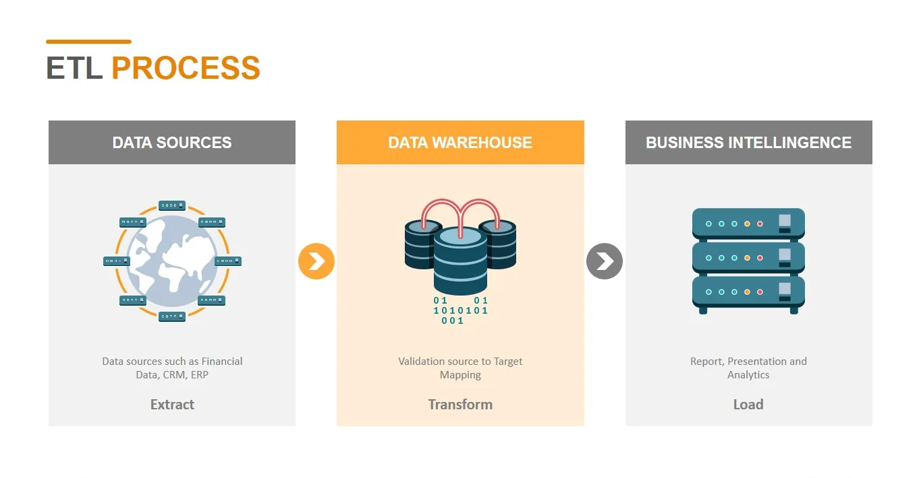

Problem: Complex ETL processes to move and transform data.

Innovation: Implement event-driven ETL pipelines that can automatically trigger ETL jobs based on changes in source data. Use containerization and orchestration (e.g., Docker and Kubernetes) for scalable and efficient ETL processing.

4.Data Warehouse Structure

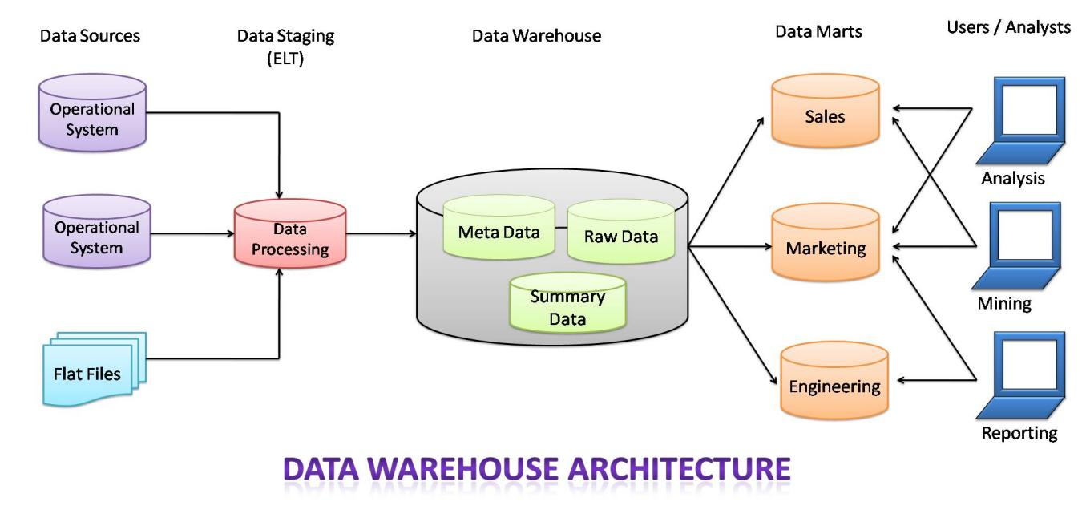

Problem: Designing an efficient data warehouse schema.

Innovation: Use automation and AI-driven schema design tools that can analyze query patterns and data relationships to suggest optimal schema structures dynamically. Consider hybrid data warehousing, which combines structured and unstructured data to meet evolving analytical needs.

5.Data Analysis Tools

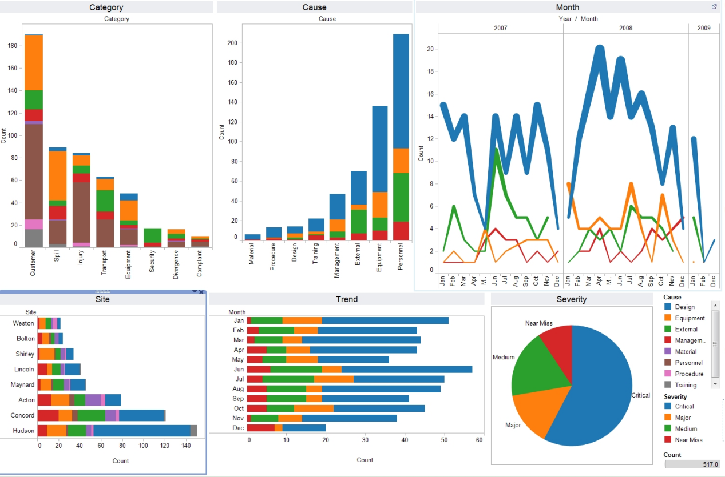

- \*\*Problem:\*\* Providing robust tools for data exploration and analysis.

- \*\*Innovation:\*\* Implement augmented analytics tools that use machine learning to assist users in finding relevant insights within the data. Incorporate natural language query interfaces, making it easier for non-technical users to access and analyze data.

6.Actionable Data



Problem: Ensuring data is actionable.

Innovation:Integrate predictive and prescriptive analytics within the data warehouse to provide insights and suggestions in real-time. Implement intelligent alerting systems that notify users when specific conditions or trends are met, enabling timely decision-making.

7.IBM Cloud Db2 Warehouse

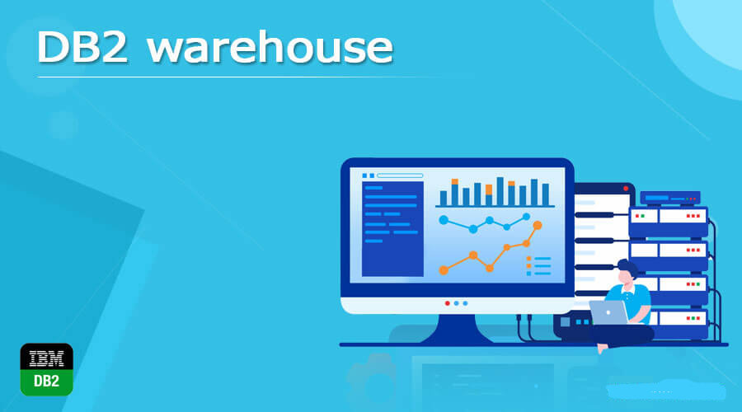

Problem: Leveraging IBM Cloud Db2 Warehouse effectively.

Innovation: Make use of IBM Cloud's AI and machine learning services to enhance the data warehouse capabilities. Implement server less data warehousing to automatically scale resources based on workload, ensuring cost-effectiveness and performance.

Innovation in data warehousing often involves the use of AI, automation, and modern cloud-based solutions. By leveraging these technologies, you can streamline processes, improve data quality, and provide more intuitive data analysis tools, ultimately empowering your organization to make more informed decisions based on high-quality data.