CAMPUSCONNECT
Student Portal UI/UX Redesign

UI/UX Design Internship – Week 3
Wireframing & Layout Design

Submitted by:
Gaura Manoj Kumar
B.Tech – CSE (AI & ML)
ACE Engineering College
Internship: YUVA INTERN
Year: 2026

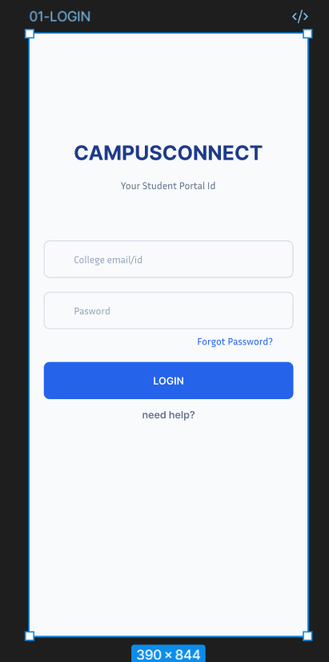

Purpose:
Allows students to securely access the CampusConnect student portal.
Key UI Elements:
- CampusConnect logo/name
- College Email / ID field
- Password field
- Forgot Password option
- Login button
- Help option
UX Considerations:
- Simple and distraction-free layout
- Clear input fields
- Primary action is visually prominent
- Help is easily accessible
User Flow:
Login → Home Dashboard

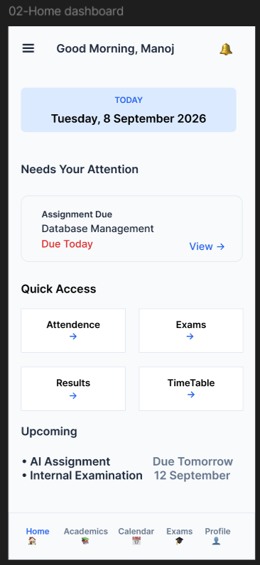
Screen 02 – Home Dashboard
Purpose:
Shows students their daily academic information and important tasks.
Key Elements:
- Greeting and notifications
- Today's date
- Pending assignments
- Quick Access
- Upcoming activities
- Bottom navigation
UX Focus:
Prioritizes important tasks and provides quick access to frequently used features.
User Flow:
Login → Home Dashboard → Select Feature

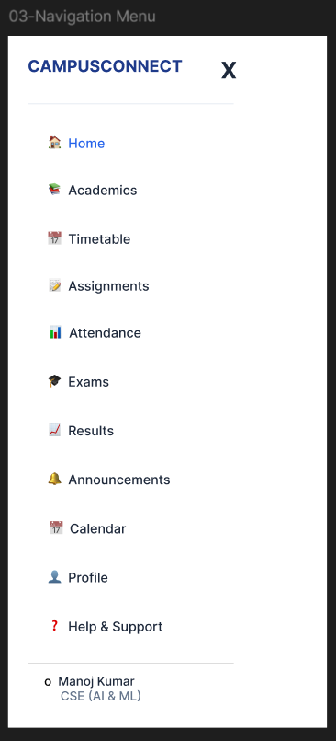
Screen 03 – Navigation Menu
Purpose:
Provides quick access to all major CampusConnect features.
Key Elements:
Home | Academics | Timetable | Assignments | Attendance | Exams | Results | Announcements | Calendar | Profile | Help & Support
UX Focus:
Keeps navigation simple and makes important sections easy to find.
User Flow:
Home → Navigation Menu → Select Feature
Home → Navigation Menu → Select Feature

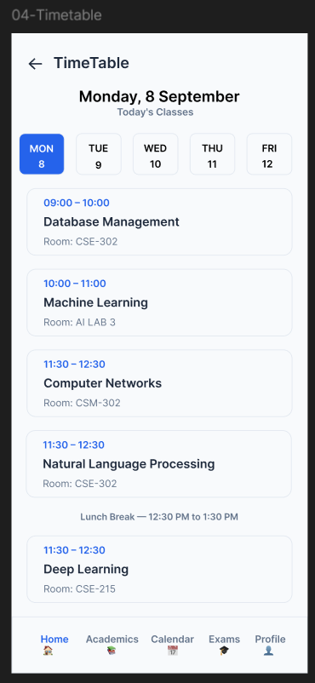
Screen 04 – Timetable
Purpose:
Helps students view their daily class schedule.
Key Elements:
Date | Day Selector | Class Time | Subject | Room Number | Lunch Break | Bottom Navigation
UX Focus:
Makes class timings and locations easy to check quickly.
User Flow:
Home → Timetable → Select Day → View Classes

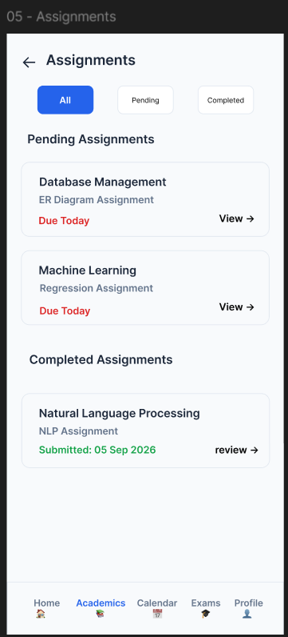
Screen 05 – Assignments
Purpose:
Helps students view and track their assignments.
Key Elements:
All | Pending | Completed | Subject | Assignment Title | Due Date | Submission Status | View
UX Focus:
Makes pending deadlines and submission status easy to identify.
User Flow:
Home → Assignments → Select Assignment → View Details

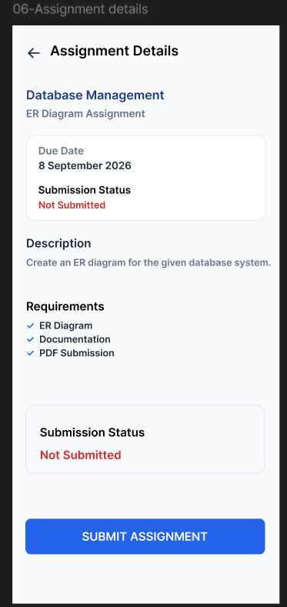
Screen 06 – Assignment Details
Purpose:
Shows detailed information about an assignment and allows students to submit it.
Key Elements:
Subject | Assignment Title | Due Date | Description | Requirements | Submission Status | Submit Assignment
UX Focus:
Clearly shows deadlines and submission status to avoid confusion.
User Flow:
Assignments → Assignment Details → Submit Assignment

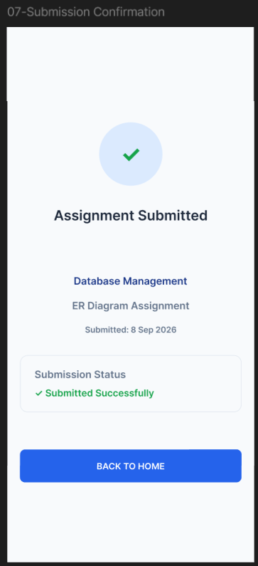
Screen 07 – Submission Confirmation
Purpose:
Confirms that the assignment has been successfully submitted.
Key Elements:
Success Icon | Submission Message | Subject | Assignment Title | Submission Date | Status | Back to Home
UX Focus:
Provides clear confirmation and reduces uncertainty after submission.
User Flow:
Assignment Details → Submit Assignment → Confirmation → Home

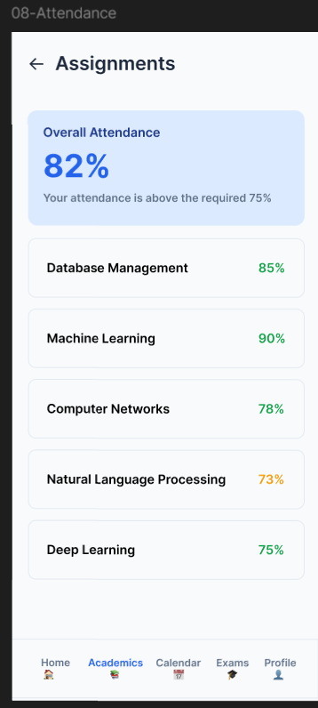
Screen 08 – Attendance
Purpose:
Helps students check their overall and subject-wise attendance.
Key Elements:
Overall Attendance | Attendance Percentage | Subject-wise Attendance | Minimum Requirement | Status
UX Focus:
Makes attendance status clear and easy to monitor.
User Flow:
Home → Attendance → View Attendance

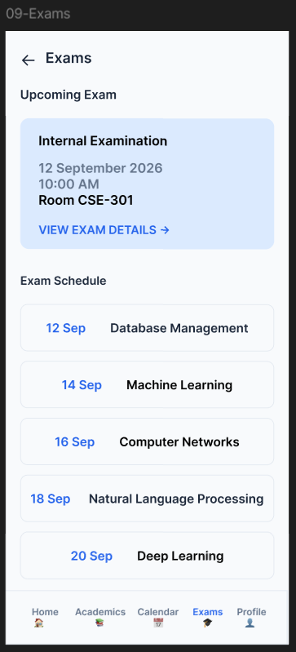
Screen 09 – Exams
Purpose:
Helps students view upcoming exams and exam schedules.
Key Elements:
Upcoming Exam | Exam Date | Time | Room Number | Exam Schedule | Subject
UX Focus:
Makes important exam dates, timings, and locations easy to find.
User Flow:
Home → Exams → View Exam Schedule

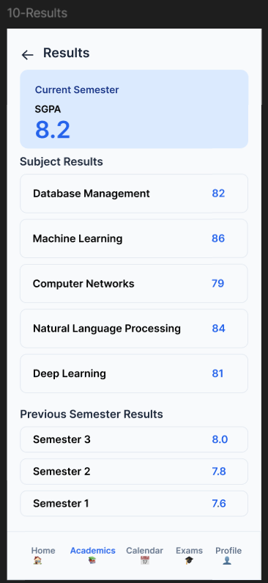
Screen 10 – Results
Purpose:
Helps students view their academic performance and semester results.
Key Elements:
Current Semester | SGPA | Subject Marks | Previous Semester Results | Academic Performance
UX Focus:
Presents academic performance in a clear and easy-to-understand format.
User Flow:
Home → Results → View Performance
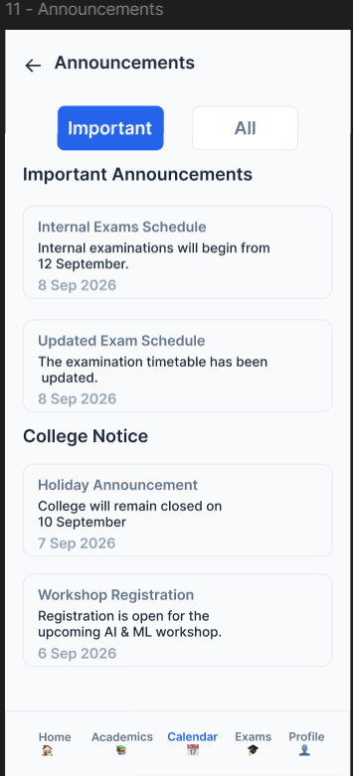
Screen 11 – Announcements
Purpose:
Helps students view important college and department announcements.
Key Elements:
Important | All | Exam Notices | College Notices | Department Updates | Date
UX Focus:
Highlights important announcements so students can quickly notice urgent updates.
User Flow:
Home → Announcements → View Announcement

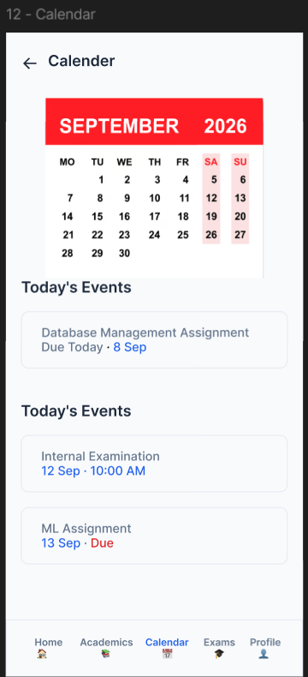
Screen 12 – Calendar
Purpose:
Helps students view important academic events, deadlines, and exams.
Key Elements:
Month View | Dates | Today | Assignments | Exams | Upcoming Events
UX Focus:
Provides a clear overview of academic activities and upcoming deadlines.
User Flow:
Home → Calendar → Select Date → View Events

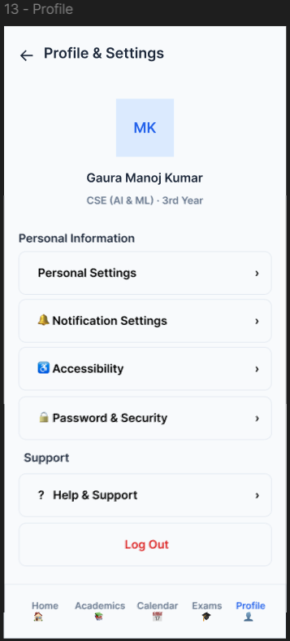
Screen 13 – Profile & Settings
Purpose:
Allows students to view their profile and manage account settings.
Key Elements:
Profile | Personal Information | Notification Settings | Accessibility | Password & Security | Help & Support | Log Out
UX Focus:
Keeps personal information and account settings organized and easy to access.
User Flow:
Home → Profile → Manage Settings

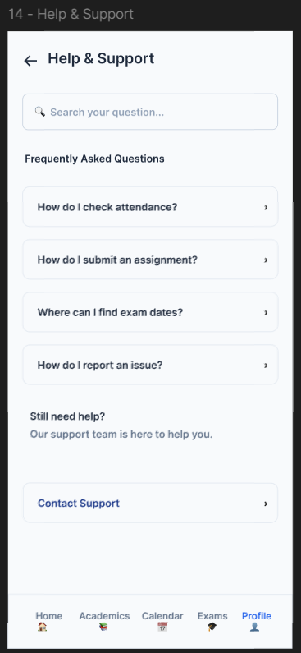
Screen 14 – Help & Support
Purpose:
Helps students find answers and get support for their issues.
Key Elements:
Search | FAQs | Common Questions | Support Information | Contact Support
UX Focus:
Makes help easy to find and provides quick solutions to common problems.
User Flow:
Profile → Help & Support → Search / Contact Support

