CAMPUSCONNECT
Student Portal UI/UX Redesign

WEEK 4 – VISUAL DESIGN & UI ELEMENT DEVELOPMENT

Submitted by: Gaura Manoj Kumar
B.Tech – CSE (AI & ML)
ACE Engineering College
YUVA INTERN – UI/UX Design Internship
2026

1. Week 4 Overview
During Week 4, the CampusConnect low-fidelity wireframes were transformed into a polished visual design. The focus was on selecting a suitable color scheme, typography, UI components, icons, spacing, visual hierarchy, and accessibility. The designs were developed in Figma while following the visual-design requirements specified in the internship task.

Objective
The objective was to create high-fidelity mockups that are visually appealing, consistent, easy to understand, and suitable for a student portal.

2. Mood Board & Design Direction
The visual direction for CampusConnect is modern, clean, trustworthy, student-friendly, and productivity-focused.
Theme | Visual Direction | Purpose
Modern | Clean layouts and simple cards | Keeps the interface current and easy to use
Trustworthy | Blue-based identity | Creates a professional academic feel
Productive | Action-focused dashboard | Helps students complete tasks quickly
Accessible | Readable text and clear contrast | Improves usability for different users

3. Color Palette & Analysis
A blue-based palette with neutral backgrounds was selected to create a calm and professional interface. Green, orange, and red are reserved for status information.
Color | Hex | Usage
Primary Blue | #2563EB | Buttons, links, active states
Dark Blue | #1E3A8A | Branding and headings
Light Blue | #DBEAFE | Highlights and selected areas
Background | #F8FAFC | Main background
White | #FFFFFF | Cards and inputs
Primary Text | #1E293B | Main content
Secondary Text | #64748B | Supporting text
Border | #E2E8F0 | Borders and dividers
Success | #16A34A | Successful actions
Warning | #F59E0B | Warnings
Error | #DC2626 | Urgent information

4. Typography
Inter was selected as the main typeface because it is clean, modern, and readable on digital screens.
Text Type | Size | Use
Heading | 20–24 px | Page titles and major sections
Subheading | 16–18 px | Cards and section headings
Body | 14–16 px | Main information
Small Text | 12–13 px | Dates, labels and supporting text

5. UI Components
Reusable components were planned to maintain consistency across the CampusConnect screens.
Primary Button | Secondary Button | Input Field | Information Card | Header | Bottom Navigation | Tabs | Status Badge | Icon Button
Consistent spacing, border radius, typography, and interaction states make the interface easier to maintain and improve.

6. High-Fidelity Mockups
The following three screens are the key high-fidelity mockups for Week 4. They represent the main entry point, dashboard, and academic task flow.

Screen 01 – Login
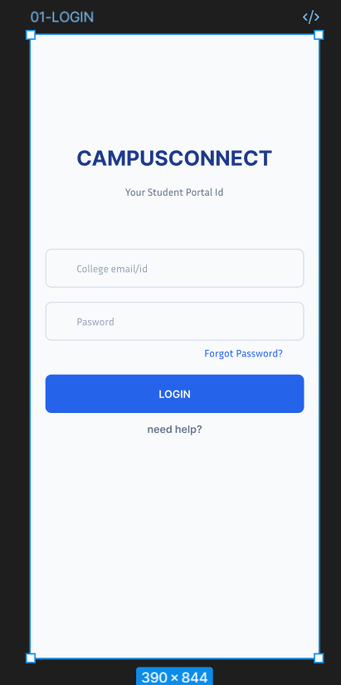
Provides a simple entry point to the portal. The primary blue button highlights the main action and the input fields use clear spacing and borders.

Screen 02 – Home Dashboard
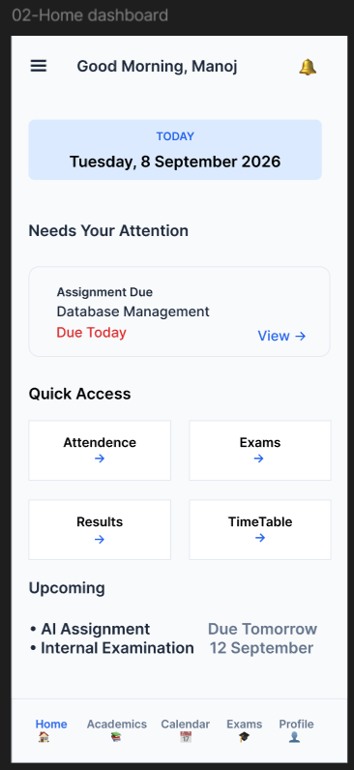
Presents today's information, urgent assignments, quick access features, and upcoming activities using an action-first layout.

Screen 05 – Assignments
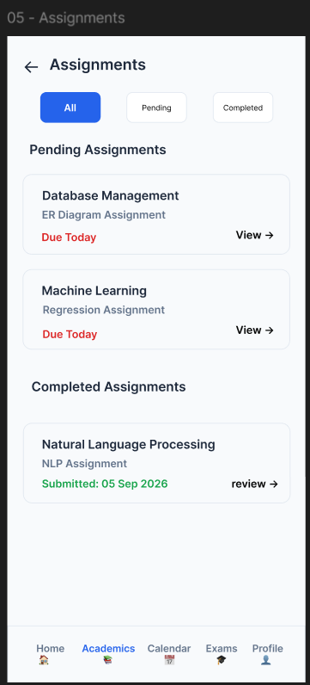
Helps students identify pending and completed work. Tabs and status information make deadlines and submission states easy to understand.

7. Design Decisions & UX Improvements
Design Area | Decision
Visual hierarchy | Important information is placed first with clear headings and spacing.
Consistency | Common components and styling are reused across screens.
Accessibility | Readable text, clear contrast, and simple layouts improve usability.
Status visibility | Colors and labels make pending, completed, urgent, and successful states easy to identify.
Navigation | Bottom navigation and a structured menu provide quick access to major features.
Mobile-first design | The interface uses a 390 × 844 px frame and avoids unnecessary clutter.

8. Before vs After
The low-fidelity wireframes established the structure and user flow, while the high-fidelity designs added the visual identity, refined components, and polished interface.
Low-Fidelity | High-Fidelity
Screen 01 – Login  [Insert Wireframe] | Screen 01 – Login  [Insert High-Fidelity]
Screen 02 – Home Dashboard  [Insert Wireframe] | Screen 02 – Home Dashboard  [Insert High-Fidelity]
Screen 05 – Assignments  [Insert Wireframe] | Screen 05 – Assignments  [Insert High-Fidelity]

9. Conclusion
Week 4 focused on transforming the CampusConnect wireframes into a clear and consistent visual design. A blue-based color system, Inter typography, reusable UI components, and accessibility-focused spacing were selected to create a professional student portal experience. The high-fidelity screens demonstrate the transition from basic structure to a polished user interface while keeping the user needs identified during the research stage.

10. Deliverables
Figma high-fidelity mockups, mood board, visual style guide, color palette analysis, typography specifications, UI component definitions, design decision notes, and before-versus-after comparison.

