CampusConnect
Week 5 – Interactive Prototyping & Animation
UI/UX Design Internship
Prepared by: Gaura Manoj Kumar
YUVA INTERN

1. Introduction
Week 5 focused on transforming the high-fidelity CampusConnect screens into a functional interactive prototype. The main objective was to connect the important screens, simulate real user journeys, and add transitions, hover states, and micro-interactions so that the design behaves more like a real student portal.
The prototype was developed in Figma because it provided the required prototyping and animation features while allowing the existing high-fidelity UI designs to be reused.

2. Prototype Overview
Item | Details
Project | CampusConnect – Student Portal UI/UX
Week | Week 5 – Interactive Prototyping & Animation
Design Tool | Figma
Screens | 14 main screens
Prototype Type | Interactive mobile-first prototype
Primary Goal | Connect major user flows and demonstrate realistic interactions

3. Main User Flows
The prototype was organized around the most important actions a student would perform.
- Login → Home Dashboard
- Home → Navigation Menu → Major Features
- Home → Assignments → Assignment Details → Submit Assignment → Confirmation → Home
- Home → Timetable → View Classes
- Home → Attendance → View Attendance
- Home → Exams → View Exam Schedule
- Home → Results → View Performance
- Home → Calendar → View Events
- Home → Profile → Help & Support

4. Key Interactive Features
Interaction | Trigger | Action | Animation / Setting
Login → Home | On Click | Navigate to Home Dashboard | Smart Animate / 300ms
Home → Navigation Menu | On Click | Open Navigation Menu | Move In / 300ms
Navigation → Features | On Click | Navigate to selected section | Smart Animate / 300ms
Home → Timetable | On Click | Open Timetable | Smart Animate / 300ms
Home → Assignments | On Click | Open Assignments | Smart Animate / 300ms
Assignments → Details | On Click | Open selected assignment | Smart Animate / 300ms
Submit Assignment | On Click | Open Submission Confirmation | Smart Animate / 300ms
Back Buttons | On Click | Return to previous screen | Move In / 300ms
Assignment Tabs | On Click | Switch All / Pending / Completed | Smart Animate / 200ms
Bottom Navigation | On Click | Switch main sections | Smart Animate / 200–300ms

5. Assignment Submission Flow
One of the most important prototype flows is the assignment submission journey. It demonstrates a complete task from viewing an assignment to receiving confirmation.
- Assignments → Assignment Details → Submit Assignment → Submission Confirmation → Home
The confirmation screen provides clear feedback after submission, reducing uncertainty and making the interaction feel complete.

6. Assignment Tabs Interaction
The Assignments screen was expanded into three prototype states so students can switch between different assignment categories.
State | Purpose | Active Tab
05A – All | Shows all assignments | All
05B – Pending | Shows assignments that still require action | Pending
05C – Completed | Shows submitted/completed assignments | Completed
The tabs are connected using On Click → Navigate to → Smart Animate with a short 200ms transition to make the category change feel quick and responsive.

7. Transitions & Animation
Technique | Where Used | Purpose
Smart Animate | Screen-to-screen navigation | Creates smooth movement between related screens
Move In | Navigation menu and back navigation | Makes directional navigation easier to understand
Ease Out | Buttons and screen transitions | Creates a natural stopping motion
Short Duration | Tabs and micro-interactions | Keeps interactions quick and responsive

8. Bottom Navigation
The bottom navigation was connected to provide quick access to the main sections of CampusConnect.
Tab | Purpose
Home | Return to the main dashboard
Academics | Access academic information and related sections
Calendar | View academic events, deadlines and dates
Exams | View upcoming examinations and schedules
Profile | View personal information and settings

9. Usability Considerations
- Important actions are reachable through clear navigation paths.
- Transitions are kept short so the interface does not feel slow.
- The assignment submission flow clearly confirms the result of an important action.
- Consistent navigation patterns are maintained across the prototype.
- The prototype focuses on realistic student tasks instead of adding unnecessary animations.

10. Prototype Testing
The main user journeys were tested by clicking through the prototype in Figma. The testing focused on whether users could move between screens, identify interactive elements, complete the assignment submission flow, switch assignment categories, and return to the appropriate previous or home screen.
The prototype was reviewed for broken links, unclear navigation, inconsistent transitions, and missing feedback states before final documentation.

11. Prototype Screenshots
Screenshots of the final interactive prototype can be inserted in this section. Recommended screenshots include:
- Login and Home Dashboard
- Navigation Menu
- Assignments and Assignment Details
- Submission Confirmation
- Assignment Tabs – All / Pending / Completed
- Bottom Navigation
- Hover or Pressed State
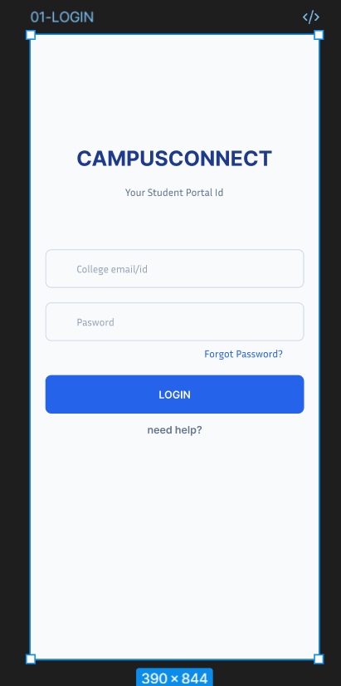
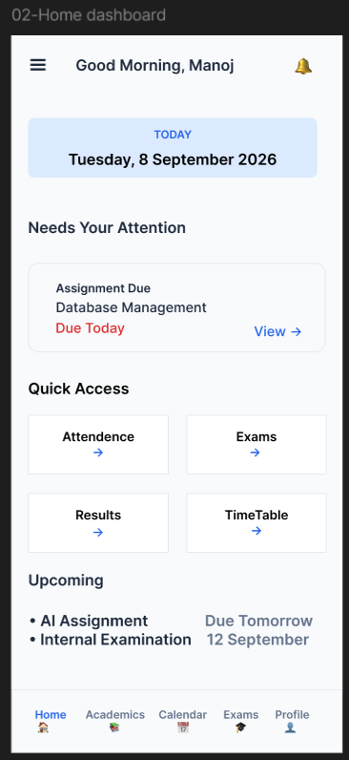
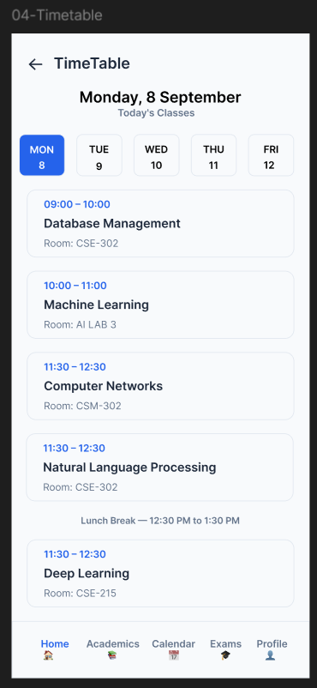
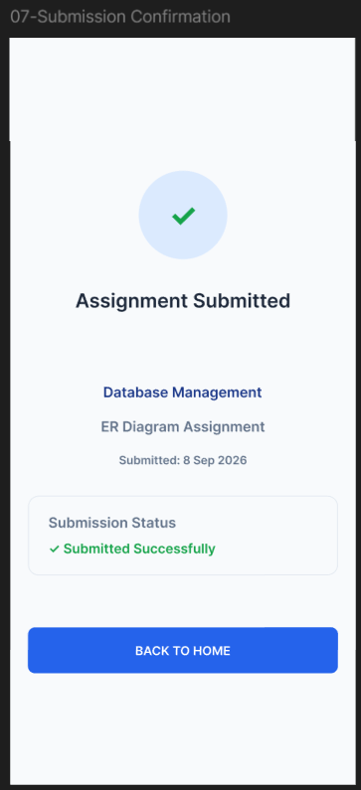

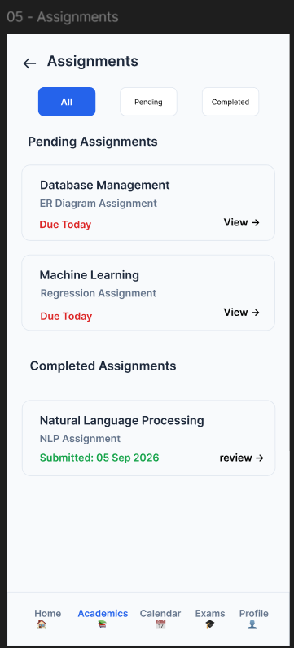
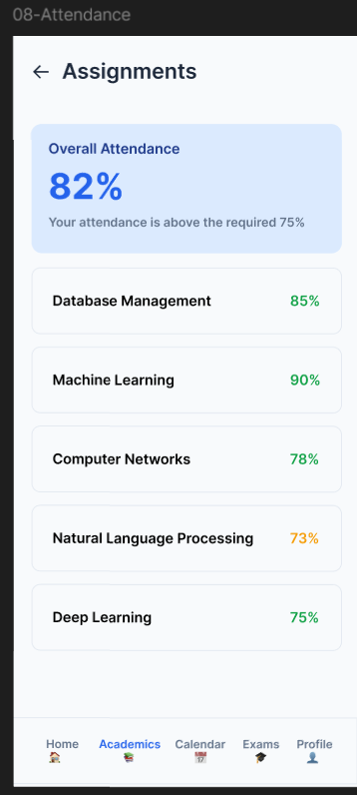

13. Figma Prototype Link
Final Figma prototype link: https://www.figma.com/design/7HouTKevwklduscRxerDug/Campus-Connect?node-id=0-1&t=68upHyCFWqp1HTpe-1

14. Conclusion
Week 5 completed the transition of CampusConnect from a collection of high-fidelity static screens into an interactive prototype. The major user journeys were connected, important actions were given feedback, and transitions and micro-interactions were added to make the experience feel more natural. The final prototype demonstrates how students can navigate the portal and complete common academic tasks through a clear and consistent interaction flow.

