**MODULE:1**

1. **What is software? What is software engineering?**

Ans: software - software is set of program used to execute an entire application. There are many program combine together to form software.

Software engineering - is an engineering discipline that’s applied to the development of software in a systematic approach. Software engineering is a detailed study of engineering to the design, development and maintenance of software.

1. **Explain types of software.**

Ans:

System software :- System software is a type of computer program that is designed to run a computer's hardware and application programs. the system software is the interface between the hardware and user applications. The operating system is the best-known example of system software.

Real time software :- real-time software include aircraft navigation programs, multimedia broadcasts, multi-player video games, data analysis programs and stock-trading applications. The success of many large enterprises depends on the real-time responsiveness of their IT systems.

Embedded software :- Embedded software applications are specialized programming within non-PC devices – either as part of a microchip or as part of another application that sits on top of the chip – to control specific functions of the device. Eg. digital watches, electronic calculators, GPS systems.

1. **What is SDLC? Explain each phase of SDLC.**

Ans: SDLC :- It stands for Software Development Life Cycle models. SDLC – is a continuous process, which starts from the moment, when it’s made a decision to launch the project. There is no one single SDLC model. They are divided into main groups, each with its features and weaknesses.

requirement analysis :- the process  
discuss the **requirements for the final product.** The goal of this stage is the detailed definition of the system requirements. Besides, it is needed to make sure that all the process participants have clearly understood the tasks and how every requirement is going to be implemented.

Designing project architecture:- At the second phase of the software development life cycle, the developers are actually designing the architecture. here are defined the technologies used in the project, team load, limitations, time frames, and budget. The most appropriate project decisions are made according to the defined requirements.

Development and programming:- After the requirements approved, the process goes to the next stage – actual development. Programmers start here with the source code writing while keeping in mind previously defined requirements. The system administrators adjust the software environment, front-end programmers develop the user interface of the program and the logics for its interaction with the server.The programming by itself assumes four stages.

Testing:- The testing phase includes the debugging process. All the code flaws missed during the development are detected here, documented, and passed back to the developers to fix. The testing process repeats until all the critical issues are removed and software workflow is stable.

Deployment:- When the program is finalized and has no critical issues – it is time to launch it for the end users. After the new program version release, the tech support team joins. This department provides user feedback; consult and support users during the time of exploitation. Moreover, the update of selected components is included in this phase, to make sure, that the software is up-to-date and is invulnerable to a security breach.

1. **What is DFD? Create a DFD diagram on Flipkart**

Ans:- data flow diagram (DFD) is a graphical or visual representation using a standardized set of symbols and notations to describe a business's operations through data movement. They are often elements of a formal methodology such as Structured Systems Analysis and Design Method.

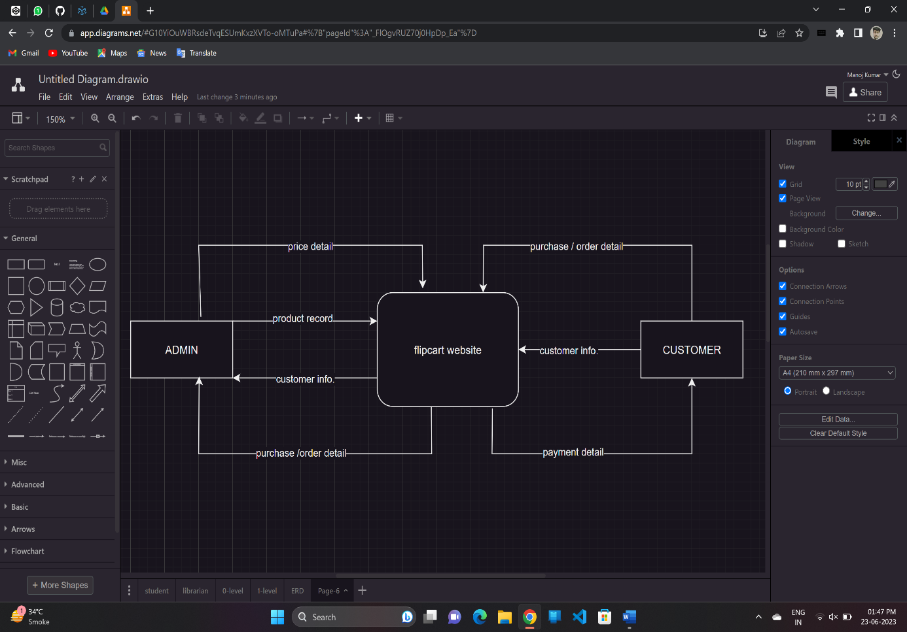

1. **What is Flow chart? Create a flowchart to make addition of two numbers.**

Ans: flowchart is a picture of the separate steps of a process in sequential order. Flowcharts make it easier for technical users to communicate more complex logic within a system.

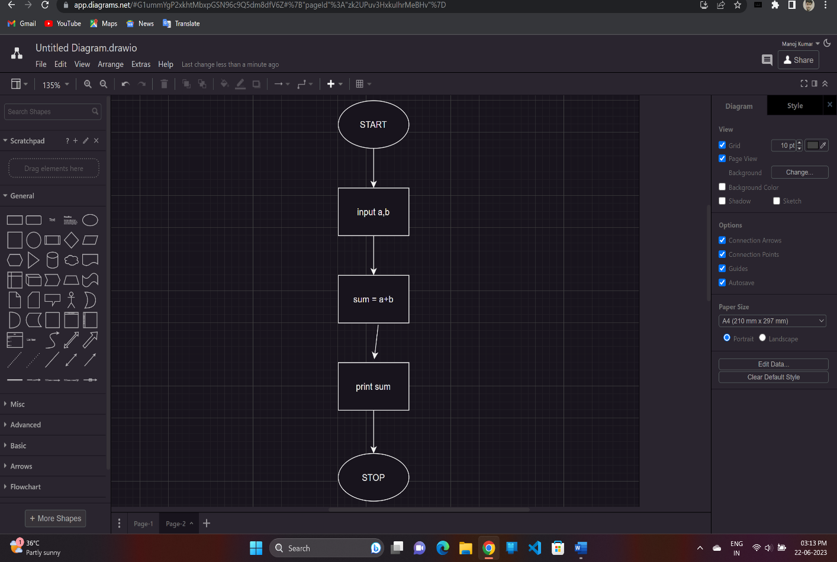

1. **What is Use case Diagram? Create a use-case on bill payment on paytm.**

Ans: Use-case diagrams describe the high-level functions and scope of a system. These diagrams also identify the interactions between the system and its actors. The use cases and actors in use-case diagrams describe what the system does and how the actors use it, but not how the system operates internally.

