**Business Requirement Document (BRD)**

**Project Details:**

* Project Title: Streamlining Hospital Operations
* Prepared by: K Manoj Kumar
* Date: 11th June, 2025
* Version: 1.0

**Introduction:** This document outlines the business requirements and the proposed solutions to address the hospital’s operational challenges. It details the needs of the hospital’s stakeholders, the scope of the project, and the functional and non-functional requirements.

**Project Scope:**

In-Scope:

* Implementation of an Electronic Medical Records (EMR) system.
* Integration of an automated patient registration system.
* Deployment of real-time inter-department communication tools (e.g., messaging, task notifications and diagnoses updates).
* Automated inventory and pharmacy management system.
* Change management support including staff onboarding and training.

Out-of-Scope:

* Clinical care procedures and medical decision-making protocols.
* Hospital infrastructure/facilities management (building upgrades, physical layout).
* Financial aspects like external healthcare partnership, insurance, and billing systems.

**Stakeholders:**

|  |  |
| --- | --- |
| **Stakeholder Group** | **Role in the Project** |
| Hospital Administration | Project sponsor, sets vision and goals |
| IT Department | Provides technical infrastructure & support |
| Doctors | Primary users of EMR, provide requirements |
| Nurses | Day-to-day users of registration and records |
| Pharmacy Staff | Users of inventory & prescription system |
| Reception / Admissions | Handle registration and check-in workflows |
| Patients (via feedback) | Provide insights on pain points and experience |

**Business Objectives:**

* Reduce average patient wait times by 20% within 6 months.
* Digitize and streamline patient data management through EMR.
* Improve communication between departments to reduce errors and delays.
* Increase operational efficiency by 20% within 3 months, automating redundant tasks.
* Ensure compliance with healthcare data security regulations.

**Process Flow Diagrams:**

**Current State Analysis (As-Is Process):**

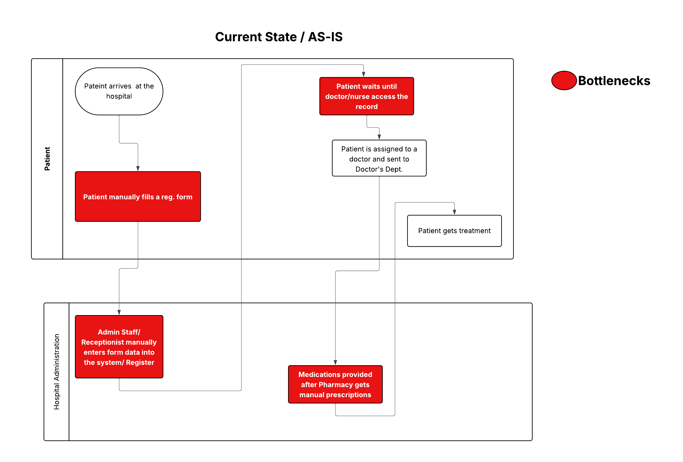

**Proposed Solution / Future State Analysis (To-Be Process):**

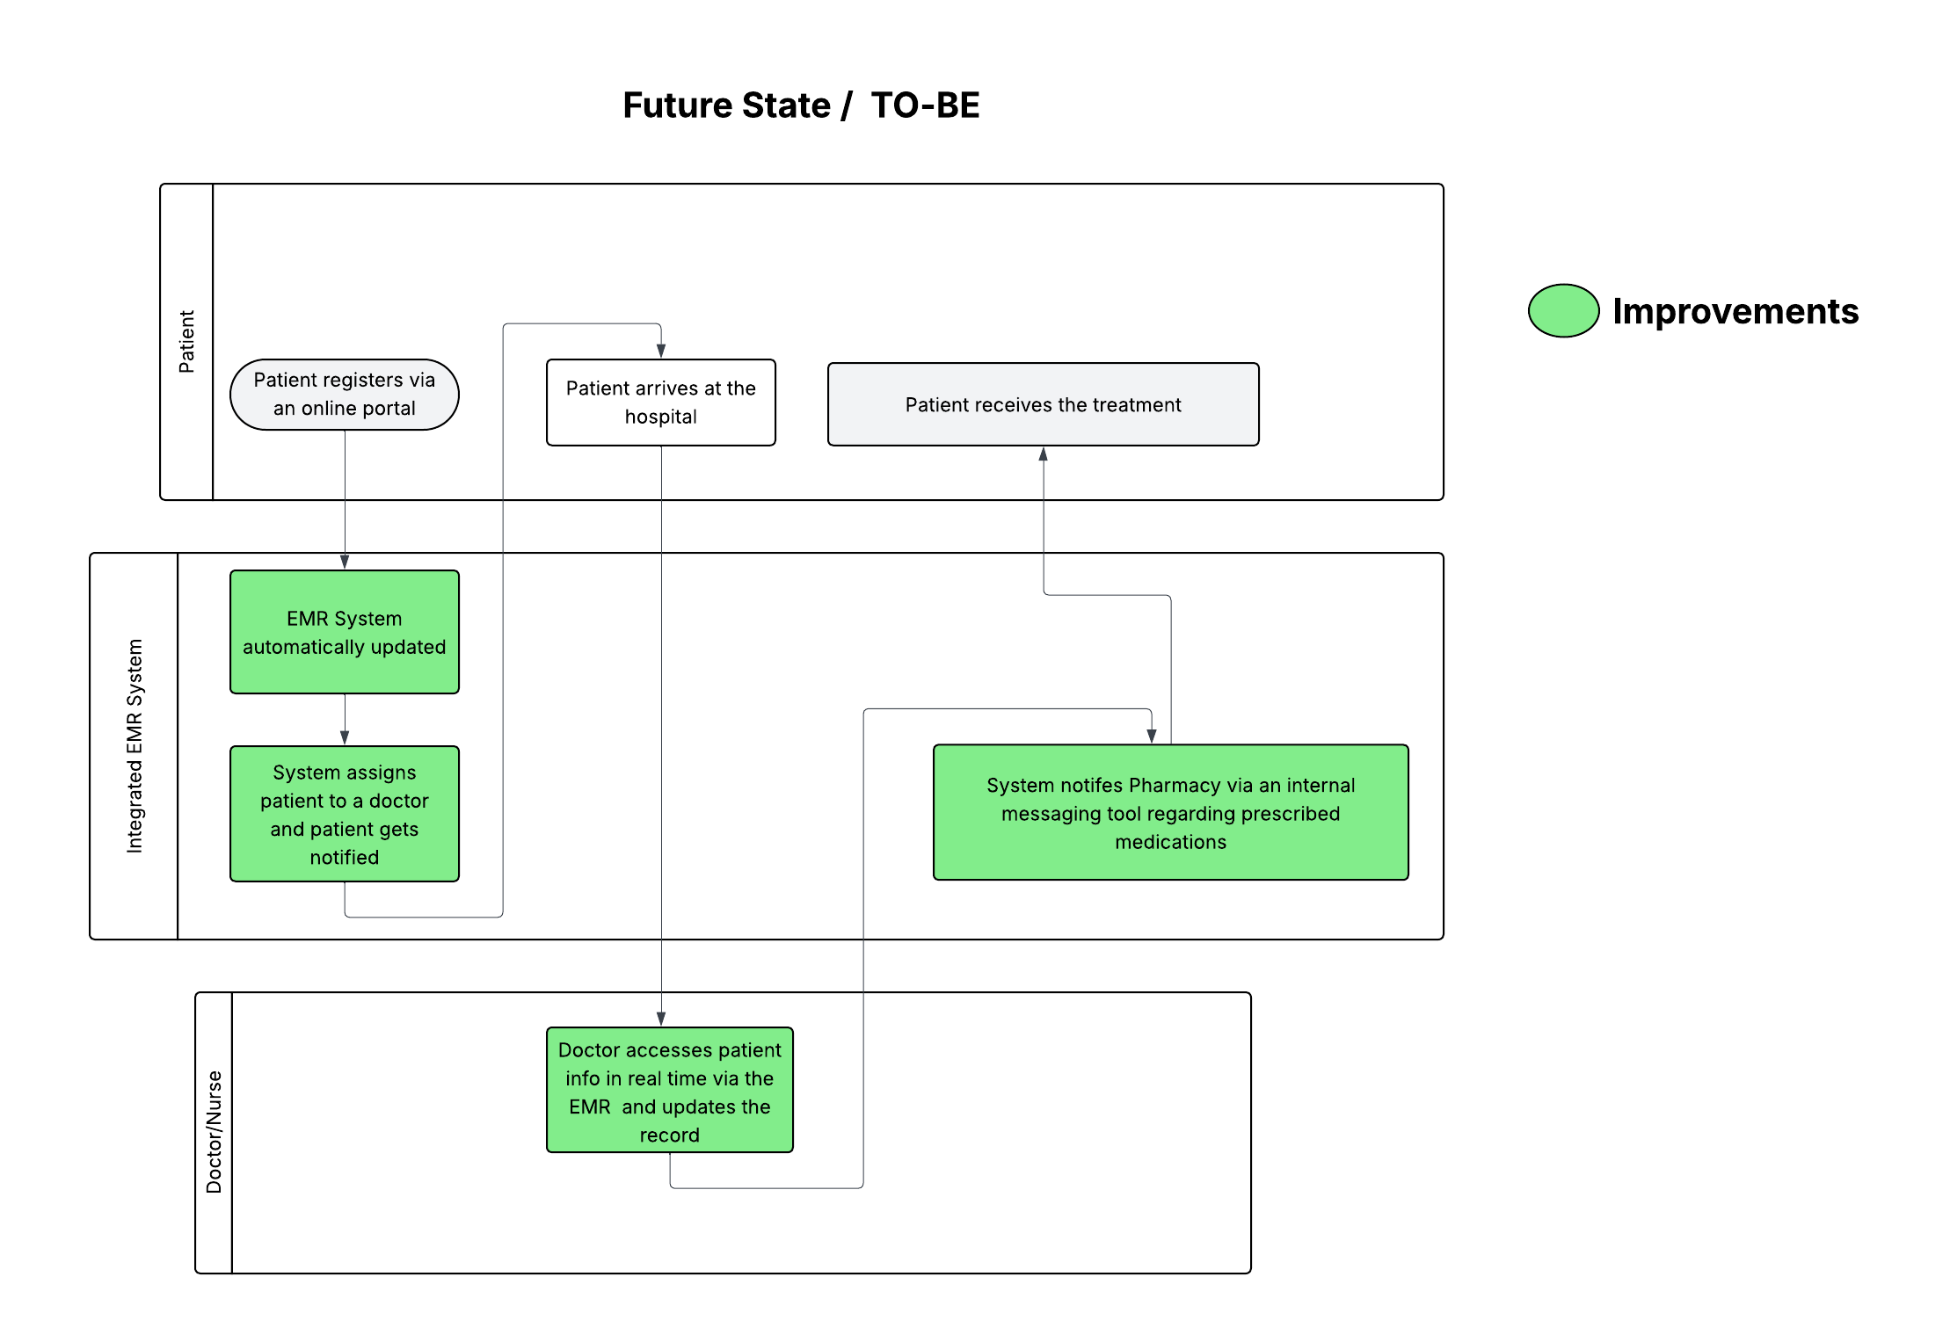

**Functional requirements:**

|  |  |  |
| --- | --- | --- |
| **Requirement ID** | **Title** | **Description** |
| **BR-01** | Centralized EMR System | Implement a centralized Electronic Medical Records (EMR) system accessible by doctors, nurses, and administrative staff. |
| **BR-02** | Automated Patient Registration | Implement an automated patient registration and check-in system integrated with the EMR. |
| **BR-03** | Real-time Communication Tools | Enable real-time communication tools for coordination between doctors, nurses, reception, and pharmacy. |
| **BR-04** | Automated Inventory Management | Implement an automated inventory management system for the pharmacy to track and restock medicines efficiently. |
| **BR-05** | Operational Dashboards | Provide dashboard views for hospital management to monitor patient flow and departmental activities. |
| **BR-06** | Role-based Access Control | Provide role-based access to protect sensitive patient data and ensure compliance with regulations. |

**Non- functional requirements:**

|  |  |
| --- | --- |
| **Category** | **Requirement** |
| Performance | System response time must be under 2 seconds for all primary user functions. |
| Availability | System must ensure 99.9% uptime with automated daily backups. |
| Scalability | System should be capable of handling at least a 30% increase in patient load over the next 2 years without performance degradation. |
| Usability | User interface must be intuitive and user-friendly, requiring no more than 2 hours of basic training for staff. |
| Security & Compliance | System must comply with relevant healthcare data privacy regulations (e.g., HIPAA or local equivalents). |

**Assumptions:**

* All departments will cooperate and provide timely feedback.
* Sufficient technical infrastructure (network, systems) exists for EMR implementation.
* Staff will be available for training sessions and workshops.
* Budget will be allocated for software, training, and minor hardware upgrades.

**Constraints:**

* Project budget capped at ₹25 lakhs.
* Implementation must be completed within 4 months.
* Some legacy systems may not integrate easily and may need replacement.
* Limited availability of staff during peak hospital hours for testing and training.

**Risk Management:**

|  |  |
| --- | --- |
| **Risk** | **Mitigation Strategy** |
| Resistance to change from staff | Conduct training sessions, gather early feedback |
| Data migration issues | Pilot testing, phased rollout, backup legacy data |
| Downtime during implementation | Plan deployment during off-peak hours |
| Budget overrun | Regular monitoring and scope control |
| Non-compliance with regulations | Consult legal/IT on compliance from the start |

**Appendices (Optional):** Stakeholder Interview Notes, Process Flow Diagrams (PFDs), Patient Feedback Survey Summary, Glossary of Terms