**Beautifulsoup**

Urllib library codes

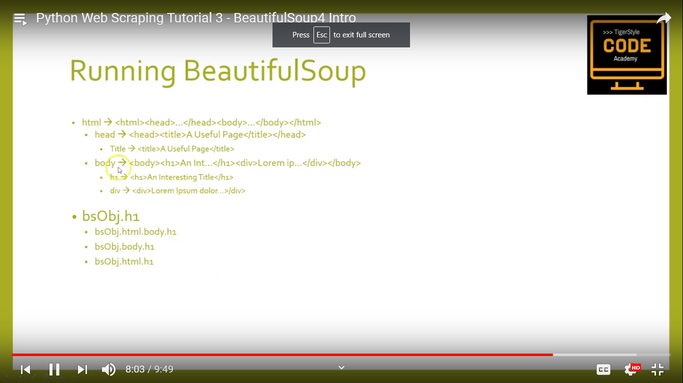

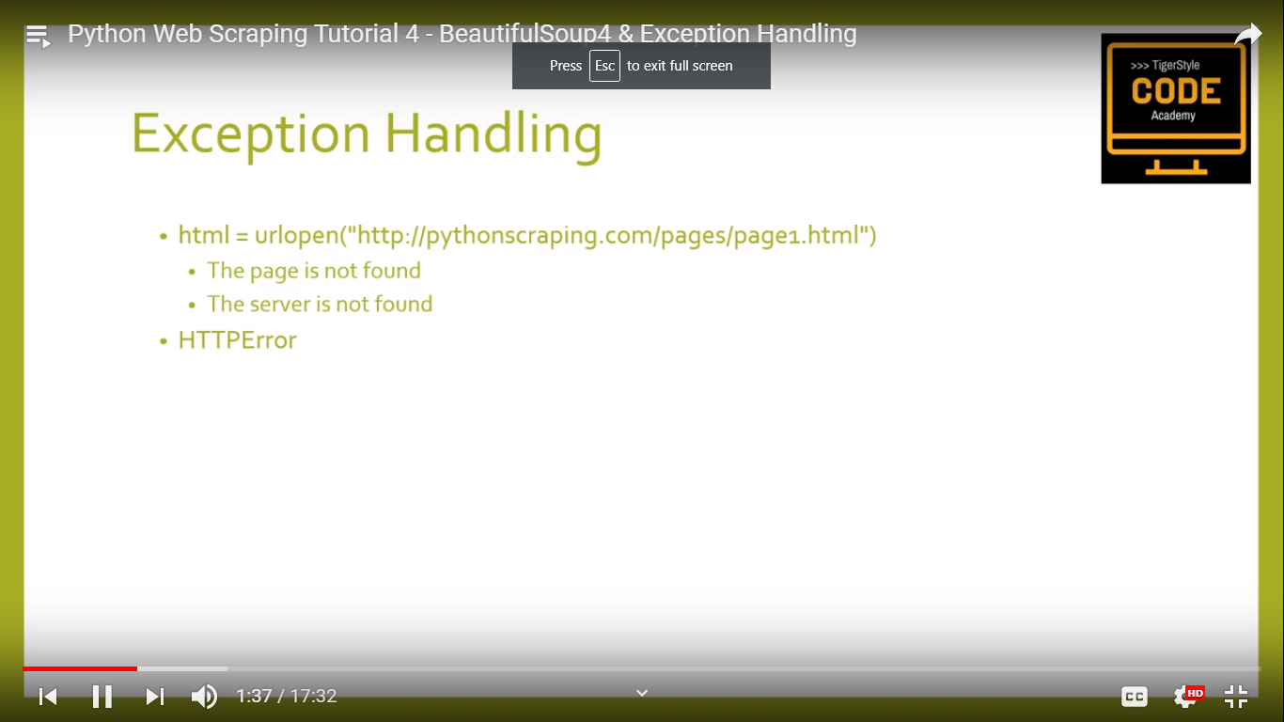

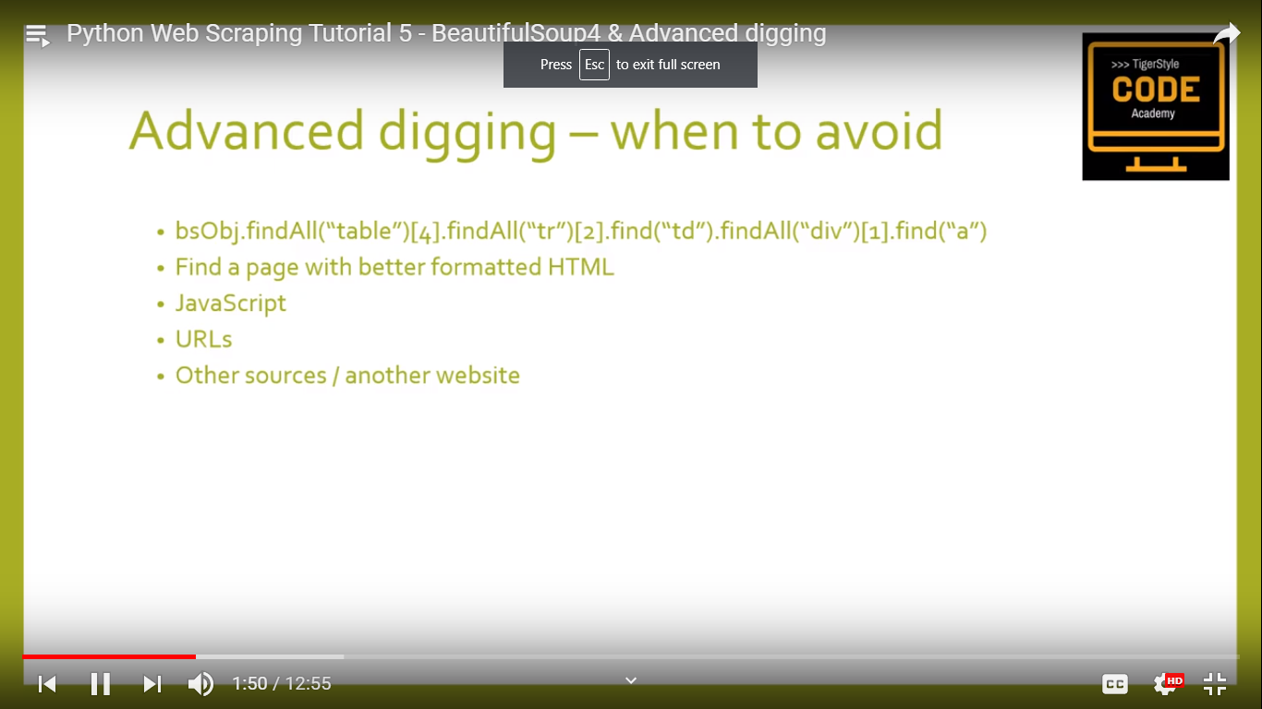

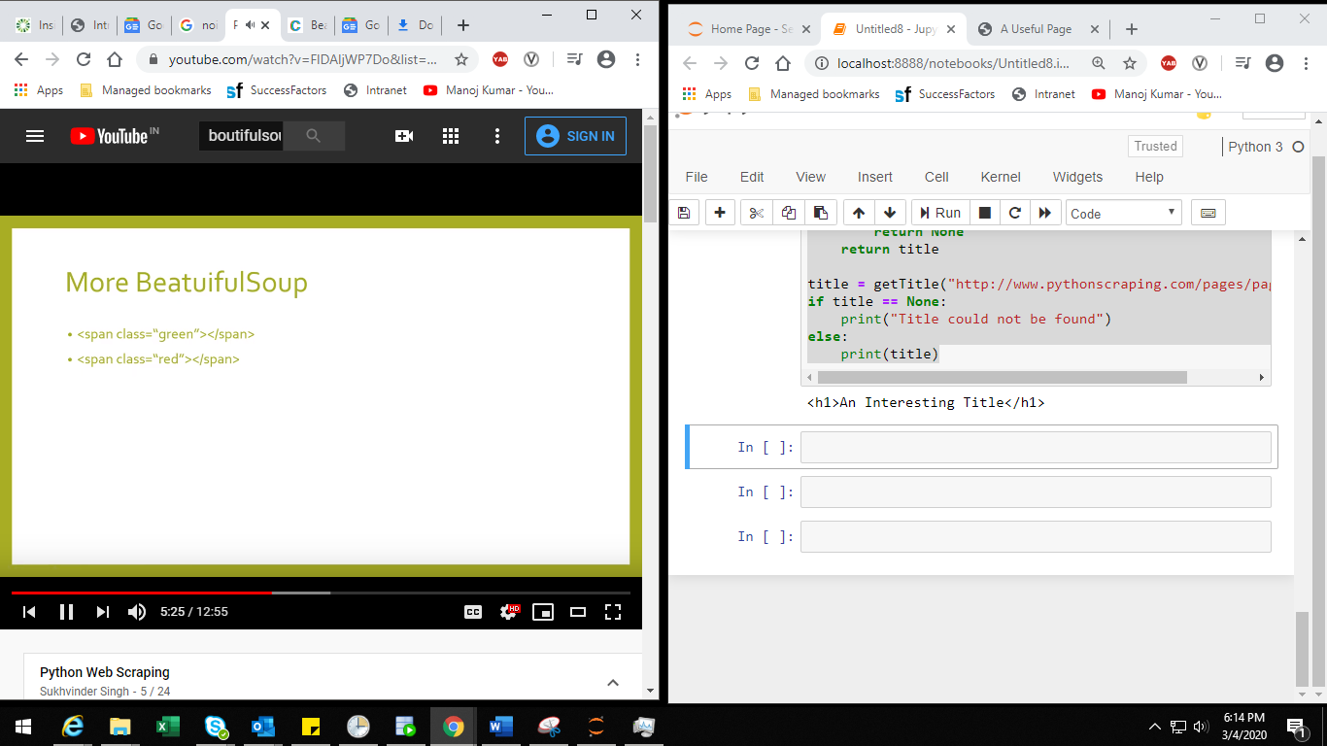

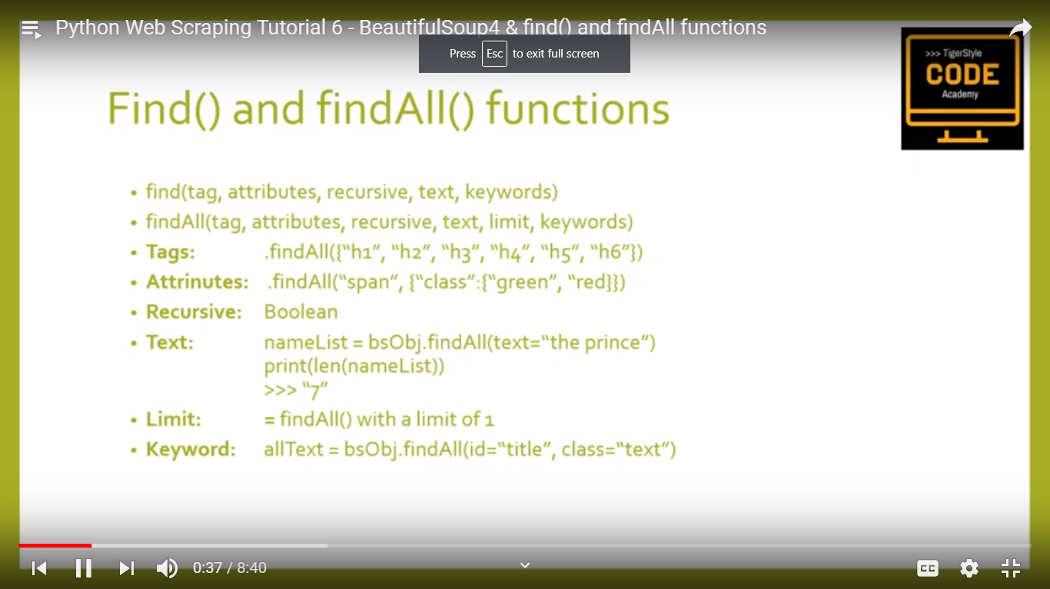

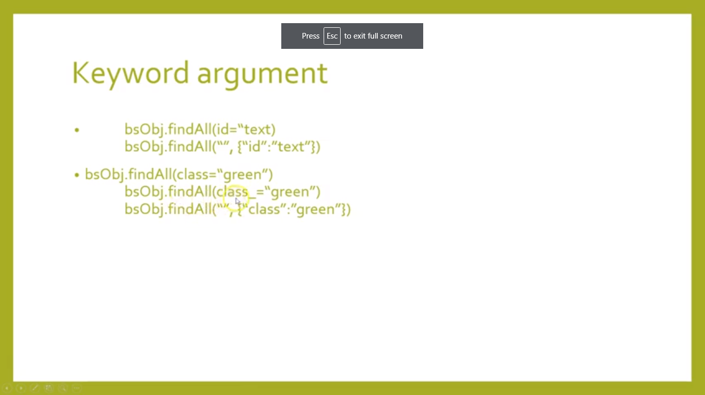

**Siblings:**

The <b> tag and the <c> tag are at the same level: they’re both direct children of the same tag. We call them siblings. When a document is pretty-printed, siblings show up at the same indentation level. You can also use this relationship in the code you write.

