NAME :Manoj kumar.M

DEGREE : B.Sc

BRANCH : Computer Science

COLLEGE : Nachiappa swamigal arts and science college-koviloor.

FATHER’S NAME : Mani.A

DATE OF BRITH : 17/11/2003

GENDER : Male

LANGUAGES KNOWN :
Read - Tamil & English

Speak - Tamil & English

Write -Tamil & English

EMAIL : nithyamanitailar@gmail.com

MOBILE : 9566245607

PERMANENT ADDRESS : S/O Mani.A ,Viralipatti,Melappanaiyur (post),
Pudukkottai (dist), pincode-622 001

ACADEMIC RECORD

COURSE | Institution | Board/  University | CompletionBy | Marks(%)  CGPA
B.Sc | Nachiappa swamigal arts and science college | Alagappa University | _ | _
XII | Alagappa matriculation higher secondary school | State Board | 2021 | 70%
X | Alagappa matriculation higher secondary school | State Board | 2019 | 63%

SKILL SET
- Proficient in Python Programming
- Expertise in Ambiance and Design Strategies
- Strong Event Management Capabilities
- Demonstrated Leadership Skills

HOBBIES
- Art and Painting Enthusiast
- Avid Reader
- Freelance Interior Designer

EXTRACURRICULAR ACTIVITIES
- Fine Arts Club: Served as a dedicated member
- CAP and Nature: Active participation in environmental initiatives
- Hostel Floor Representative: Provided exceptional service and support
- Engaged in various Drawing and Painting Competitions showcasing talent

DECLARATION
I M.Manoj kumar do here by confirm that the information given above is true to the best of my knowledge.
Place : Koviloor
Date : 26/10/2023

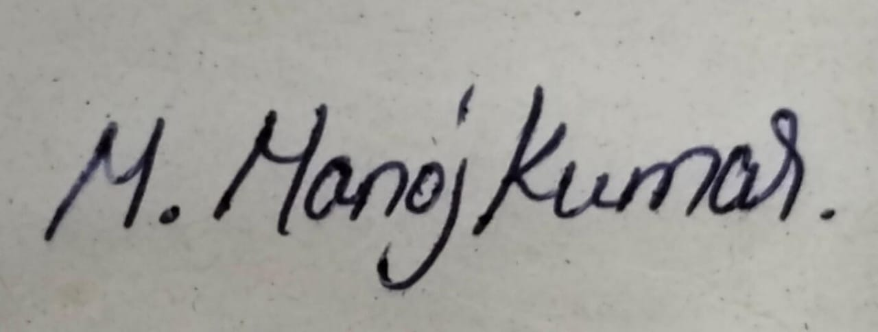
M. Manoj Kumar

